Title: Near complete repair after myocardial infarction in adult mice by altering the inflammatory response with intramyocardial injection of α-gal nanoparticles (Supplementary Section for DOI: 10.3389/fcvm.2021.719160)

Authors: Uri Galili PhDª, Zhongkai Zhu MD^{b}, Jiwang Chen PhD^{b}, Josef W. Goldufsky PhDª, Gary L. Schaer MD FAHA, FACCª

Affiliations:
ªDepartment of Medicine, Rush University Medical Center, Chicago IL
^{b}Department of Medicine, University of Illinois in Chicago, Chicago IL

Short Title: α-gal nanoparticles reduce myocardial infarct size

Category: Original Article

Correspondence to Uri Galili, 910 S. Michigan Ave, #904, Chicago, IL 606052; Telephone: 312-753-5997. Email: uri.galili@rcn.com

SUPPLEMENTAL FIGURE LEGENDS
Supplemental Figure S1. Histological sections of mouse hearts, 28 days post-MI. Sections stained with Trichrome are presented in pairs as total view of the heart (upper) and magnification of the fibrotic area (lower). A. Five additional saline injected post-MI hearts as in Figure 3C. B. Fifteen additional α-gal nanoparticles injected post-MI hearts as in Figure 3D. Scale in each group as indicated in the first figure from the left, unless specifically indicated. Corresponding planimetry analysis is included in Figure 3B.

Supplemental Figure S2. Histological sections of control mouse hearts 28 days post-MI. A. Mouse hearts post-MI receiving two injections each of 100μg in 10μl of nanoparticles lacking α-gal epitopes, i.e., nanoparticles produced from cell membranes of GT-KO pig RBC. B. Mice as in Figure 3D injected with α-gal nanoparticles, however, the GT-KO mice lack the anti-Gal antibody, i.e., mice that were not immunized with pig kidney membranes (PKM). Corresponding planimetry analysis is included in Figure 3B.

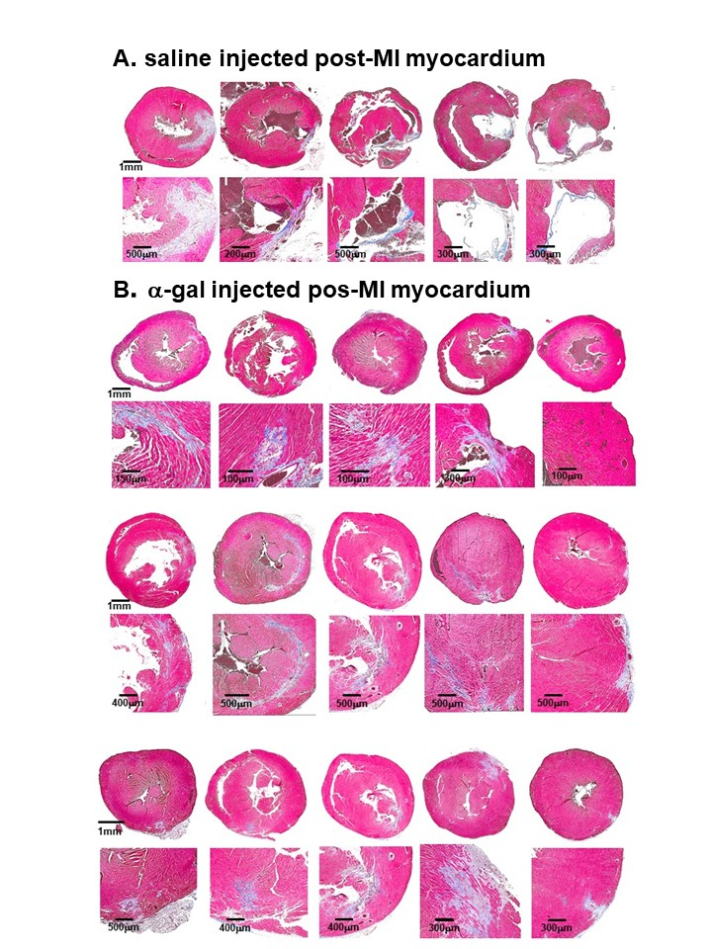
Supplemental Figure S1
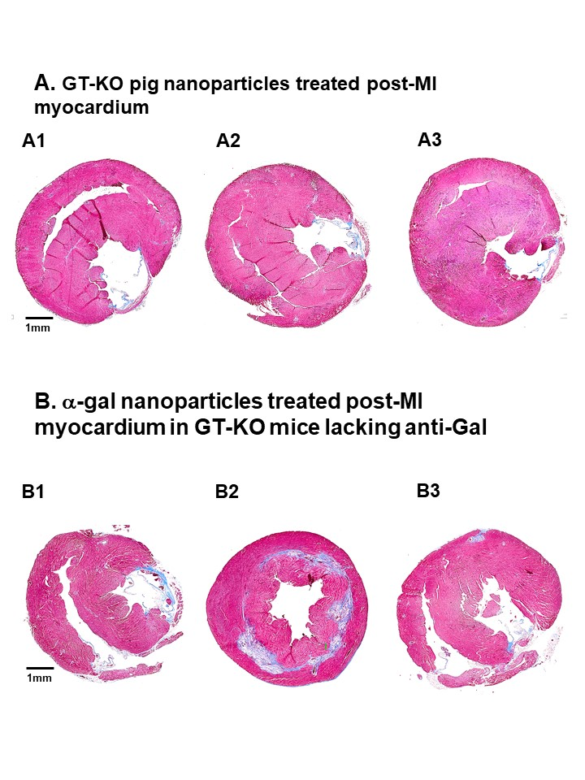
Supplemental Figure S2

