SUPPLEMENTARY MATERIALS
Fig S1 Predicted MP concentration (mg/l) versus time (min) for SpO2 based on the linear mixed effects model.
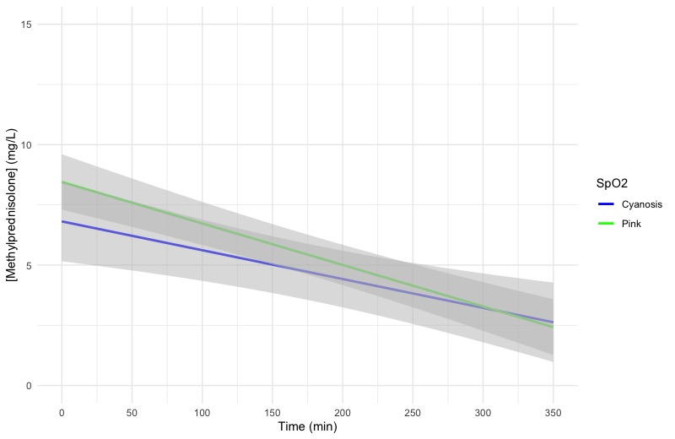
Grey ribbon: 95 % confidence interval
T = 0: start of CPB
Fig S2 Predicted MP concentration (mg/l) versus time (min) for all STSEACTS mortality risk categories based on the linear mixed effects model.
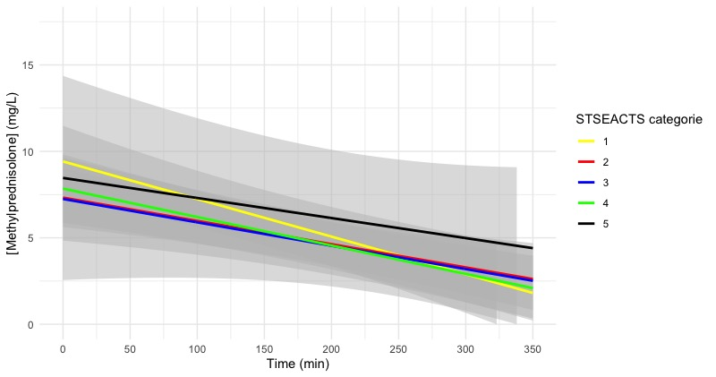
Grey ribbon: 95 % confidence interval
T = 0: start of CPB
Fig S3 Predicted MP concentration (mg/l) versus time (min) for sex based on the linear mixed effects model.
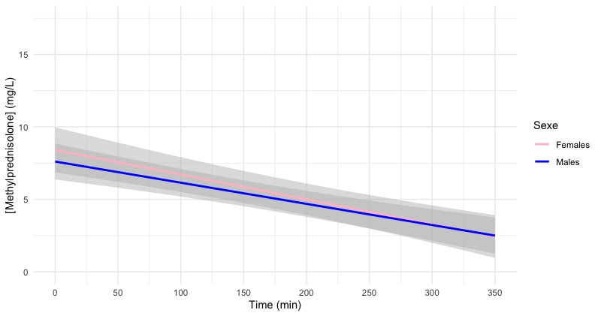
Grey ribbon: 95 % confidence interval
T = 0: start of CPB
Fig S4 Predicted MP concentration (mg/l) versus time (min) for volume overload based on the linear mixed effects model.
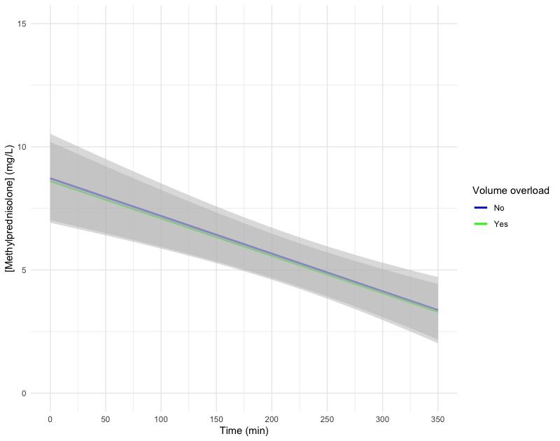
Grey ribbon: 95 % confidence interval
T = 0: start of CPB
Fig S5 Predicted MP concentration (mg/l) versus time (min) for roller pump vs centrifugal pump based on the linear mixed effects model.
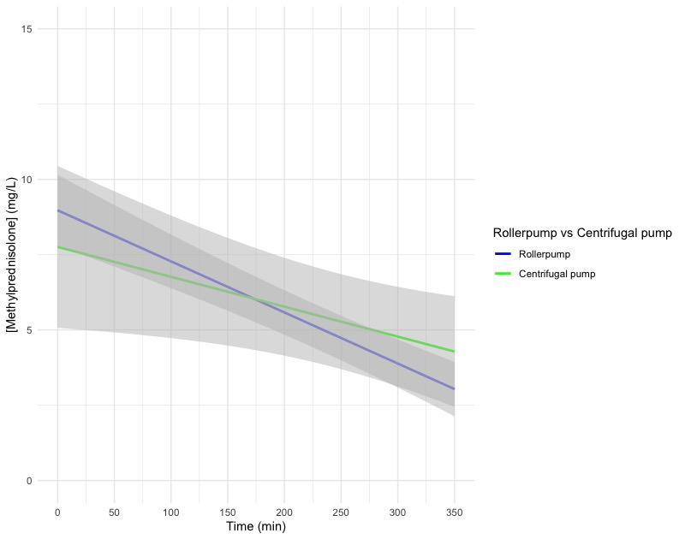
Grey ribbon: 95 % confidence interval
T = 0: start of CPB
Fig S6 Predicted MP concentration (mg/l) versus time (min) for FFP in the priming fluid based on the linear mixed effects model.
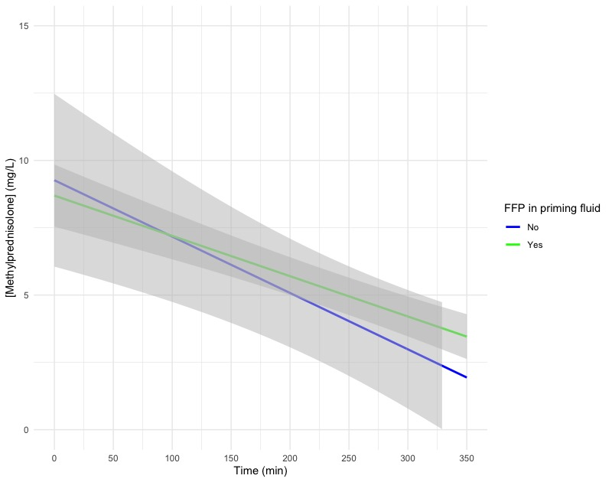
Grey ribbon: 95 % confidence interval
T = 0: start of CPB

Fig S7 Predicted MP concentration (mg/l) versus time (min) for PC in the priming fluid based on the linear mixed effects model.
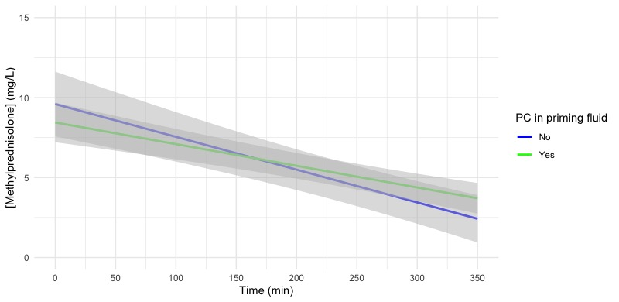
Grey ribbon: 95 % confidence interval
T = 0: start of CPB
Fig S8 Predicted MP concentration (mg/l) versus time (min) for aortic occlusion as a dichotomous variable based on the linear mixed effects model.
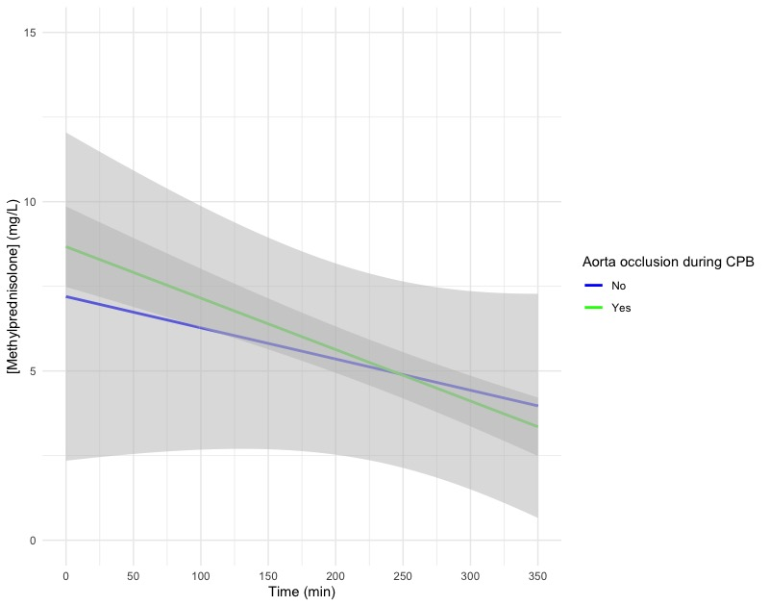
Grey ribbon: 95 % confidence interval
T = 0: start of CPB
Fig S9 Predicted MP concentration (mg/l) versus time (min) for multiple CPB runs as a dichotomous variable based on the linear mixed effects model.
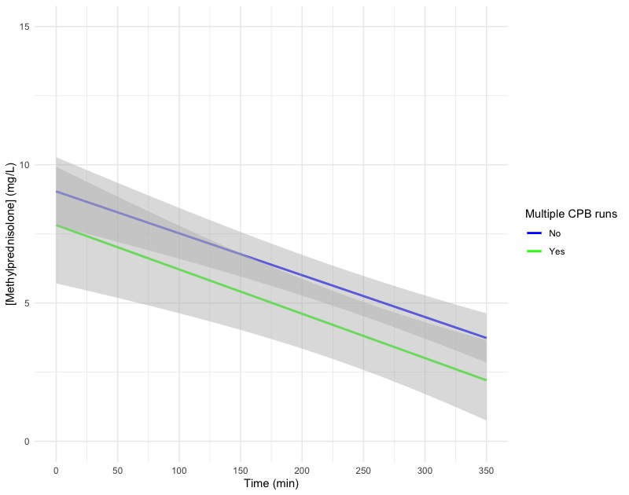
Grey ribbon: 95 % confidence interval
T = 0: start of CPB
Fig S10 Predicted MP concentration (mg/l) versus time (min) for use of a hemofilter as a dichotomous variable based on the linear mixed effects model.
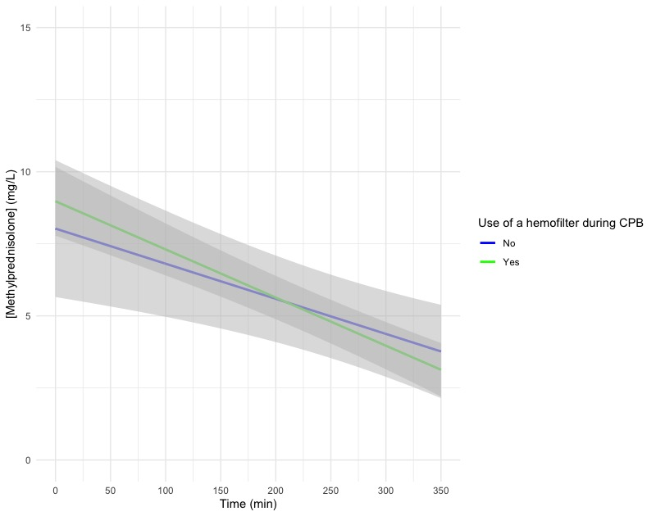
Grey ribbon: 95 % confidence interval
T = 0: start of CPB
Fig S11 Predicted MP concentration (mg/l) versus time (min) for perfusion time as a dichotomous variable based on the linear mixed effects model.
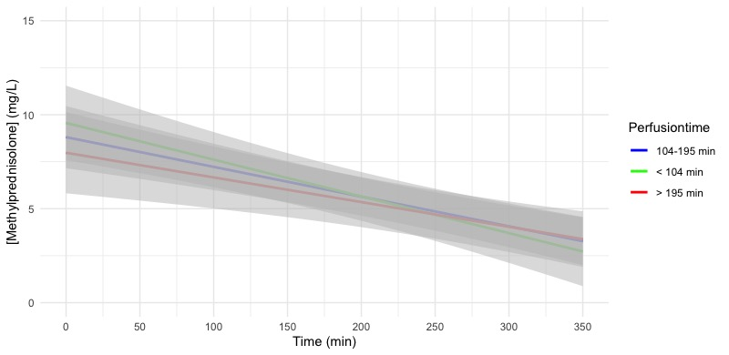
Grey ribbon: 95 % confidence interval
T = 0: start of CPB
Fig S12 Predicted MP concentration (mg/l) versus time (min) for diuresis as a categorical variable based on the linear mixed effects model.
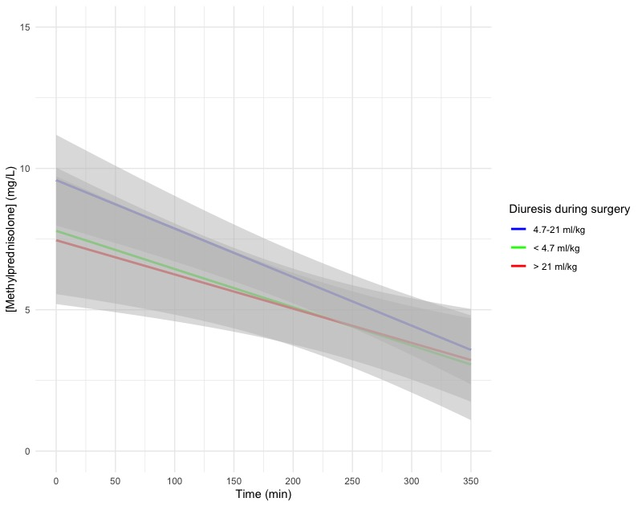
Grey ribbon: 95 % confidence interval
T = 0: start of CPB

