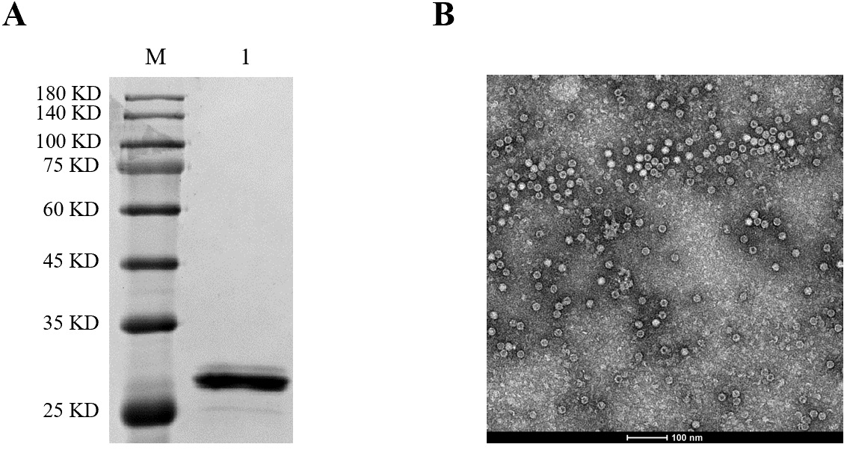

Supplementary Figure. 1 Identification of PCV2 Cap protein and VLPs assembled in vitro. (A) SDS-PAGE of purified PCV2 Cap protein (Lane M: protein marker; Lane 1: purified PCV2 Cap protein). (B) Formation of PCV2 VLPs observed with TEM.

Supplementary Table 1. Reactivity of PCV4 VLP-immunized or PCV2 VLP-immunized mouse serum with PCV4 or PCV2, determined with ELISA.
Coating antigen | Sera | OD450
PCV4 VLPs | PCV4 | 1.404±0.064
 | PCV2 | 0.169±0.014
 | PBS | 0.112±0.001
PCV2 VLPs | PCV4 | 0.091±0.016
 | PCV2 | 1.766±0.041
 | PBS | 0.067±0.001

