<Supplementary Materials>
Supplementary Figure 1. Representative images showing gross appearance of spleens (the upper panels) and cervical lymph nodes (the lower panels) from 8-week-old MRL/lpr mice.

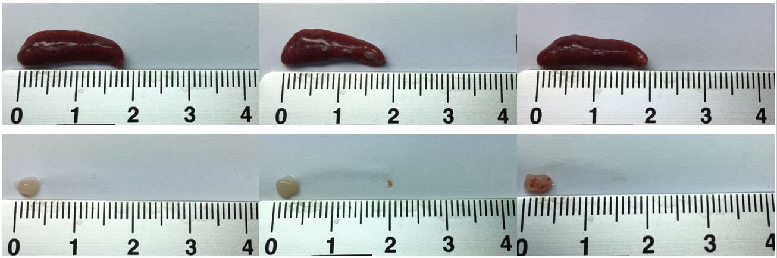

Supplementary Figure 2. The gating strategies of flow cytometry analysis in Figure 2B. The gating strategy for central memory CD8+ T cells (CD44+ CD62L+) is as lymphocytes in forward scatter (FSC)-A vs. side scatter (SSC)-A, singlets in FSC-H vs. FSC-A and live cells in fixable viability dye-A vs. FSC-A.
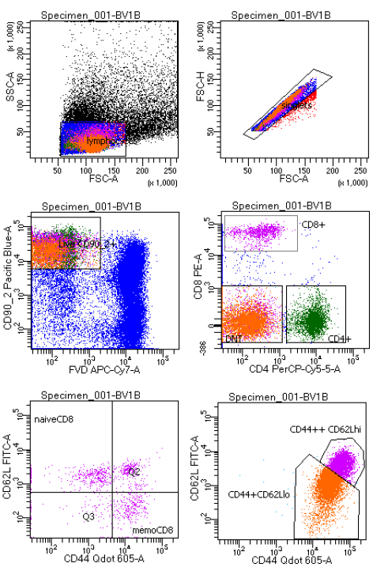

Supplementary Figure 3. Representative dotplots of regulatory T cells (CD4+CD25+CXCR5-FOXP3+, the upper panels), follicular regulatory T cells (CD4+CD25-CXCR5+PD-1+FOXP3+, the lower panels), and follicular helper T cells (CD4+CD25-CXCR5+PD-1+FOXP3-, the lower panels) in Figure 2C.

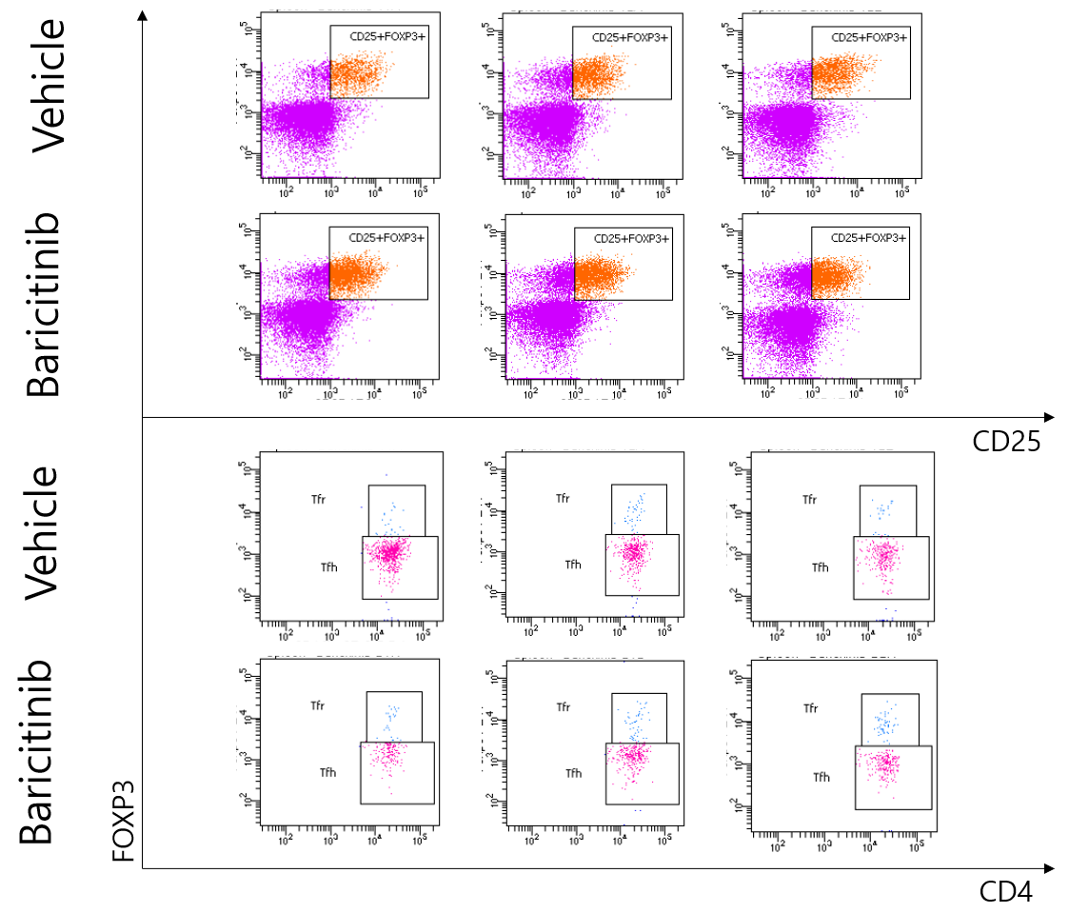

Supplementary Figure 4. Representative dotplots of regulatory T cells (CD4+CD25+CXCR5- FOXP3+) in Figure 3E.
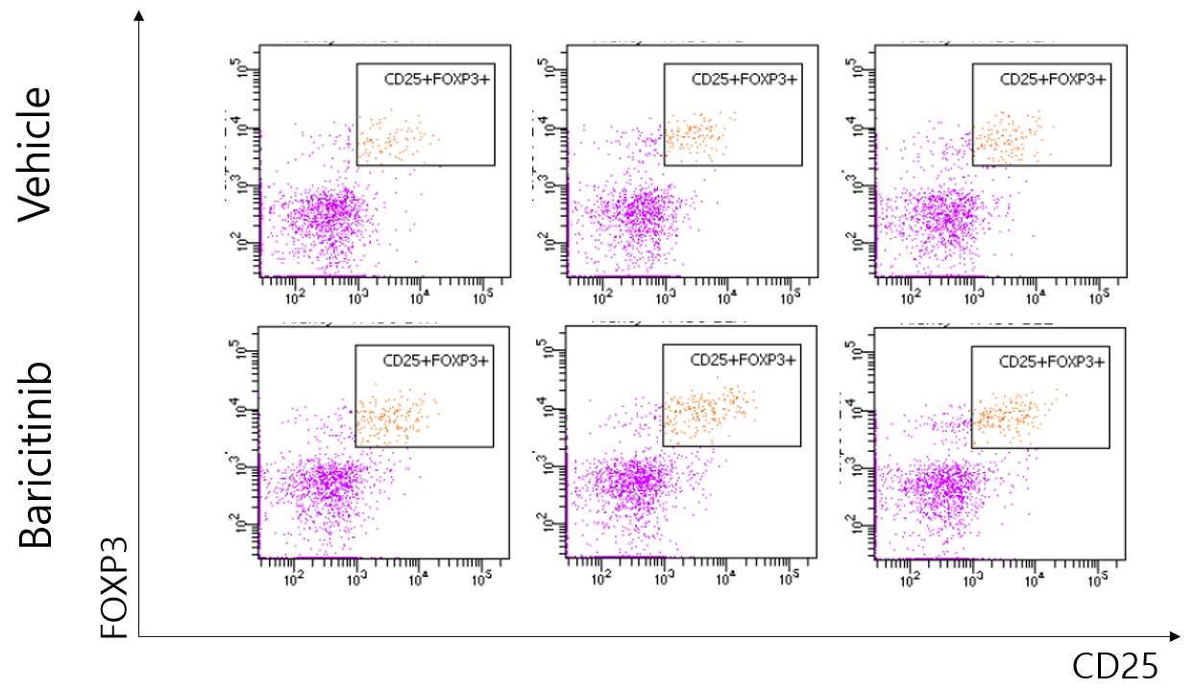

Supplementary Figure 5. (A) Representative flow cytometric image showing CD19+ B cells isolated from spleens of MRL/lpr mice. (B) B cells (5 × 10⁵ cells per well) treated with 1 μg/mL IgM antibodies, 250 ng/mL sCD40L, and 100 ng/mL IL-4 for 2 days with or without graded dose of baricitinib. mRNA levels of Aicda, and Bcl6 were determined using real-time PCR. (C) B cells were treated with the same condition for 5 days. mRNA levels of Xbp1 and Irf4 were determined using real-time PCR. (D) Levels of IgG in culture supernatant were measured by ELISA.
