Supplementary Material

- Biochar-enhanced resistance to Botrytis cinerea in strawberry fruits (but not leaves) is associated with changes in the rhizosphere microbiome
Caroline De Tender^{1,2}, Bart Vandecasteele¹, Bruno Verstraeten³, Sarah Ommeslag¹, Tina Kyndt³, Jane Debode¹

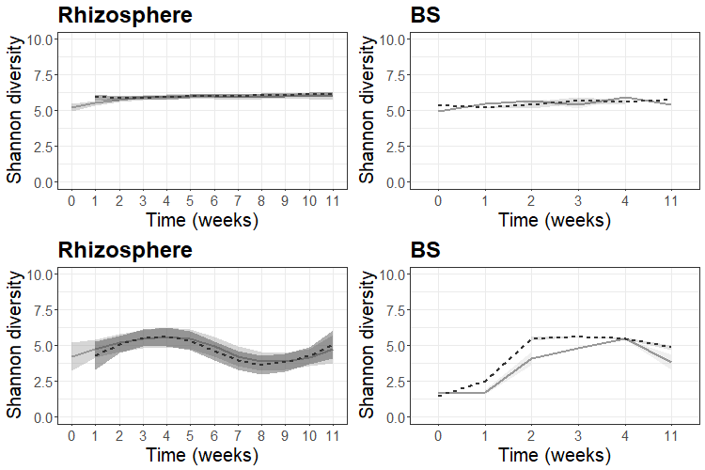
Figure S1 Visualization diversity (Shannon index) of the bacterial (top) and fungal (down) community of the rhizosphere (left) and bulk peat substrate (BS; right). Values represent mean values (n= 5 for rhizosphere and n=3 for bulk growing medium) with standard error illustrated as a shaded zone surrounding the mean. Solid gray line = samples from non-amended peat substrate, black dashed line = 2 g/L biochar amended peat substrate.
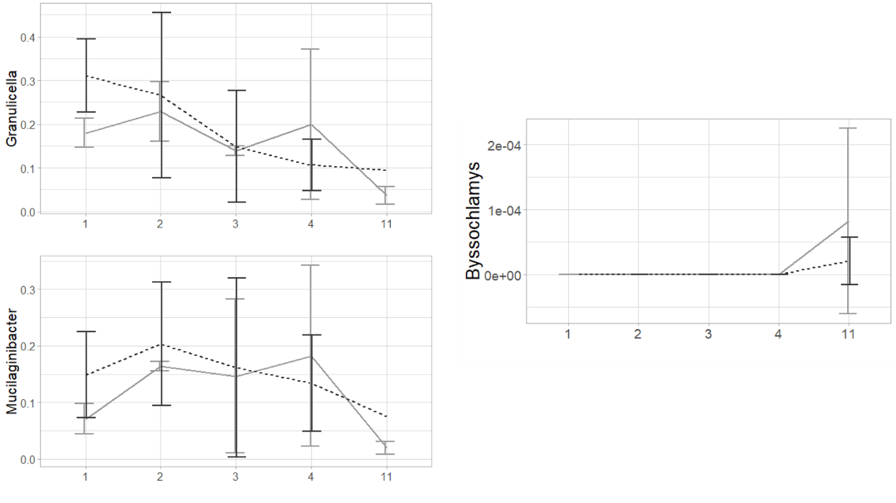
Figure S2: Effect of biochar addition on the bacterial (V3-V4 fragment of the 16S rRNA gene) and fungal (ITS2 gene) community of the bulk peat substrate (BS) and peat substrate (PS) over time. Bacterial and fungal genera that showed consistent increases under biochar addition in the rhizosphere are shown. For bacteria, the same trend is observed, whereas the fungal genus Byssochlamys is almost absent in BS. For all plots, samples taken from peat substrate (PS) are indicated in light gray, while biochar-amended PS is indicated in black.

Figure S3: EC (µS/cm), pH (-) and water-extractable elements (mg/L peat substrate (PS)) for the peat substrate (pots with plants) over 11 weeks of plant growth. Dots represent the mean value with the standard deviation as error bars (n=3). If no values occur, the measurement was below detection limit (EC: Electrical conductivity; DM: Dry Matter).
Figure S4: EC (µS/cm), pH (-) and water-extractable elements (mg/L peat substrate (PS)) for the peat substrate (pots without plants) over 11 weeks of plant growth. Measures were taken on week 3, 6, 9 and 11 of the experiment. Dots represent the mean value with the standard deviation as error bars (n=3). If no values occur, the measurement was below detection limit (EC: Electrical conductivity).

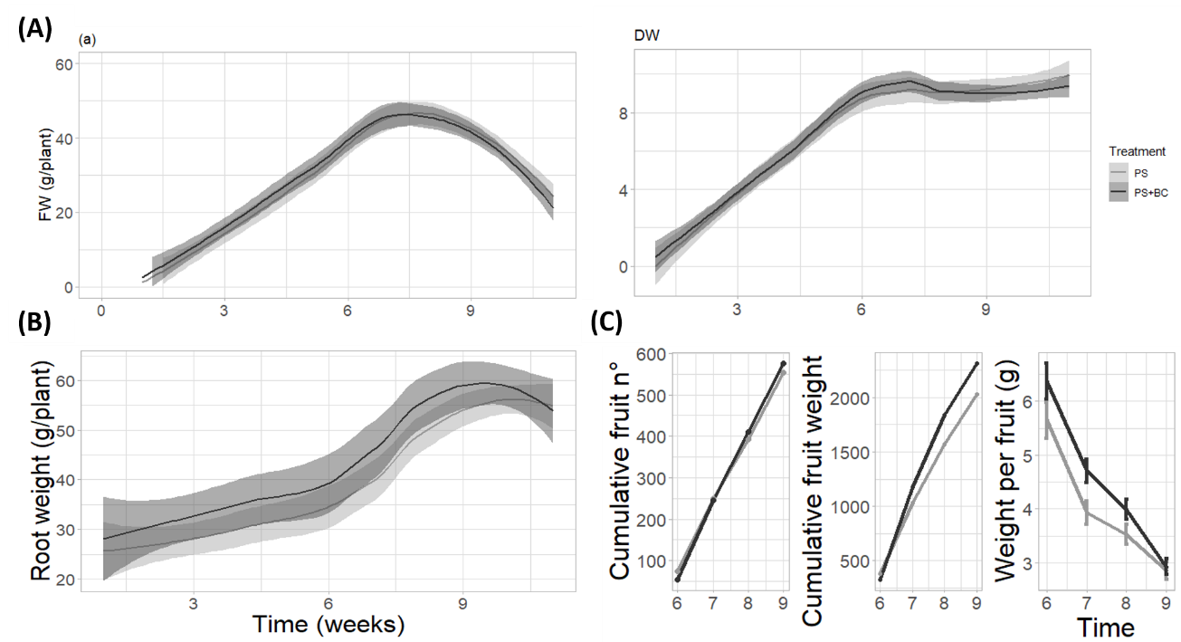
Figure S5 Changes in plant physiological parameters by the addition of biochar to PS. (A) Fresh weight and dry weight of the strawberry plant by biochar addition. No significant changes were noted (n=6). (B) Root weight is positively influenced by the addition of biochar to PS. (C) Effect of biochar on strawberry fruit. Biochar had no effect on the fruit number (left) a positive effect on total fruit weight (middle) , with an overall increase of fruit weight and a higher weight per fruit (right). For all figures, PS is indicated in gray, while PS+BC is indicated in black.

Table S1: Statistical significance of Permutational Analysis of Variance (PERMANOVA) test on the ASV table of the bacterial community. Variables include Treatment (no biochar versus biochar addition), Time (weekly measurement from the start of the experiment (=0) to the end of the experiment (=11 weeks)) and sample type (bulk growing medium (BS) and rhizosphere). Statistically significant results are illustrated by either *p < 0.05; **p < 0.01 or ***p<0.001.

Call:
adonis(formula = dissimilarity_matrix_PS_CH ~ Treatment * Time * SampleType)

Permutation: free
Number of permutations: 999

Terms added sequentially (first to last)

Df SumsOfSqs MeanSqs F.Model R2 Pr(>F)
Treatment 1 0.3489 0.34887 4.7221 0.01279 0.001 ***
Time 11 12.1126 1.10114 14.9044 0.44401 0.001 ***
SampleType 3 2.4002 0.80008 10.8294 0.08799 0.001 ***
Treatment:Time 11 1.5780 0.14346 1.9417 0.05785 0.001 ***
Treatment:SampleType 1 0.1869 0.18694 2.5304 0.00685 0.014 *
Time:SampleType 5 2.5042 0.50084 6.7790 0.09180 0.001 ***
Treatment:Time:SampleType 4 0.3916 0.09791 1.3252 0.01436 0.111
Residuals 105 7.7574 0.07388 0.28436
Total 141 27.2799 1.00000
---

Table S2: Statistical significance of Permutational Analysis of Variance (PERMANOVA) test on the ASV table of the fungal community. Variables include Treatment (no biochar versus biochar addition), Time (weekly measurement from the start of the experiment (=0) to the end of the experiment (=11 weeks)) and sample type (bulk growing medium (BS) and rhizosphere). Statistically significant results are illustrated by either *p < 0.05; **p < 0.01 or ***p<0.001.
Call:
adonis(formula = dissimilarity_matrix_PS_CHF ~ TreatmentF * TimeF * SampleTypeF)

Permutation: free
Number of permutations: 999

Terms added sequentially (first to last)

Df SumsOfSqs MeanSqs F.Model R2 Pr(>F)
TreatmentF 1 0.309 0.30913 4.2244 0.00932 0.007 **
TimeF 11 18.561 1.68738 23.0588 0.55984 0.001 ***
SampleTypeF 3 1.763 0.58754 8.0289 0.05316 0.001 ***
TreatmentF:TimeF 11 1.948 0.17705 2.4194 0.05874 0.001 ***
TreatmentF:SampleTypeF 1 0.475 0.47454 6.4847 0.01431 0.001 ***
TimeF:SampleTypeF 5 1.828 0.36563 4.9964 0.05514 0.001 ***
TreatmentF:TimeF:SampleTypeF 4 0.441 0.11028 1.5070 0.01330 0.069 .
Residuals 107 7.830 0.07318 0.23617
Total 143 33.154 1.00000
---
Signif. codes: 0 ‘***’ 0.001 ‘**’ 0.01 ‘*’ 0.05 ‘.’ 0.1 ‘ ’ 1

Table S3 Enrichments and depletions of bacterial ASVs with biochar treatment. Biochar-induced increase in relative abundance at a specific time point (week 1 (t1) to week 11 (t11)), is indicated by +. Statistically significant (p<0.05) decreases in relative abundance are indicated by – .

ASV | Genus | t1 | t2 | t3
107 | Acidocella |  |  | -
796 | Amnibacterium | +
265 | Arsenicitalea |  | -
63 | Bryobacter | + | +
188 | Candidatus_Koribacter | +
477 | Candidatus_Ovatusbacter |  | +
548 | Caulobacter |  | -
118 | Devosia | +
37 | Granulicella |  | +
167 | Granulicella | + | + | +
233 | Granulicella |  | +
290 | Granulicella | +
390 | Granulicella | +
208 | Haliangium | +
544 | Haliangium | +
602 | Iamia | + | +
2169 | Lysobacter |  |  | +
162 | Methylovirgula | +
68 | Mucilaginibacter | +
78 | Mucilaginibacter | +
159 | Mucilaginibacter | +
181 | Mucilaginibacter | +
301 | Mucilaginibacter |  | +
365 | Mucilaginibacter | +
380 | Mucilaginibacter |  | +
426 | Mucilaginibacter |  | +
431 | Mucilaginibacter |  | +
926 | Mucilaginibacter | +
54 | Occallatibacter | +
119 | Occallatibacter | +
253 | Occallatibacter | +
295 | Occallatibacter |  | +
505 | Occallatibacter | +
21 | Opitutus |  |  | -
80 | Opitutus | +
2045 | Rahnella |  | +
425 | Reyranella |  |  | +
859 | Rhodanobacter |  |  | -
349 | Roseiarcus | + | +
327 | Schlesneria |  | -
807 | Spirochaeta_2 | -
2233 | SWB02 |  | -
359 | Terracidiphilus | + |  | -

Table S4 Enrichments and depletions of fungal ASVs with biochar treatment. Biochar-induced increase in relative abundance at a specific time point (week 1 (t1) to week 11 (t11)), is indicated by +. Statistically significant (p<0.05) decreases in relative abundance are indicated by – .
ASV | Genus | t1 | t2 | t3 | t4 | t5 | t6 | t7 | t8 | t9 | t10 | t11
3 | Basidiodendron |  |  |  |  |  |  | -
14 | Mortierella |  |  |  |  |  |  |  |  | +
26 | Fusarium |  |  |  |  |  |  |  |  | +
28 | Clonostachys |  |  |  |  |  |  |  |  |  | -
34 | Clavaria |  |  |  |  |  |  | - | -
41 | Trichoderma |  |  |  |  |  |  |  |  | -
45 | Plectosphaerella |  |  |  |  |  |  |  |  |  | -
47 | Cladosporium |  |  |  |  |  |  | +
104 | Podospora |  |  |  |  |  |  |  |  | +
105 | Delicatula |  |  |  |  |  |  |  | + | + | +
124 | Oidiodendron |  |  |  |  |  |  |  |  |  |  | -
130 | Stachybotrys |  |  |  |  |  |  |  |  | +
132 | Acidomelania |  |  |  |  |  |  |  | - |  |  | +
140 | Archaeorhizomyces |  |  |  |  |  |  | - |  | +
146 | Subulicystidium |  |  |  |  |  |  |  |  | +
153 | Clavispora |  |  |  |  |  |  | + |  |  |  | +
155 | Microscypha |  |  |  |  |  |  | + | +
163 | Microdochium | + |  |  |  |  |  |  |  | +
175 | Neobulgaria |  |  |  |  |  |  |  | -
178 | Calyptrozyma |  |  |  |  |  |  |  |  | +
183 | Sarcoleotia |  |  |  |  |  |  |  |  |  | - | +
187 | Rhizophagus |  |  |  |  |  |  | +
191 | Lachnum |  |  |  |  |  |  |  |  | + |  | +
193 | Rhexocercosporidium |  |  |  |  |  |  |  |  |  | -
199 | Tetrachaetum |  |  |  |  |  |  | -
204 | Gibellulopsis |  |  |  |  |  |  | + | - | +
205 | Holtermanniella |  |  |  |  |  |  |  | +
212 | Boothiomyces |  |  |  |  |  |  |  | - | +
224 | Geoglossum |  |  |  |  |  |  |  |  | +
258 | Zopfiella |  |  |  |  |  |  |  | +
259 | Guehomyces |  |  |  |  |  |  | +
274 | Alternaria |  |  |  |  |  |  |  | +
289 | Ophiosphaerella |  |  |  |  |  |  |  | - | + | -
298 | Claroideoglomus | - |  |  |  |  |  | -
305 | Cercophora |  |  |  |  |  |  | + |  |  | -
307 | Pseudaleuria |  |  |  |  |  |  |  |  | +
312 | Pyrenochaetopsis |  |  |  |  |  |  | - |  | + | +
317 | Peniophora |  |  |  |  |  |  |  |  | + | -
318 | Gaeumannomyces |  |  |  |  |  |  |  | + |  |  | -
325 | Dimorphospora |  |  |  |  |  |  |  |  | -
336 | Coprinus |  |  |  |  |  |  |  |  | +
337 | Trebouxia |  |  |  |  |  |  |  | - | +
339 | Plenodomus |  |  |  |  |  |  | + | -
341 | Wallemia |  |  |  |  |  |  | +
355 | Codinaea |  |  |  |  |  |  |  |  | +
382 | Byssochlamys | + | + |  | + | + | + | + | + | + | +
384 | Eocronartium |  |  |  |  |  |  |  |  |  | -
391 | Trichocladium |  |  |  |  |  |  |  |  |  | -
395 | Cladorrhinum |  |  |  |  |  |  |  | - | + | -
399 | Apodospora |  |  |  |  |  |  |  | + | +
408 | Sistotrema |  |  |  |  |  |  |  |  | -
460 | Hygrocybe |  |  |  |  |  |  |  | + | +
477 | Chloridium |  |  |  |  |  |  | +
479 | Periconia |  |  |  |  |  |  |  | - |  | +
498 | Slopeiomyces |  |  |  |  |  |  |  | + | +
505 | Leucosporidium |  |  |  |  |  | +
541 | Naganishia |  |  |  |  |  |  | +
553 | Clitopilus |  |  |  |  |  |  |  |  |  | - | -
627 | Drechslera |  |  |  |  |  |  |  |  | + | =
657 | Blastobotrys |  |  | +
660 | Leptosphaeria |  |  |  |  |  |  |  |  | +
666 | Entorrhiza |  |  |  |  |  |  |  | - | =
688 | Lindgomyces |  |  |  |  |  |  |  |  | + | -
708 | Nidulariopsis |  |  |  |  |  |  |  | + | +
720 | Paraphoma |  |  |  |  |  |  |  |  |  | -
739 | Hannaella |  |  |  |  |  |  |  |  |  |  | +
748 | Ophiocordyceps |  |  |  |  |  |  |  | + | +
768 | Fusicolla |  |  |  |  |  |  |  | -
790 | Lachnella |  |  |  |  |  |  |  |  | +
812 | Scytalidium |  |  |  |  |  | +
857 | Henningsomyces |  |  |  |  |  |  | -
1011 | Lecythophora |  |  |  |  |  |  |  |  | +
1031 | Torula |  |  |  |  |  |  |  |  |  | -
1099 | Arthrinium |  |  |  |  |  |  |  |  |  | -
1110 | Cistella |  |  |  |  |  |  | - |  |  |  | +
1119 | Psilocybe |  |  |  |  |  |  |  |  | +
1121 | Cyphellophora |  |  |  |  |  |  |  |  |  | +
1177 | Pulvinula |  |  |  |  |  |  | +
1224 | Leohumicola |  |  |  |  |  |  |  |  | +
1277 | Glomus |  |  |  |  |  |  |  |  |  | - | +
1359 | Basidiobolus |  |  |  |  |  |  |  |  | +

Table S5: Nutrient concentrations (a) and total uptake (b) in strawberry leaves after 3, 6 and 9 weeks of strawberry plant growth in the time course experiment. Values are represented as mean values ± standard deviation (n=3). Values for concentration are indicated as %/DM (N), g/kg dry matter (P, K, Mg, Ca) or mg/kg dry matter (Fe, Mn). Values for total uptake are indicated in mg.
 |  | 3 weeks |  | 6 weeks |  |  | 9 weeks
(a) | Optimal range | PS | PS+BC |  | PS | PS+BC |  | PS | PS+BC
N | 2.0-2.8 | 2.6±0.1 (c) | 2.6±0.1 (c) |  | 1.1±0.1 (b) | 1.1±0.1 (b) |  | 1.0±0.1 (b) | 0.6±0.1 (a)
P | 2.5-4.0 | 3.7±0.1 (c) | 4.0±0.1 (c) |  | 2.0±0.1 (b) | 1.9±0.1 (b) |  | 1.6±0.1 (a) | 1.5±0.1 (a)
K | 15-25 | 19.2±1.0 (c) | 20.9±0.8 (c) |  | 8.8±2.1 (b) | 8.3±0.4 (b) |  | 4.2±0.8 (a) | 4.9±0.9 (a)
Mg | 3.0-5.0 | 4.6±0.1 (b) | 4.3±0.2 (b) |  | 3.5±0.1 (a) | 3.2±0.1 (a) |  | 4.4±0.1 (b) | 3.6±0.2 (a)
Ca | 7.0-17 | 8..1±0.1 (a) | 8.0±0.4 (a) |  | 7.5±0.7 (a) | 7.5±0.1 (a) |  | 10.4±0.4 (b) | 9.8±05 (b)
(b)
N |  | 66±4.3 (ab) | 79.4±16.4 (bc) |  | 105±14.5 (c) | 95.8±16.6 (c) |  | 77±7.4 (b) | 47.9±1.9 (a)
P |  | 9.4±1.3 (a) | 12.0±2.3 (a) |  | 18.5±2.1 (b) | 17.2±1.7 (b) |  | 12.9±1.4 (a) | 11.4±1.4 (a)
K |  | 48.9±6.4 (ab) | 63.0±11.3 (b) |  | 81.5±26.0 (b) | 74.9±3.1 (b) |  | 34.7±8.9 (a) | 37.9±7.5 (a)
Mg |  | 11.5±1.4 (a) | 12.8±2.2 (a) |  | 31.7±3.5 (b) | 28.8±2.9 (b) |  | 35.4±2.9 (b) | 27.4±2.7 (b)
Ca |  | 20.7±3.0 (a) | 24.0±4.0 (a) |  | 69.3±10.3 (b) | 67.3±5.8 (b) |  | 85.5±8.0 (b) | 75.1±5.4 (b)

Table S6: Nutrient concentrations (a) and total uptake (b) in strawberry fruit. Values are represented as mean values ± standard deviation (n=3). (a) Values for concentration are indicated as %/DM (N), g/kg dry matter (P, K, Mg, Ca). (b) Values for total uptake are indicated in mg and could only be calculated for fruits taken 7 weeks after starting the experiment.
 |  | PS | PS+BC
(a)
N | 0.71±0.07 (a) |  | 0.64±0.05 (a)
P |  | 1.51±0.09 (a) | 1.50±0.03 (a)
K |  | 8.41±0.40 (a) | 8.82±0.39 (a)
Mg |  | 1.54±0.33 (a) | 1.48±0.22 (a)
Ca |  | 2.74±0.68 (a) | 2.58±0.45 (a)
(b)
N |  | 45 | 45.7
P |  | 9.5 | 10.6
K |  | 52.3 | 63.5
Mg |  | 9.6 | 10.2
Ca |  | 17.1 | 18.4

Table S7: Up- and downregulated genes (RNA sequencing) by B. cinerea infection on the leaves (PS vs. PS+I).
Gene ID | logFC
FANhyb_icon00000056_a.1.g00002.1 | -1.46328
FANhyb_icon00000286_a.1.g00001.1 | -1.65077
FANhyb_icon00000491_a.1.g00001.1 | -1.59752
FANhyb_icon00000519_a.1.g00001.1 | 2.623343
FANhyb_icon00000804_a.1.g00001.1 | 1.205036
FANhyb_icon00001250_a.1.g00001.1 | 2.04092
FANhyb_icon00001351_a.1.g00001.1 | -3.48359
FANhyb_icon00001395_a.1.g00001.1 | -2.37085
FANhyb_icon00001624_a.1.g00001.1 | -1.81845
FANhyb_icon00002769_a.1.g00001.1 | 2.092776
FANhyb_icon00003078_a.1.g00001.1 | -1.41588
FANhyb_icon00003278_a.1.g00001.1 | 2.988231
FANhyb_icon00003811_a.1.g00001.1 | -1.82469
FANhyb_icon00006080_a.1.g00001.1 | 1.812699
FANhyb_icon00006480_a.1.g00001.1 | -1.53254
FANhyb_icon00006642_a.1.g00001.1 | -1.7653
FANhyb_icon00007591_a.1.g00001.1 | -2.00512
FANhyb_icon00007641_a.1.g00001.1 | 2.769313
FANhyb_icon00008755_a.1.g00001.1 | 3.663744
FANhyb_icon00008971_a.1.g00001.1 | -2.41087
FANhyb_icon00009318_a.1.g00001.1 | -2.02074
FANhyb_icon00010779_a.1.g00001.1 | -1.56057
FANhyb_icon00011188_a.1.g00001.1 | -3.18512
FANhyb_icon00015158_a.1.g00001.1 | 5.86393
FANhyb_icon00016429_a.1.g00001.1 | -2.43218
FANhyb_icon00018851_a.1.g00001.1 | -2.16913
FANhyb_icon00020670_a.1.g00001.1 | -2.36458
FANhyb_icon00027359_a.1.g00001.1 | -3.83043
FANhyb_icon00030108_a.1.g00001.1 | -2.82337
FANhyb_icon00030158_a.1.g00001.1 | -2.14398
FANhyb_icon00030879_a.1.g00001.1 | -2.06324
FANhyb_icon00031686_a.1.g00001.1 | -3.08189
FANhyb_icon00035972_a.1.g00001.1 | -4.31642
FANhyb_icon00038336_a.1.g00001.1 | -2.38021
FANhyb_icon00039674_a.1.g00001.1 | 1.947749
FANhyb_icon00040024_a.1.g00001.1 | -6.38869
FANhyb_icon00044428_a.1.g00001.1 | 1.454863
FANhyb_icon00045239_a.1.g00001.1 | -2.1469
FANhyb_icon19625041_s.1.g00001.1 | -3.11226
FANhyb_icon19730437_s.1.g00001.1 | 4.068712
FANhyb_icon20235835_s.1.g00001.1 | -3.5418
FANhyb_rscf00000002.1.g00026.1 | 2.223493
FANhyb_rscf00000003.1.g00046.1 | -4.26686
FANhyb_rscf00000005.1.g00035.1 | 1.765768
FANhyb_rscf00000008.1.g00049.1 | 1.992491
FANhyb_rscf00000012.1.g00021.1 | 3.770001
FANhyb_rscf00000013.1.g00025.1 | -2.14136
FANhyb_rscf00000015.1.g00031.1 | -3.01656
FANhyb_rscf00000024.1.g00007.1 | 1.096966
FANhyb_rscf00000030.1.g00022.1 | -3.58355
FANhyb_rscf00000036.1.g00021.1 | 3.640636
FANhyb_rscf00000040.1.g00016.1 | -1.55709
FANhyb_rscf00000046.1.g00002.1 | -1.91905
FANhyb_rscf00000046.1.g00011.1 | -1.09269
FANhyb_rscf00000046.1.g00026.1 | -1.64534
FANhyb_rscf00000047.1.g00005.1 | 1.402856
FANhyb_rscf00000049.1.g00022.1 | -1.32629
FANhyb_rscf00000050.1.g00021.1 | 3.952462
FANhyb_rscf00000078.1.g00008.1 | -1.96526
FANhyb_rscf00000087.1.g00005.1 | 1.417515
FANhyb_rscf00000112.1.g00005.1 | 1.937623
FANhyb_rscf00000129.1.g00011.1 | -2.28517
FANhyb_rscf00000141.1.g00004.1 | 1.36689
FANhyb_rscf00000160.1.g00010.1 | -1.0189
FANhyb_rscf00000160.1.g00014.1 | 1.366491
FANhyb_rscf00000177.1.g00014.1 | 1.060159
FANhyb_rscf00000187.1.g00018.1 | -1.50299
FANhyb_rscf00000201.1.g00002.1 | -2.41701
FANhyb_rscf00000219.1.g00018.1 | 1.840994
FANhyb_rscf00000223.1.g00009.1 | -2.14999
FANhyb_rscf00000235.1.g00009.1 | -1.7566
FANhyb_rscf00000272.1.g00003.1 | -1.93362
FANhyb_rscf00000295.1.g00001.1 | -2.2763
FANhyb_rscf00000328.1.g00001.1 | 2.427299
FANhyb_rscf00000354.1.g00005.1 | -1.21667
FANhyb_rscf00000359.1.g00002.1 | -2.78798
FANhyb_rscf00000382.1.g00011.1 | 3.018209
FANhyb_rscf00000425.1.g00006.1 | -2.54808
FANhyb_rscf00000476.1.g00003.1 | 4.944425
FANhyb_rscf00000495.1.g00008.1 | -3.35668
FANhyb_rscf00000515.1.g00008.1 | 1.265377
FANhyb_rscf00000545.1.g00004.1 | -2.56291
FANhyb_rscf00000569.1.g00007.1 | -3.68875
FANhyb_rscf00000637.1.g00004.1 | -2.20429
FANhyb_rscf00000647.1.g00001.1 | -2.21105
FANhyb_rscf00000660.1.g00009.1 | -3.09054
FANhyb_rscf00000699.1.g00002.1 | 1.231724
FANhyb_rscf00000702.1.g00005.1 | -1.93811
FANhyb_rscf00000752.1.g00004.1 | 4.299374
FANhyb_rscf00000773.1.g00007.1 | -2.22147
FANhyb_rscf00000787.1.g00001.1 | 1.31778
FANhyb_rscf00000804.1.g00001.1 | 1.985126
FANhyb_rscf00000891.1.g00002.1 | -1.79605
FANhyb_rscf00000923.1.g00002.1 | -2.19737
FANhyb_rscf00000957.1.g00002.1 | -2.15449
FANhyb_rscf00000991.1.g00008.1 | -2.51299
FANhyb_rscf00001060.1.g00002.1 | 1.804379
FANhyb_rscf00001201.1.g00004.1 | -1.20825
FANhyb_rscf00001213.1.g00003.1 | -1.88722
FANhyb_rscf00001242.1.g00002.1 | 1.991122
FANhyb_rscf00001253.1.g00003.1 | -1.98118
FANhyb_rscf00001329.1.g00002.1 | -1.51067
FANhyb_rscf00001389.1.g00001.1 | 2.439888
FANhyb_rscf00001408.1.g00001.1 | -3.41108
FANhyb_rscf00001605.1.g00002.1 | -1.65177
FANhyb_rscf00001608.1.g00001.1 | -1.49103
FANhyb_rscf00001917.1.g00001.1 | -2.09968
FANhyb_rscf00002071.1.g00001.1 | 1.245997
FANhyb_rscf00002141.1.g00001.1 | -1.69813
FANhyb_rscf00002433.1.g00001.1 | -1.95202
FANhyb_rscf00002447.1.g00002.1 | -4.45129
FANhyb_rscf00002550.1.g00001.1 | 2.306307
FANhyb_rscf00002652.1.g00001.1 | 1.871111
FANhyb_rscf00002735.1.g00001.1 | -2.17595
FANhyb_rscf00002799.1.g00001.1 | -2.57553
FANhyb_rscf00003077.1.g00001.1 | -2.04258
FANhyb_rscf00003576.1.g00001.1 | -2.25355
FANhyb_rscf00003837.1.g00001.1 | -2.39717
FANhyb_rscf00003859.1.g00001.1 | -4.21937
FANhyb_rscf00004064.1.g00001.1 | -1.42268
FANhyb_rscf00004717.1.g00002.1 | 2.092764
FANhyb_rscf00004895.1.g00001.1 | -1.92429
FANhyb_rscf00004952.1.g00001.1 | -1.41259
FANhyb_rscf00005149.1.g00001.1 | 4.646209
FANhyb_rscf00005343.1.g00002.1 | -1.69946
FANhyb_rscf00005491.1.g00001.1 | 2.17172
FANhyb_rscf00005522.1.g00001.1 | 2.82753
FANhyb_rscf00005614.1.g00001.1 | -3.46321
FANhyb_rscf00005726.1.g00001.1 | -7.27607
FANhyb_rscf00006543.1.g00001.1 | 1.736176
FANhyb_rscf00006551.1.g00001.1 | 3.024366
FANhyb_rscf00007376.1.g00001.1 | -3.57314
FANhyb_rscf00007376.1.g00001.1 -3.573140

