Supplementary Material

Supplementary Figures

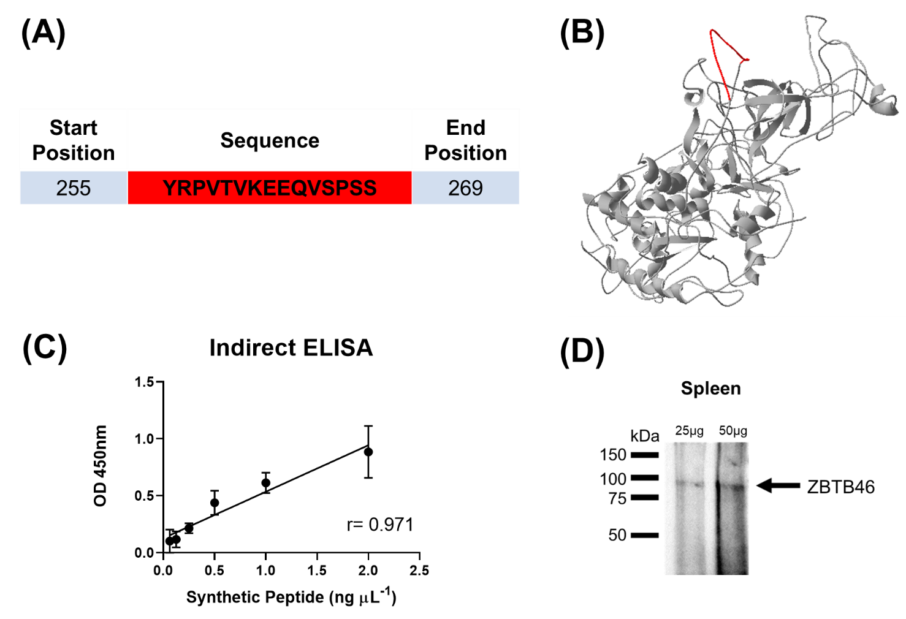
Supplementary Figure 1. The antibody against Zinc Finger and BTB Domain Containing 46 (zbtb46) was obtained from mouse using a synthetic peptide as antigen. (A): in red, antigenic peptide selected from A0A1S3LH90 (UniProtKB). (B): three-dimensional model prediction by Phyre2. In red: antigenic peptide. (C) Affinity test against synthetic peptide by indirect ELISA at 450 nm. (D) The specificity to recognize zbtb46 was evaluated by Western blotting using a pool of six spleen samples from FM-fish group. The arrows indicate the band corresponding to the expected zbtb46 molecular weight (88 kDa).

