Supplementary Material for
Naive regulatory T cell subset is altered in X-linked agammaglobulinemia.
Shelyakin P.V. et al.
*Corresponding author e-mail: olbritan@gmail.com
This file includes:
Tables S1 to S4
Figures S1 to S3
Supplemental Materials and Methods
Supplemental References

Supplementary Table S1. Age of donors included in the cell sorting experiments. There was no significant difference (p < 0.43, two sample t-test) in age between healthy young and XLA donors.
Donor ID | Age | Naive&memory T cell sorting | nCD4 subset sorting | RNA-seq | Status | Mean age for the group
O1 | 55 | yes | yes | no | healthy old | 65.8
O2 | 75 | yes | no | no | healthy old
O3 | 83 | yes | yes | no | healthy old
O4 | 78 | yes | yes | no | healthy old
O5 | 49 | yes | yes | no | healthy old
O6 | 55 | yes | no | no | healthy old
X1 | 18 | yes | yes | no | XLA | 26.9
X2 | 31 | yes | yes | no | XLA
X3 | 18 | yes | yes | no | XLA
X4 | 33 | yes | yes | yes | XLA
X5 | 36 | yes | yes | no | XLA
X6 | 34 | yes | yes | no | XLA
X7 | 30 | yes | yes | no | XLA
X8 | 19 | no | yes | yes | XLA
X9 | 30 | no | yes | yes | XLA
X10 | 20 | no | yes | yes | XLA
Y1 | 31 | yes | yes | no | healthy young | 28.9
Y2 | 35 | yes | no | no | healthy young
Y3 | 25 | yes | yes | yes | healthy young
Y4 | 29 | yes | no | no | healthy young
Y5 | 33 | yes | no | no | healthy young
Y6 | 29 | no | yes | no | healthy young
Y7 | 32 | yes | yes | no | healthy young
Y8 | 26 | no | yes | no | healthy young
Y9 | 31 | no | yes | no | healthy young
Y10 | 26 | no | yes | yes | healthy young
Y11 | 24 | no | yes | yes | healthy young
Y12 | 30 | no | yes | no | healthy young
Y13 | 28 | no | yes | no | healthy young
Y14 | 22 | no | no | yes | healthy young
Y15 | 33 | no | no | yes | healthy young

Supplementary Table S2. Sequencing data on TCR repertoires of naive and memory T cell subsets in healthy and XLA donors.
Donor ID | Cell type | Status | Number of sorted cells | Total number of paired reads (raw) | Number of UMI (counts) from aligned functional sequences (threshold 1)
O1 | CD4 memory | healthy old | 300000 | 2330467 | 618654
O1 | CD4 naive | healthy old | 200000 | 2240220 | 572471
O1 | CD8 memory | healthy old | 200000 | 1493828 | 413494
O1 | CD8 naive | healthy old | 200000 | 1390589 | 331903
O2 | CD4 memory | healthy old | 300000 | 2169391 | 407682
O2 | CD4 naive | healthy old | 300000 | 530258 | 96994
O2 | CD8 naive | healthy old | 60000 | 181847 | 28304
O3 | CD4 memory | healthy old | 200000 | 1188282 | 353104
O3 | CD4 naive | healthy old | 190000 | 2191332 | 576971
O3 | CD8 memory | healthy old | 75000 | 1024344 | 269138
O3 | CD8 naive | healthy old | 12000 | 182559 | 60998
O4 | CD4 memory | healthy old | 100000 | 1533425 | 312381
O4 | CD4 naive | healthy old | 58400 | 1583383 | 142639
O4 | CD8 memory | healthy old | 100000 | 639473 | 142334
O4 | CD8 naive | healthy old | 9250 | 403449 | 40438
O5 | CD4 memory | healthy old | 304000 | 1047115 | 369613
O5 | CD4 naive | healthy old | 300000 | 1778966 | 490267
O5 | CD8 memory | healthy old | 213000 | 1253241 | 400856
O5 | CD8 naive | healthy old | 105000 | 1102012 | 393467
O6 | CD4 memory | healthy old | 300000 | 163703 | 15437
O6 | CD4 naive | healthy old | 150000 | 359720 | 25716
O6 | CD8 memory | healthy old | 300000 | 343359 | 39798
O6 | CD8 naive | healthy old | 100000 | 288934 | 17172
X1 | CD4 memory | XLA | 190000 | 1458318 | 203967
X1 | CD4 naive | XLA | 200000 | 1420250 | 237168
X1 | CD8 memory | XLA | 45000 | 441958 | 65578
X1 | CD8 naive | XLA | 47000 | 499610 | 67734
X2 | CD4 memory | XLA | 300000 | 2328990 | 667082
X2 | CD4 naive | XLA | 90000 | 1332053 | 370952
X2 | CD8 memory | XLA | 300000 | 1788389 | 338321
X2 | CD8 naive | XLA | 86000 | 534476 | 107238
X3 | CD4 memory | XLA | 170000 | 1579727 | 211647
X3 | CD4 naive | XLA | 180000 | 1034922 | 228737
X3 | CD8 memory | XLA | 300000 | 1391606 | 212678
X3 | CD8 naive | XLA | 160000 | 1363199 | 185751
X4 | CD4 memory | XLA | 205900 | 1741321 | 324635
X4 | CD4 naive | XLA | 203900 | 1976928 | 353453
X4 | CD8 memory | XLA | 58900 | 1015104 | 284765
X4 | CD8 naive | XLA | 135200 | 1877057 | 430777
X5 | CD4 memory | XLA | 209400 | 1518782 | 434814
X5 | CD4 naive | XLA | 164700 | 1644108 | 380478
X5 | CD8 memory | XLA | 207600 | 1121537 | 351410
X5 | CD8 naive | XLA | 205200 | 1203754 | 341509
X6 | CD4 memory | XLA | 183000 | 824388 | 152747
X6 | CD4 naive | XLA | 200000 | 989675 | 167846
X6 | CD8 memory | XLA | 127000 | 481130 | 101789
X6 | CD8 naive | XLA | 60000 | 592415 | 75266
X7 | CD4 memory | XLA | 200000 | 2133880 | 477699
X7 | CD4 naive | XLA | 200000 | 2132147 | 406435
X7 | CD8 memory | XLA | 300000 | 2505246 | 620529
X7 | CD8 naive | XLA | 131000 | 1691171 | 290494
Y2 | CD4 memory | healthy young | 200000 | 141614 | 37128
Y2 | CD4 naive | healthy young | 200000 | 1172647 | 138035
Y2 | CD8 memory | healthy young | 200000 | 63574 | 20640
Y2 | CD8 naive | healthy young | 200000 | 972143 | 94326
Y3 | CD4 memory | healthy young | 100000 | 362098 | 133453
Y3 | CD4 naive | healthy young | 200000 | 1407700 | 242047
Y3 | CD8 memory | healthy young | 100000 | 498459 | 57120
Y3 | CD8 naive | healthy young | 100000 | 439871 | 181693
Y4 | CD4 memory | healthy young | 200000 | 419978 | 65785
Y4 | CD4 naive | healthy young | 150000 | 446586 | 72364
Y4 | CD8 memory | healthy young | 200000 | 141131 | 31167
Y4 | CD8 naive | healthy young | 200000 | 347094 | 48649
Y5 | CD4 memory | healthy young | 300000 | 698076 | 100479
Y5 | CD4 naive | healthy young | 300000 | 1009843 | 118602
Y5 | CD8 memory | healthy young | 300000 | 491595 | 65599
Y5 | CD8 naive | healthy young | 300000 | 428576 | 56365

Supplementary Table S3. Sequencing data on TCR repertoires of nCD4⁺ T cell subsets in healthy and XLA donors.
Donor ID | Cell type | Status | Number of sorted cells | Total number of paired reads | Number of UMI (counts) from aligned functional sequences (threshold 1) | Number of UMI (counts) from aligned functional sequences (threshold 2)
O1 | MN CD4+ | healthy old | 189000 | 2043345 | 321349 | 156952
O3 | MN CD4+ | healthy old | 100000 | 2906904 | 577411 | 212809
O4 | MN CD4+ | healthy old | 28072 | 793612 | 86867 | 35893
O5 | MN CD4+ | healthy old | 323000 | 2622294 | 646992 | 223748
Y6 | MN CD4+ | healthy young | 50000 | 470985 | 53605 | 38488
Y7 | MN CD4+ | healthy young | 144000 | 1338766 | 83156 | 62492
Y3 | MN CD4+ | healthy young | 62574 | 2549767 | 209207 | 114159
Y8 | MN CD4+ | healthy young | 30000 | 495295 | 24333 | 22407
Y9 | MN CD4+ | healthy young | 50000 | 593328 | 67031 | 35586
Y10 | MN CD4+ | healthy young | 83000 | 1526602 | 68149 | 63072
Y11 | MN CD4+ | healthy young | 72000 | 1396886 | 47505 | 43084
Y12 | MN CD4+ | healthy young | 100000 | 736639 | 66325 | 42160
Y13 | MN CD4+ | healthy young | 100000 | 457562 | 42486 | 38619
X1 | MN CD4+ | XLA | 78000 | 4260597 | 863985 | 247626
X2 | MN CD4+ | XLA | 51000 | 3022054 | 755989 | 190780
X3 | MN CD4+ | XLA | 33000 | 1093429 | 271215 | 76836
X8 | MN CD4+ | XLA | 100000 | 1639200 | 74820 | 68849
X4 | MN CD4+ | XLA | 194800 | 1223852 | 789834 | 204758
X5 | MN CD4+ | XLA | 49100 | 598713 | 359602 | 67603
X6 | MN CD4+ | XLA | 190000 | 3863017 | 330943 | 151587
X7 | MN CD4+ | XLA | 100000 | 2128540 | 206551 | 144939
X9 | MN CD4+ | XLA | 99000 | 1469998 | 48293 | 43882
X10 | MN CD4+ | XLA | 94000 | 1998287 | 97035 | 89065
O1 | naive Treg | healthy old | 10700 | 310625 | 80589 | 17908
O3 | naive Treg | healthy old | 12000 | 525318 | 76220 | 19392
O4 | naive Treg | healthy old | 16853 | 1195470 | 93608 | 24560
O5 | naive Treg | healthy old | 6100 | 229621 | 80739 | 26278
Y6 | naive Treg | healthy young | 14000 | 269023 | 35242 | 12415
Y7 | naive Treg | healthy young | 20200 | 257518 | 32578 | 12513
Y3 | naive Treg | healthy young | 27209 | 1490885 | 98480 | 36160
Y8 | naive Treg | healthy young | 22000 | 412909 | 9400 | 8239
Y9 | naive Treg | healthy young | 12000 | 650526 | 79602 | 18014
Y10 | naive Treg | healthy young | 17000 | 221675 | 6453 | 5844
Y11 | naive Treg | healthy young | 19000 | 290758 | 6351 | 5680
Y12 | naive Treg | healthy young | 24000 | 195519 | 41874 | 11837
Y13 | naive Treg | healthy young | 100000 | 940613 | 62040 | 45507
X1 | naive Treg | XLA | 35600 | 1531419 | 359692 | 78057
X2 | naive Treg | XLA | 8400 | 446788 | 77355 | 24007
X3 | naive Treg | XLA | 8000 | 466671 | 115627 | 23929
X8 | naive Treg | XLA | 8000 | 150551 | 3900 | 3530
X4 | naive Treg | XLA | 28200 | 3057744 | 350508 | 69723
X11 | naive Treg | XLA | 22300 | 248726 | 136902 | 18771
X6 | naive Treg | XLA | 12000 | 1096572 | 54251 | 10968
X7 | naive Treg | XLA | 42000 | 1636683 | 284577 | 80358
X9 | naive Treg | XLA | 6000 | 79844 | 1448 | 1293
X10 | naive Treg | XLA | 5000 | 90279 | 1920 | 1628
O1 | RTE | healthy old | 89000 | 889597 | 107969 | 73052
O3 | RTE | healthy old | 38000 | 1437936 | 311263 | 87857
O4 | RTE | healthy old | 13589 | 771670 | 65447 | 15895
O5 | RTE | healthy old | 278000 | 2181649 | 737941 | 147979
Y6 | RTE | healthy young | 50000 | 1012540 | 78115 | 43684
Y7 | RTE | healthy young | 101600 | 1352037 | 110401 | 75998
Y3 | RTE | healthy young | 200000 | 4833735 | 361526 | 282498
Y8 | RTE | healthy young | 65000 | 1912640 | 51533 | 46717
Y9 | RTE | healthy young | 50000 | 2158803 | 113779 | 79069
Y10 | RTE | healthy young | 100000 | 1719074 | 62098 | 57269
Y11 | RTE | healthy young | 100000 | 2720945 | 68486 | 62140
Y12 | RTE | healthy young | 63000 | 782534 | 85155 | 58059
Y13 | RTE | healthy young | 100000 | 399037 | 25024 | 22643
X1 | RTE | XLA | 100000 | 4824002 | 919183 | 311655
X2 | RTE | XLA | 63000 | 1711852 | 593317 | 124202
X3 | RTE | XLA | 100000 | 5378974 | 888787 | 282102
X8 | RTE | XLA | 100000 | 2111958 | 80849 | 74430
X4 | RTE | XLA | 195900 | 3134087 | 789834 | 199881
X5 | RTE | XLA | 204000 | 1330223 | 860097 | 215747
X6 | RTE | XLA | 300000 | 2711716 | 326189 | 160291
X7 | RTE | XLA | 200000 | 4343520 | 958138 | 285878
X9 | RTE | XLA | 100000 | 2166006 | 68567 | 63244
X10 | RTE | XLA | 100000 | 3112793 | 125698 | 116025

Supplementary Table S4. STAR alignment data on RNA-seq for nCD4⁺ T cell subsets in healthy and XLA donors
Donor ID | Cell type | Total number of reads | Uniquely mapped reads % | Reads mapped to multiple loci, % | Reads unmapped, %
X4 | MN CD4+ | 30632044 | 84,73 | 5,22 | 9,81
X4 | naive Treg | 30029556 | 87,39 | 4,30 | 8,13
X5 | MN CD4+ | 30674684 | 86,26 | 4,61 | 8,91
X5 | naive Treg | 30160220 | 86,01 | 4,54 | 9,25
X8 | MN CD4+ | 39137111 | 84,94 | 4,92 | 9,90
X9 | MN CD4+ | 16772512 | 82,45 | 5,56 | 11,74
X9 | naive Treg | 21909157 | 84,40 | 4,43 | 10,99
X10 | MN CD4+ | 19450031 | 83,86 | 5,27 | 10,58
X10 | naive Treg | 16418419 | 84,59 | 4,19 | 11,05
Y3 | naive Treg | 19779343 | 80,50 | 5,02 | 14,24
Y8 | MN CD4+ | 13781205 | 85,83 | 4,93 | 9,08
Y8 | naive Treg | 18493797 | 86,57 | 3,96 | 9,33
Y10 | MN CD4+ | 18907655 | 86,30 | 4,20 | 9,30
Y10 | naive Treg | 22131898 | 85,53 | 4,39 | 9,89
Y11 | MN CD4+ | 16102186 | 83,47 | 4,78 | 11,53
Y11 | naive Treg | 19841472 | 85,34 | 4,34 | 10,14
Y14 | MN CD4+ | 31151485 | 83,78 | 5,34 | 10,60
Y14 | naive Treg | 31584154 | 85,25 | 4,82 | 9,72
Y15 | MN CD4+ | 21833653 | 87,05 | 4,12 | 8,68
Y15 | naive Treg | 23880769 | 87,24 | 4,56 | 8,02

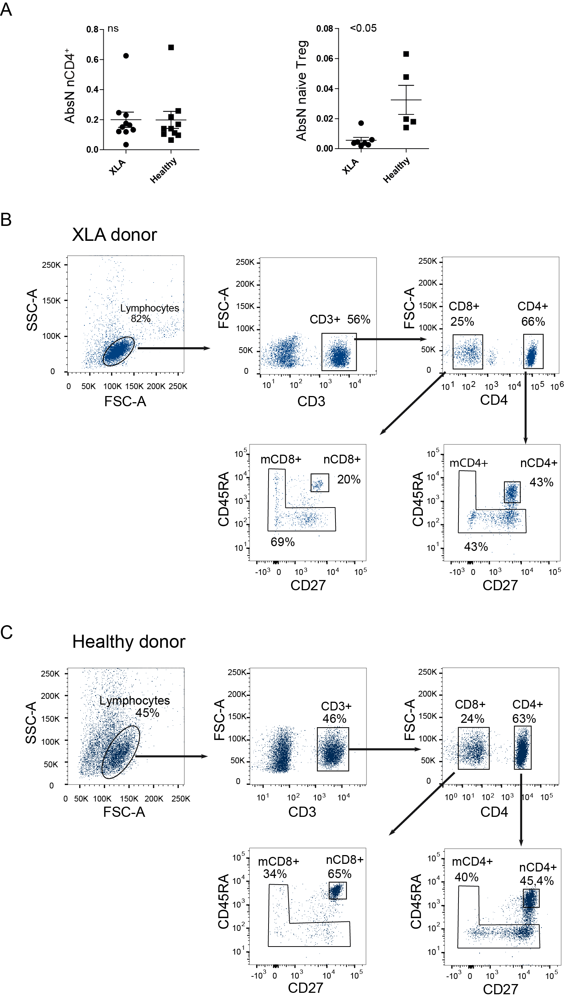
Supplementary Figure S1. Cell count of nCD4⁺ and naïve T_{reg} cells and gating strategy for cell sorting of naive and memory CD4⁺ and CD8⁺ cells. (A) Absolute count for nCD4+ and naïve T_{reg} cells (10^3 cells per ul blood). Naive and memory CD4⁺ and CD8⁺ cells for (B) XLA and (C) healthy donors. Lymphocytes were gated based on forward (FSC) and side scatter (SSC) profiles; doublets were excluded in the next step (not shown). Within the singlets, CD3⁺ and (sequentially) CD8⁺ and CD4⁺ cell subsets were discriminated. Naive CD4⁺ and CD8⁺ were defined as CD45RA⁺CD27⁺ on the sequential gates.

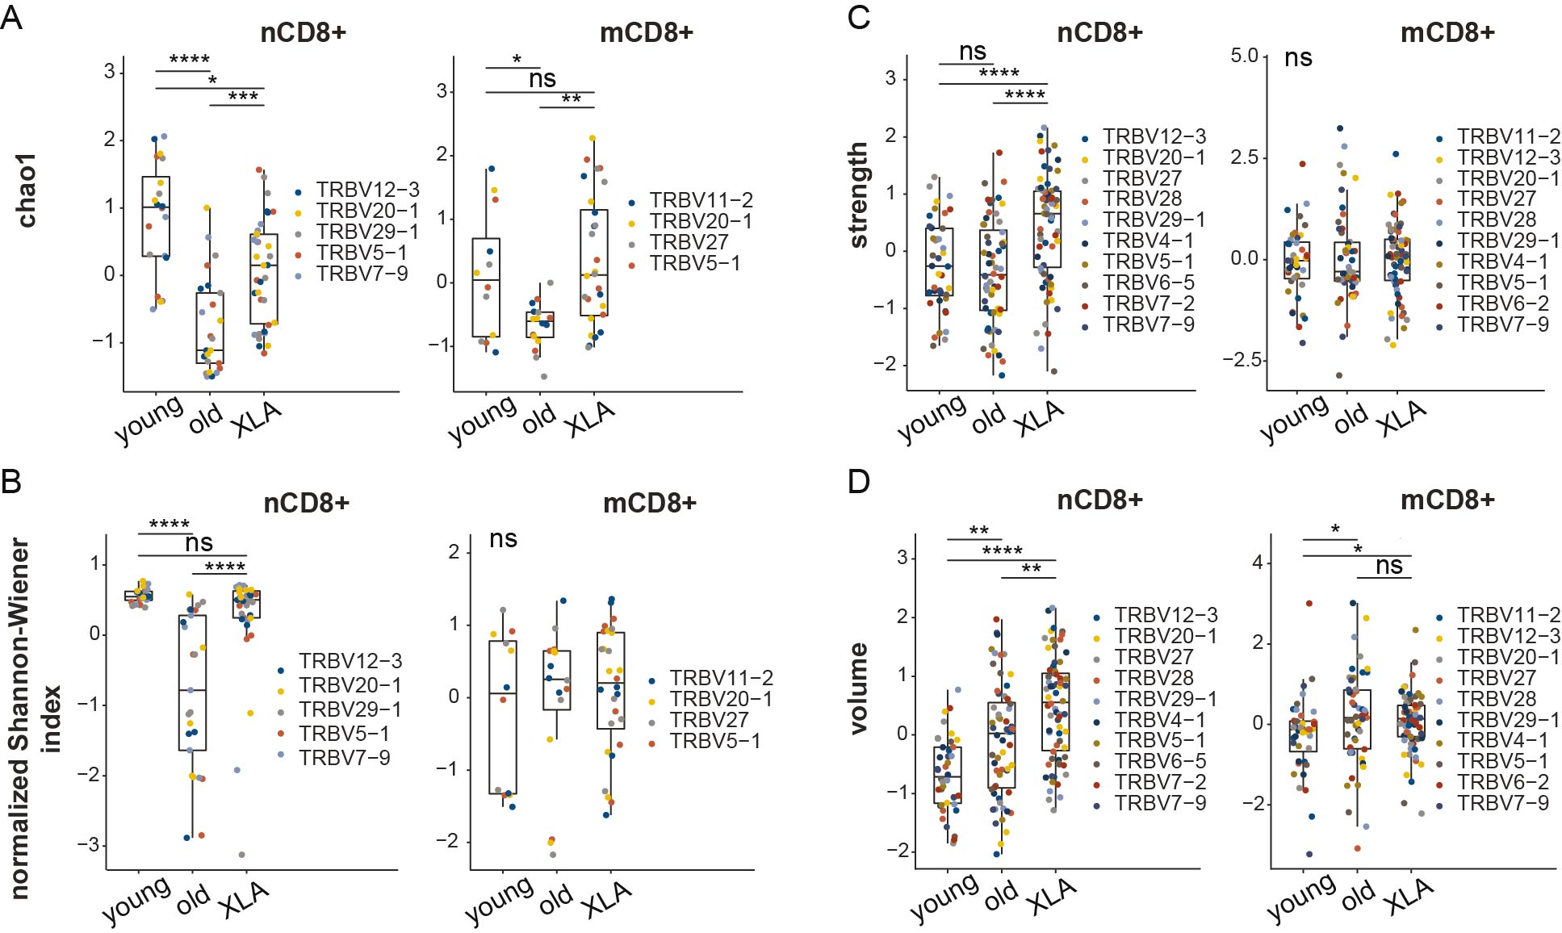
Supplementary Figure S2. Characteristics of memory and naive CD8⁺ TCR repertoires in XLA and healthy donors. Analysis of repertoire diversity using the (A) Chao1 index and (B) normalized Shannon-Wiener index. (C) Clonotype interaction strength, as represented by the fraction of hydrophobic and aromatic amino acids, and (D) clonotype volume, based on bulky amino acids, in the central region of CDR3 from XLA (N = 7), and healthy young (N = 6) or old (N = 6) donors. All analyzed features were calculated for the most abundant V segments extracted from full clonotype datasets. For diversity analysis, all segment sets were down-sampled to 800 (naïve CD8⁺), and 750 (memory CD8⁺) randomly-chosen UMI-labeled TCRβ cDNA molecules. Only segments with a sufficient number of UMIs were included. To exclude potential dependence of features from the V segment, all features within the same cell type and the same V segment were turned to Z-scores. Differences between groups were examined using the Kruskal-Wallis test followed by the Dunn test with the Benjamini-Hochberg correction. *p<0.05, **p<0.01, ***p<0.001, ****p<0.0001.

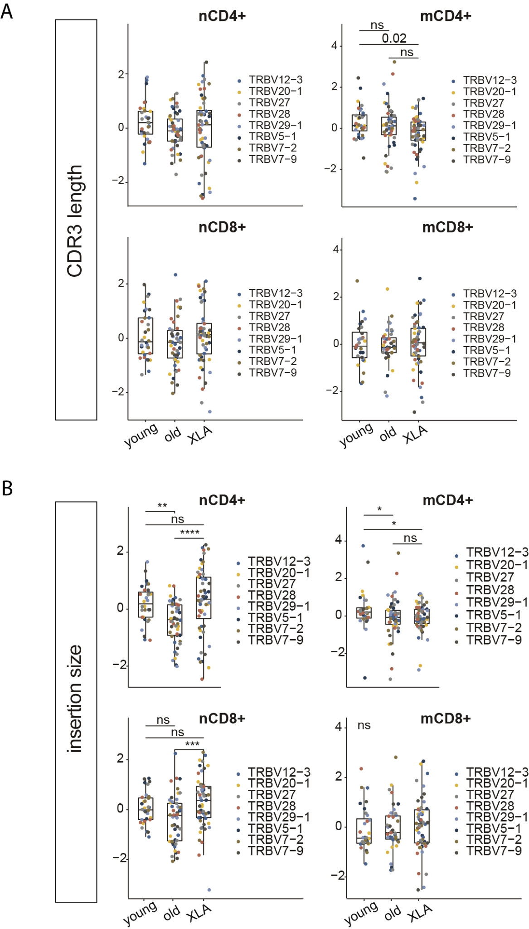
Supplementary Figure S3. Characteristics of TCR repertoires of CD4⁺ and CD8⁺ cell subsets in XLA and healthy donors. (A) CDR3β length and (B) added nucleotides in CDR3β were calculated for the most frequent V segments extracted from full datasets. The number of samples was XLA N=7, young N=6, old N=6. All analyzed features were calculated for the most abundant V segments extracted from full clone sets. For diversity analysis, all segment sets were down-sampled to 1,000 (for naive and memory CD4⁺), 800 (for naïve CD8⁺) and 750 (for memory CD8⁺) randomly chosen UMI-labeled TCRβ beta cDNA molecules. Only segments with enough number of UMI were included in the analysis. To exclude potential dependence of features from the V segment, all features within the same cell type and the same V segment were turned to Z-scores. The difference between groups was examined using the Kruskal-Wallis test followed by the Dunn test with Benjamini-Hochberg correction. *p<0.05, **p<0.01, ***p<0.001, ****p<0.0001.
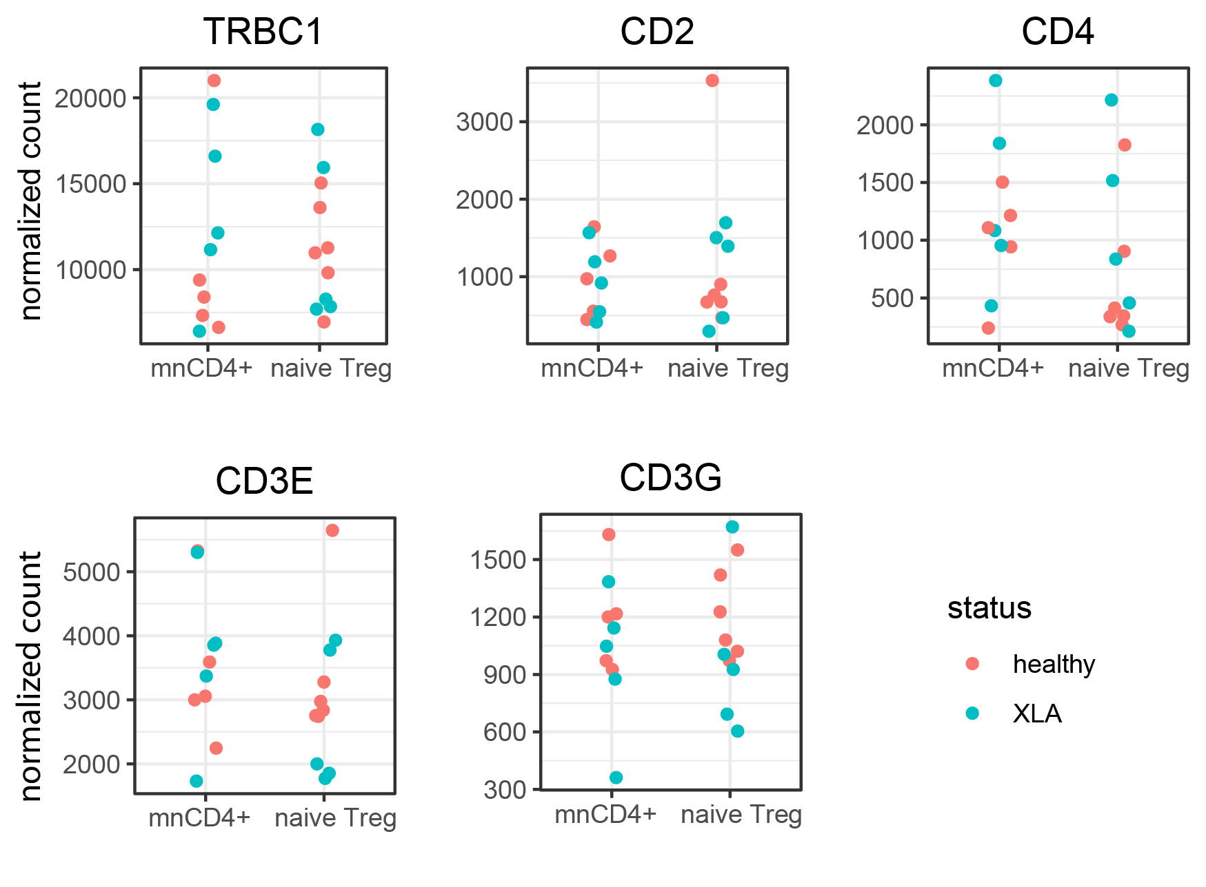
Supplementary Figure S4. Expression of T-cell-specific genes in XLA and healthy donors. Counts are normalized by DESeq2 (median of ratios method).
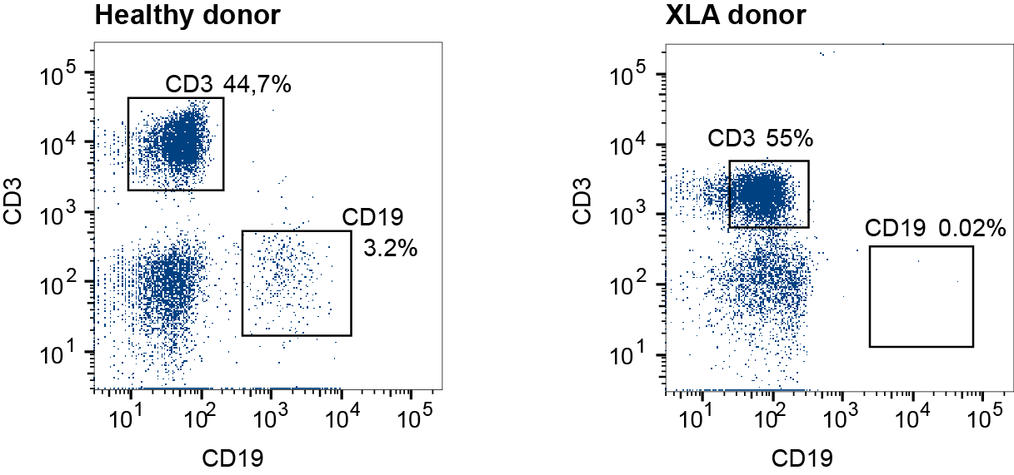
Supplementary Figure S5. Representative staining for B-cell marker CD19. PBMCs from young healthy (left) and XLA (right) donors were stained with antibodies against CD3 and CD19 to validate the XLA phenotype in patients. B cells were defined as CD3⁻CD19⁺.

Supplementary Materials and Methods
Genotyping of XLA donors.
High-throughput sequencing analysis was performed on 10 XLA patients. The pathogenic mutations were found, and two donors had additional benign mutations (X1, X3). No mutations in the BTK gene were detected in two donors (X2, X10) with apparent XLA symptoms, which probably reflects autosomal recessive agammaglobulinemia. In contrast, patient X8, with a diagnosis of PID, had a pathogenic mutation in BTK that confirmed the XLA diagnosis. Two patients had the same deletion (Cys145>AlafsTer31/c.433delA). Each of four benign mutations (c.1889G>A, c.1350-29T>C, c.71T>C/Glu24>Gly, and c.22T>C) were detected in more than two patients. Three novel mutations were identified: two deletions (NP_000052.1:p.Met570del/NM_000061.2:c.1708_1710delCAT and p.Cys145Alafs*31/NM_000061.2:c.433delA) and one SNP (NM_000061.2:c.1909-1C>T). These novel variants were predicted to alter highly-conserved amino acids and were submitted to the Leiden Open Variation Database (LOVD).

Cell sorting
For memory and naive CD4⁺ and CD8⁺ (defined as CD3⁺ CD4⁻) T cell sorting, PBMCs were isolated by standard Ficoll density gradient centrifugation, washed twice, and stained with fluorescently-labeled antibodies CD3-APC-Cy7 (clone UCHT1), CD4-PE (clone RPA-T4), CD45RA-FITC (clone JS-83), and CD27-eFluor450 (clone O323) in the dark. Forward and side scatter were used to exclude dead cells, cell aggregates, and cell debris. For RTE, naive T_{reg}, and mnCD4⁺ T cell sorting, CD4⁺ T cells were purified on a Ficoll density gradient with RosetteSep Human CD4 enrichment cocktail (STEMCELL) and stained with CD4-APC-Cy7 (clone 13B8.2), CD25-PE (clone BC96), CD31-AlexaFluor647 (clone WM59), CD27-eFluor450 (clone O323), and CD45RA-FITC (clone JS-83) antibodies. From the naïve T cells parent gate, the following helper T-cells were selected: naive T_{reg} (CD4⁺CD45RA⁺CD27⁺CD25⁺) and mnCD4⁺ (CD4⁺CD45RA⁺CD27⁺CD25⁻CD31⁻), RTE (CD4⁺CD45RA⁺CD27⁺CD25⁻CD31⁺). To confirm the XLA phenotype of patients, we performed a flow cytometry analysis of PBMCs stained with CD3-APC-Cy7 (clone UCHT1) and CD19-FITC (clone HIB19). Flow cytometry and cell sorting was performed on BD FACSAria III, data was analyzed using BD FACSDiva software.
Sequencing and data treatment.
Raw sequencing data were analyzed using MIGEC software v.1.2.9 [3]. to group sequencing reads carrying the same UMI and thus covering the same cDNA molecule (SI Table 2, 3). Briefly, the Checkout utility was used for data demultiplexing and UMI sequence extraction, yielding ~90% sample barcode matching, and the data were then assembled using the Assemble utility with erroneous UMI filtering option. Over-sequencing threshold - minimal required number of reads per UMI - was set as 1, for all tasks except for the analysis of plasticity and publicity metrics, where it was set as 2. The latter types of analysis are sensitive to even minor cross-sample contaminants that may happen on the solid phase of Illumina. However, such contaminations are efficiently removed using reads-per-UMI threshold. In-frame TCR alpha and beta CDR3 repertoires were extracted using MiXCR version 2.1.1 software. Normalisation, data transformation, in-depth analysis, statistics calculations and visualization were performed using VDJtools version 1.2.1 software and R scripts, using libraries ggplot2, ggpubr and ggbiplot.
The input of each clonotype was proportional to its frequency within a sample. Basic analysis included 6 of the characteristics provided in VDJtools software, which were previously selected in various TCR and IG repertoire datasets [1,2]: CDR3 length, number of added random (N) nucleotides, interaction "strength", Kidera factor 4 (hydrophobicity), "volume", "surface".
Kidera factor 4 reflects the abundance of hydrophobic amino acids with reversed scale, lower values refer to more hydrophobic amino acids. The “surface” characteristic in VDJtools reflects the relative abundance of amino acids which do not change their accessibility when TCR is in contact with pMHC in the whole CDR3 region or in the selected region of interest.
To calculate the mean charge of CDR3β, each amino acid residue was assigned a number depending on the charge: (+1) for R, H, K; (-1) for D, E; and (0) for the remaining residues. The sum was then divided by the number of amino acid residues. To calculate the mean strength of CDR3β, each amino acid residue was assigned a value depending on whether it is strongly binding (1) or not (0). The set of strongly binding amino acid residues includes F, L, I, M, V, W, Y, which are involved in hydrophobic, Van der Waals, and other interactions [5]. The presence of strongly-binding amino acids in CDR3 often leads to the removal of T cells during negative selection [6].
Chao1 was calculated to estimate changes in repertoire diversity. This statistic is calculated using the formula $сhao1=S_{obs}+\frac{{F_{1}}^{2}}{2F_{2}}$ , where S_obs is the number of clones in the sample, F_1 is the number of clones met only once, and F_2 is the number of clones met twice. Chao1 estimates overall diversity, considering unmet clones. Therefore, a term is added to the total number of clones in the sample that estimates the number of unmet clones. It is assumed that the more clones that are met once in relation to clones met twice, the more clones that are not reflected in the sample. To estimate the presence of clonal expansion we used the normalized Shannon-Weiner index $D=\frac{-\sum_{i}^{S}{}p_{ilogp_{i}}}{logS}$, where $S$ is the number of clones, and $p$ is the frequency of clones. As one can see from the formula, the index reflects normalized information entropy. The closer the index is to one, the more homogeneous the sample. If large clonotypes are present in the sample, then the index deviates significantly from one. The average volume was calculated with values for each amino acid residue shown in Supplementary Table S5 [7].
Supplementary Table S5. Values for calculating volume parameter by VDJtools.
Amino acid | A | C | D | E | F | G | H | I | K | L
Volume | 67 | 86 | 91 | 109 | 135 | 48 | 118 | 124 | 135 | 124
Amino acid | M | N | P | Q | R | S | T | V | W | Y
Volume | 124 | 96 | 90 | 114 | 148 | 73 | 93 | 105 | 163 | 141

Following data on the most abundant V segments were excluded: TRBV28 and TRBV29-1 naive T_{reg} for a single XLA patient from analysis of CDR3β length; TRBV28 and TRBV29-1 naive T_{reg} for a single XLA patient from analysis of added nucleotides in CDR3β; TRBV28 and TRBV29-1 naive Treg are excluded for a single XLA patient; TRBV6-5 naive T_{reg} is excluded for a single XLA patient from analysis of estimated average number of strongly binding amino acids.
RNA-seq library preparation and analysis.
The quality control of raw sequencing data and pre-treatment was performed with FastQC. RNA-Seq raw reads were aligned to the Ensembl reference genome (Homo_sapience.GRCh38.dna.primary_assembly.fa) with genome indexes generated using the Ensembl annotated transcripts (Homo_sapience.GRCh38.99.gtf) with STAR (version 2.7.5a). Read counts were generated with --quantMode GeneCounts option. A read is counted if it overlaps only one gene. Both ends of the paired-end read are checked for overlaps. Read-counts were further analyzed by DESeq2 (version 1.24.0) for differential expression according to the manual recommendations. The batch effect of different runs was removed by Limma. We measured the effect of the condition or cell type, controlling the batch differences. FDR cutoff is 0.05. The ‘ashr’ shrinkage estimator was used for ranking and visualization. False discovery rates: a new deal. Biostatistics, 18:2. [4]. Raw data is available at by PRJNA752868 in the SRA (NCBI).
Supplementary References
- Davydov AN, Obraztsova AS, Lebedin MY, Turchaninova MA, Staroverov DB, Merzlyak EM, Sharonov GV, Kladova O, Shugay M, Britanova OV, et al. 2018. Comparative Analysis of B-Cell Receptor Repertoires Induced by Live Yellow Fever Vaccine in Young and Middle-Age Donors. Front Immunol 9: 2309.
- Izraelson M, Nakonechnaya TO, Moltedo B, Egorov ES, Kasatskaya SA, Putintseva EV, Mamedov IZ, Staroverov DB, Shemiakina II, Zakharova MY, et al. 2018. Comparative analysis of murine T-cell receptor repertoires. Immunology 153: 133–144.
- Shugay M, Britanova OV, Merzlyak EM, Turchaninova MA, Mamedov IZ, Tuganbaev TR, Bolotin DA, Staroverov DB, Putintseva EV, Plevova K, et al. 2014. Towards error-free profiling of immune repertoires. Nat Methods 11: 653–655.
- Stephens M. 2017. False discovery rates: a new deal. Biostatistics 18: 275–294
- Chakrabarti P, Bhattacharyya R. 2007. Geometry of nonbonded interactions involving planar groups in proteins. Prog Biophys Mol Biol. 95:83–137.
- Kosmrlj A, Jha AK, Huseby ES, Kardar M, Chakraborty AK. 2008. How the thymus designs antigen-specific and self-tolerant T cell receptor sequences. Proc Natl Acad Sci U S A. 105:16671–6.
- Pommié C, Levadoux S, Sabatier R, Lefranc G, Lefranc MP. 2004. IMGT standardized criteria for statistical analysis of immunoglobulin V-REGION amino acid properties. J Mol Recognit. 17:17–32.

