Production of Biodiesel from Croton gratissimus Oil using Sulphated Zirconia and KOH as Catalysts
Phiwe Charles Jiyane¹, Kaniki Tumba^{1,*}, Paul Musonge²
¹Thermodynamics-Materials-Separations Research Group (TMSRG), Department of Chemical Engineering, Mangosuthu University of Technology, uMlazi, Durban, 4031, South Africa.
²Faculty of Engineering, Mangosuthu University of Technology, uMlazi, Durban, 4031, South Africa.
* Correspondence: Corresponding Author - tumba@mut.ac.za

Supplemental Materials

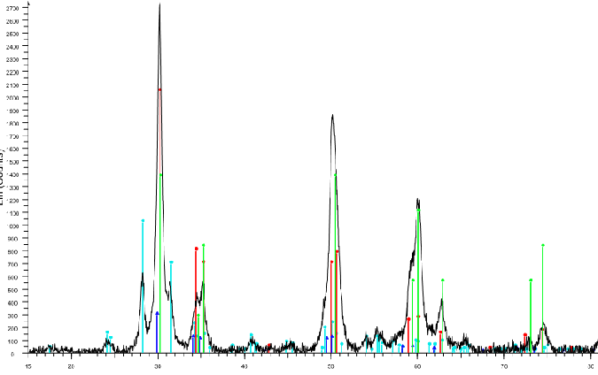
2700

2400

2100

1800

1500

1200

900

600

300

0
Lin (Counts)
M
M
T
M
T
T
T
M
M
M
T
M
M
T
T
M

Fig. S1: X-ray diffraction profiles of the SO₄^{2–}/ZrO₂ catalyst calcined at 620 ⁰C. M – Monoclinic Phase – Powder Blue; Orthorhombic Phase – Light Green; T – Tetragonal Phase – Red (No match to the reference pattern)

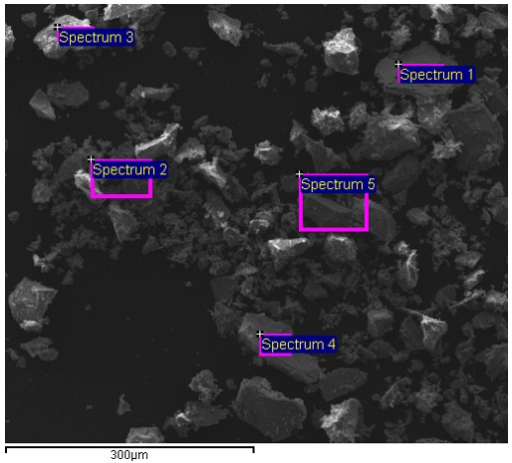
Fig. S2: SEM micrograph of SO₄^{2–}/ZrO₂ catalyst calcined at 620⁰C

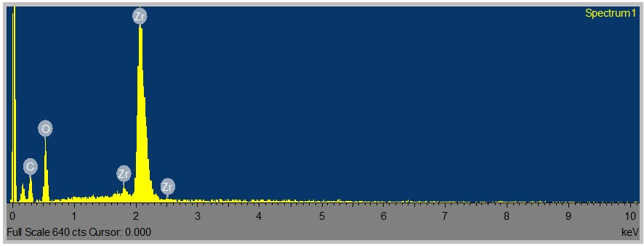
Fig. S3: SEM – EDS Spectra for the Elemental Composition of the SO₄^{2–}/ZrO₂ catalyst

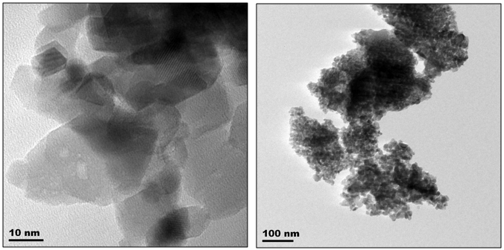
Fig. S4: TEM Micrographs of the Monoclinic SO₄^{2–}/ZrO₂ catalyst

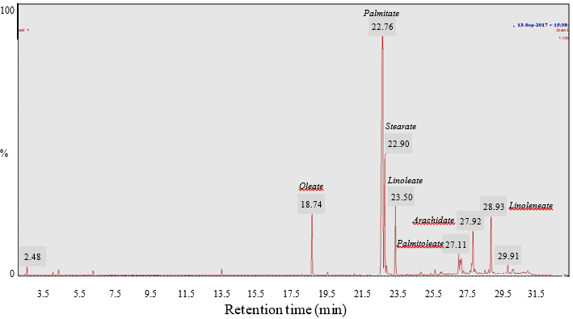
Fig. S5: GC-MS Spectrum for Croton gratissimus FAME

