Supporting Information
Probing Electronic Properties of CVD Monolayer Hexagonal Boron Nitride by Atomic Force Microscope
Shiyu Deng†, Yanyun Gu‡, Xi Wan‡*, Mingliang Gao‡, Shijia Xu‡, Kun Chen†*, Huanjun Chen†*

† State Key Laboratory of Optoelectronic Materials and Technologies, School of Electronics and Information Technology and Guangdong Province Key Laboratory of Display Material, Sun Yat-sen University, Guangzhou, Guangdong 510275, P.R. China

‡ Engineering Research Center of IoT Technology Applications (Ministry of Education), Department of Electronic Engineering, Jiangnan University, Wuxi, Jiangsu 214122, P.R. China

Keywords: h-BN, resistance, surface potential, chemical vapor deposition, PeakForce TUNA, KPFM

* Corresponding authors.
E-mail addresses: chenk69@mail.sysu.edu.cn (K. Chen),
xwan@jiangnan.edu.cn (X. Wan),
chenhj8@mail.sysu.edu.cn (H. Chen)

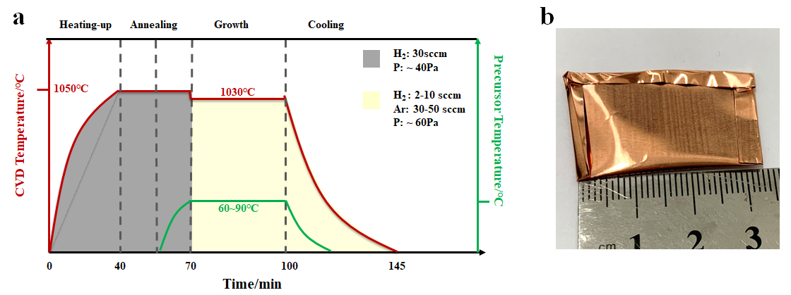
Figure S1. CVD parameters for the growth monolayer h-BN. a) Time dependence of CVD parameters, including: temperature, and gas flowrate and pressure for h-BN growth on copper enclosure. b) Photograph of copper-foil enclosure.
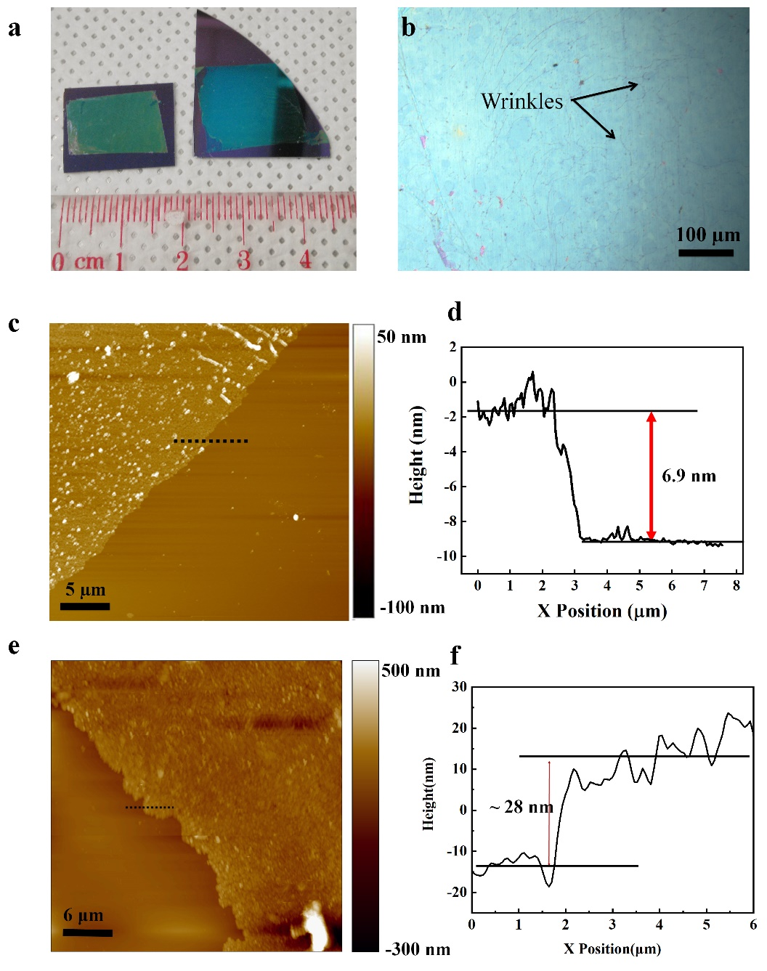
Figure S2. Characterization of continuous h-BN films on the outside of the Cu-foil enclosure. a). A photographic of h-BN films on 300-nm thick SiO₂/Si substrate. b). An optical image of h-BN films on 300-nm thick SiO₂/Si substrate. c). AFM morphology image of thin h-BN films transferred on SiO₂/Si substrate. d). Plot of the height measured along the dash line depicted in panel c, implying the thickness of ~ 6.9 nm. e). AFM morphology image of thick h-BN films transferred on SiO₂/Si substrate. f). Plot of the height measured along the dash line depicted in panel e, implying the thickness of ~ 28 nm.

Section S1
Figure S2a shows a photographic of h-BN films on SiO₂/Si. Figure S2 displays the microscope image of the h-BN films on SiO₂/Si with uniform thickness. Like graphene, due to the negative thermal expansion coefficients of h-BN¹, there are several wrinkles formed on the h-BN film. Since h-BN films were grown on the Cu foil at a high growth temperature (~1030˚C) and after the sample was cooled to room temperature, the Cu foil shrinks while the h-BN films expand, resulting in wrinkles.
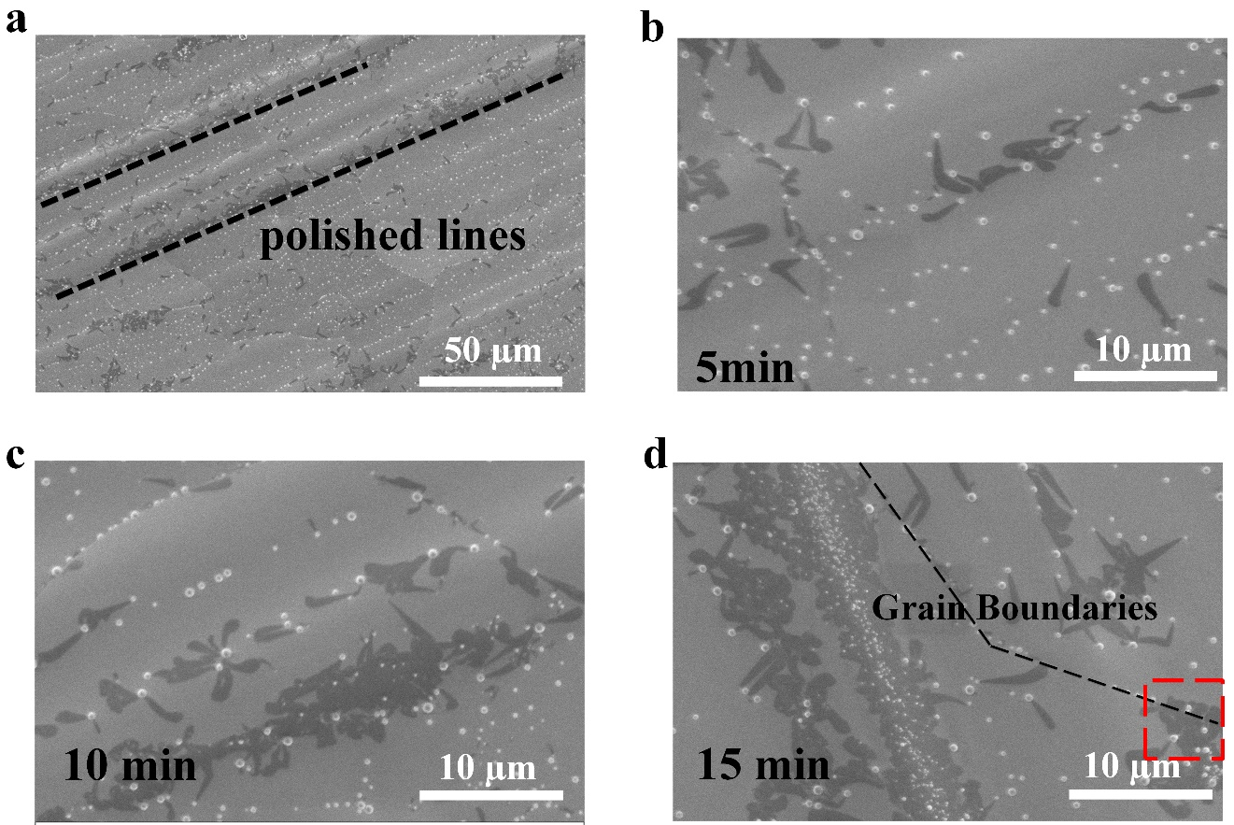
Figure S3. SEM characterization of h-BN nanoflakes with growth time between 5-15 min. a). SEM image of h-BN grown along the copper polished lines. SEM images of h-BN films on the copper surface with growth time of b) 5 min, c) 10 min, and d) 15 min, respectively.

Section S2
With a growth time of 5 min, most of the h-BN nuclei/islands shown in Figure S3d appear to have random orientations, which could suggest the weak epitaxial relation between h-BN lattice and that of underlying Cu grain. By increasing the growth time to 10 min, the h-BN nuclei/islands start to coalesce into large flakes as displayed in Figure S3e. Figure S3f (growth time: 15 min) shows many h-BN flakes and islands, which consist of either a single grain or a few coalesced grains. As shown in the red dotted region of Figure S3f, individual h-BN grains can be grown continuously across Cu grain boundaries without any apparent shape distortion, demonstrating that, like graphene,²⁻⁴ single-crystalline h-BN may also grow on polycrystalline Cu. The bright particles are believed to come from the quartz tube used in the LPCVD chamber, as reported by the literature.⁵
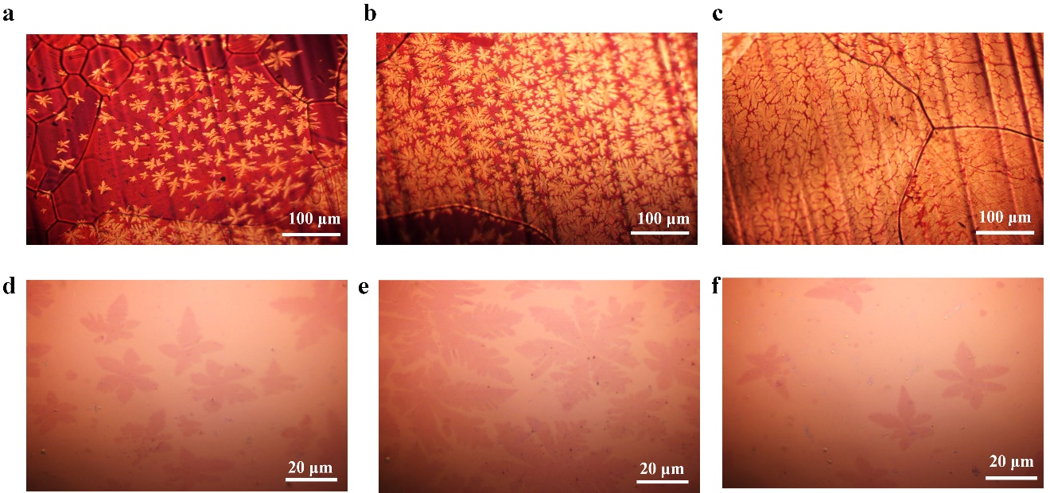
Figure S4. Optical image of h-BN films on the inner of Cu foil-enclosure and 300-nm thick SiO₂/Si substrate. a-c). optical images of h-BN films on Cu substrate at different locations of the inner side of Cu foil-enclosure with prolonged growth time (20-30 min). d-f). Optical images of h-BN nanoflakes transfer on 300-nm thick SiO₂/Si substrate, showing different regular shapes and dimensions.

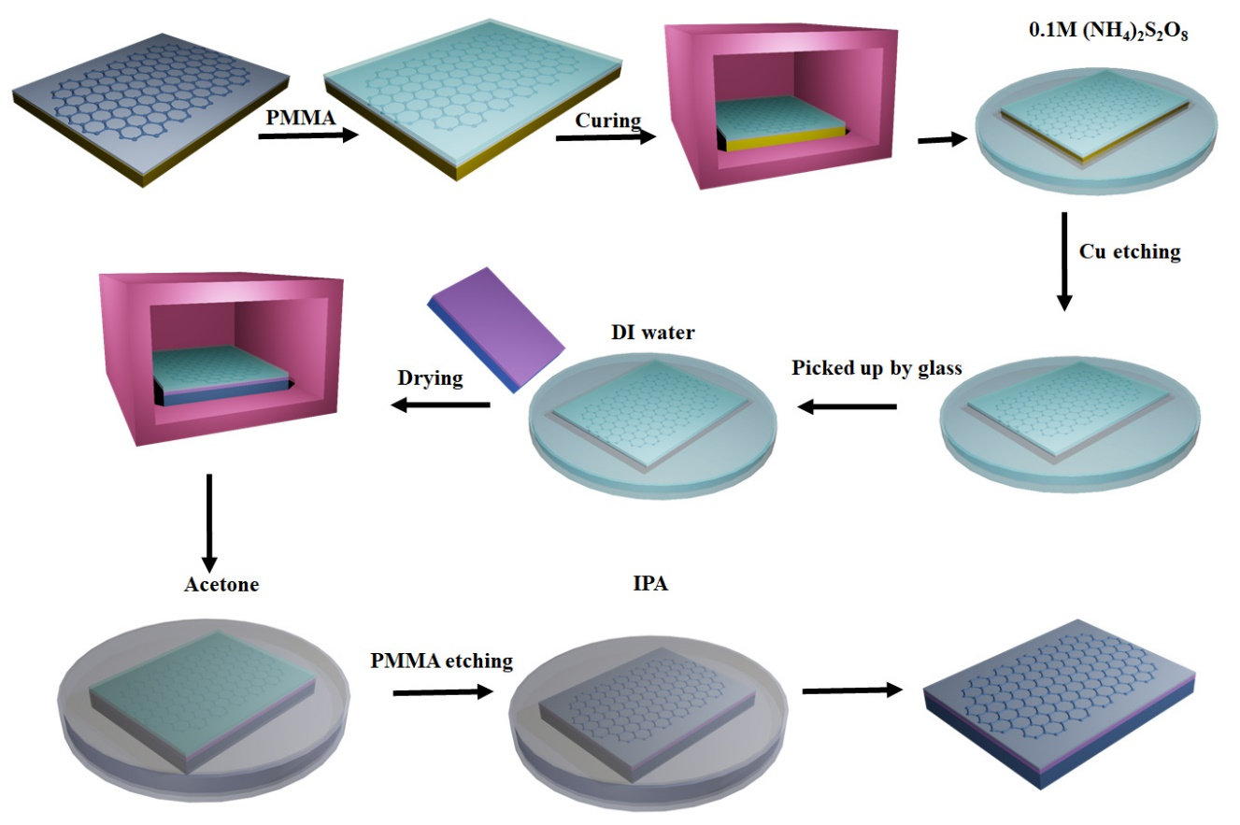Figure S5. Schematic diagram of h-BN transfer process.
Section S3
A typical transfer process is as follows^{4, 6}: (1) the h-BN films on copper foil was firstly spin coated with a poly-methyl methacrylate layer (PMMA) (3000 rpm for 1 min, 2%-7% wt., in anisole); (2) then the sample was baked at 140˚C for 3 min; (3) after that , the Cu foil was etched away in 0.1M ammonium persulphate ((NH₄)₂S₂O₈) solution or Marble’s reagent (CuSO₄ ~ 20 g, HCl ~ 100 mL, H₂O ~ 100 mL) overnight; (4) the floating film was picked up with a clean glass substrate and transferred into DI water to remove the etchant ions; (5) the floating film was carefully picked up with a desired substrate and was dried on a hot plate at 60 ˚C; (6) finally, the sample wad dipped into acetone to remove the PMMA layer and dried with N₂ gas gently.

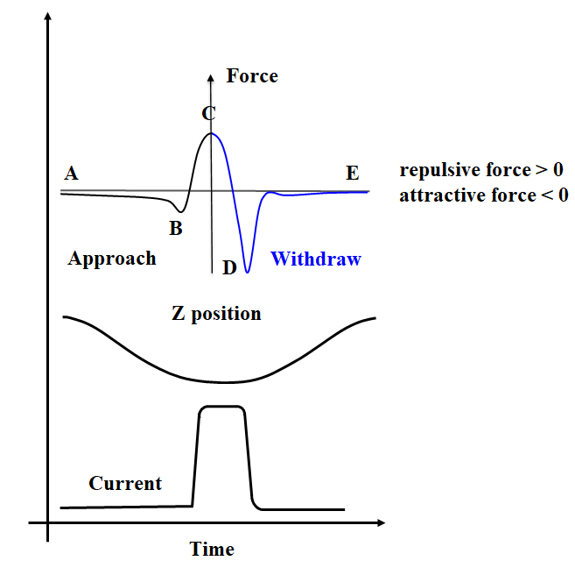
Figure S6. The time dependence of the Z position, Force and Current during one typical Peak Force Tapping cycle. Black indicates approach process and blue indicates retract. TUNA Current is the average current over one entire tapping cycle, from point A to point E. It includes both the current measured while tip is approaching to the surface as well as when it is off the surface.
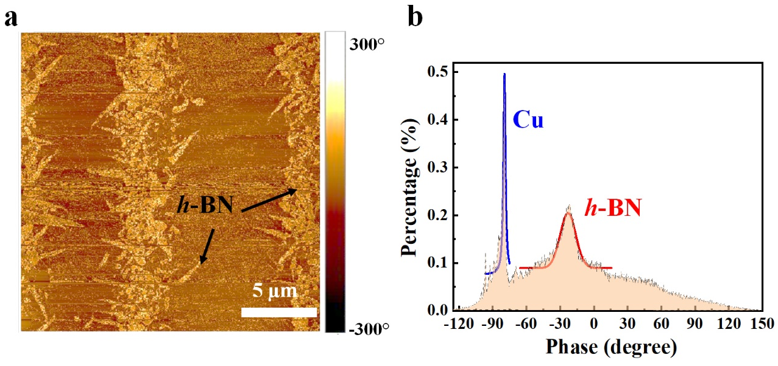
Figure S7. AFM characterization of monolayer h-BN on Cu foil. a). AFM phase image of monolayer h-BN on copper. b). The histogram distribution of the phase.
Section S4
For the phase image, when the AFM tip is driven with a sinusoidal signal at its resonance ω₀, the motion of the tip Z(t) can be approximately sinusoidal ⁷⁻⁸:
(1)
where A is the amplitude, h is the static tip height above the sample surface and φ is the phase lag with respect to the driving force, which can be written as⁹:
(2)
where m* is the effective mass of the cantilever, k_{c} is the spring constant of the cantilever, Q = ω₀/γ_{D} is the quality factor of the cantilever (~ 100 in air, ~10,000 in vacuum) ⁸ and γ_{D} is the damping coefficient. The quality factor describes the relative width of the resonance peak. The phase shift φ is close to zero for lower frequencies, φ = 90˚ at and becomes to 180˚ for higher frequencies.⁹⁻¹⁰ Since the damping coefficients of the tip located above the h-BN and Cu foil are different, thus a clear phase contrast as shown in Figure S8a can be obtained. The histogram distribution of the phase shift under scanning over the entire sample surface is displayed in Figure S8b, which can be well fitted using two Gaussian peaks as plotted by the solid red and blue lines, reflecting the distribution characteristics of h-BN (centered at ~ − 23.1˚) and Cu (centered ~ − 79.5˚), respectively.
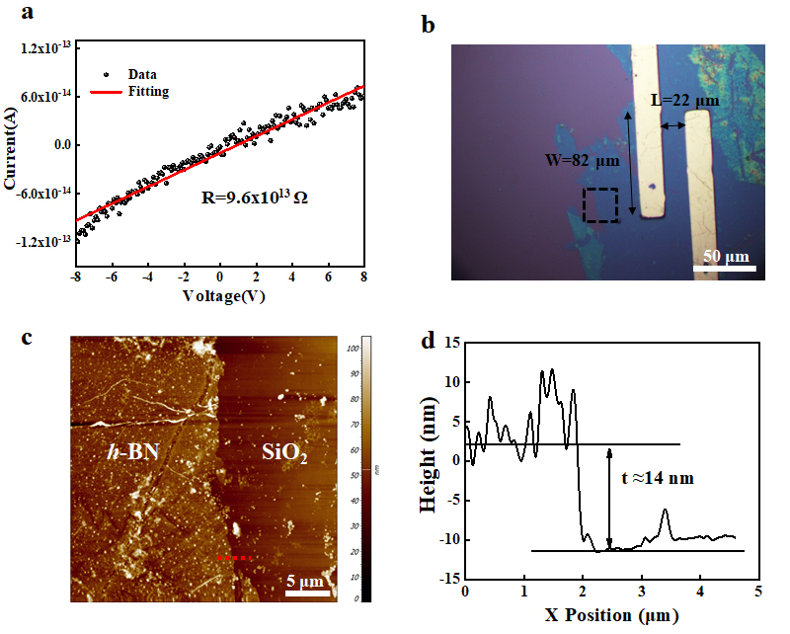
Figure S8. Electrical characterization of h-BN films. a). The typical I-V curve of h-BN film. b). Optical image of h-BN film transferred onto the SiO₂/Si substrate with 50-nm thick Au as the electrodes. c). AFM height image of the same h-BN film measured from the black dotted region in panel b. d). Plot of the height measured along the red dash line depicted in panel c.

Section S5
Electrical measurement was carried out on h-BN film transferred onto the 300-nm SiO₂/Si substrate. The I-V characteristics curve measured under ambient condition is shown in Figure S9a, which can be well fitted by a linear curve, giving a large channel resistance of 9.6×10¹³ Ω. Figure S9b shows the optical image of the in-plane h-BN device with 50 nm-thick Au electrodes. The channel width (W) and length (L) and were 82 and 22 µm, respectively. Figure S9c shows the AFM image of the same h-BN films transferred on a SiO₂/Si substrate, which was taken from the black dotted region in Figure S9b. Figure S9d displays the height distribution along the red dotted line in Figure 4c, indicating the thickness of the h-BN film t ~ 14 nm. Thus, the resistivity (ρ) of the h-BN film can be obtained by:and the resulting ρ was ~ 501 MΩ⸱cm. For comparison, the resistivity reported by previous literatures is in the order of 1×10⁹ and 10⁷ ~10⁸ Ω⸱cm for h-BN and cubic boron nitride (c-BN), respectively,¹¹⁻¹² and our result are in good agreement with these values.

References

1. Kim, K. K., et al., Synthesis of Monolayer Hexagonal Boron Nitride on Cu Foil Using Chemical Vapor Deposition. Nano Lett. 2012, 12, 161-166.
2. Yu, Q., et al., Control and Characterization of Individual Grains and Grain Boundaries in Graphene Grown by Chemical Vapour Deposition. Nat. Mater. 2011, 10, 443-449.
3. Wan, X.; Chen, K.; Liu, D.; Chen, J.; Miao, Q.; Xu, J., High-Quality Large-Area Graphene from Dehydrogenated Polycyclic Aromatic Hydrocarbons. Chem. Mater. 2012, 24, 3906-3915.
4. Wan, X.; Chen, K.; Du, J.; Liu, D.; Chen, J.; Lai, X.; Xie, W.; Xu, J., Enhanced Performance and Fermi-Level Estimation of Coronene-Derived Graphene Transistors on Self-Assembled Monolayer Modified Substrates in Large Areas. J. Phys. Chem. C 2013, 117, 4800-4807.
5. Zhang, Y.; Li, Z.; Kim, P.; Zhang, L.; Zhou, C., Anisotropic Hydrogen Etching of Chemical Vapor Deposited Graphene. ACS Nano 2012, 6, 126-132.
6. Wan, X.; Chen, K.; Xu, J., Interface Engineering for Cvd Graphene: Current Status and Progress. Small 2014, 10, 4443-4454.
7. Cleveland, J. P.; Anczykowski, B.; Schmid, A. E.; Elings, V. B., Energy Dissipation in Tapping-Mode Atomic Force Microscopy. Appl. Phys. Lett. 1998, 72, 2613-2615.
8. Platz, D.; Forchheimer, D.; Tholén, E. A.; Haviland, D. B., Interaction Imaging with Amplitude-Dependence Force Spectroscopy. Nat. Commun. 2013, 4, 1360.
9. Butt, H.-J.; Cappella, B.; Kappl, M., Force Measurements with the Atomic Force Microscope: Technique, Interpretation and Applications. Surf. Sci. Rep. 2005, 59, 1-152.
10. Melcher, J.; Carrasco, C.; Xu, X.; Carrascosa, J. L.; Gómez-Herrero, J.; José de Pablo, P.; Raman, A., Origins of Phase Contrast in the Atomic Force Microscope in Liquids. Proc. Natl. Acad. Sci. USA 2009, 106, 13655-13660.
11. Teii, K.; Kawamoto, S.; Fukui, S.; Matsumoto, S., Electrical Transport and Capacitance Characteristics of Metal-Insulator-Metal Structures Using Hexagonal and Cubic Boron Nitride Films as Dielectrics. J. Appl. Phys. 2018, 123, 145701.
12. Hirama, K.; Taniyasu, Y.; Yamamoto, H.; Kumakura, K., Control of N-Type Electrical Conductivity for Cubic Boron Nitride (C-Bn) Epitaxial Layers by Si Doping. Appl. Phys. Lett. 2020, 116, 162104.

