Osj10gBTF3-mediated import of chloroplast protein is essential for pollen development in rice
Supplementary Figures
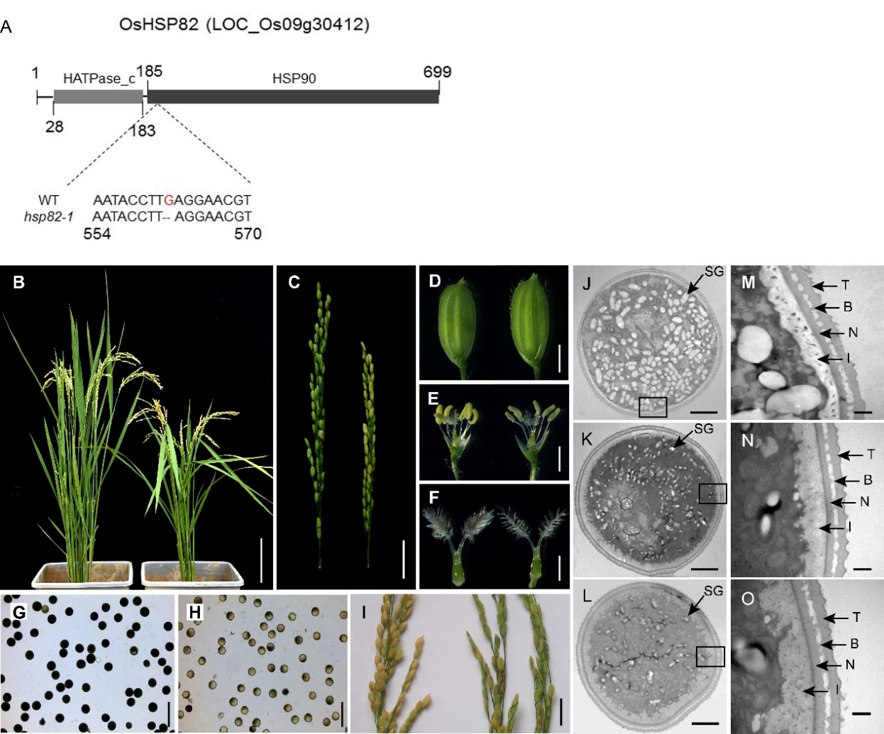
Supplementary Figure 1. Phenotypic analysis of the hsp82-1 mutant.
(A) Schematic of domain structure of OsHSP82 and the mutation type of hsp82-1.
(B) WT plants (left) and the hsp82-1 mutant (right) and after flowering.
(C) The panicles of the WT (left) and hsp82-1 mutant (right) at the filling stage.
(D) to (F) The spikelets (D), anthers (E) and pistils (F) of WT (left) and the hsp82-1 mutant (right) at the flowering stage.
(G) and (H) KI-I₂ staining of WT (G) and hsp82-1 mutant (H) pollen, respectively.
(I) The panicles of WT (left) and the hsp82-1 mutant (right) at the harvest stage.
(J) to (L) Transmission electron microscopy image of pollen grain of WT and two hsp82-1 mutant lines.
(M) to (O) Higher magnification images of the pollen walls were shown in (J), (K), and (L), respectively. SG, starch grain; T, tectum; B, bacula; N, nexine; I, intine. Scale bars: 20 cm in (B), 3 cm in (C), 2 mm in (D), 1 mm in (E) and (F), 100 μm in (G) and (H), 5 cm in (I), 5 μm in (J) to (L), 500 nm in (M) to (O).
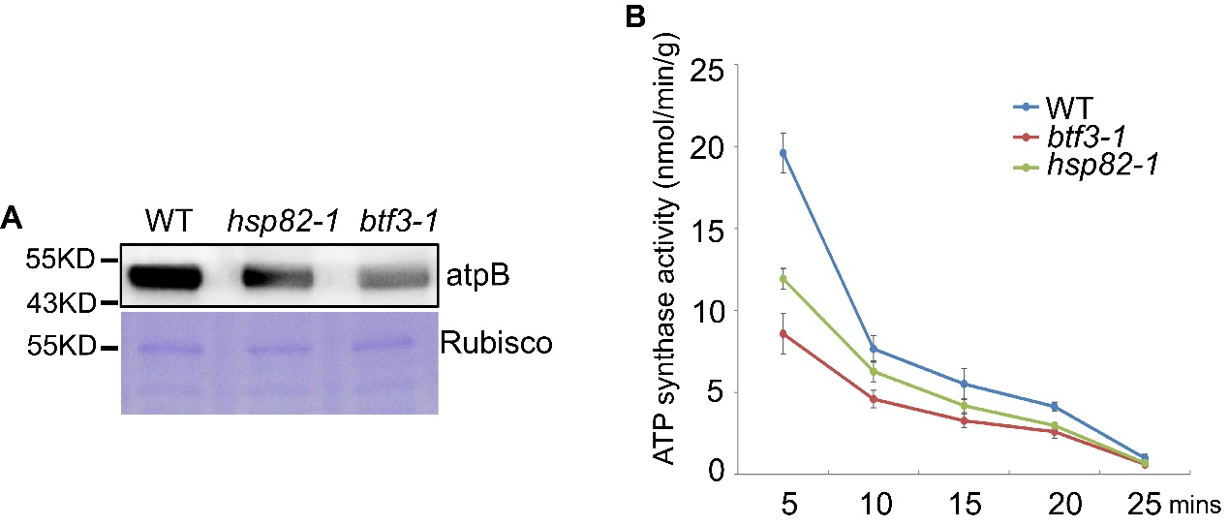
Supplementary Figure 2. Effect of OsHSP82 and Osj10gBTF3 on the accumulation of atpB protein and the activity of ATP synthase.
(A) Chloroplast proteins from WT and hsp82-1 and btf3-1 mutant seedlings were measured with atpB antibody and Coomassie Blue staining was used to indicate the sample loading amount.
(B) Total ATP-hydrolytic activity of ATP synthase was measured in the chloroplasts of WT and the hsp82-1 and btf3-1 mutants. Error bars indicate the SE based on three biological replicates.
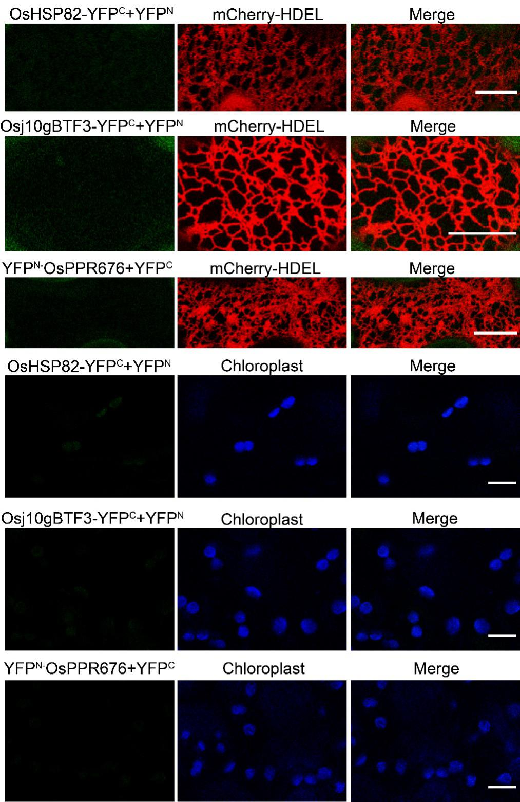
Supplementary Figure 3. Negative controls of BiFC assay in Figure 3.
The negative combination OsHSP82-YFP^{C} and YFP^{N} empty, Osj10gBTF3-YFP^{C} and YFP^{N} empty, and YFP^{N}-OsPPR676 and YFP^{C} empty were co-transformed into leaf epidermal cells of N. benthamiana, respectively. The mCherry-HDEL represents the endoplasmic reticulum marker, Chloroplast indicates auto-fluorescence of chloroplasts. Scale bar=10μm.
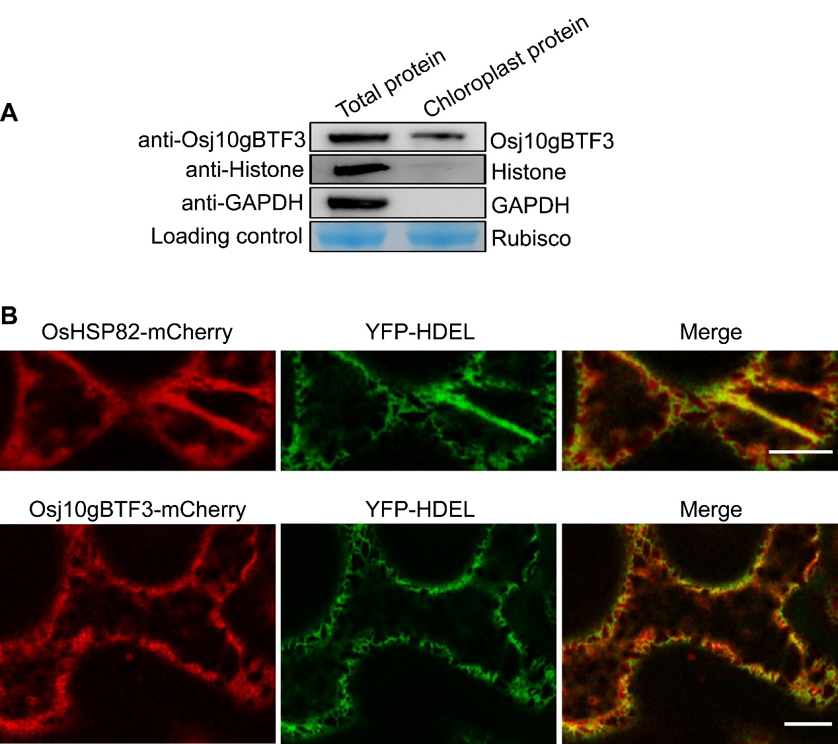
Supplementary Figure 4. The localization of Osj10gBTF3 and OsHSP82.
(A) The chloroplast localization of Osj10gBTF3.Total protein and the chloroplast protein were extracted from rice seedlings, the nuclear protein Histone and cytoplasmic protein GAPDH were used as negative control.
(B) The localization of Osj10gBTF3 and OsHSP82 in tobacco. YFP-HDEL is an endoplasmic reticulum marker.
Table S1. Main primer sequences.

Primer name | Primer Sequence (5' to 3') | Use for
HSP82-Y2H-F1 | GGAATTCCATATGATGGCGTCGGAGACCGA | Yeast two-hybrid
HSP82-Y2H-R2 | TCCCCCGGGTTAGTCGACCTCCTCCATC | Yeast two-hybrid
PPR676-Y2H-F1 | CCGGAATTCATGGCTTCCCCTTCCTCCCT | Yeast two-hybrid
PPR676-Y2H-R | ACGCGTCGACCACCGCTACTAACTCTGCCG | Yeast two-hybrid
HSP82-ENF | CACCATGGCGTCGGAGACCGA | BiFC
HSP82-ENR | GTCGACCTCCTCCATC | BiFC
OsPPR676-ENF1 | CACCATGGCTTCCCCTTCCTCCCT | BiFC
OsPPR676-ENR1 | CACCGCTACTAACTCTGCCG | BiFC
HSP82-F | GCTCTAGAATGGCGTCGGAGACCGA | Subcellular localization
HSP82-R | GCTCTAGAGTCGACCTCCTCCATCTTGC | Subcellular localization
GP1095-F | CCACCAAGCACAACGACGAC | Confirm hsp82-1 mutant
GP1095-R | CCTTGGTGATCTCCTCTGGC | Confirm hsp82-1 mutant
GP1101-F | ACACATGCATCAAAATGCACA | Confirm btf3-1 mutant
GP1101-R | TTGAACCTGCTGTTGTTGGC | Confirm btf3-1 mutant

