Supplementary Figure 1. All subjects’ state transitions for the two kinds of music.
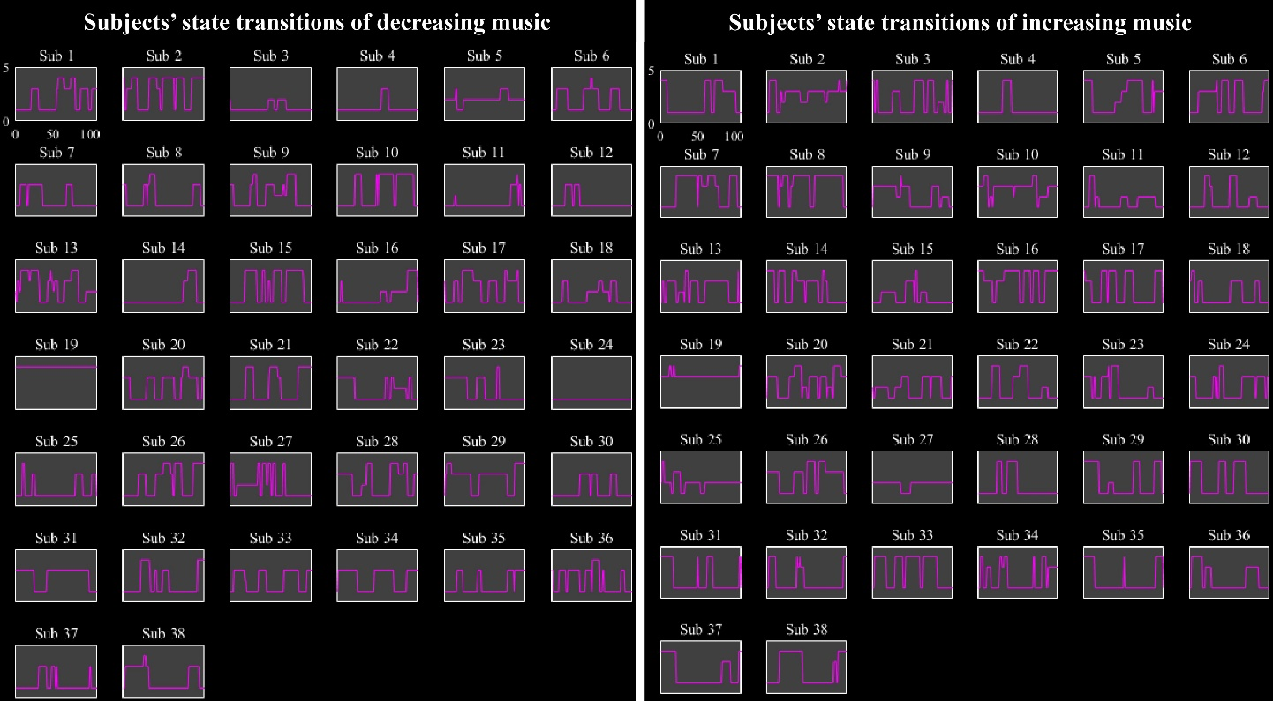

Supplementary Table 1. The details of the experiment music
 | Tempo | Music | Edition | bpm
1 | Decreasing | Czerny, 599-63 | Erster Lehrmeister | 140-80
2 |  | Trudeau's Dream | Lang Lang | 125-65
3 |  | Carmen overture | Classical Day Bank | 180-70
4 |  | Sinfonia of Spring Festival Ensemble-1 | Lang Lang | 165-70
8 | Increasing | Chinese Cowboy With His Flute | Lang Lang | 90-135
9 |  | Humor with sorrow | Beethoven | 65-180
10 |  | North Wind Blow | Chengzong Yin | 60-170
11 |  | Partita of little stars | Mozart | 70-120

ICs in Decreasing | x | y | Z | ICs in Increasing | x | y | z
2 | 2.5 | -80.5 | 23.5 | 1 | 54.5 | -51.5 | 15.5
4 | 59.5 | 15.5 | 9.5 | 2 | 38.5 | -30.5 | 71.5
5 | 30.5 | 53.5 | 23.5 | 3 | -33 | 47.5 | 29.5
6 | -47.5 | 8.5 | 23.5 | 4 | 33.5 | 15.5 | -8.5
7 | -17.5 | 75.5 | -21.5 | 5 | 23.5 | -78.5 | 36.5
8 | -35.5 | -69.5 | 39.5 | 6 | -3.5 | 44.5 | 12.5
9 | 56.5 | -32.5 | 44.5 | 7 | -57.5 | 11.5 | 26.5
10 | 3.5 | -71.5 | 39.5 | 8 | 23.5 | -77.5 | 42.5
11 | 29.5 | -80.5 | 21.5 | 9 | 59.5 | -36.5 | 33.5
12 | -3.5 | 69.5 | 56.5 | 10 | 47.5 | -44.5 | 47.5
13 | -15 | 51 | 42 | 11 | 54.5 | -6.5 | 36.5
14 | -32.5 | -33.5 | 51.5 | 12 | -47.5 | 11.5 | 33.5
15 | -54.5 | -18.5 | 14.5 | 13 | 23.5 | -71.5 | -27.5
16 | 56.5 | -5.5 | -12.5 | 14 | -56.5 | -33.5 | 5.5
17 | 2.5 | -57.5 | 24.5 | 15 | -15.5 | -39.5 | 68.5
18 | 0.5 | -66.5 | 62.5 | 16 | -2.5 | -71.5 | 33.5
19 | 23.5 | -33.5 | 68.5 | 17 | 45.5 | -12.5 | 11.5
20 | 30.5 | -44.5 | 60.5 | 18 | -35.5 | -74.5 | 32.5
21 | 51.5 | -17.5 | 36.5 | 19 | 2.5 | -80.5 | 18.5
22 | 47.5 | -62.5 | 41.5 | 20 | -3.5 | 41.5 | 53.5
23 | 29.5 | -87.5 | 3.5 | 21 | 2.5 | -66.5 | 62.5
 |  |  |  | 22 | -41.5 | -63 | 43
 |  |  |  | 23 | -35.5 | -44.5 | 57.5
 |  |  |  | 24 | 26.5 | -87.5 | -2.5
 |  |  |  | 25 | 38.5 | -35.5 | 54.5

Supplementary Table 2. The coordinate information of ICs.

