****

(A)

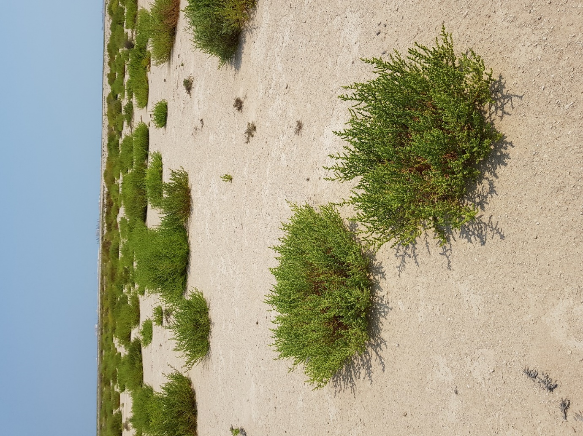

(B)

Supplementary Figure 2. Many Sabkhas and drylands scattered around Qatar are rich in halophyte and xerophyte plants. (A) Inland Sabkha, (B) Inland dry land.