Table S1. Selected radiomics features.
Type | Name |  | Calculation formula
First Order Features
Mean* |  | 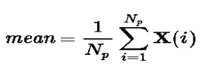
GLCM
 | Inverse Variance* |  | 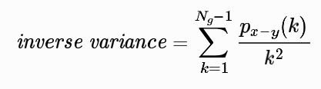
 | Cluster Shade* |  | 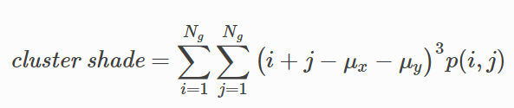
 | IMC 1# |  | 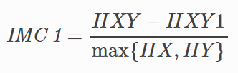
GLSZM
 | SZNN*# |  | 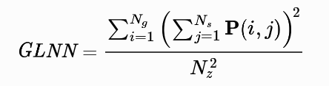
 | SALGLE*# |  | 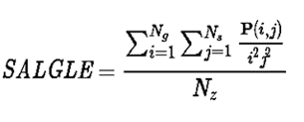
NGTDM
 | Busyness* |  | 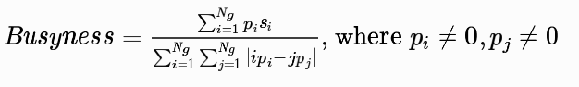
GLDM | DV*# |  | 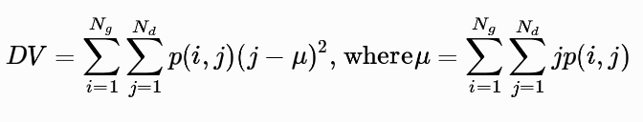
NOTE: *, the features were from the filter of logarithm; #, the features were from the filter of wavelet.
(1) First order features.
1)Mean, The average gray level intensity within the ROI.
(2) GLCM, Gray Level Co-occurrence Matrix Features.
1) Inverse Variance, is a measure of the local homogeneity of an image.
2) Cluster Shade, is a measure of the skewness and uniformity of the GLCM.
3) IMC 1, assesses the correlation between the probability distributions.
(3) GLSZM, Gray Level Size Zone Matrix Features Gray Level Co-occurrence Matrix Features.
1) SALGLE, Small Area Low Gray Level Emphasis, measures the joint distribution of small dependence with lower gray-level values.
2) SZNN, Size-zone non-uniformity normalized, it describes the variability of size zone volumes throughout the image.
(4) NGTDM, Neighboring Gray Tone Difference Matrix Features
1) Busyness, it measures the change from a pixel to its neighbor.
(5) GLDM, Gray Level Dependence Matrix Features.
1) Dependence Variance, Measures the variance in dependence size in the image.

