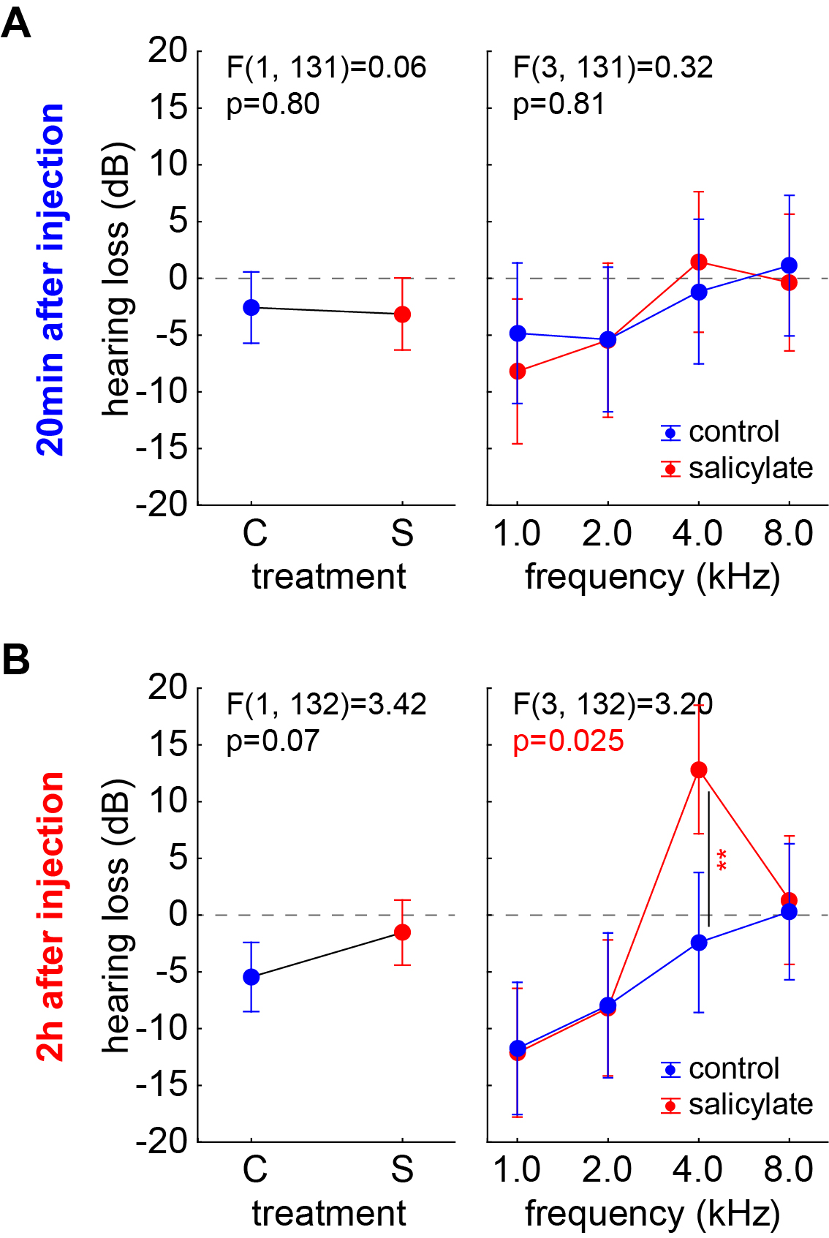
Supplementary Figure 1
Comparison of the HL of group C and S by for both time points independent two-factorial ANOVAs with the factors group (left panels) and its interaction with the frequency (right panels). A: 20 min after injection no significant effects of both factors on the HL could be identified. B 2h after injection no difference between both groups but a significant interaction of both factors with a significant Tukey post-hoc test at 4 kHz was detected.

