Supplementary Materials
Radiomic Feature
In our study, seven texture features (including five wavelet-based features and two original features) were selected to build the radiomics signature, which were based on gray level co-occurrence matrix (GLCM) /gray level size zone matrix (GLSZM).
- GLSZM
Let:
- N_{g} be the number of discreet intensity values in the image
- N_{s} be the number of discreet zone sizes in the image
- N_{p} be the number of voxels in the image
- Nz be the number of zones in the ROI, which is equal to 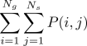 and 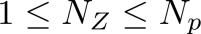
- 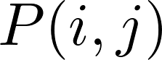 be the size zone matrix.
- 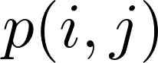 be the normalized size zone matrix, define as 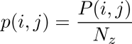
wavelet-HHH_glszm_SmallAreaEmphasis
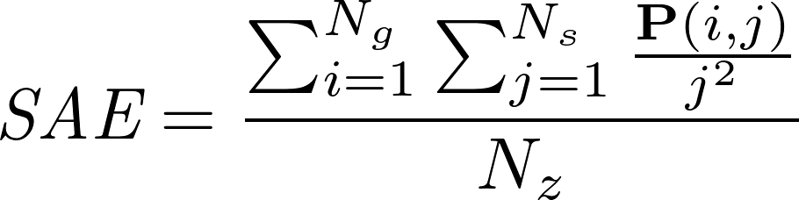
original_glszm_LowGrayLevelZoneEmphasis
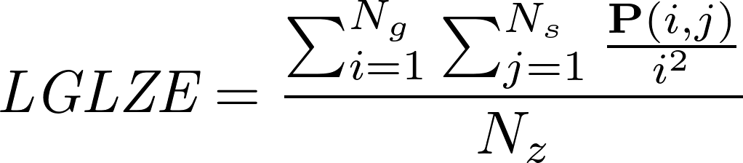
original_glszm_SmallAreaLowGrayLevelEmphasis
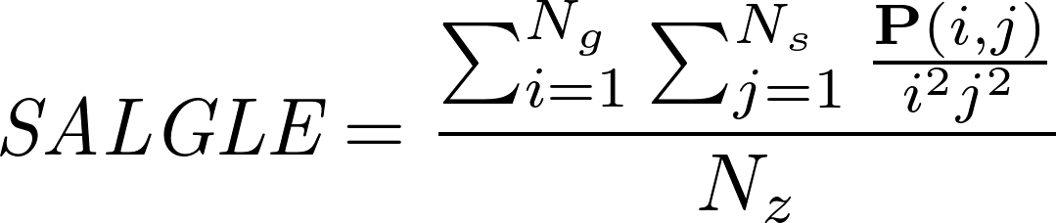
wavelet-LLH_glszm_GrayLevelNonUniformity
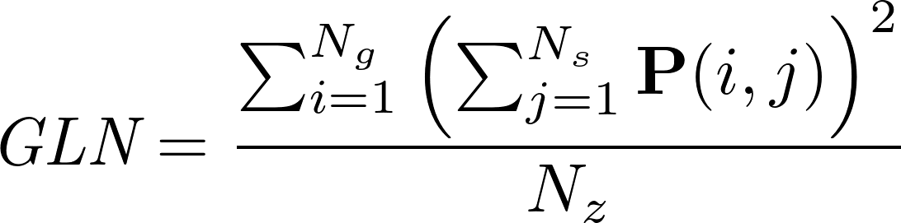
- GLCM
Let:
- be an arbitrary small positive number (2.2x10⁻¹⁶)
- be the co-occurence matrix for an arbitary 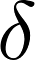 and 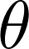
- be the normalized co-occurence matrix and equal to 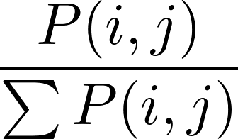
- N_{g} be the number of discrete intensity levels in the image
- 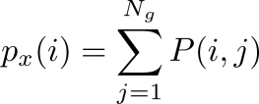 be the marginal row probabilities
- 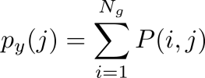be the marginal column probabilities
- 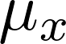 be the mean gray level intensity of 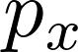 and defined as 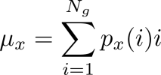
- be the mean gray level intensity of 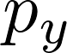 and defined as 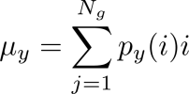
- 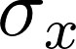 be the standard deviation of
- 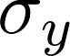 be the standard deviation of
- 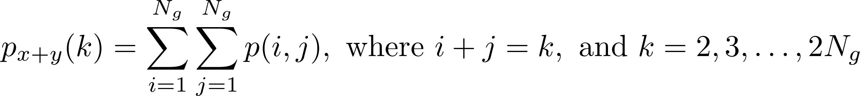
- 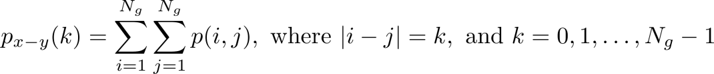
- 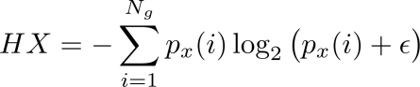 be the entropy of
- 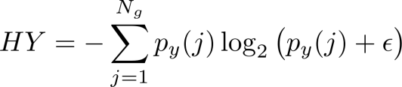 be the entropy of
- 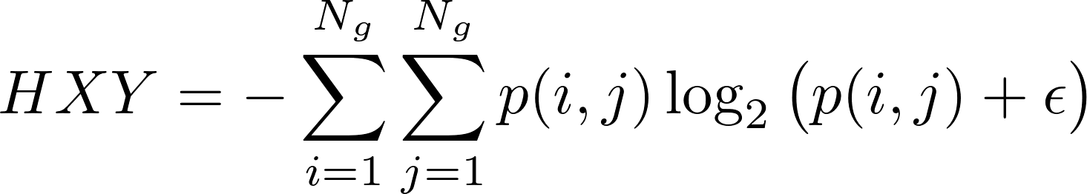 be the entropy of
- 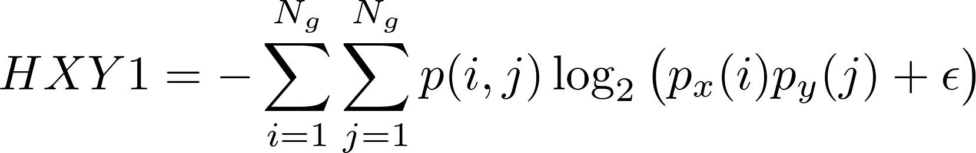
- 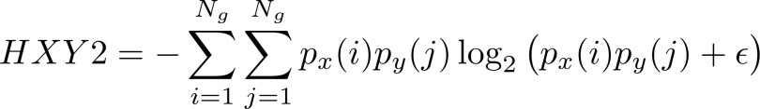
wavelet-LLH_glcm_ClusterShade
wavelet-HHL_glcm_Imc2
wavelet-LHH_glcm_SumSquares
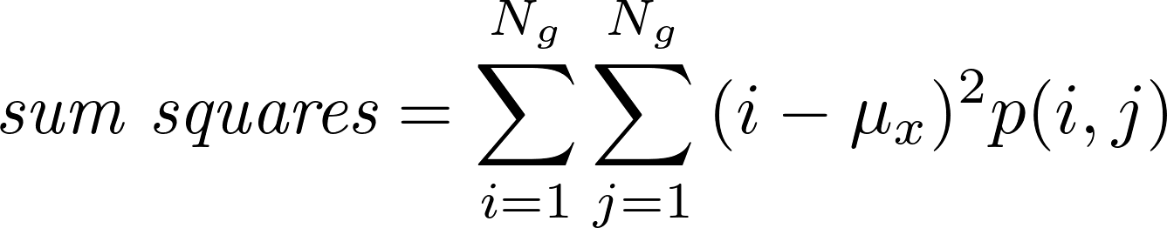

Table S1 Baseline characteristics of the training set and validation set
Characteristic | Training set  (n = 85) | Validation set  (n = 37) | P value
Age (mean ± SD) | 57.72 ± 11.90 | 60.49 ± 10.67 | 0.207
Gender |  |  | 0.320
Male | 60 (70.6) | 22 (59.5)
Female | 25 (29.4) | 15 (40.5)
Tumor size (> 3 cm) | 16 (18.8) | 7 (18.9) | 0.811
CT-reported LN status |  |  | 0.892
LN negative | 58 (68.2) | 25 (67.6)
LN positive | 27 (31.8) | 12 (32.4)
CT-reported vascular  invasion | 30 (35.3) | 13 (35.1) | 0.850
Tumor origin |  |  | 0.854
Duodenum | 24 (28.2) | 10 (27.1)
Ampulla of Vater | 16 (18.9) | 8 (21.6)
Common bile duct | 12 (14.1) | 7 (18.9)
Pancreas | 33 (38.8) | 12 (32.4)
CA 19-9 (> 39 U/ml) | 63 (72.1) | 26 (70.3) | 0.218
CA 125 (> 39 U/ml) | 3 (3.5) | 2 (5.4) | 0.987
CEA (> 10 ng/ml) | 4 (4.7) | 4 (10.8) | 0.393
Radiomics score (mean ± SD) | -0.84 ± 1.34 | -0.97 ± 1.01 | 0.537

Note: Data are number of patients; data in parentheses are percentage unless otherwise indicated. CA 125 = carbohydrate antigen 125, CA 19-9 = carbohydrate antigen 19-9, CEA = carcinoembryonic antigen, LN = lymph node, SD = standard deviation.

Table S2 VIFs for all the candidate variables in the logistic regression analysis
Variable | VIF
CT-reported LN status | 1.090070
Radiomics score | 1.390886
Tumor origin | 1.504284
Tumor size | 1.702389
CT-reported vascular invasion | 2.432624
Note: LN = lymph node, VIF = variance inflation factor.

Table S3 Multivariable analysis for features used in the nomogram
Variable | Coefficient | P value | Odds ratio (95% CI)
Radiomics score | 0.8586 | 0.0031 | 3.2544 (1.4884, 7.1157)
CT-reported LN status | 1.6872 | 0.0020 | 5.4046 (1.8493, 15.7950)
NOTE: LN = lymph node.

Figure S1. The scatter plot of the radiomics score for each patient in training set (A) and validation set (B). The red markers indicate patients with synchronous LN metastasis; the green markers indicate patients without LN metastasis. The yellow horizontal line represents the threshold.

