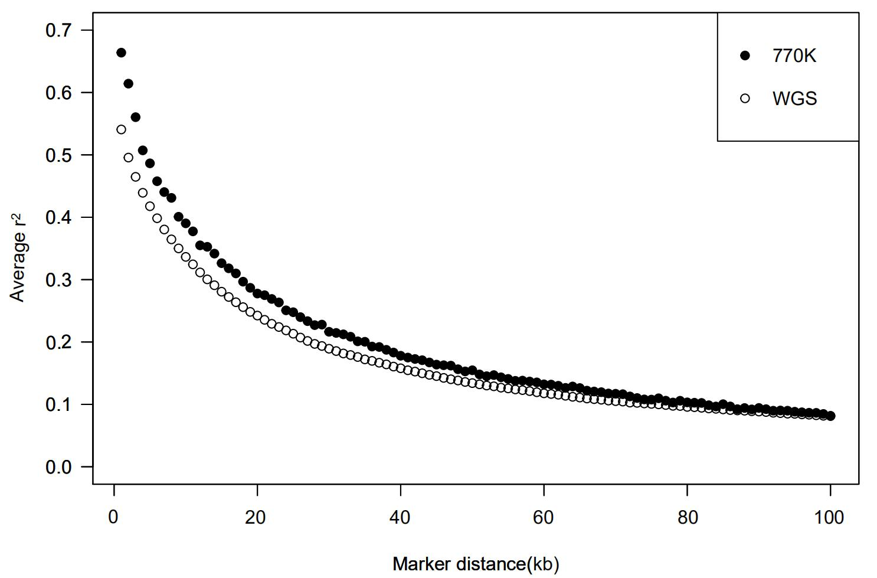
Figure S1 | The LD decay of BTA1 in the 770K data and WGS data

