Supplementary Material

Growth of C. glutamicum wild type on glucose in the absence and presence of the phenolic compounds ferulic acid, vanillin and vanillic acid
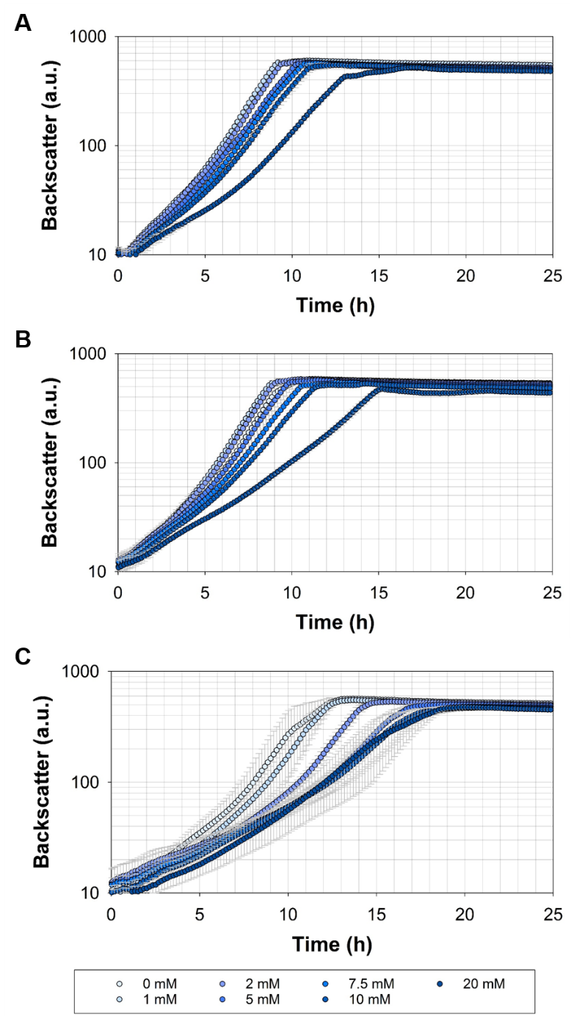
Figure S1: Growth of C. glutamicum wild type in microliter scale cultivations with CGXII minimal medium and 20 g glucose L⁻¹ with different concentrations (shades of blue) of (A) ferulic acid, (B) vanillin and (C) vanillic acid. Error bars represent standard deviation of at least three cultivations.

Growth of C. glutamicum ΔP_{aceE}::vanR-P_{vanABK}* on glucose in the absence and presence of the phenolic compounds ferulic acid, vanillin and vanillic acid
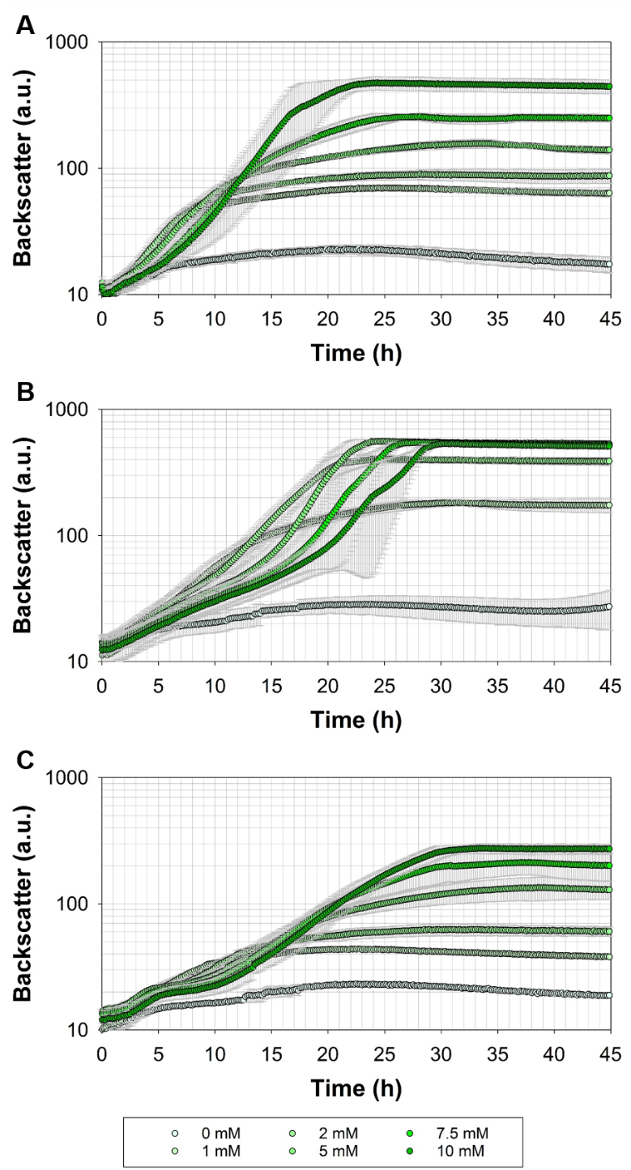
Figure S2: Growth of C. glutamicum ΔP_{aceE}::vanR-P_{vanABK}* in microliter scale cultivations with CGXII minimal medium and 20 g glucose L⁻¹ with different concentrations (shades of green) of (A) ferulic acid, (B) vanillin and (C) vanillic acid. Error bars represent standard deviation of at least three cultivations.

Glucose consumption and product accumulation of C. glutamicum wild type and ΔP_{aceE}::vanR-P_{vanABK}* in shaking flask cultivations supplemented with one specific concentration of ferulic acid, vanillin or vanillic acid
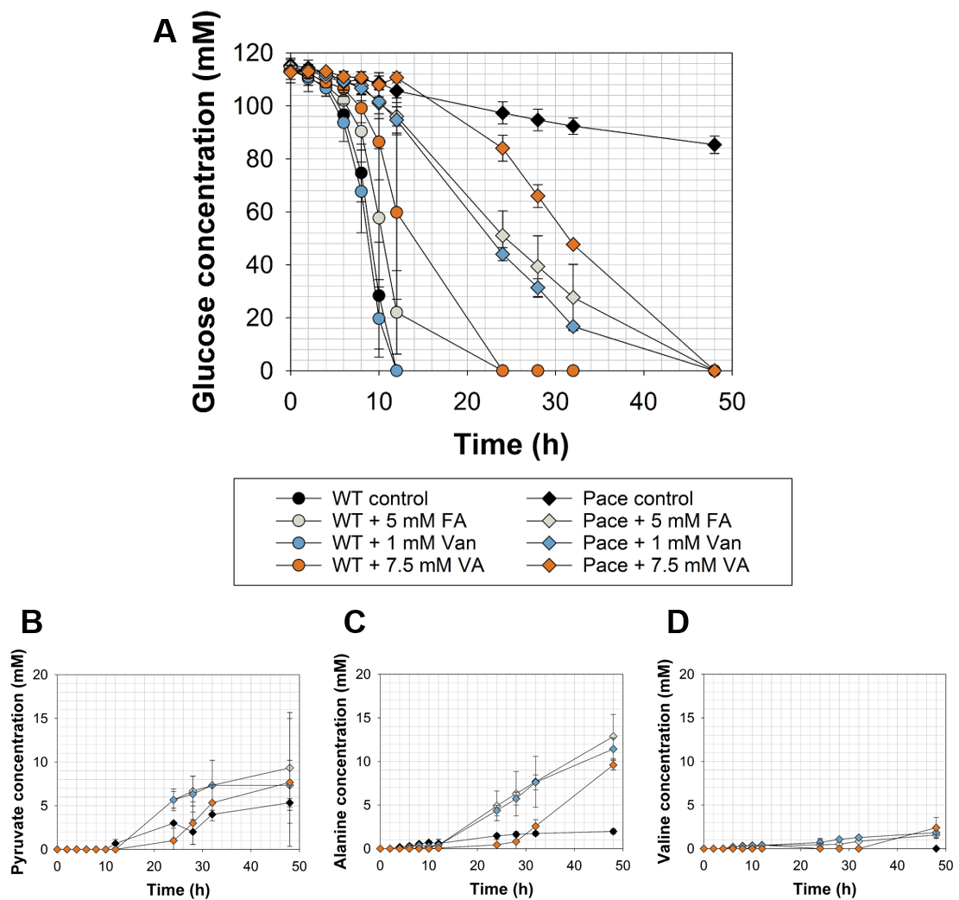
Figure S3: (A) Glucose consumption and (B – D) product accumulation of C. glutamicum wild type (circles; WT) and ΔP_{aceE}::vanR-P_{vanABK}* (diamonds; Pace) in shaking flasks with CGXII minimal medium and 20 g glucose L⁻¹ without (black) and with 5 mM ferulic acid (grey; FA), 1 mM vanillin (blue; Van) or 7.5 mM vanillic acid (orange; VA). Error bars represent standard deviation of cultivations of at least three biological replicates.

Consumption of glucose and accumulation of pyruvate and alanine of C. glutamicum ΔP_{aceE}::vanR-P_{vanABK}* (pJC4-ilvBNCE) in shaking flask cultivations supplemented with one specific concentration of ferulic acid, vanillin or vanillic acid
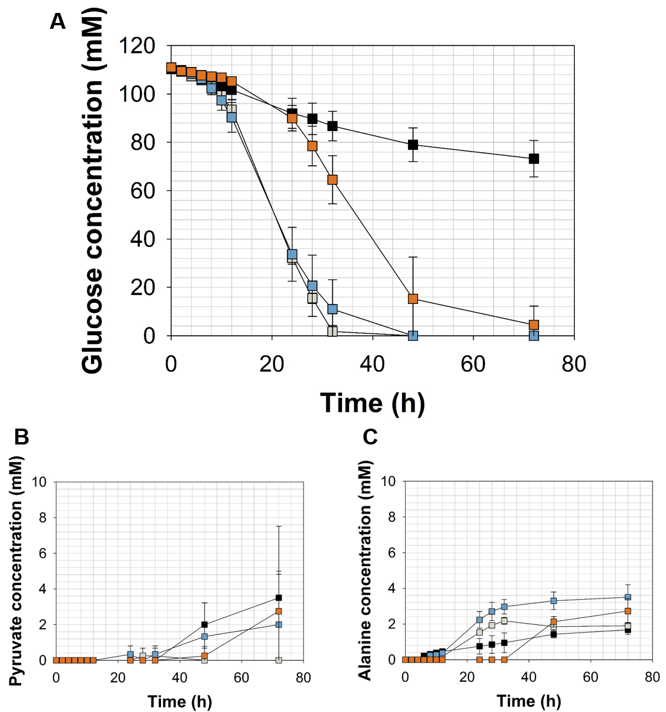
Figure S4: (A) Glucose consumption and (B – C) pyruvate and alanine accumulation of C. glutamicum ΔP_{aceE}::vanR-P_{vanABK}*(pJC4-ilvBNCE) in shaking flasks with CGXII minimal medium (with 20 g ammonium sulfate L⁻¹) and 20 g glucose L⁻¹ without (black) and with 5 mM ferulic acid (grey), 1 mM vanillin (blue) or 7.5 mM vanillic acid (orange). Error bars represent standard deviation of cultivations of at least three biological replicates.

Consumption of ferulic acid, vanillin or vanillic acid of C. glutamicum ΔP_{aceE}::vanR-P_{vanABK}* (pJC4-ilvBNCE) and C. glutamicum ΔP_{aceE}::vanR-P_{vanABK}* (pJC4) in shaking flask cultivations
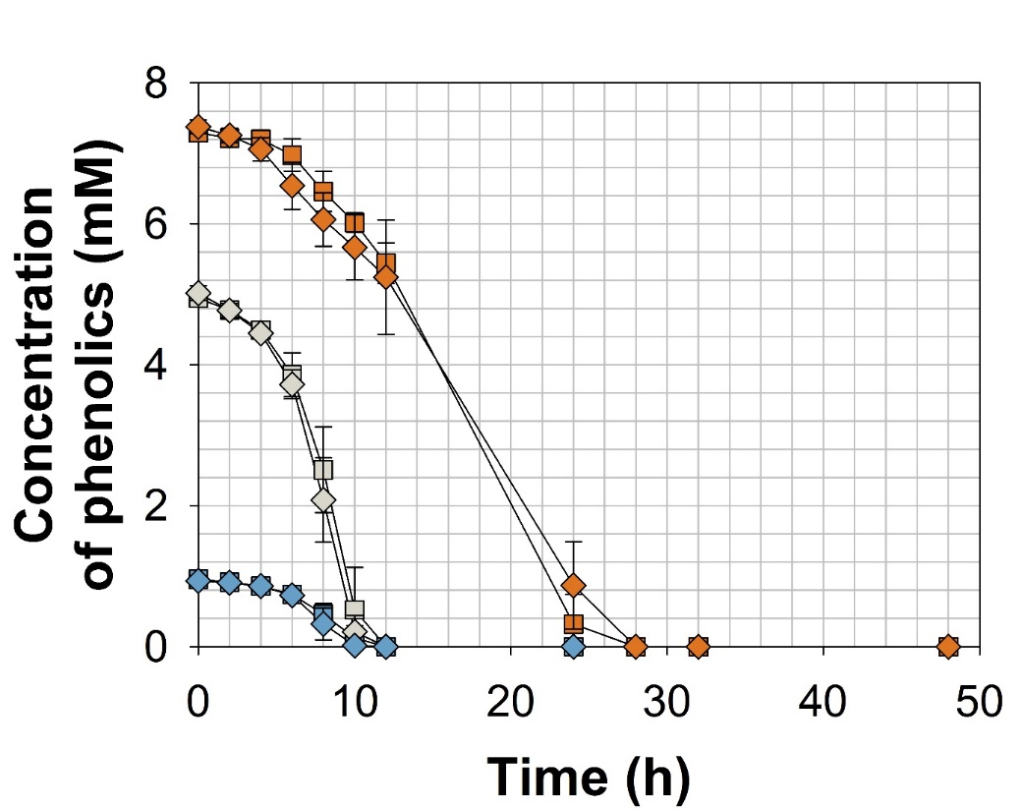
Figure S5: Phenolic compound consumption of C. glutamicum ΔP_{aceE}::vanR-P_{vanABK}*(pJC4-ilvBNCE) (squares) and C. glutamicum ΔP_{aceE}::vanR-P_{vanABK}*(pJC4) (diamonds) in shaking flasks with CGXII minimal medium (with 20 g ammonium sulfate L⁻¹) and 20 g glucose L⁻¹ with ferulic acid (grey), vanillin (blue) or vanillic acid (orange). Error bars represent standard deviation of cultivations of at least three biological replicates.

Growth, consumption of glucose and accumulation of pyruvate, alanine and valine of C. glutamicum ΔP_{aceE}::vanR-P_{vanABK}* (pJC4) in shaking flask cultivations supplemented with one specific concentration of ferulic acid, vanillin or vanillic acid
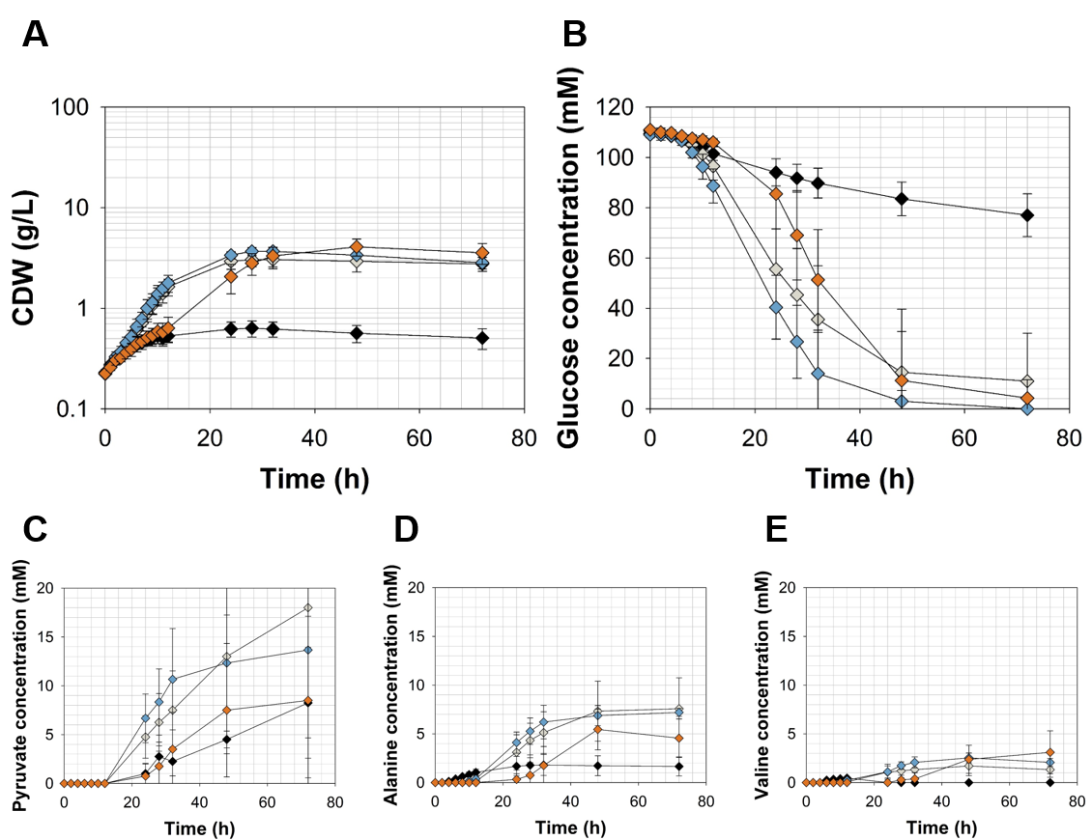
Figure S6: (A) Growth (B) glucose consumption and (C – D) pyruvate, alanine and valine accumulation of C. glutamicum ΔP_{aceE}::vanR-P_{vanABK}*(pJC4) in shaking flasks with CGXII minimal medium (with 20 g ammonium sulfate L⁻¹) and 20 g glucose L⁻¹ without (black) and with 5 mM ferulic acid (grey), 1 mM vanillin (blue) or 7.5 mM vanillic acid (orange). Error bars represent standard deviation of cultivations of at least three biological replicates.

