Supplementary Material

Table S1. Composite secondary outcomes according to serum bicarbonate concentration
 | Model 1 |  | Model 2 |  | Model 3 |  | Model 4
Serum bicarbonate | HR (95% CI) | P-value | HR (95% CI) | P-value | HR (95% CI) | P-value | HR (95% CI) | P-value
Categorical variable
Low  (<22 mmol/L) | 1.56 (1.05, 2.32) | 0.029 | 1.41 (0.94, 2.10) | 0.093 | 1.38 (0.91, 2.10) | 0.134 | 1.29 (0.83, 2.02) | 0.259
Lower normal  (22-26 mmol/L) | Reference | - | Reference | - | Reference | - | Reference | -
Higher normal  (26.1-29.9 mmol/L) | 0.79 (0.55, 1.13) | 0.199 | 0.93 (0.64, 1.33) | 0.676 | 1.02 (0.70, 1.50) | 0.917 | 1.14 (0.76, 1.69) | 0.532
High  (≥30 mmol/L) | 0.96 (0.61, 1.52) | 0.877 | 1.27 (0.80, 2.03) | 0.312 | 1.40 (0.85, 2.32) | 0.187 | 1.25 (0.72, 2.16) | 0.426
Continuous variable
TCO₂  (per 1 mmol/L increase) | 0.94 (0.91, 0.98) | 0.004 | 0.98 (0.94, 1.02) | 0.315 | 0.99 (0.94, 1.04) | 0.619 | 0.99 (0.94, 1.04) | 0.741
Composite secondary outcomes consist cardiovascular events and all-cause mortality.
Model 1: Unadjusted
Model 2: Adjusted for age, sex, HTN, DM, preexisting CVD, systolic blood pressure, BMI
Model 3: Model 2 + eGFR, log UPCR
Model 4: Model 3 + albumin, total cholesterol, logCRP, ACEi or ARB use, and diuretics use
HR: hazard ratio; CI: confidence interval; TCO₂: total carbon dioxide; DM: diabetes mellitus; HTN: hypertension; CVD: cardiovascular disease; BMI: body mass index; eGFR: estimated glomerular filtration rate by CKD-EPI creatinine equation; UPCR: urine protein creatinine ratio; CRP: C-reactive protein; ACEi: angiotensin converting enzyme inhibitor; ARB: angiotensin II receptor blocker

Figure S1. The eGFR slope according to serum bicarbonate groups

Serum TCO₂ | eGFR slope
Low (<22 mmol/L) | -2.93 ± 1.61
Lower normal (22-26 mmol/L) | -2.60 ± 1.97
Higher normal (26.1-29.9 mmol/L) | -2.32 ± 2.18
High (≥30 mmol/L) | -2.13 ± 2.11

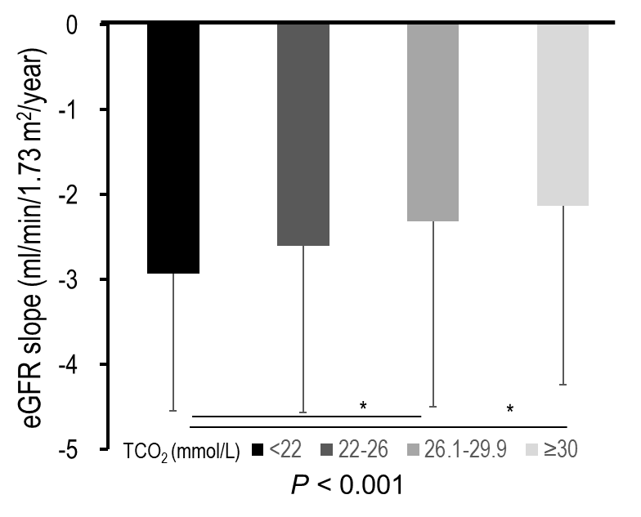
The eGFR slope was analyzed in 1,571 patients with eGFR measured more than three times during the follow-up period.
*P < 0.001; eGFR: estimated glomerular filtration rate by CKD-EPI creatinine equation; TCO₂: total CO₂

