Supplementary materials
Additional analysis using Newmark’s displacement method
Jibson (2007) developed a regression model to estimate Newmark’s displacement of the sliding block. Several studies (Jibson and Michael, 2009; Rodríguez-Peces et al., 2011; Gallen et al., 2016; Ma and Xu, 2018) have used this model to calculate the permanent displacement of landslide. This equation correlates the Newmark’s displacement (D_{N}) with critical acceleration (a_{c}) and peak ground acceleration (PGA) as follows:
$$LogD_{N}=0.215+\left({\left(1-\frac{a_{c}}{PGA}\right)}^{2.341} {\left(\frac{a_{c}}{PGA}\right)}^{-1.438}\right)±0.510$$
Newmark’s displacement method uses a threshold displacement. When calculated displacement exceeds the threshold displacement, slope failure occurs. Wieczorek et al. (1985) used 5 cm as threshold displacement to categorize landslide susceptibility. Jibson and Keefer (1993) considered a 5-10 cm reasonable displacement for the landslide occurrence. Similarly, Wang and Lin (2010) observed that displacement larger than 5 cm appeared consistent with the landslide scars identified from satellite images. Likewise, Gallen et al. (2016) adopted a 5 cm threshold displacement to evaluate ETL for the 2015 Gorkha earthquake. Consistent with these studies, we adopted 5 cm as threshold displacement for triggering a landslide.
We calculated critical acceleration for each cell using Eq. 4 and a factor of safety using Eq. 3. Then, we calibrated landslide thickness by varying landslide thickness using Jibson’s (2007) regression model. We validate the model by comparing it with landslide obtained from DEM difference. Then we used the Matthews correlation coefficient (MCC) for the accuracy assessment. The landslide thickness corresponding to the susceptibility map with the highest MCC value was adopted. The peak MCC value was observed at landslide thickness 3.0 m, where the MCC value is 0.118 (Fig. I (B)). Figure I shows the comparison between Newmark’s displacement method (Jibson, 2007) and the critical acceleration method.
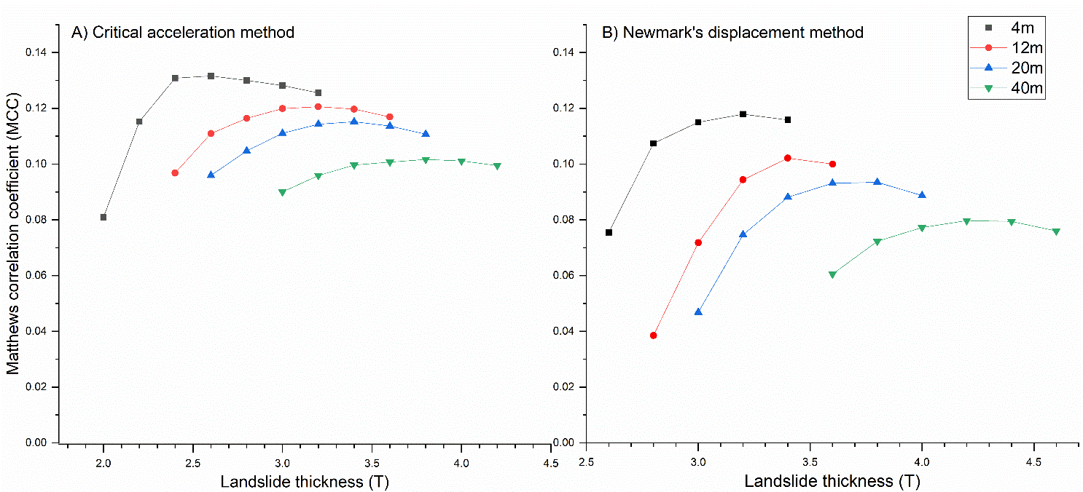
Fig. S1: Matthews correlation coefficient (MCC) for various DEM cell sizes (4m, 12m, 20m, and 40m) and assumed landslide thickness with the peak value of 0.132 and 0.118 using A) Critical acceleration method and B) Newmark’s displacement method respectively.
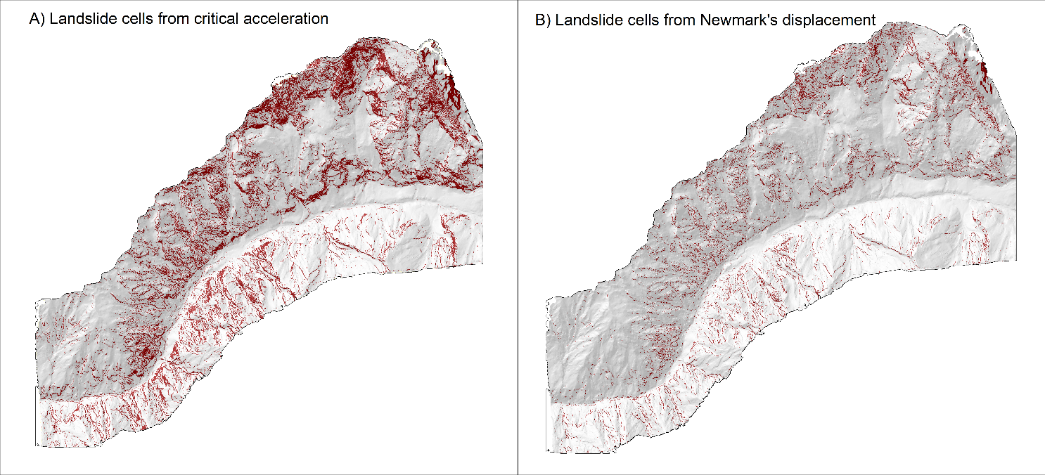
Fig. S2. The earthquake-triggered landslide map produced from A) critical acceleration method for landslide thickness = 2.6 m, and B) Newmark’s displacement method for landslide thickness = 3.0 m. Brown color the map represents landslide source cells.
Similarly, the landslide susceptibility map developed from the critical acceleration method and Newmark’s displacement method is shown in Figure ii. While the spatial distribution of landslide cells in these two maps shows a similar pattern, the critical acceleration method shows more landslide cell density. After implementing both approaches, we found that critical acceleration results yield better results than Newmark’s acceleration method in the Langtang valley.
Fig. S1. Visually interpreted landslide polygon inventories from different authors overlaid on the landslide cells obtained from DEM subtraction.

