Supporting Information for

**Advection not dispersion and transient storage controls streambed nutrient and greenhouse gas concentrations**

Sophie Comer-Warner1, Phillip Blaen1, Nicolai Brekenfeld1, Daren Gooddy2, Christopher Lovell3, Kieran Khamis 1, Alexandra Bryden1 and Stefan Krause1

1School of Geography, Earth and Environmental Sciences, University of Birmingham, Edgbaston, Birmingham B15 2TT, UK, 2British Geological Survey (BGS), Maclean Building, Wallingford, Oxfordshire OX10 8BB, UK, 3Lucideon Ltd, Penkhull, Stoke-on-Trent, ST4 7LQ, UK,

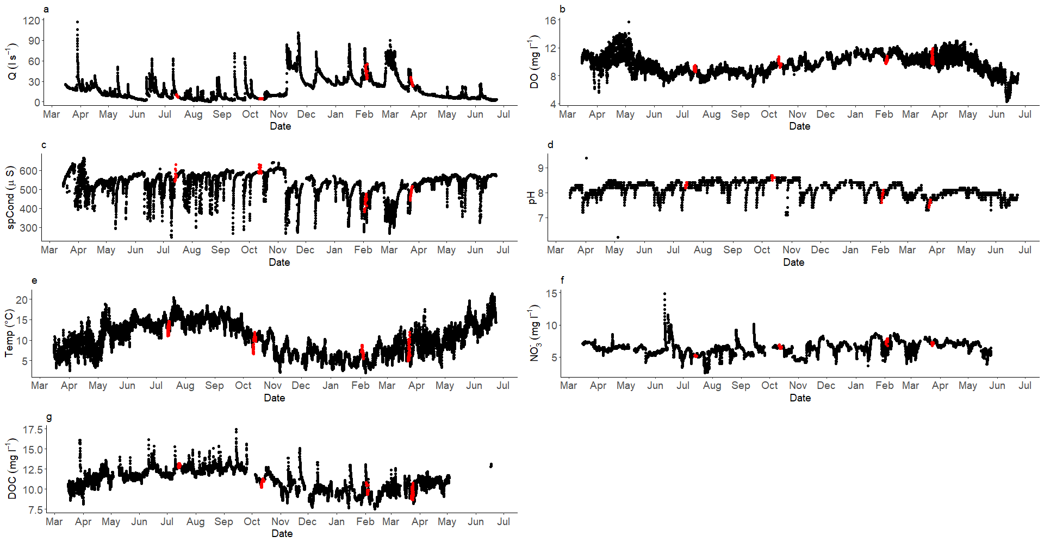

Figure S1. Surface water data measured at the most downstream point of the study reach (Figure 1) between March 2016 and July 2017, the experimental periods are marked in red. Details of the stream gauge and data handling can be found in Blaen et al., 2017a.

Table S1. Seasonal vertical hydraulic gradients for each piezometer where streambed chemistry was measured.



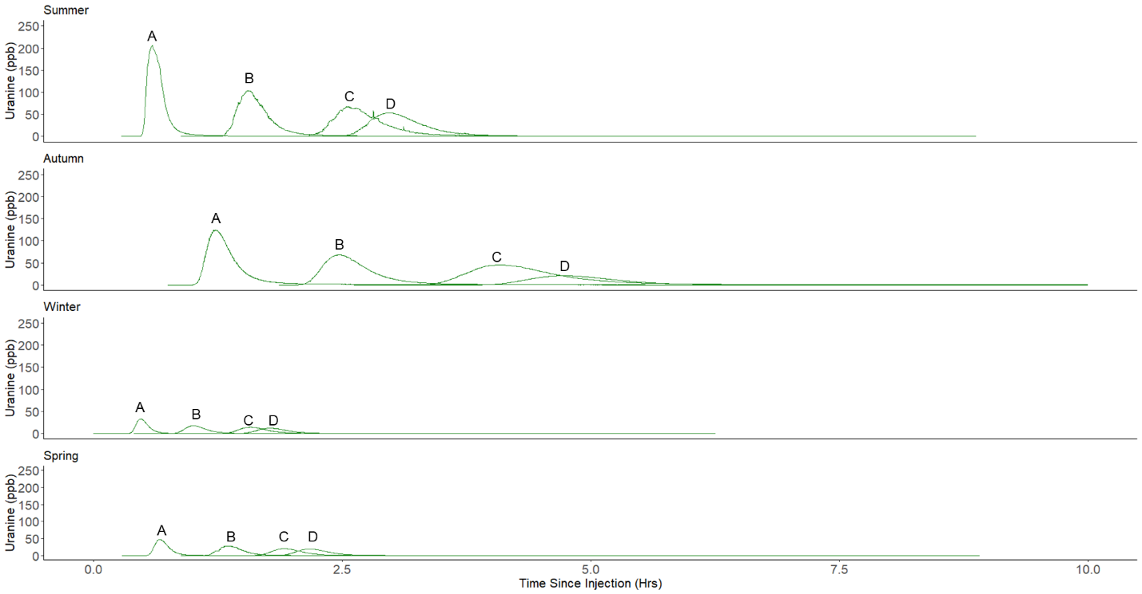

Figure S2. Seasonal breakthrough curves of uranine in ppb at each of the four fluorometer locations (A-D).

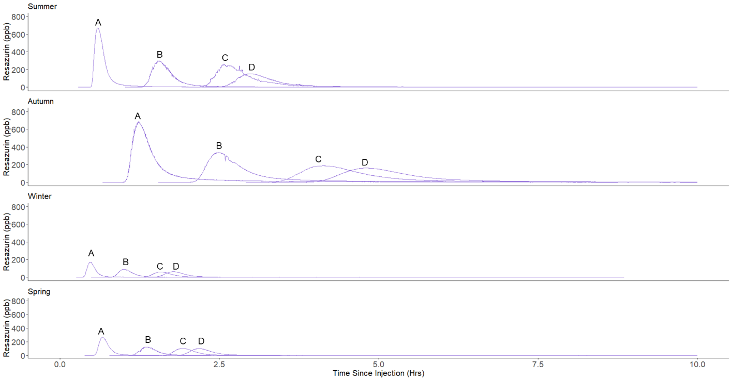

Figure S3. Seasonal breakthrough curves of resazurin in ppb at each of the four fluorometer locations (A-D).

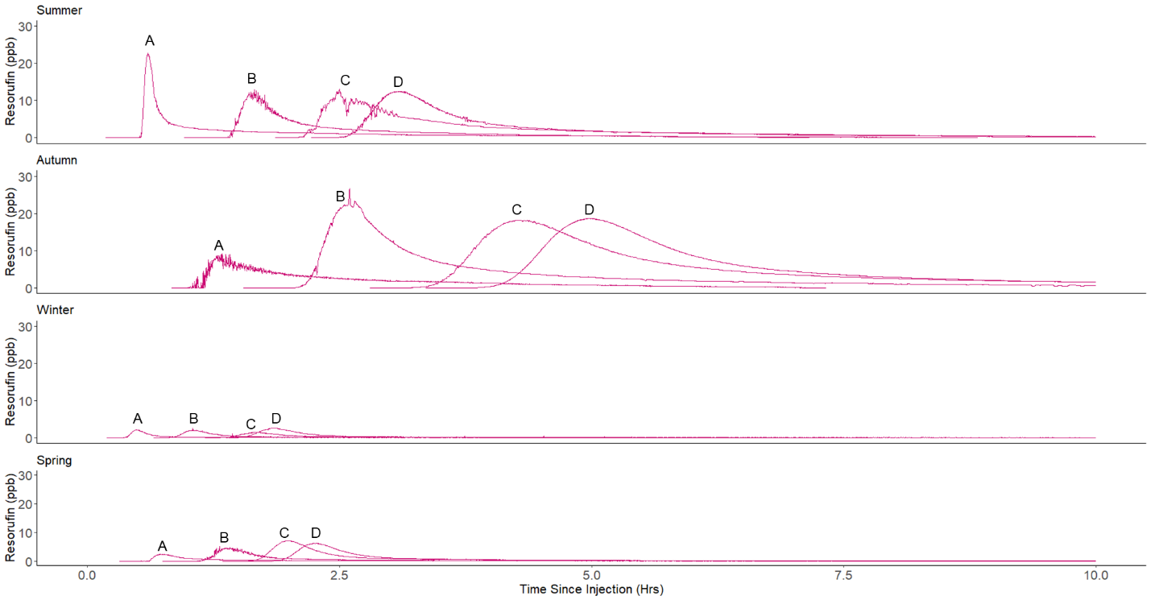

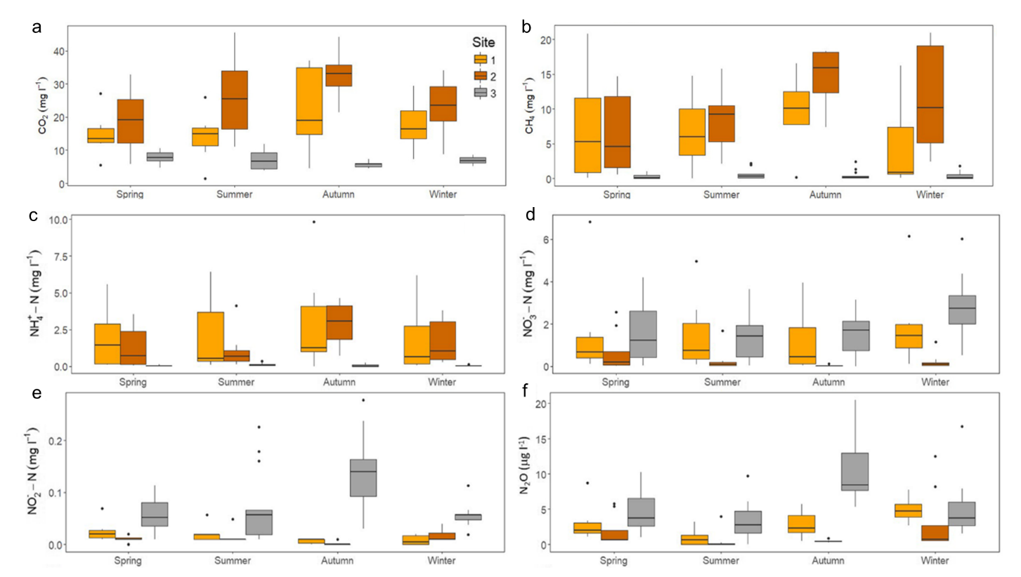Figure S4. Seasonal breakthrough curves of resorufin in ppb at each of the four fluorometer locations (A-D).

Figure S5. The concentrations of a. CO2 (mg l-1), b. CH4 (mg l-1), c. NH4+ (mg N l-1), d. NO3- (mg N l-1), e. NO2- (mg N l-1) and f. N2O (mg l-1) at each streambed chemistry site across all seasons, data from 10 and 20 cm depths from all piezometers within a reach are included for each site. The median of the data is indicated by the bold line of the boxplot and the first and third quartiles are shown by the lower and upper hinges, respectively. The smallest value is indicated by the lower whisker while the upper whisker represents the largest value, however, the whiskers do not extend past 1.5* the inter-quartile range of the lower and upper hinges. The individual points are considered outliers as they represent data outside of the range of the whiskers. Figure adapted from Comer-Warner *et al*. (2019 and 2020).

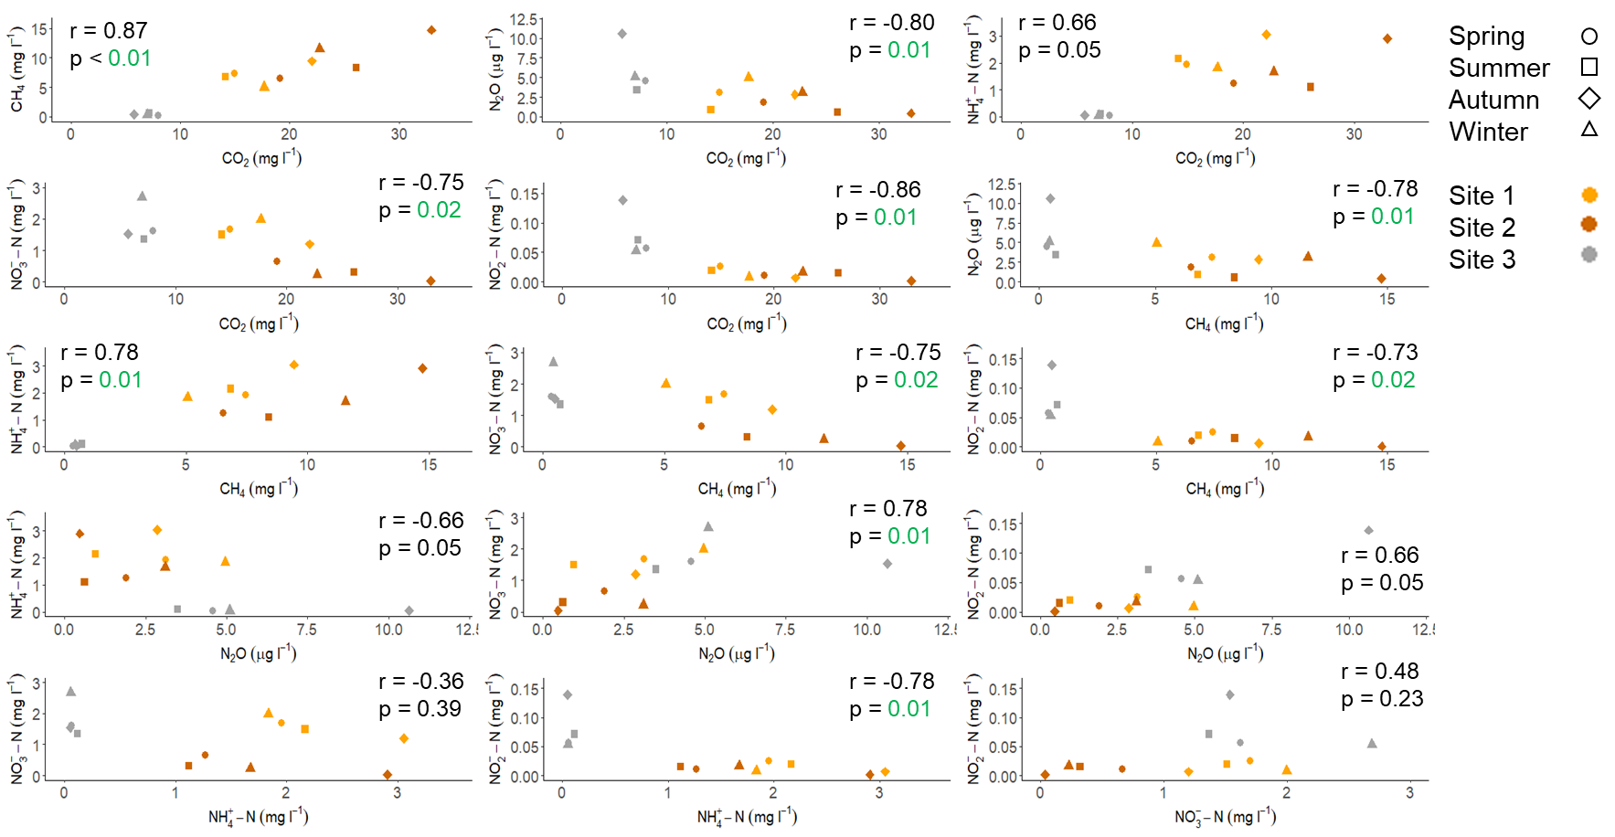

Fig. S6. Bivariate plots of streambed chemical species against each other. The Spearman rank correlation coefficient (r) and the adjusted p-values (False Discovery Rate (FDR) method) are also presented. Significant p-values are shown in green.

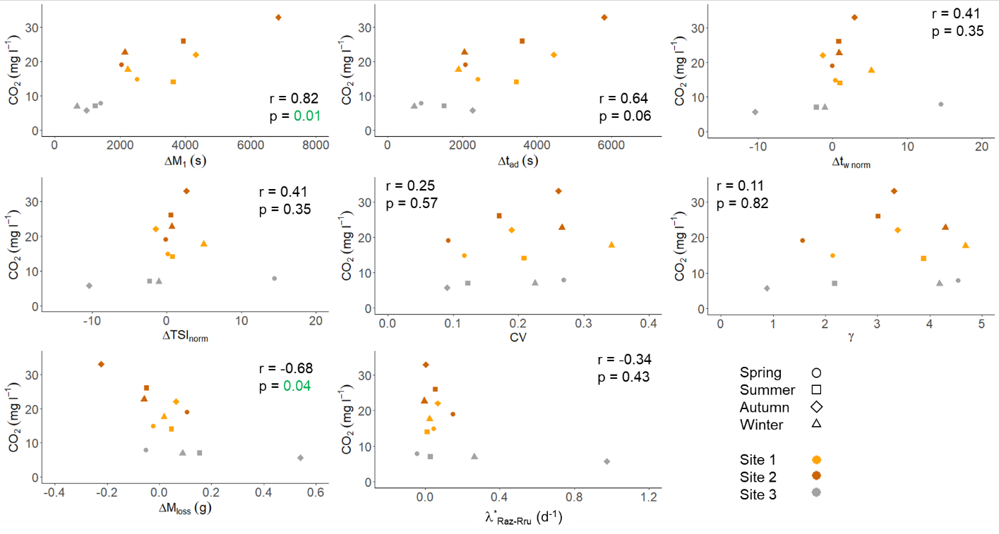

Figure S7. Bivariate plots of CO2 against the hydrological metrics and the turnover of resazurin to resorufin as a proxy for aerobic microbial metabolism. The Spearman rank correlation coefficient (r) and the adjusted p-values (FDR method) are also presented. Significant p-values are shown in green.

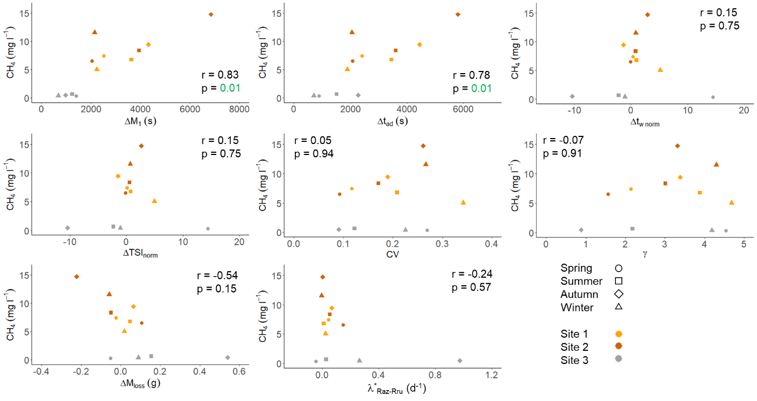

Figure S8. Bivariate plots of CH4 against the hydrological metrics and the turnover of resazurin to resorufin as a proxy for aerobic microbial metabolism. The Spearman rank correlation coefficient (r) and the adjusted p-values (FDR method) are also presented. Significant p-values are shown in green.

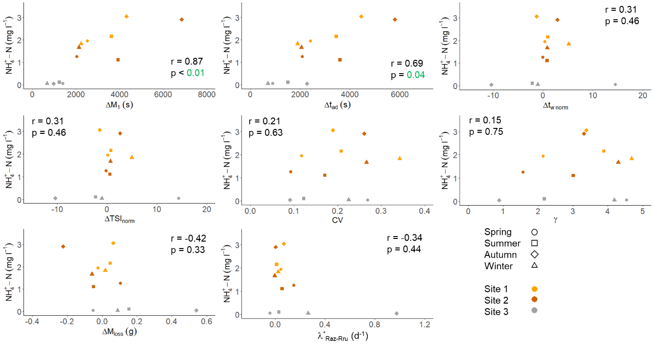

Figure S9. Bivariate plots of NH4+-N against the hydrological metrics and the turnover of resazurin to resorufin as a proxy for aerobic microbial metabolism. The Spearman rank correlation coefficient (r) and the adjusted p-values (FDR method) are also presented. Significant p-values are shown in green.

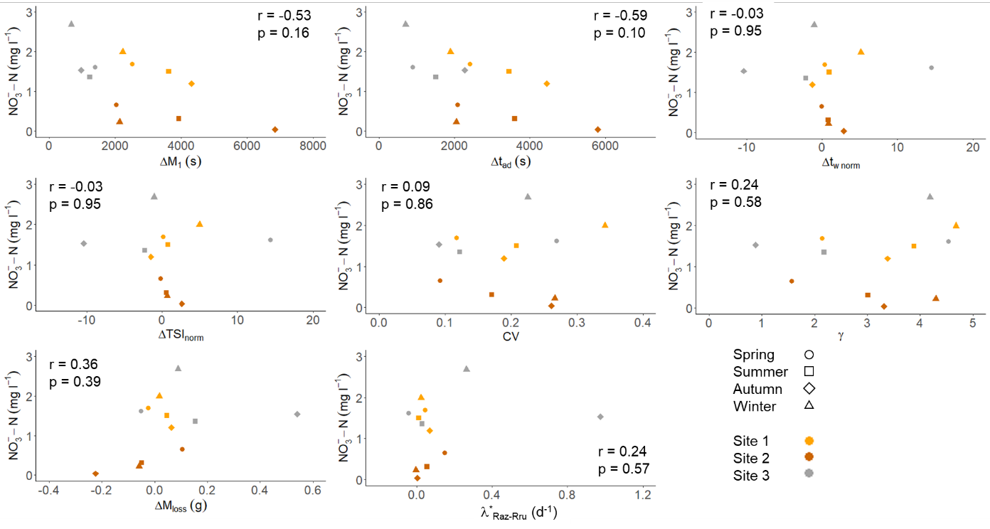

Figure S10. Bivariate plots of NO3--N against the hydrological metrics and the turnover of resazurin to resorufin as a proxy for aerobic microbial metabolism. The Spearman rank correlation coefficient (r) and the adjusted p-values (FDR method) are also presented. Significant p-values are shown in green.

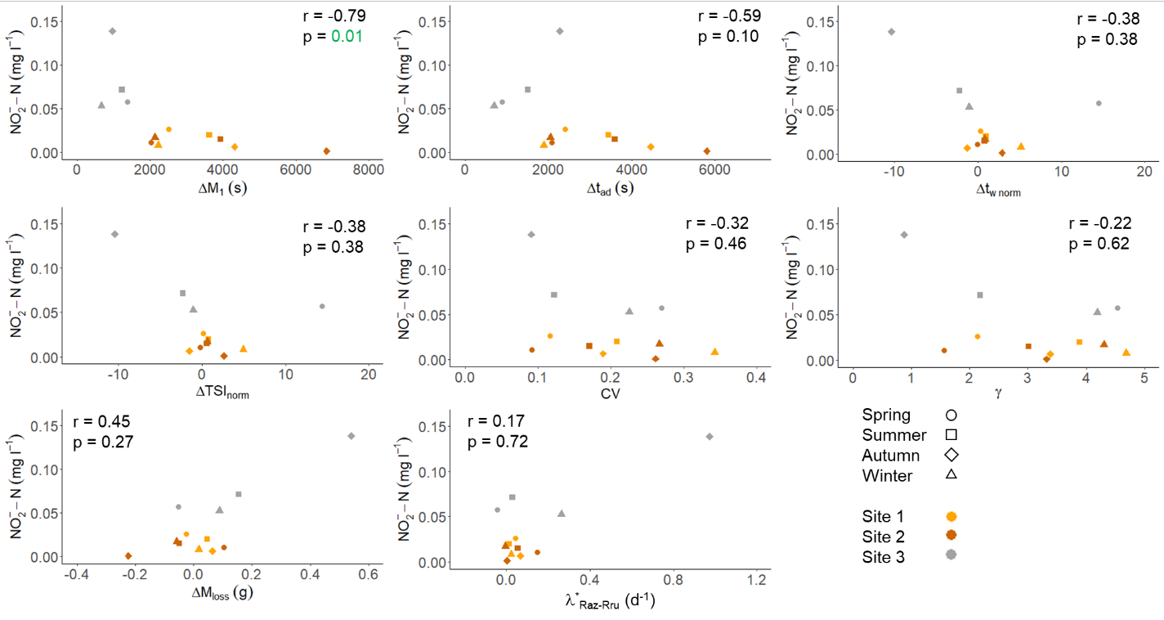

Figure S11. Bivariate plots of NO2--N against the hydrological metrics and the turnover of resazurin to resorufin as a proxy for aerobic microbial metabolism. The Spearman rank correlation coefficient (r) and the adjusted p-values (FDR method) are also presented. Significant p-values are shown in green.

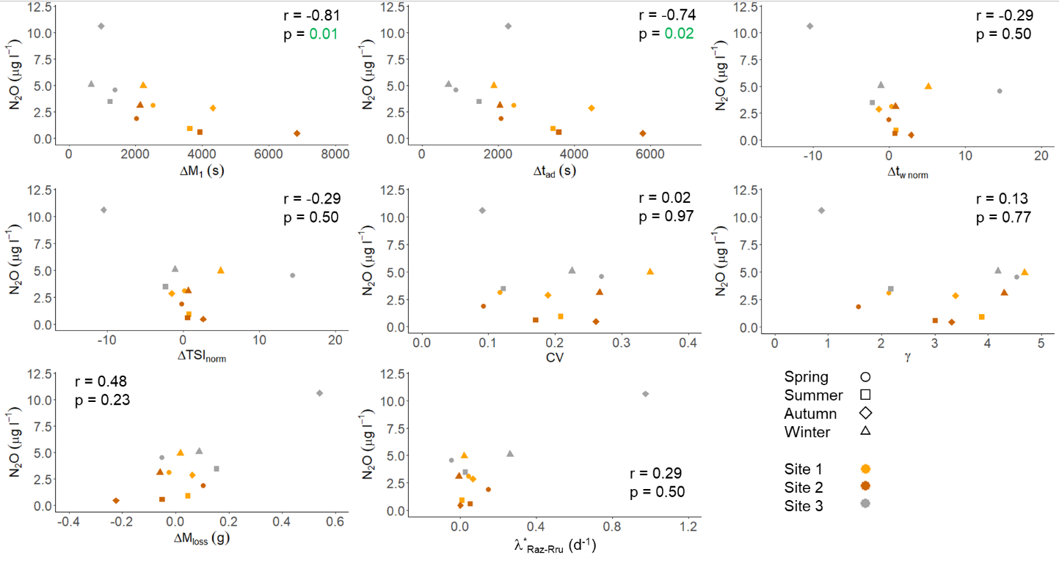

Figure S12. Bivariate plots of N2O against the hydrological metrics and the turnover of resazurin to resorufin as a proxy for aerobic microbial metabolism. The Spearman rank correlation coefficient (r) and the adjusted p-values (FDR method) are also presented. Significant p-values are shown in green.

**References**

Blaen, P. J., Khamis, K., Lloyd, C., Comer-Warner, S., Ciocca, F., Thomas, R. M., et al. (2017). High-frequency monitoring of catchment nutrient exports reveals highly variable storm event responses and dynamic source zone activation. *Journal of Geophysical Research: Biogeosciences*, *122*, 1–17. https://doi.org/10.1002/2017JG003904