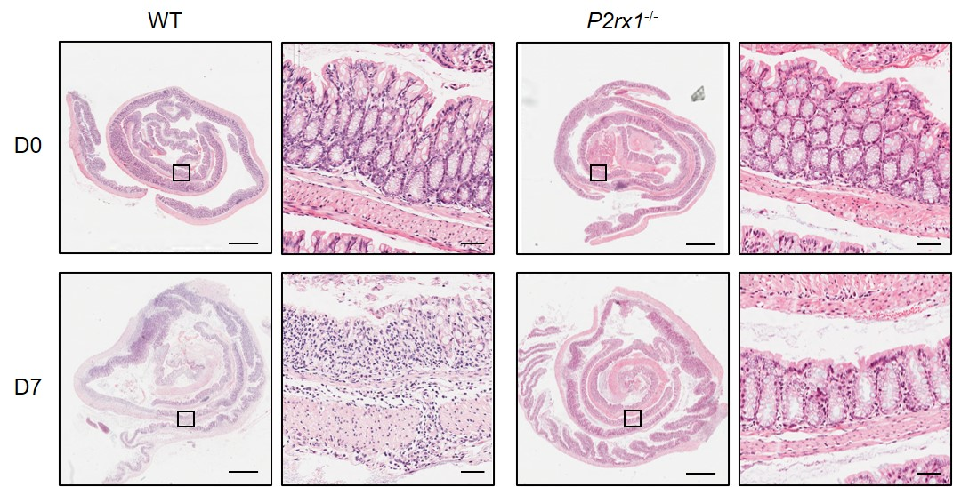
Figure S1. Pathological examinations of DSS-exposed WT and P2rx1-/- mice. WT and P2rx1^{-/-} mice were treated with 2% DSS for 7 days. Intestinal tissues from D0 and D7 mice were harvested and H&E staining was performed (Scale bar 1mm for high power fields, 50μm for low power fields).
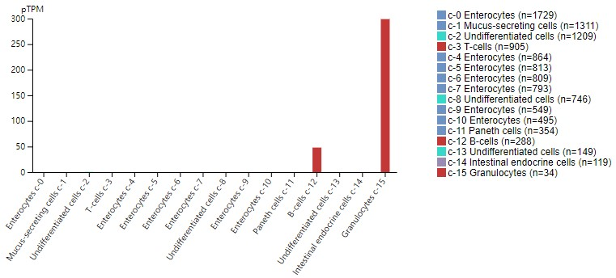
Figure S2. Expression pattern of P2RX1 in inessential tissue. Expression pattern of P2RX1 in inessential tissue was scanned in public HPA single cell sequencing database (https://www.proteinatlas.org/).

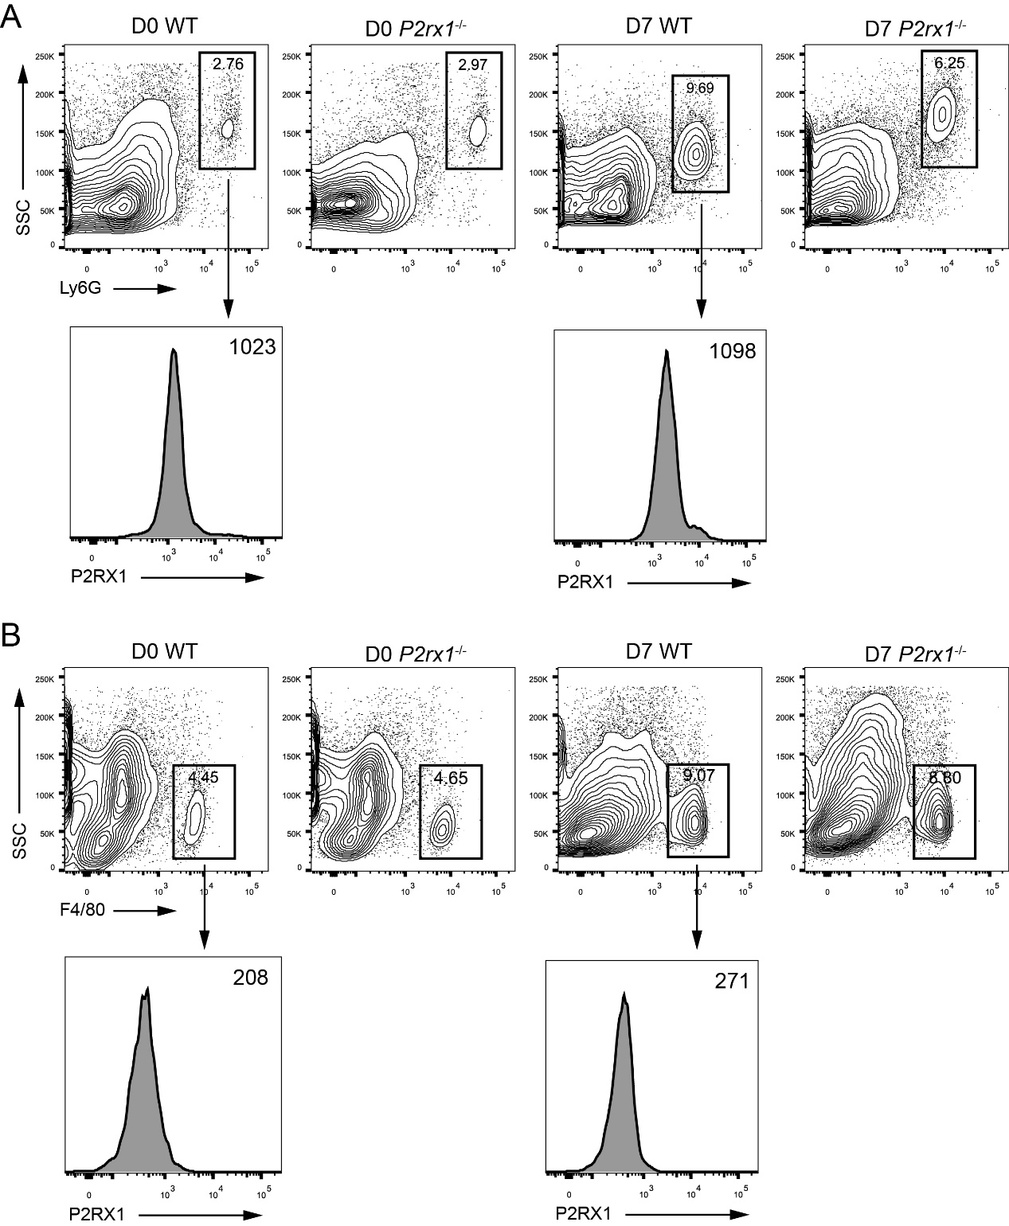
Figure S3. Flow cytometry analyses of neutrophils and macrophages infiltration in DSS-exposed WT and P2rx1-/- mice. WT and P2rx1^{-/-} mice were treated with 2% DSS for 7 days. Ly6G was used to label neutrophils, and F4/80 was used to label macrophages. Infiltrated neutrophils and macrophages, and P2RX1 expression in each cell type were determined at D0 and D7.
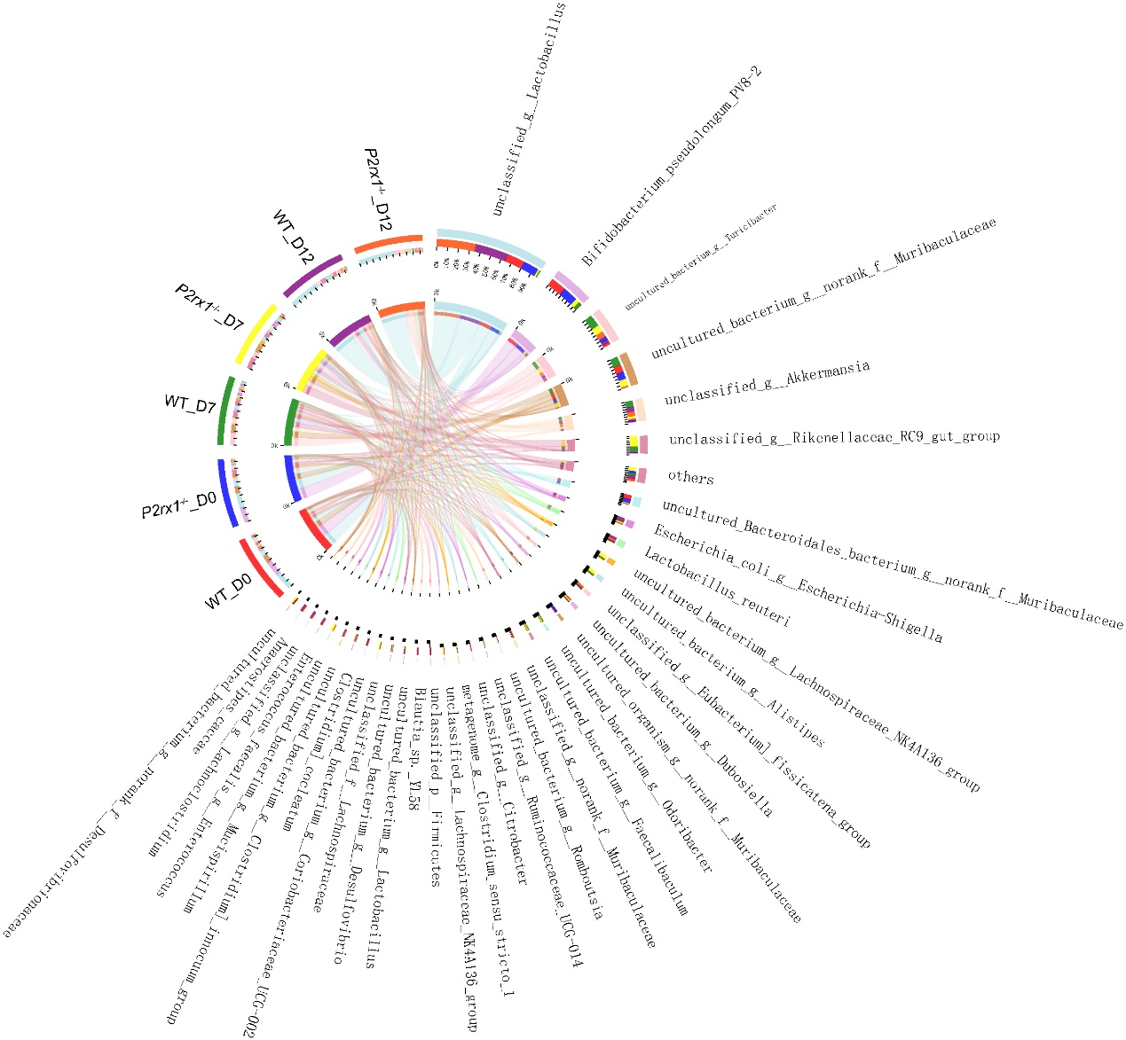
Figure S4. Composition of intestinal microbiota species in DSS-exposed WT and P2rx1^{-/-} mice. WT and P2rx1^{-/-} mice were treated with 2% DSS for 7 days. At day 0, 7 and 12, fecal microbiota was quantified using 16S rDNA sequencing. Detailed composition of intestinal microbiota species in each group was shown (n=6 for D0 WT and P2rx1^{-/-} groups, n=3 for the rest groups).

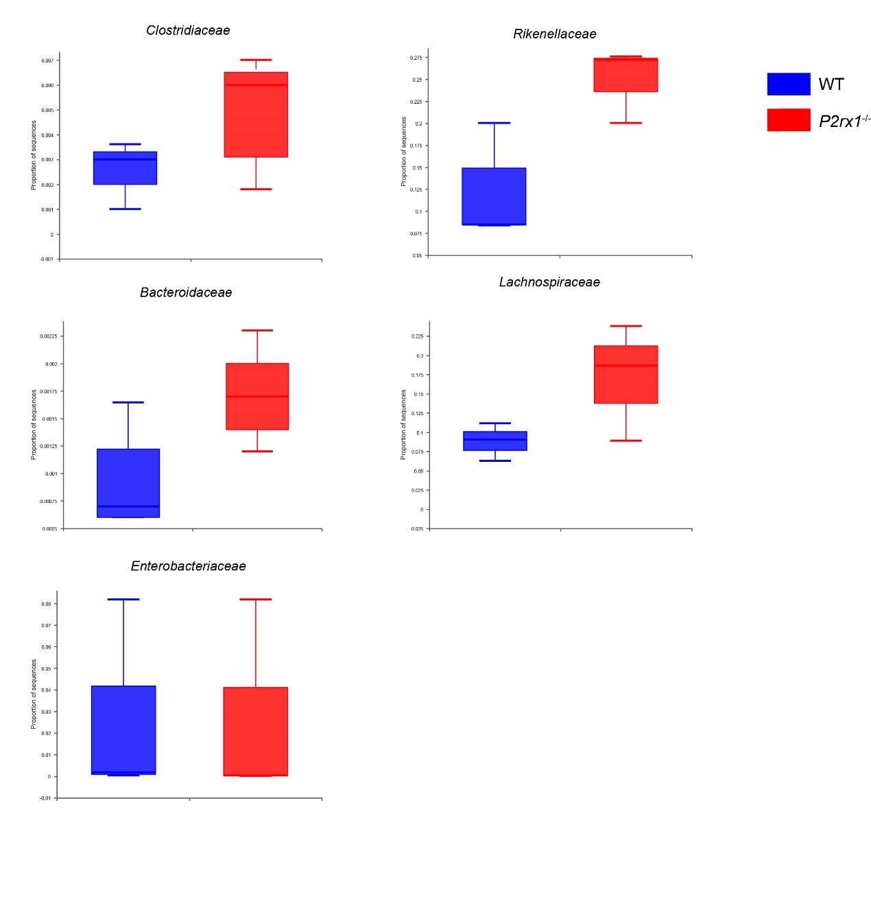
Figure S5. Composition of intestinal microbiota species in DSS-exposed WT and P2rx1^{-/-} mice. WT and P2rx1^{-/-} mice were treated with 2% DSS for 7 days. At day 7, fecal microbiota was quantified using 16S rDNA sequencing. Detailed composition of intestinal microbiota species in each group was shown (n=3 for each group).

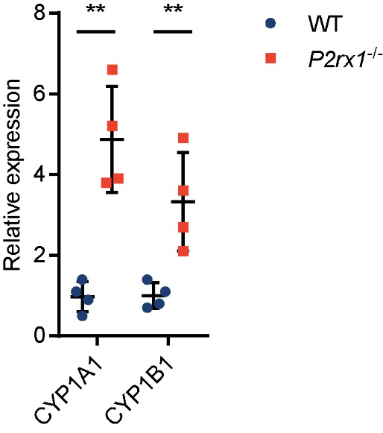
Figure S6. Expression of AhR target genes in DSS-exposed WT and P2rx1^{-/-} mice. WT and P2rx1^{-/-} mice were treated with 2% DSS for 7 days. At day 7, colon tissues were harvested and two AhR target genes, CYP1A1 and CYP1B1, were detected by RT-qPCR (n=4 per group).

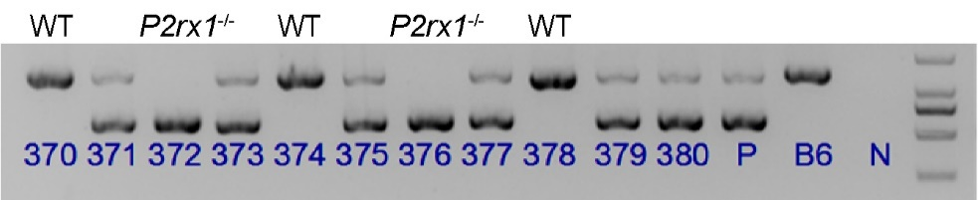
Figure S7. Genotyping results of WT and P2rx1^{-/-} mice. PCR was performed for genotyping gene-edited mice. As shown in the representative image, No. 370, 374 and 378 were WT mice, whereas No. 372 and 376 were P2rx1^{-/-} mice. Heterozygous parent (P), C57BL/6 (B6) and null (N) were set as controls. The rest are heterozygous mice.

