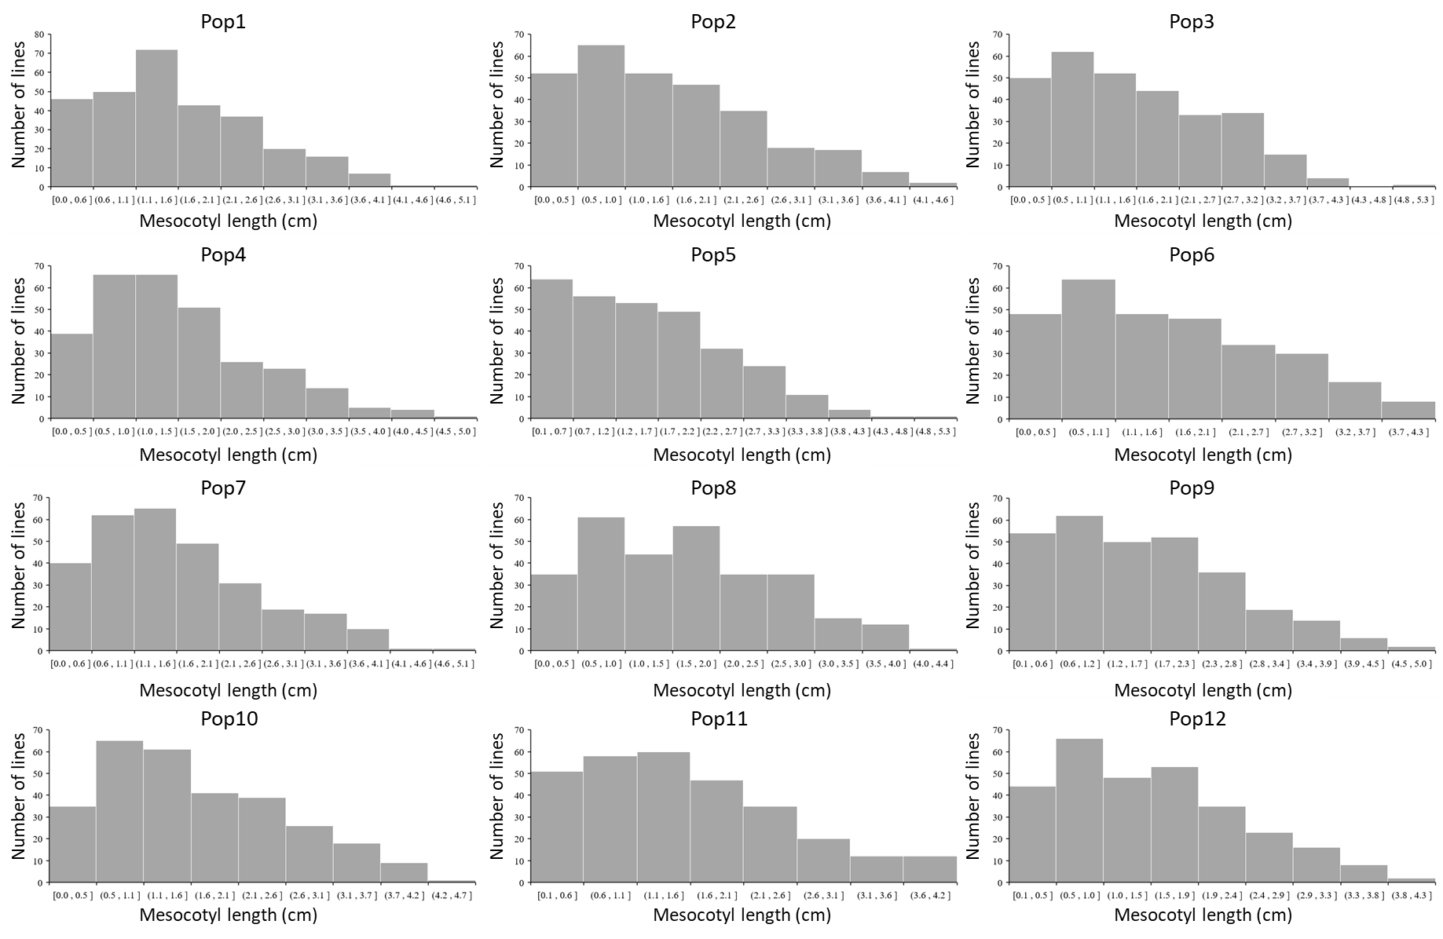
Figure S1 Distribution of mesocotyl length in 12 F₂ populations
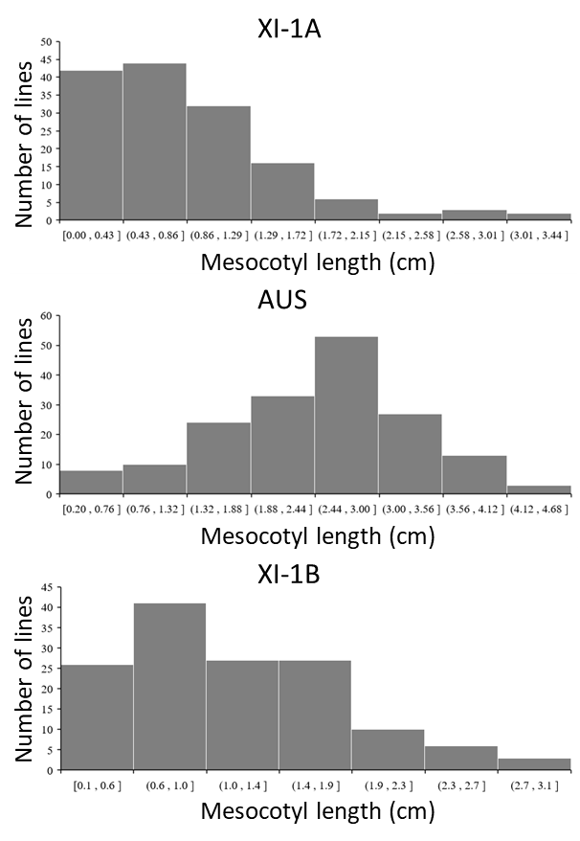
Figure S2 Distribution of mesocotyl length in XI-1A, AUS and XI-1B panel
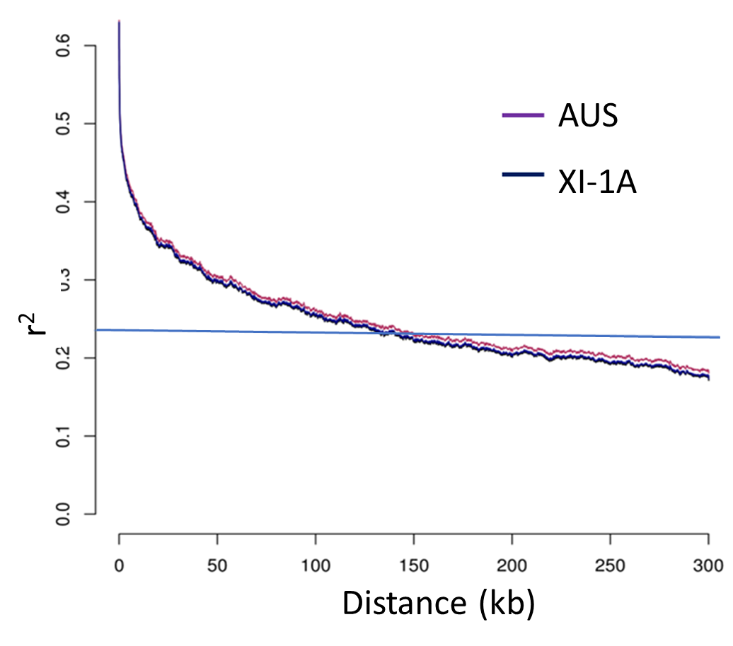
Figure S3 LD decay along the whole genome of the AUS and XI-1A panel
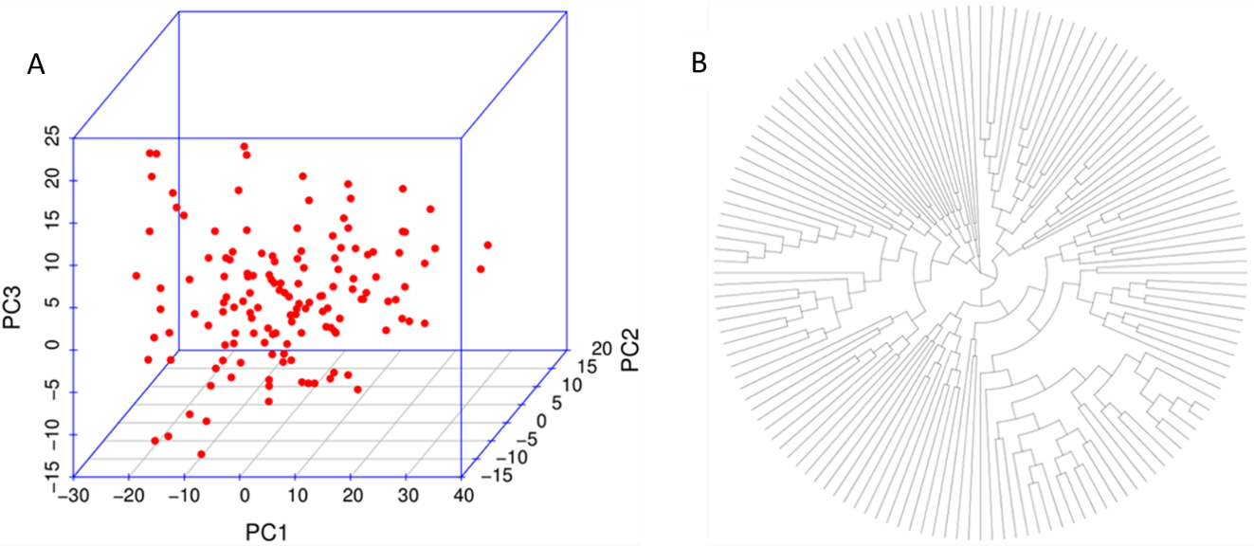Figure S4 Population and kinship analysis for the XI-1B panel
A, PCA analysis; B, Kinship analysis

