Supplementary Material

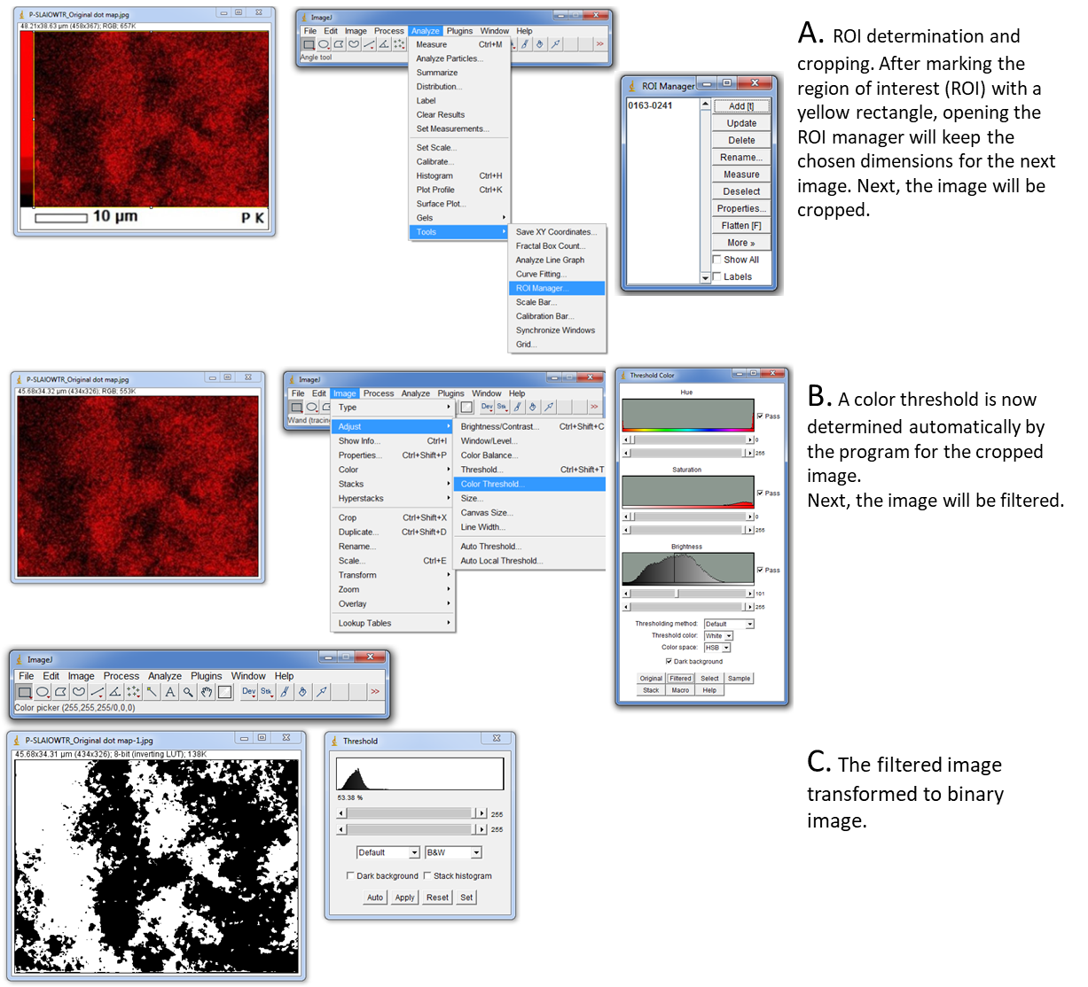

Supplementary Figure 1. Image processing and menus in use for (A) ROI (region of interest) determination, (B) Filtration and (C) Binary transformation.

