Supplementary Material
Supplementary Tables
Table S1 Clinical characteristics and biochemical results of healthy control and patients with hepatic fibrosis
 | Control(n=10) | HBV(n=30) | HCV(n=2) | AIH(n=6) | NASH  (n=1) | Overlap syndromen  (n=4) | Cholelithiasis  (n=6)
Gender
Male | 5(50%) | 22(73%) | 1(50%) | 1(17%) | 1(100%) | 0(0%) | 1(17%)
Female | 5(50%) | 8(27%) | 1(50%) | 5(83%) | 0(0%) | 4(100%) | 5(83%)
Age(years) | 51.4±10.6 | 49.5(36.8,61.5) | 45.0 | 53.8±7.8 | 59.0 | 54.5±11.2 | 56.0±6.4
ALT(u/l) | 11.6(9.8,29.9) | 43.4(23.5,59.0) | 30.4 | 116.9(43.0,518.6) | 77.1 | 87.8±9.1 | 106.3(13.1,115.8)
AST(u/l) | 17.8(15.1,28.6) | 43.4(23.5,59.0) | 31.4 | 110.3(43.1,494.1) | 38.8 | 160.0±54.4 | 69.9±36.5
TBIL (umol/l) | 8.5±2.2 | 10.9(7.0,17.1) | 11.1 | 38.8±30.6 | 4.5 | 101.3±84.4 | 21.6(13.9,130.5)
PT(s) | 12.5(11.9,14.3) | 13.4(12.9,14.0) | 13.2 | 14.5±1.7 | 12.6 | 12.8±1.1 | 13.3±0.9
PTA (%) | 110.9(91.8,115.6) | 98.9(92.4,108.5) | 103.3 | 89.7±18.7 | 109.8 | 105.8±13.6 | 92.6±16.5
INR | 1.0(1.0,1.1) | 1.1(1.0,1.1) | 1.0 | 1.1±1.1 | 1.0 | 1.0±0.1 | 1.1±0.1
WBC(x10*9/l) | 5.3±1.1 | 5.5(4.7,7.5) | 6.0 | 4.4±1.3 | 6.3 | 5.9±2.1 | 7.5±2.8
PLT(x10*9/l) | 175.4±38.1 | 181.0(137.8,207.3) | 96.0 | 119.0(89.0,175.5) | 124.0 | 195.5(195.0,200.5) | 243.7±53.6
Note: Values were expressed as number (percentage) or median M (P25, P75) or mean ± standard deviation. HBV, hepatitis B virus; HCV, hepatitis C virus; AIH, autoimmune hepatitis; NASH, non-alcoholic steatohepatitis.

Table S2 Clinical characteristics and biochemical results of healthy control and patients with liver cirrhosis
 | Control(n=10) | HBV(n=10) | HCV(n=1) | AIH(n=6) | PBC(n=5) | Overlap syndrome  (n=8) | Cholelithiasis  (n=7)
Gender
Male | 5(5%) | 8(80%) | 1(100%) | 1(17%) | 2(40%) | 1(13%) | 1(14%)
Female | 5(50%) | 2(20%) | 0(0%) | 5(83%) | 3(60%) | 7(87%) | 6(86%)
Age (years) | 51.4±10.6 | 49.4±14.0 | 61.0 | 59.8±4.8 | 46.6±8.2 | 49.9±11.4 | 50.0(49.0,70.0)
ALT (u/l) | 11.6(9.8,29.9) | 33.5(24.6,49.3) | 18.1 | 89.3(67.5,152.4) | 113.2±99.1 | 88.5±48.5 | 62.5±42.5
AST (u/l) | 17.8(15.1,28.6) | 40.4(29.3,45.8) | 30.9 | 122.6(87.4,222.2) | 152.1±128.5 | 124.8±54.6 | 58.8(37.1,78.0)
TBIL (umol/l) | 8.5±2.2 | 14.3(12.1,17.8) | 38.1 | 22.0(21.6,54.0) | 58.0(31.2,419.5) | 63.4(34.6,141.4) | 20.6(13.4,130.9)
PT (s) | 12.5(11.9,14.3) | 14.1(13.4,14.9) | 15.5 | 15.3(14.5,21.6) | 13.5(13.0,19.4) | 15.0(13.5,22.3) | 13.4(13.0,14.2)
PTA (%) | 110.9(91.8,115.6) | 90.8(80.3,95.2) | 70.3 | 69.6±28.1 | 103.0(64.3,105.4) | 69.5±30.5 | 94.0(92.3,103.3)
INR | 1.0(1.0,1.1) | 1.1(1.0,1.2) | 1.2 | 1.2(1.1,1.7) | 1.0(1.0,1.5) | 1.2(1.1,1.8) | 1.0(1.0,1.1)
WBC (x10*9/l) | 5.3±1.1 | 4.7±2.2 | 5.1 | 4.1(2.8,5.8) | 4.2(4.0,7.4) | 6.8±2.5 | 3.4±1.1
PLT (x10*9/l) | 175.4±38.1 | 126.3±61.8 | 71.0 | 102.7±27.6 | 151.0±52.7 | 124.3±67.4 | 114.1±37.0
Note: Values were expressed as number (percentage) or median M (P25, P75) or mean ± standard deviation. HBV, hepatitis B virus; HCV, hepatitis C virus; AIH, autoimmune hepatitis; PBC, primary sclerosing cholangitis.

Table S3. Clinical characteristics and biochemical results of healthy control and patients with HBV hepatic fibrosis
 | Control（n=10） | F1 （n=10） | F2（n=10） | F3（n=10） | F4（n=10）
Clinical Features
Gender
Male | 5 (50%) | 5 (50%) | 8 (80%) | 9 (90%) | 8 (80%)
Female | 5 (50%) | 5 (50%) | 2 (20%) | 1 (10%) | 2 (20%)
Age(years) | 51.4±10.6 | 45.1±13.4 | 54.8±12.1 | 54.8±12.1 | 49.4±14.0
Biochemical results
ALT (u/l) | 11.6 (9.8,29.9) | 33.1±21.2 | 43.8 (27.0,58.6)† | 53.3 (23.5,76.9)† | 33.5 (24.6,49.3)†
AST (u/l) | 17.8 (15.1,28.6) | 32.2±15.9 | 40.4 (31.5,60.4)† | 52.7 (27.9,74.6)†‡ | 40.4 (29.3,45.8)†
TBIL (umol/l) | 8.5±2.2 | 7.0 (5.7,13.9) | 10.7±5.9 | 17.2±6.7†‡ | 14.3 (12.1,17.8)†‡§
PT (s) | 12.5 (11.9,14.3) | 13.4±0.7 | 13.3±0.6 | 13.7 (13.0,14.3) | 14.1 (13.4,14.9)†‡§
PTA (%) | 110.9 (91.8,115.6) | 100±7.8 | 99.8±6.8 | 92.9 (84.3,104.6) | 90.8 (80.3,95.2)†‡§
INR | 1.0 (1.0,1.1) | 1.1±0.1 | 1.0±0.1 | 1.1 (1.0,1.1) | 1.1 (1.0,1.2)†§
WBC (x10*9/l) | 5.3±1.1 | 5.8±1.4 | 4.9 (4.3,9.3) | 7.2±2.3† | 4.7±2.2#
PLT (x10*9/l) | 175.4±38.1 | 170.2±55.9 | 190.0 (175.3,203.8) | 169.5±66.7 | 126.3±61.8†§
Note: Values were expressed as number (percentage) or median M (P25, P75) or mean ± standard deviation. Measurement data were analyzed with the Shapiro-Wilk test for normality, and data with a normal distribution were expressed as mean± SEM. Differences between groups were evaluated using two independent samples t-test. Data with a non-normal distribution were presented as the median M (P25, P75) and differences between groups were assessed with the Mann-Whitney U rank-sum test. Count data were presented as the number of cases (percentage) and differences between groups were analyzed with the χ2 test. †. Compared with control group, P<0.05; ‡. Compared with F1 group, P<0.05; §. Compared with F2 group, P<0.05. #. Compared with F3 group, P<0.05. The severity of liver fibrosis was divided into F1-F4 four stages according to the Metavir score. HBV, hepatitis B virus.
Table S4. The sequences of primers used for RT-PCR
GAPDH | Forward: TGTTGCCATCAATGACCCCTT  Reverse: CTCCACGACGTACTCAGCG
BRD4 | Forward: CTCCCCGCTTATGATACATTCC  Reverse: GTTTCTTAGGCTGGACGTTTTG
CXLC6 | Forward: ACGCTGAGAGTAAACCCCAAAACG  Reverse: CGGGTCCAGACAAACTTGCTTCC
Note: BRD4, bromodomain-containing protein 4; CXCL6, C-X-C motif chemokine ligand 6.

Supplementary Figures
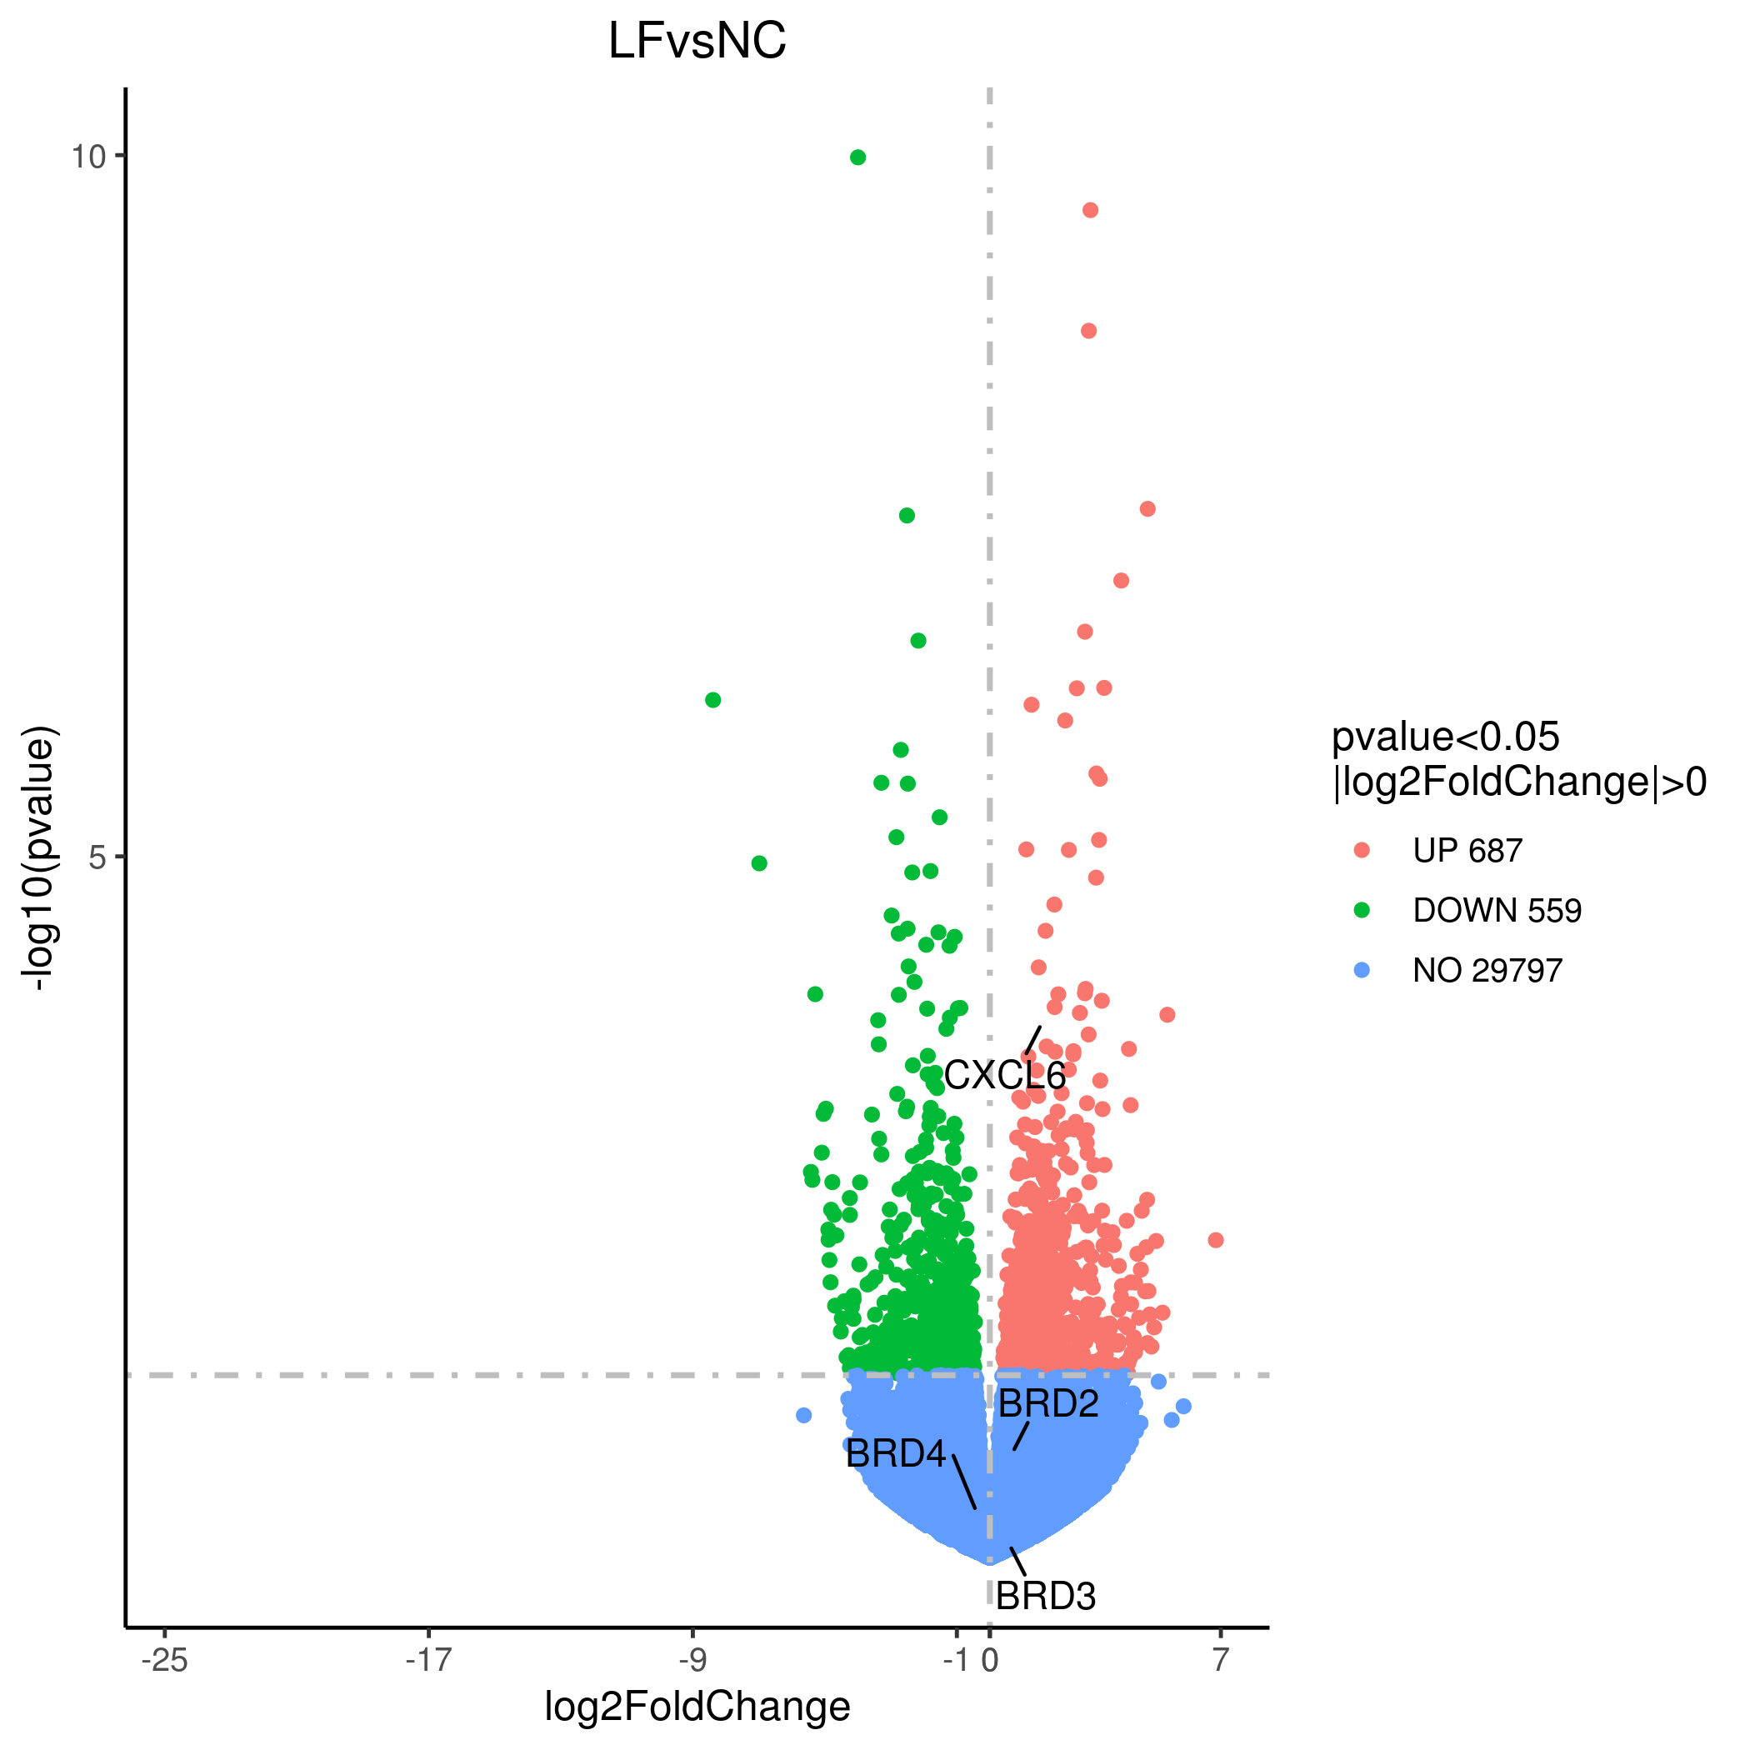
Figure S1 Volcano plot of RNA-sequencing data for analysis of differential expression of hepatic mRNAs in liver fibrosis. RNA-sequencing (RNA-seq) was conducted using the RNA samples extracted from patients with liver fibrosis and normal controls (n=4 in each group).1240 genes were changed with greater than log2-fold change in liver fibrosis versus normal control. Among them, 687 genes were up-regulated and 559 genes were down-regulated. NC, normal control; LF, liver fibrosis.

Figure S2. Clustered heat map of RNA-seq data for analysis of differential expression of hepatic mRNAs in liver fibrosis. A heat map was constructed using the RNA-seq data. NC, normal control; LF, liver fibrosis.

Figure S3. Western blotting images of BRD4 in human hepatic tissues. The hepatic tissues were obtained as described in Materials and Methods. Western Bolt was performed to examine BRD4 protein expression in patients with liver fibrosis（n=9） and normal controls（n=9）. BRD4, bromodomain-containing protein.
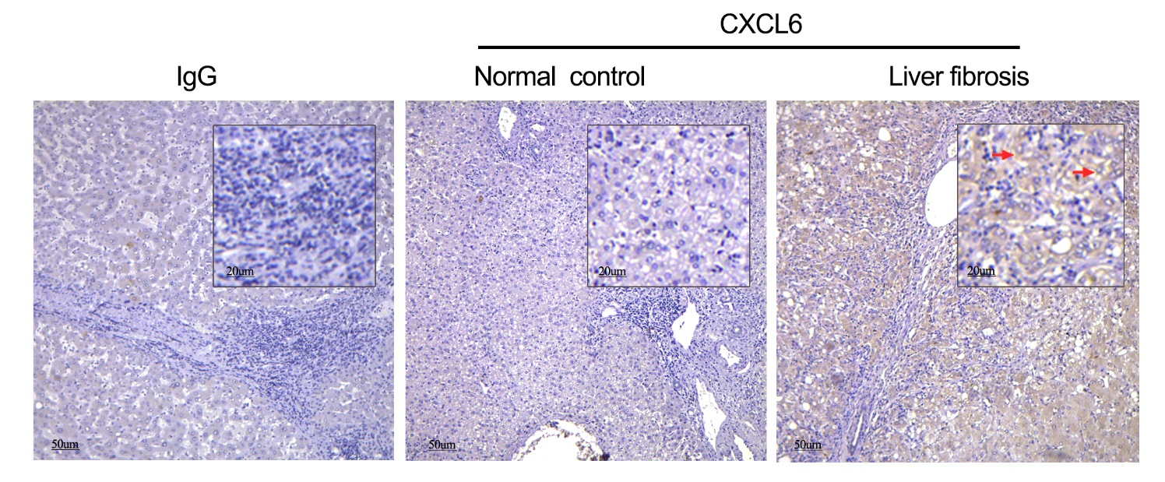
Figure S4. CXCL6 localization in human hepatic tissues. Immunohistochemistry analysis was performed to examine hepatic CXCL6 protein expression in liver fibrosis. Arrows indicate the positive staining of CXCL6. Scale bar:50μm. CXCL6, C-X-C motif chemokine ligand 6.

Figure S5. Spearman correlation analysis of the relationship between clinical characteristics and BRD4 expression in liver fibrosis. Spearman correlation analysis was conducted to assess the correlation between BRD4 expression and clinical characteristics of patients with liver fibrosis. BRD4, bromodomain-containing protein 4; IHC, immunohistochemistry; ALT: alanine aminotransferase;WBC, white blood cell; PLT, platelet count; PT: prothrombin time; PTA, plasma thromboplastin antecedent; INR, international normalized ratio.
.

