Table S1 Chemical composition of nutrient solution used in this study
Compounds | Unit | N₄S_{0.1} | N₄S_{2.4} | N₈S_{0.1} | N₈S_{2.4}
KH₂PO₄ | mmol·L⁻¹ | 0.4 | 0.4 | 0.4 | 0.4
KCl | mmol·L⁻¹ | 1.8 | -- | 1.8 | --
K₂SO₄ | mmol·L⁻¹ | -- | 0.9 | -- | 0.9
MgSO₄ | mmol·L⁻¹ | 0.1 | 0.5 | 0.1 | 0.5
MgCl₂ | mmol·L⁻¹ | 0.4 | -- | 0.4 | --
CaCl₂ | mmol·L⁻¹ | 2.5 | 1.5 | 2.5 | 1.5
Ca(NO₃)₂ | mmol·L⁻¹ | -- | 1.0 | -- | 1.0
(NH₄)₂SO₄ | mmol·L⁻¹ | -- | 1.0 | -- | 1.0
NH₄NO₃ | mmol·L⁻¹ | 2.0 | -- | 4.0 | 2.0
H₃BO₃ | μmol·L⁻¹ | 18.0 | 18.0 | 18.0 | 18.0
(NH₄)₆Mo₇O₂₄ | μmol·L⁻¹ | 0.1 | 0.1 | 0.1 | 0.1
CuSO₄ | μmol·L⁻¹ | 0.15 | 0.15 | 0.15 | 0.15
ZnCl₂ | μmol·L⁻¹ | 0.15 | 0.15 | 0.15 | 0.15
MnCl₂ | μmol·L⁻¹ | 3.5 | 3.5 | 3.5 | 3.5
Fe-EDTA | μmol·L⁻¹ | 36.0 | 36.0 | 36.0 | 36.0

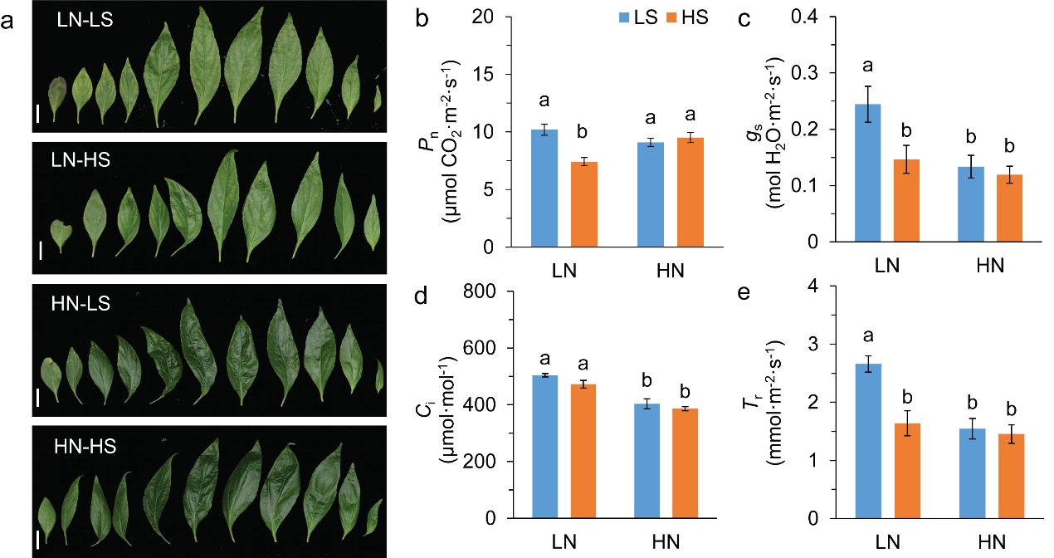
Fig.S1 Phenotype of leaf position and leaf gas exchange parameters. a, leaf position in main stem; b, net photosynthetic rate; c, stomatal conductance; d, intercellular CO₂ concentration; e, transpiration rate. Data were presented as mean ± SE (n = 4). Different letters on the bars indicates significant difference among treatments at P < 0.05 using the method of LSD. Scar bar=1 cm in a. LN, low nitrogen; HN, high N; LS, low sulfur; HS, high sulfur.

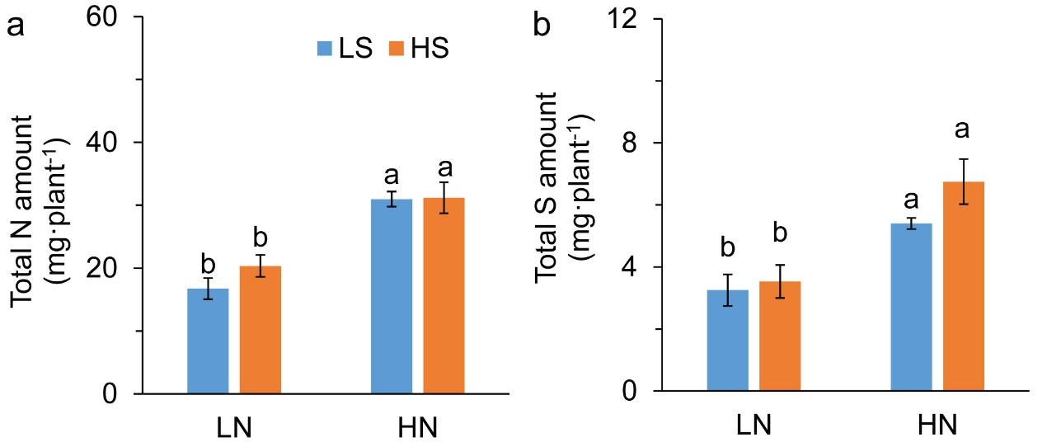
Fig.S2 Total amounts of leaf nitrogen (a) and sulfur (b) based on per plant. Data were presented as mean ± SE (n = 4). Different letters on the bars indicates significant difference among treatments at P < 0.05 using the method of LSD. LN, low nitrogen; HN, high N; LS, low sulfur; HS, high sulfur.

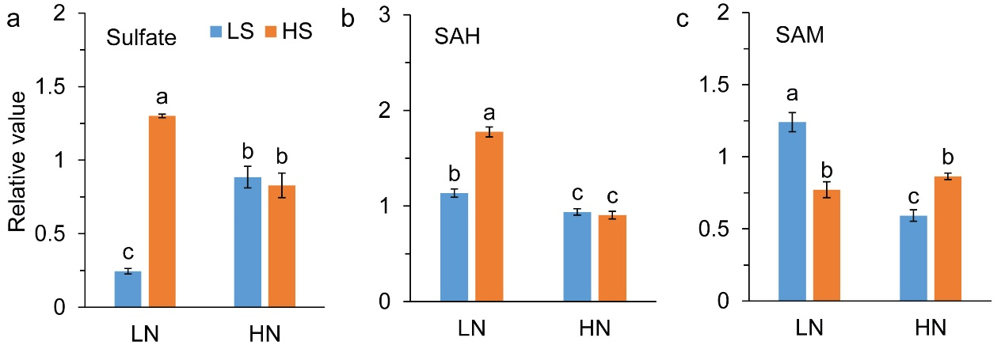
Fig.S3 Contents of sulfate (a), S-adenosyl-L-homocysteine (b), and S-adenosyl-methionine (c). Data were presented as mean ± SE (n = 4). Different letters on the bars indicates significant difference among treatments at P < 0.05 using the method of LSD. LN, low nitrogen; HN, high N; LS, low sulfur; HS, high sulfur.

