Supplementary Material

Supplementary Figures
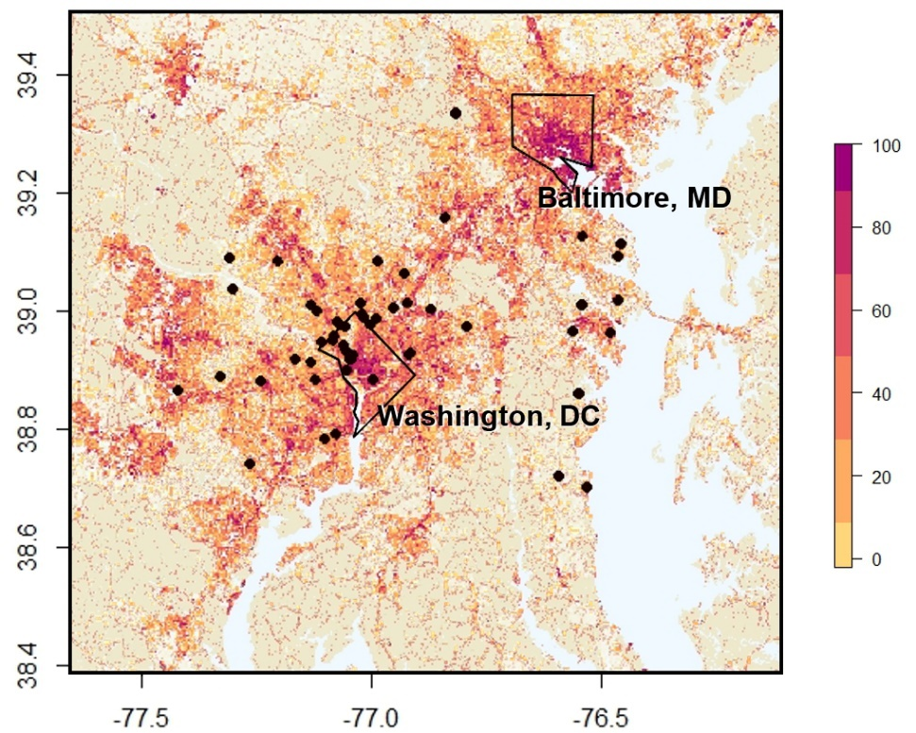
Supplementary Figure 1. Mean percent impervious surface cover within 100 m of 53 Neighborhood Nestwatch sites in the Washington, DC region.

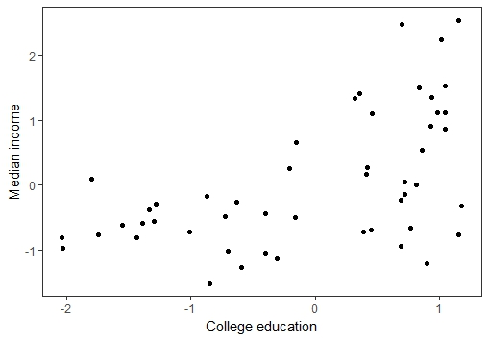

Supplementary Figure 2. Association of median household income and percent attainment of a bachelor’s or associate degree among census tracts encompassing 53 sites in the Washington, DC region. Values are scaled.

Supplementary Tables
Table S1. Variables examined for relationships with cat abundance (λ), detection (p), and availability for detection (ϕ) in the Washington, DC region, 2016.
Variable | Description | Parameter | Method
imp | Percent impervious surface cover in 100 m radius of site | λ | Both
imp² | Impervious surface cover, squared | λ | Both
density | Human population density within site’s census tract | λ | Both
density² | Human population density, squared | λ | Both
income | Median income in census tract | λ | Both
edu | Percent individuals in census tract with college degree | λ | Both
time | Time of day transect survey, in minutes after midnight | ϕ, p | Transect
time² | Time of day, squared | ϕ, p | Transect
temp | Temperature at the time of the transect | p | Transect
dew | Dew point at the time of the transect | p | Transect
doy | Day of the year | p | Both
tempHigh | Daily high temperature | p | Camera
tempLow | Daily low temperature | p | Camera
dewHigh | Daily low dew point | p | Camera

.
Table S2. Summary statistics of the candidate models examining cat detection and availability for detection in the Washington, DC region, 2016. Models are ranked by Akaike Information Criterion, AIC_{c}. ϕ represents availability for detection, p represents detection, and λ represents abundance. Models up to a cumulative weight of 0.75 are shown.

Model set | Formula | Kª | AIC_{c} | ΔAIC_{c} | w^{b} | LL^{c}
Transect
 | $ϕ^{time}+p^{1}+λ^{1}$ | 6 | 459.95 | 0 | 0.23 | -223.06
 | $ϕ^{time}+p^{dew}+λ^{1}$ | 7 | 460.15 | 0.20 | 0.21 | -221.83
 | $ϕ^{time}+p^{temp + dew}+λ^{1}$ | 8 | 462.10 | 2.16 | 0.08 | -221.41
 | $ϕ^{time}+p^{temp}+λ^{1}$ | 7 | 462.28 | 2.33 | 0.07 | -222.90
 | $ϕ^{time}+p^{time}+λ^{1}$ | 7 | 462.38 | 2.44 | 0.07 | -222.95
 | $ϕ^{time + {time}^{2}}+p^{1}+λ^{1}$ | 7 | 462.58 | 2.63 | 0.06 | -223.05
Camera
 | $p^{dewHigh}+λ^{1}$ | 4 | 673.78 | 0 | 0.41 | -332.43
 | $p^{tempLow + dewHigh}+λ^{1}$ | 5 | 675.34 | 1.56 | 0.19 | -331.96
 | $p^{doy+ dewHigh}+λ^{1}$ | 5 | 676.19 | 2.41 | 0.12 | -332.38
ª Number of parameters estimated
^{b} AIC_{c} weight
^{c} Log-likelihood

