Supplementary Material

Supplementary Figures and Tables
Supplementary tables can found as Word files under the following names:
Supplementary Table 1: Detailed serological data of all convalescent individuals seronegative for spike-IgG by EUROIMMUN screening.
Supplementary Table 2: Detailed serological data of all seropositive convalescent individuals and healthy controls.

Supplementary Figures
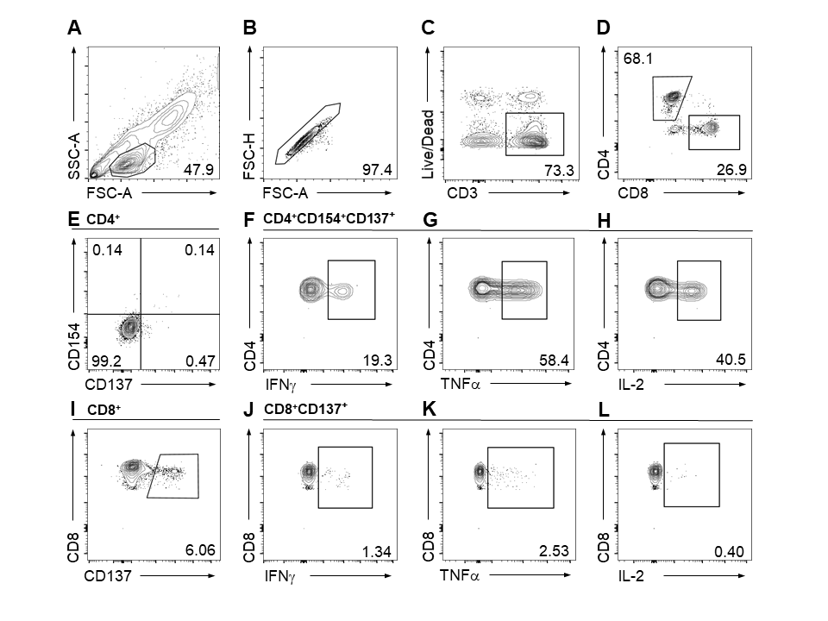
Supplementary Figure 1: Gating Strategy for flow cytometry analysis of peptide reactive CD4+ and CD8+ T Cells and expression of cytokines in response to stimulation with SARS-CoV-2 S C-terminal peptide pool exemplarily shown in a seropositive convalescent COVID-19 patient. Depicted are lymphocytes (A), single lymphocytes (B), living CD3+ T cells (C), CD4+ and CD8+ T cells (D), activated CD4+CD154+CD137+ T cells (E) and the corresponding expression of the cytokines IFNγ, TNFα and IL-2 (F-H), as well as activated CD8+CD137+ T cells (I) and the corresponding expression of the cytokines IFNγ, TNFα and IL-2 (J-K). Single, double or triple cytokine producing activated T cell subsets were analyzed by Boolean combination gating using FlowJo software.

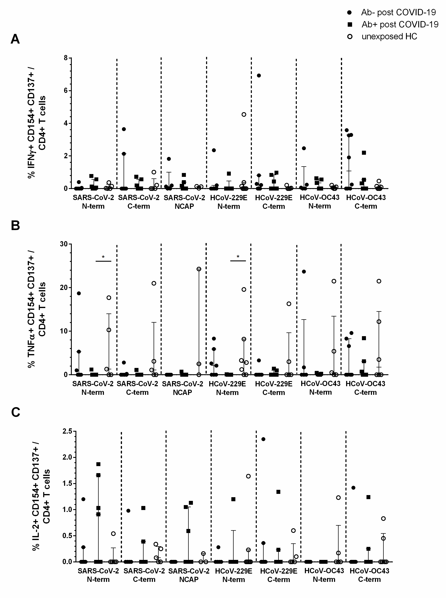
Supplementary Figure 2a: Single cytokine producing activated CD4+ T cells in seropositive and -negative post COVID-19 in response to SARS-CoV-2 and HCoV peptide pools compared to HCs. IFNγ, TNFα, or IL2 single producing (sp) activated CD4+ T cells were analyzed by Boolean combination gating strategy. IFNγ (A), TNFα (B) and IL2 (C) sp activated CD4+ T cells in response to peptide pools (1µg/ml) are shown. Median and interquartile range (IQR) are indicated. Statistical analysis was performed by non-parametric two-tailed Mann–Whitney-U test for comparison of control and patient groups. A p-value ≤ 0.05 was considered as statistically significant. p ≤ 0.05 = *; p ≤ 0.001 = **
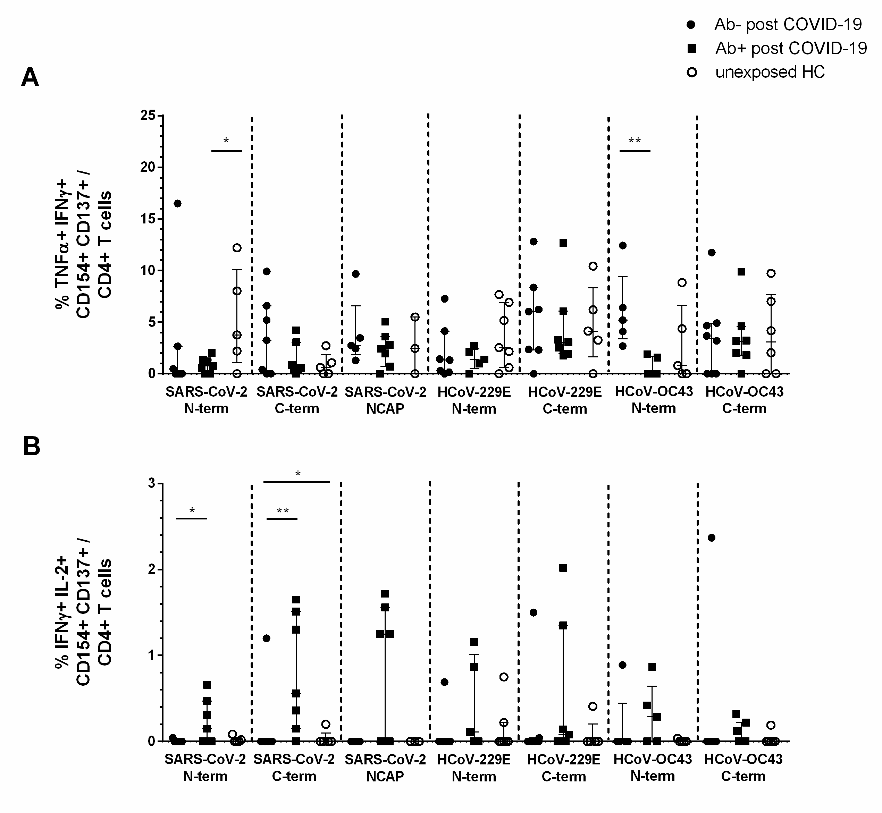
Supplementary Figure 2b: Double cytokine producing activated CD4+ T cells in seropositive and -negative post COVID-19 in response to SARS-CoV-2 and HCoV peptide pools compared to HCs. IFNγ, TNFα, or IL2 double producing (dp) activated CD4+ T cells were analyzed by Boolean combination gating strategy. TNFα/IFNγ (A) and IFNγ/IL2 (B) dp activated CD4+ T cells in response to peptide pools (1 µg/ml) are shown. Median and interquartile range (IQR) are indicated. Statistical analysis was performed by non-parametric two-tailed Mann–Whitney-U test for comparison of control and patient groups. A p-value ≤ 0.05 was considered as statistically significant. p ≤ 0.05 = *; p ≤ 0.001 = **

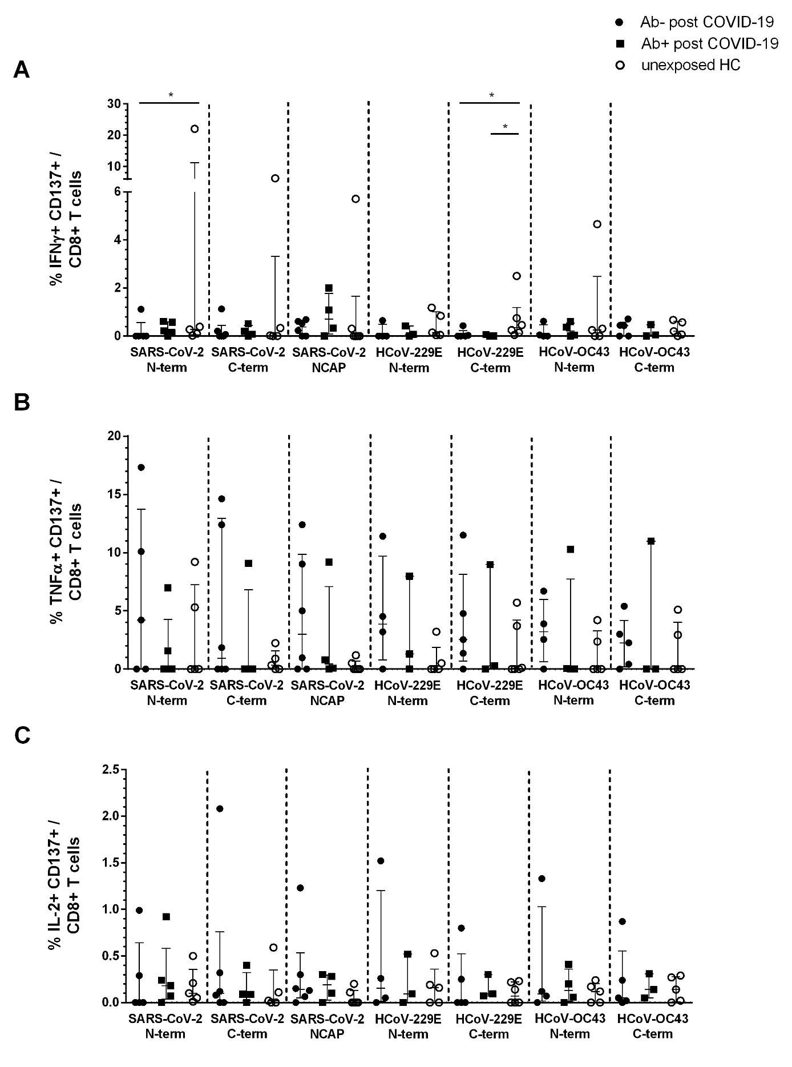
Supplementary Figure 3a: Single cytokine producing activated CD8+ T cells in seropositive and -negative post COVID-19 in response to SARS-CoV-2 and HCoV peptide pools compared to HCs. IFNγ, TNFα, or IL2 single producing (sp) activated CD8+ T cells were analyzed by Boolean combination gating strategy. IFNγ (A), TNFα (B) and IL2 (C) sp activated CD8+ T cells in response to peptide pools (1 µg/ml) are shown. Median and interquartile range (IQR) are indicated. Statistical analysis was performed by non-parametric one-tailed Mann–Whitney-U test for comparison of control and patient groups. A p-value ≤ 0.05 was considered as statistically significant. p ≤ 0.05 = *; p ≤ 0.001 = **
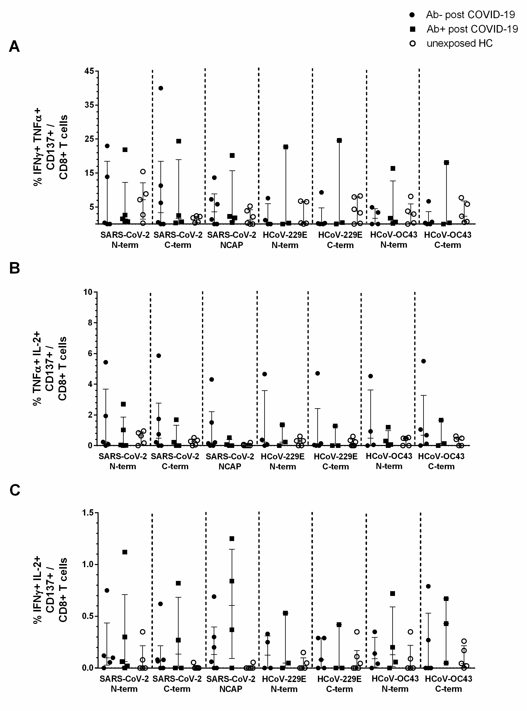
Supplementary Figure 3b: Single cytokine producing activated CD8+ T cells in seropositive and -negative post COVID-19 in response to SARS-CoV-2 and HCoV peptide pools compared to HCs. IFNγ, TNFα, or IL2 double producing (dp) activated CD8+ T cells were analyzed by Boolean combination gating strategy. IFNγ/TNFα (A), TNFα/IL-2 (B) and IFNγ/IL2 (C) dp activated CD8+ T cells in response to peptide pools (1 µg/ml) are shown. Median and interquartile range (IQR) are indicated. Statistical analysis was performed by non-parametric one-tailed Mann–Whitney-U test for comparison of control and patient groups. A p-value ≤ 0.05 was considered as statistically significant. p ≤ 0.05 = *; p ≤ 0.001 = **

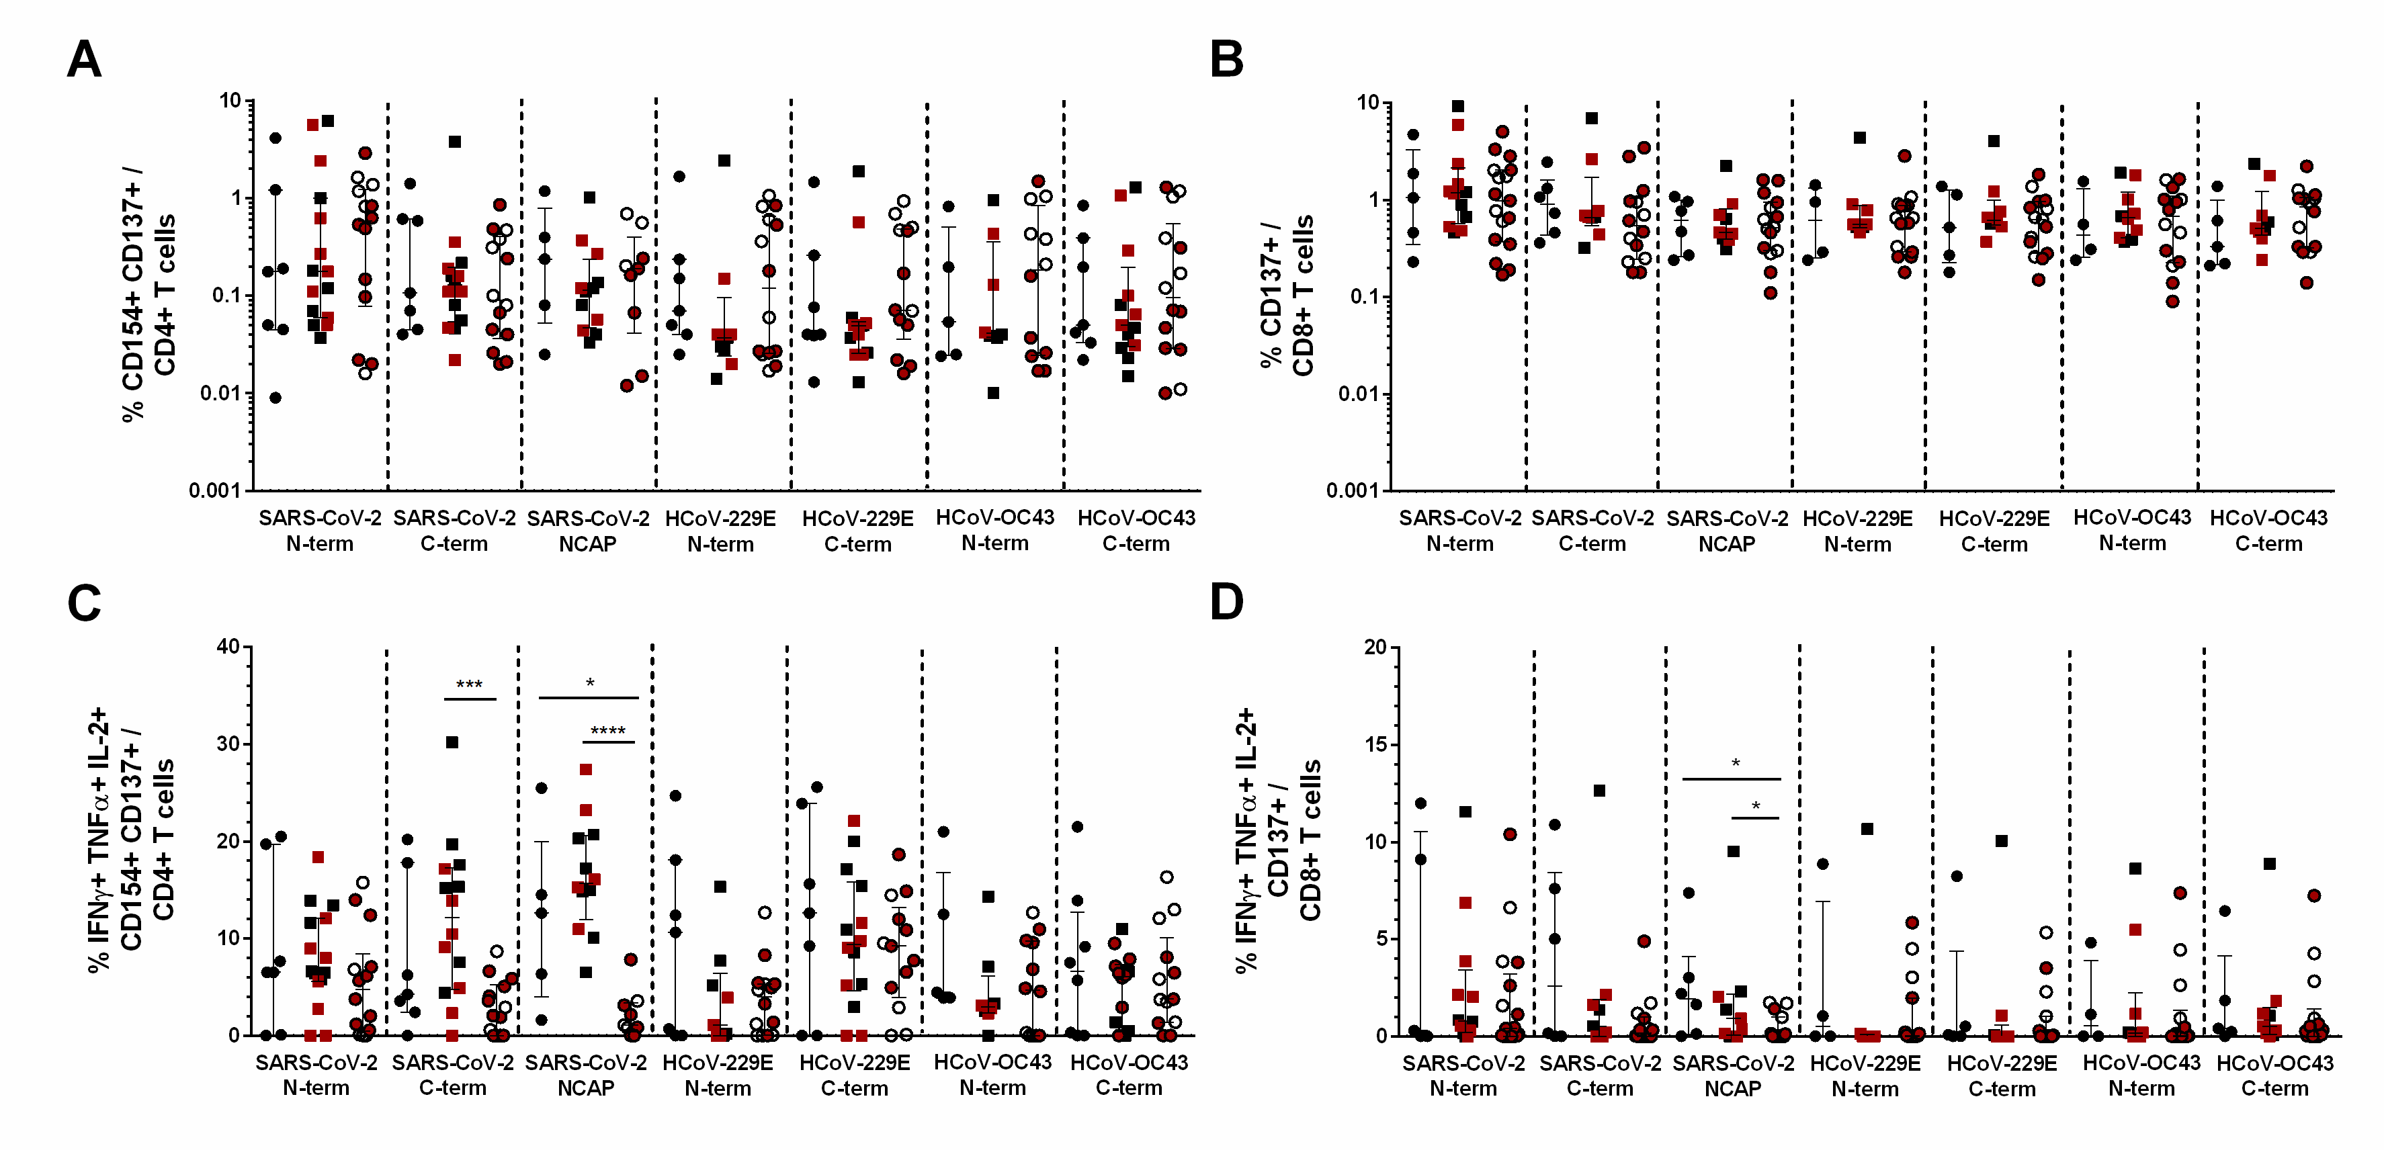
Supplementary Figure 4: Pooled data analysis of activated CD4+ and CD8+ T cell frequencies and triple cytokine producing activated T cells in seropositive and –negative post COVID-19 in response to the peptide pools compared to HCs. PBMCs of post COVID-19 Ab- (n=8; filled black dot), post COVID-19 Ab+ (n=7; filled black squares), HC (n=8; empty black dots) of this study and PBMCs of post COVID-19 Ab+ (n=12; filled red squares) and HC (n=12; filled red dots) of the former study (14) were pooled for analysis. Frequencies of activated CD4+ (A) and CD8+ (B) T cells after peptide stimulation. Frequencies of activated IFNγ, TNFα and IL-2 triple cytokine producing CD4+ (C) and CD8+ (D) T cells. Triple producing activated CD4+ and CD8+ T cells were analyzed by Boolean combination gating strategy. Median and interquartile range (IQR) are indicated. Statistical analysis was performed by non-parametric two-tailed Mann–Whitney-U test for comparison of control and patient groups. A p-value ≤ 0.05 was considered as statistically significant. p ≤ 0.05 = *; p ≤ 0.001 = **; p ≤ 0.0001 = ***, p ≤ 0.00001 = ****

