Supplementary Material
Contents
1. Experimental data 2
1.1. General consideration 2
1.2. Synthesis process 2
1.3. Fluorescence quantum yield measurements 6
1.4. Generation of ROS/RNS 6
1.5. LOD calculation 6
1.6. Reaction of DSM with ClO⁻: 6
1.7. Computational details 7
1.8. Bacterial experiments 7
2. Results 8
2.1. NMR and Mass spectra 8
2.2. Photophysical results 17
2.3. Computational calculation results 22
2.4. Bacterial experiments results 28
3. Reference 31

- Experimental data
  - General consideration
All reagents and organic solvents used in the synthesis were obtained from Aldrich, TCI (South Korea) and used without further purification. Flash chromatography was carried out on silica gel (230-400 mesh) followed by determination of ¹H and ¹³C NMR spectra using a Bruker Avance 400 MHz spectrometer. Mass spectra were obtained using a maXis-HD (Bruker). UV absorption spectroscopy measurements were carried out on V-730 UV-Visible Spectrophotometer (Jasco) at room temperature. Fluorescence emission spectra were obtained using an F-7000 Fluorescence Spectrophotometer (Hitachi High-Tech).
  - Synthesis process
Scheme S1. Synthesis process of R₁IR₂.
    - Synthesis DBr: 2,4-Dibromotoluene (3.0 g, 2 mmol) was added in 50 mL CH₃CN including NBS (2.3 g – 12.9 mmol). The mixture was stirred and irradiated under white lamp 25W during 30 min. The reaction solution was evaporated and purified by column chromatography on silica gel using n-hexane as eluent to obtain yellow oil as pure product (yield ~ 95 %). ¹H NMR (400 MHz, Chloroform-d) δ 7.72 (d, J = 2.0 Hz, 1H), 7.41 (dd, J = 8.2, 2.0 Hz, 1H), 7.30 (d, J = 8.2 Hz, 1H), 4.52 (s, 2H). ¹³C NMR (101 MHz, CHLOROFORM-D) δ 136.61, 136.16, 132.67, 131.65, 125.52, 123.46, 32.82.
Scheme S2. Synthesis of DBr and CBr.
    - Synthesis CBr: A mixture of carbazole (5.0 g), benzene (15 mL), 1,4 dichlorobutane (10 eq.), benzyltriethylammonium chloride (phase transfer catalyst) and aqueous sodium hydroxide (15 mL, 50%) was stirred overnight. The obtained solution was acidified with HCl to pH around 3, extracted with chloroform, and then dried over anhydrous Na₂SO₄. After evaporation, the viscous liquid was purified by column chromatography on silica gel using n-hexane-DCM (9/1) as eluent to obtain brown powder as pure product (yield ~ 65%). ¹H NMR (400 MHz, Chloroform-d) δ 8.10 (dq, J = 7.7, 1.1 Hz, 2H), 7.46 (ddt, J = 8.2, 7.1, 1.3 Hz, 2H), 7.36 (s, 2H), 7.28 – 7.19 (m, 2H), 4.29 (td, J = 7.0, 1.3 Hz, 2H), 3.33 (t, J = 6.5 Hz, 2H), 2.08 – 1.96 (m, 2H), 1.93 – 1.81 (m, 2H); ¹³C NMR (101 MHz, Chloroform-d) δ 140.43, 125.89, 123.04, 120.59, 119.11, 108.70, 42.26, 33.32, 30.37, 27.78; ESI HRMS m/z = 302.0534 [M+H]⁺, calc. for C₁₆H₁₆BrN = 301.05.
    - Synthesis of I: A mixture of 2,4-diaminonaphthalene (2.0 g) and formic acid (20 mL) was refluxed at 100 °C for 24 h. The obtained solution was added NaOH solution (50%) to pH 9, extracted with chloroform, and then dried over anhydrous Na₂SO₄. After evaporation, the crude product was purified by column chromatography on silica gel using n-hexane-Methanol (95/5) as eluent to obtain white powder as pure product (yield ~ 75%). ¹H NMR (400 MHz, Acetone-d₆) δ 8.43 (s, 1H), 8.15 (s, 2H), 7.99 (dt, J = 6.0, 3.0 Hz, 2H), 7.42 – 7.34 (m, 2H). ¹³C NMR (101 MHz, DMSO-D₆) δ 147.08, 130.33, 128.42, 123.98. ESI HRMS m/z = 169.0761 [M+H]⁺, calc. for C₁₁H₈N₂ = 168.07.
    - Synthesis of R₁I: NaH (200 mg) was added to the mixture of I (1.0 g, 5.95 mmol) and tetrahydrofuran (20 mL) under ice bath, and the mixture was stirred for 30 min. Then, R₁Br or R₂Br (6.0 mmol) was added, and ice bath was removed. The mixture was refluxed under N₂ overnight. After solvent evaporation, water was added and washed with MC. Organic phase was collected, dried over anhydrous Na₂SO₄, then evaporation. The crude product was purified by column chromatography on silica gel using n-hexane-Ethyl acetate (9/1) as eluent to obtain brown powder as pure product (yield ~ 50%).
      - BI: ¹H NMR (400 MHz, Chloroform-d) δ 8.32 (s, 1H), 8.12 (s, 1H), 8.04 – 7.96 (m, 1H), 7.91 – 7.83 (m, 1H), 7.70 – 7.59 (m, 2H), 7.45 – 7.34 (m, 2H), 7.23 – 7.12 (m, 2H), 6.87 – 6.78 (m, 1H), 5.50 (s, 2H); ¹³C NMR (101 MHz, CHLOROFORM-D) δ 147.43, 143.93, 134.68, 134.46, 133.37, 130.75, 130.33, 129.95, 128.70, 128.63, 128.15, 127.59, 124.79, 123.82, 122.98, 117.83, 105.93, 49.10; ESI HRMS m/z = 337.0339 [M+H]⁺, calc. for C₁₈H₁₃BrN₂ = 336.03.
      - CI: ¹H NMR (400 MHz, Chloroform-d) δ 8.25 (s, 1H), 8.09 (dt, J = 7.7, 1.0 Hz, 2H), 8.01 – 7.95 (m, 1H), 7.91 – 7.79 (m, 2H), 7.60 (s, 1H), 7.46 – 7.36 (m, 4H), 7.33 (dt, J = 8.2, 0.9 Hz, 2H), 7.23 (ddd, J = 7.9, 7.1, 1.0 Hz, 3H), 4.33 (d, J = 5.8 Hz, 2H), 4.05 (d, J = 5.8 Hz, 2H), 3.47 (s, 2H); ¹³C NMR (101 MHz, CHLOROFORM-D) δ 140.31, 130.55, 130.16, 128.67, 127.53, 125.94, 124.68, 123.69, 123.03, 120.64, 119.25, 117.62, 108.58, 105.41, 50.92, 44.95, 42.46, 27.48, 26.37; ESI HRMS m/z = 390.1967 [M+H]⁺, calc. for C₂₇H₂₃N₃ = 389.19.
      - DI: ¹H NMR (400 MHz, Chloroform-d) δ 8.32 (s, 1H), 8.12 (s, 1H), 8.04 – 7.96 (m, 1H), 7.91 – 7.84 (m, 1H), 7.81 (d, J = 2.0 Hz, 1H), 7.63 (s, 1H), 7.46 – 7.35 (m, 2H), 7.30 (dd, J = 8.3, 2.0 Hz, 1H), 6.69 – 6.62 (m, 1H), 5.44 (s, 2H). ¹³C NMR (101 MHz, CHLOROFORM-D) δ 147.25, 143.81, 135.73, 134.22, 133.82, 131.33, 130.79, 130.39, 129.58, 128.72, 127.56, 124.95, 123.95, 123.38, 122.80, 118.00, 105.83, 48.66. ESI HRMS m/z = 414.9443 [M+H]⁺, calc. for C₁₈H₁₂Br₂N₂ = 413.94.
    - Synthesis of R₁IR₂: A mixture of R₁I (1.0 mmol) and R₂Br or CH₃I (1.2 mmol) in CH₃CN were refluxed overnight. After cooled to room temperature, solvents were removed, then residue was dissolved in methanol (1 mL). Hexane (15-25 mL) was added to the solution, vibrate in Ultrasonic Cleaner and the precipitate was collected by filter to obtain the product as white solid (yield ~ 90%).
      - BIB: ¹H NMR (400 MHz, DMSO-d6) δ 10.03 (s, 1H), 8.61 (s, 2H), 8.22 – 8.13 (m, 2H), 7.79 (dd, J = 7.8, 1.4 Hz, 2H), 7.70 – 7.62 (m, 2H), 7.47 – 7.35 (m, 6H), 5.95 (s, 4H). ¹³C NMR (101 MHz, DMSO-D6) δ 148.43, 133.86, 133.19, 131.64, 131.46, 130.81, 130.71, 129.01, 128.84, 127.52, 123.43, 112.08, 51.24. ESI HRMS m/z = 504.9909 [M]⁺, calc. for C₂₅H₁₉Br₂N₂ = 504.99.
      - BIM: ¹H NMR (400 MHz, DMSO-d6) δ 9.91 (s, 1H), 8.68 (s, 1H), 8.55 (s, 1H), 8.28 – 8.21 (m, 1H), 8.21 – 8.14 (m, 1H), 7.80 (dd, J = 7.8, 1.6 Hz, 1H), 7.73 – 7.62 (m, 2H), 7.47 – 7.34 (m, 3H), 5.90 (s, 2H), 4.20 (s, 3H). ¹³C NMR (101 MHz, DMSO-D6) δ 147.92, 133.81, 133.28, 131.66, 131.55, 131.50, 131.44, 130.80, 130.68, 128.97, 128.84, 128.81, 127.31, 123.48, 111.87, 111.47, 50.87, 34.13. ESI HRMS m/z = 504.9909 [M]⁺, calc. for C₂₅H₁₉Br₂N₂ = 504.99. ESI HRMS m/z = 351.0497 [M]⁺, calc. for C₁₉H₁₆BrN₂ = 351.05.
      - CIB: ¹H NMR (400 MHz, DMSO-d₆) δ 9.93 (s, 1H), 8.68 (s, 1H), 8.52 (s, 1H), 8.23 – 8.09 (m, 4H), 7.74 (ddd, J = 7.1, 2.8, 1.6 Hz, 1H), 7.72 – 7.64 (m, 2H), 7.61 (dt, J = 8.2, 0.9 Hz, 2H), 7.41 (ddd, J = 8.3, 7.1, 1.2 Hz, 2H), 7.39 – 7.32 (m, 3H), 7.18 (ddd, J = 7.9, 7.2, 0.9 Hz, 2H), 5.84 (s, 2H), 4.64 (t, J = 7.0 Hz, 2H), 4.48 (t, J = 6.9 Hz, 2H), 2.07 (q, J = 7.4 Hz, 2H), 1.91 (dq, J = 14.5, 7.0 Hz, 2H). ¹³C NMR (101 MHz, DMSO-D6) δ 147.56, 140.50, 133.90, 133.20, 131.64, 131.58, 131.52, 131.02, 130.84, 130.75, 129.03, 128.90, 127.45, 126.27, 123.54, 122.67, 120.91, 119.36, 112.03, 111.75, 109.86, 51.13, 47.44, 42.26, 31.55, 26.53, 26.13, 22.66, 14.56. ESI HRMS m/z = 558.1539 [M]⁺, calc. for C₃₄H₂₉BrN₃ = 558.15.
      - CIC: ¹H NMR (600 MHz, DMSO-d₆) δ 9.82 (s, 1H), 8.55 (d, J = 2.3 Hz, 2H), 8.14 (dt, J = 5.7, 2.7 Hz, 2H), 8.10 (d, J = 7.7 Hz, 4H), 7.69 (dt, J = 5.8, 2.6 Hz, 2H), 7.56 (d, J = 8.2 Hz, 4H), 7.39 (t, J = 7.8 Hz, 4H), 7.16 (t, J = 7.3 Hz, 4H), 4.51 (t, J = 7.2 Hz, 4H), 4.43 (t, J = 7.2 Hz, 4H), 2.01 (p, J = 7.6 Hz, 4H), 1.87 (p, J = 7.3 Hz, 4H). ¹³C NMR (101 MHz, DMSO-D₆) δ 146.60, 140.40, 131.41, 130.67, 128.78, 127.17, 126.18, 122.58, 120.84, 119.29, 111.50, 109.74, 47.14, 42.16, 26.34, 26.00. ESI HRMS m/z = 611.3169 [M]⁺, calc. for C₄₃H₃₉N₃ = 611.32.
      - CID: ¹H NMR (600 MHz, DMSO-d₆) δ 9.87 (s, 1H), 8.68 (s, 1H), 8.53 (s, 1H), 8.17 (ddd, J = 8.6, 7.1, 1.7 Hz, 2H), 8.12 (dt, J = 7.7, 0.9 Hz, 2H), 8.01 (d, J = 2.0 Hz, 1H), 7.73 – 7.65 (m, 2H), 7.64 – 7.57 (m, 3H), 7.41 (ddd, J = 8.2, 7.1, 1.2 Hz, 2H), 7.30 (d, J = 8.4 Hz, 1H), 7.18 (ddd, J = 7.9, 7.1, 0.9 Hz, 2H), 5.79 (s, 2H), 4.62 (t, J = 7.1 Hz, 2H), 4.47 (t, J = 7.1 Hz, 2H), 2.06 (p, J = 7.1 Hz, 2H), 1.89 (p, J = 7.3 Hz, 2H). ¹³C NMR (101 MHz, DMSO-D₆) δ 146.66, 139.65, 134.93, 131.91, 131.77, 131.12, 130.81, 129.89, 128.06, 126.63, 125.43, 123.77, 122.63, 121.83, 120.09, 118.53, 111.19, 110.90, 109.02, 49.80, 46.63, 41.44, 25.70, 25.31. ESI HRMS m/z = 636.0654 [M]⁺, calc. for C₃₄H₂₈Br₂N₃ = 636.06.
      - CIM: ¹H NMR (400 MHz, DMSO-d₆) δ 9.81 (s, 1H), 8.59 (d, J = 2.6 Hz, 2H), 8.25 – 8.19 (m, 1H), 8.19 – 8.15 (m, 1H), 8.15 – 8.08 (m, 2H), 7.70 (dt, J = 6.0, 3.4 Hz, 2H), 7.62 (d, J = 8.2 Hz, 2H), 7.43 (ddd, J = 8.3, 7.1, 1.2 Hz, 2H), 7.23 – 7.14 (m, 2H), 4.58 (t, J = 7.0 Hz, 2H), 4.49 (t, J = 6.8 Hz, 2H), 4.09 (s, 3H), 3.39 (s, 5H), 2.06 (dd, J = 17.1, 8.6 Hz, 2H), 1.94 (t, J = 7.7 Hz, 2H). ¹³C NMR (101 MHz, DMSO-D₆) δ 147.24, 140.44, 131.57, 131.40, 130.57, 128.81, 128.77, 127.15, 127.12, 126.20, 122.58, 120.83, 119.29, 111.44, 111.30, 109.80, 47.07, 42.24, 33.88, 26.56, 26.07. ESI HRMS m/z = 404.2121 [M]⁺, calc. for C₂₈H₂₆N₃ = 404.21.
      - DIB: ¹H NMR (400 MHz, DMSO-d₆) δ 10.01 (s, 1H), 8.62 (d, J = 6.5 Hz, 2H), 8.18 (dt, J = 7.4, 3.1 Hz, 2H), 8.09 (d, J = 2.0 Hz, 1H), 7.80 (dd, J = 7.7, 1.5 Hz, 1H), 7.72 – 7.63 (m, 3H), 7.48 – 7.30 (m, 4H), 5.93 (d, J = 10.0 Hz, 4H). ¹³C NMR (101 MHz, DMSO-D₆) δ 148.44, 135.74, 133.86, 133.17, 132.72, 132.34, 131.95, 131.66, 131.44, 130.79, 130.76, 130.61, 129.00, 128.85, 127.54, 124.51, 123.39, 112.08, 51.24, 50.79. ESI HRMS m/z = 582.9015 [M]⁺, calc. for C₂₅H₁₈Br₃N₂ = 582.90.
      - DID: ¹H NMR (400 MHz, DMSO-d₆) δ 9.97 (s, 1H), 8.61 (s, 2H), 8.22 – 8.14 (m, 2H), 8.08 (d, J = 2.0 Hz, 2H), 7.72 – 7.62 (m, 4H), 7.31 (d, J = 8.3 Hz, 2H), 5.90 (s, 4H). ¹³C NMR (101 MHz, DMSO-D₆) δ 135.74, 132.73, 132.25, 131.95, 131.69, 130.76, 128.89, 127.59, 124.47, 123.36, 112.09, 50.80. ESI HRMS m/z = 660.8120 [M]⁺, calc. for C₂₅H₁₇Br₄N₂ = 660.81.
      - DIM: ¹H NMR (400 MHz, DMSO-d₆) δ 9.87 (s, 1H), 8.69 (s, 1H), 8.56 (s, 1H), 8.28 – 8.22 (m, 1H), 8.22 – 8.15 (m, 1H), 8.09 (d, J = 2.0 Hz, 1H), 7.74 – 7.63 (m, 3H), 7.34 (d, J = 8.3 Hz, 1H), 5.87 (s, 2H), 4.19 (s, 3H). ¹³C NMR (101 MHz, DMSO-D₆) δ 135.71, 132.41, 131.91, 131.65, 128.87, 127.35, 124.57, 123.38, 111.88, 111.49, 50.42, 34.10. ESI HRMS m/z = 428.9596 [M]⁺, calc. for C₁₉H₁₅Br₂N₂ = 428.96.
  - Fluorescence quantum yield measurements
The photoluminescence quantum yield (Փ_{F}) was determined according to following equation:
$$Փ_{s}=Փ_{ref}×\left(\frac{A_{ref}}{A_{s}}\right)×\left(\frac{I_{s}}{I_{ref}}\right)×{\left(\frac{η_{s}}{η_{ref}}\right)}^{2}$$
Where the subscripts ref and s denote reference and test respectively, Փ is the fluorescence quantum yield, A is absorbance of test solution, I is integrated fluorescence intensity, and η the refractive index of the solvent. 9,10-Diphenylanthracene (Փ_{F} = 0.90 in Cyclohexane) was used as a reference.¹
  - Generation of ROS/RNS
H₂O₂ was diluted from a 28 % solution in water, and tert-butyl hydroperoxide was diluted from a 70 % solution in water. ROO· was generated from 2,2’- azobis(2-amidinopropane)dihydrochloride, NO· was generated from SNP (sodium nitroferricyanide(III)dihydrate), and ·OH was generated from the reaction of iron(II) chloride with H₂O₂. ONOO⁻ was prepared according to previous literature, and the concentration was determined by the absorbance at 302 nm.² NaClO was obtained by dilution of 5 % of the solution in water. The above ROS or reactive nitrogen species (RNS) was incubated with the probe in a PBS (pH 7.4)/THF (5/5) mixture for 15 min.
  - LOD calculation
The limit of detection was calculated according to the literature procedure. ³ The linear calibration cure was assumed that the response y is linearly related to the concentration x for a limited range of concentration and expressed as y = a + bx. This model was used to determine the sensitivity (b) and the LOD value. The limit of detection (LOD) was calculated using the following equation: LOD=3×S_{a}/b, where S_{a} is the standard deviation of the response and b as the slope of calibration cure.
  - Reaction of DSM with ClO⁻:
0.1 mL of NaClO solution (5%) was added slowly to the solution of DSM (100 mg) in CH₃CN (25 mL) under stirring 30 min. The solvent was removed under reduced pressure, the residue was purified by silica gel column chromatography, using MC/MeOH (from 9/1) as eluent to get a white solid as the main product (DSM’) (yield ~ 91 %) which assigned DIM. ¹H NMR (400 MHz, DMSO-d₆) δ 9.90 – 9.85 (m, 1H), 8.68 (d, J = 1.1 Hz, 1H), 8.55 (d, J = 1.0 Hz, 1H), 8.27 – 8.21 (m, 1H), 8.21 – 8.14 (m, 1H), 8.08 (d, J = 2.0 Hz, 1H), 7.73 – 7.62 (m, 3H), 7.33 (d, J = 8.3 Hz, 1H), 5.86 (s, 2H), 4.21 – 4.16 (m, 3H); ¹³C NMR (101 MHz, DMSO-D₆) δ 147.38, 135.14, 132.27, 131.86, 131.35, 131.10, 131.01, 130.96, 130.07, 128.31, 128.27, 126.78, 124.01, 122.83, 111.33, 110.93, 49.87, 40.13, 33.59; ESI HRMS m/z = 428.9602 [M]⁺, calc. for C₁₉H₁₅Br₂N₂ = 428.96.
  - Computational details
The DFT calculations of the molecules were performed using the Gaussian 09 program package. Geometry optimizations of the molecule were performed using the B3LYP hybrid functional with 6-31+G(2d,p) basis set.⁴⁻⁵ After optimizing structures, vibrational frequencies were computed to ensure that there are no imaginary frequencies. Optical excitation energies were calculated with various functionals using time-dependent DFT (TD-DFT) with the 6-31+G(2d,p), def-2-TZVP and cc-PVTZ basis sets in ACN solvent.⁶ The solvent was modeled by the polarizable continuum model (PCM) using the integral equation formalism variant (IEFPCM) as implemented in Gaussian 09. Our calculated excitation energies using the Cam-B3LYP functional with Def2-TZVP for R₁IR₂ and TPSSTPSS functional with 6-31+G(2d,p) for R₁SR₂ were nearest to the experimental data (Table S2). Natural transition-orbital (NTO) analysis was done to characterize the nature of different molecular excited states.⁷
  - Bacterial experiments
Three strains of gram-negative bacteria (E. Coli, ESBL EC, EC GFP) and two strains of gram-positive bacteria (S. Aureus, MRSA) were procured from the Korean Collection for Type Cultures (KCTC) at the Korea Research Institute of Bioscience and Biotechnology (KRIBB). Three isolated colonies were transferred to 3 mL LB broth and grown overnight at 37 °C in a shaking incubator at 250 rpm. The final test concentration of bacterial suspension was adjusted to 2×10⁵ CFU/mL in LB broth. R₁IR₂ and R₁SR₂ were dissolved in DMSO. The obtained solution was diluted with sterilized LB broth to give a stock solution of 256 µM in 1% DMSO (stock solution). The stock solution was diluted two-fold serially in the LB in microplates to a final volume of 100 μL in each well. The same volume (100 μL) of bacterial suspension was added in each well making concentration range of 1, 2 to 128 µM for each test compound. The microplates were then incubated at 37 °C for 18 h, and the absorbance at 600 nm was measured using a FilterMax™ F5 Multi-Mode Microplate Reader (Molecular Devices, USA). CFU rate (%) was calculated by ratio of CFU value between bacteria treated with/without reagents. To compare the antibacterial activity between couple of R₁IR₂ and R₁SR₂, we calculated the concentration (µM) (CFU₅₀), at which the CFU rate equals 50 %; and the $P= \frac{{CFU}_{50(R_{1}IR_{2})}}{{CFU}_{50(R_{1}SR_{2})}}$ between a couple of imidazolium salt and imidazoline-2-thiones. The CFU₅₀ of imidazoline-2-thiones are higher than 128 µM.

- Results
  - NMR and Mass spectra
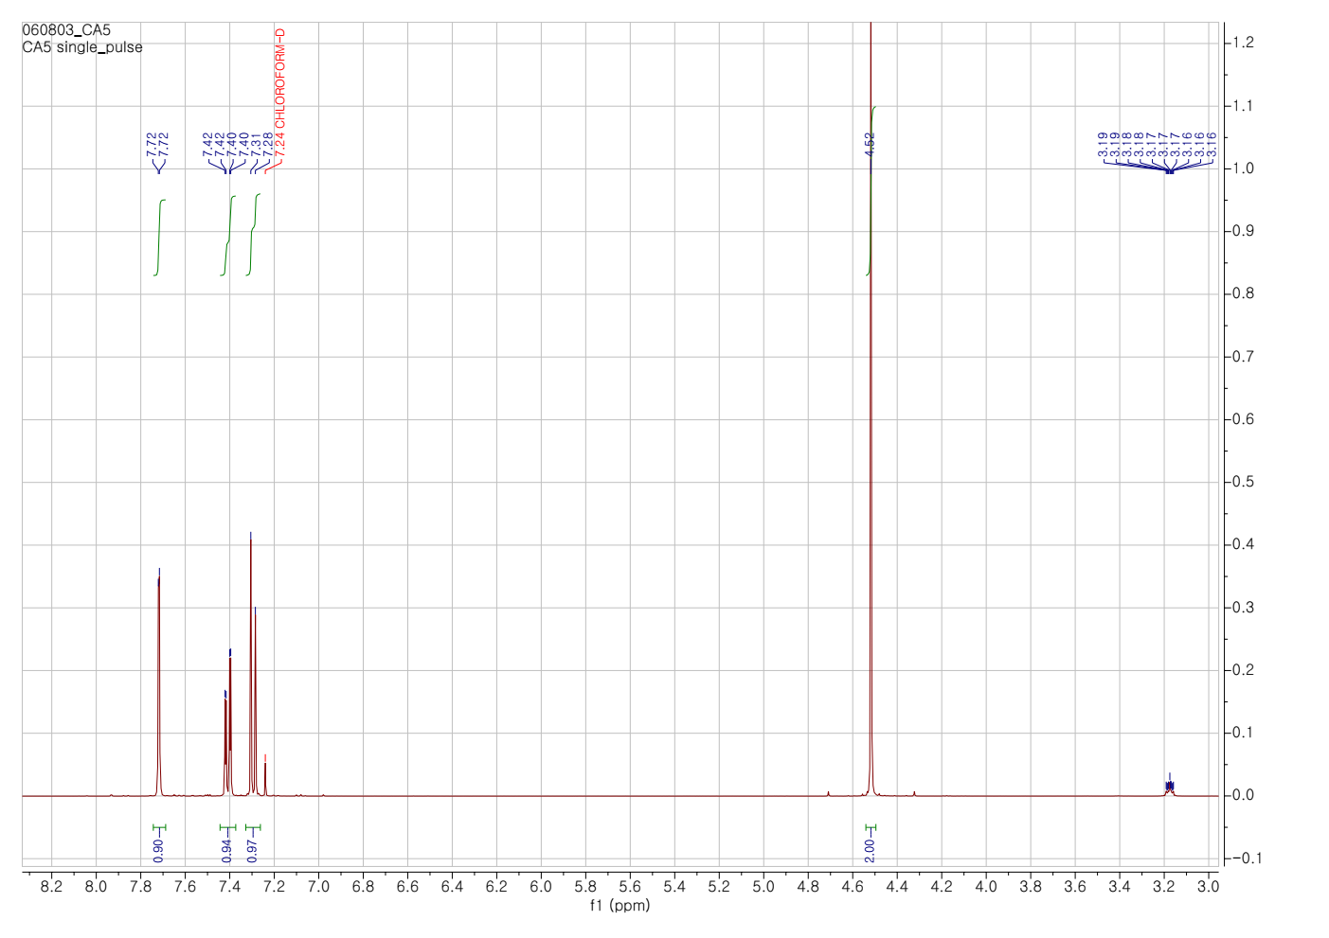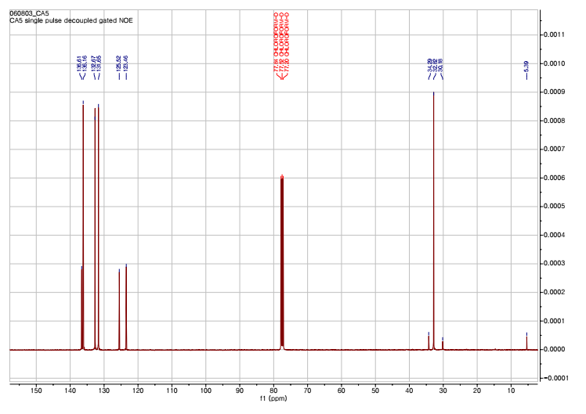
Figure S1. ¹H-NMR and ¹³C-NMR spectra of DBr in CDCl₃
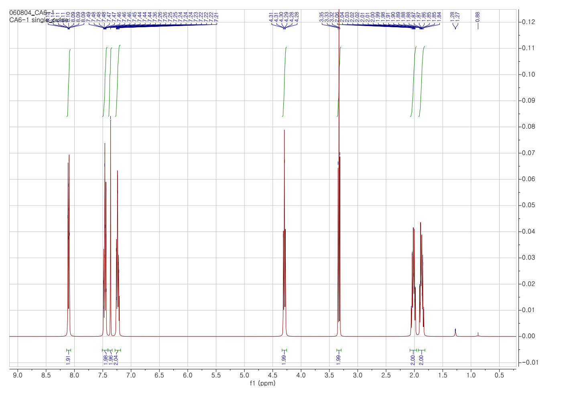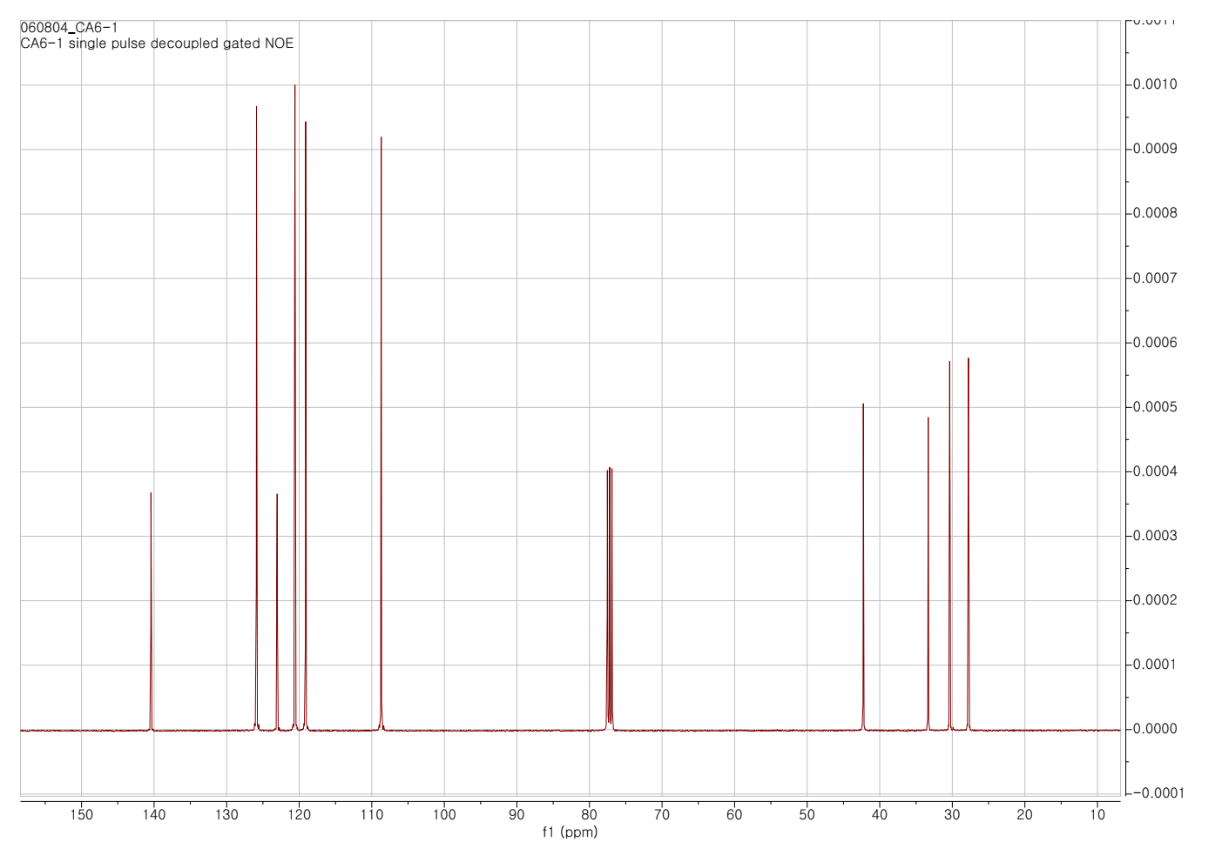
Figure S2. ¹H-NMR and ¹³C-NMR spectra of CBr in CDCl₃
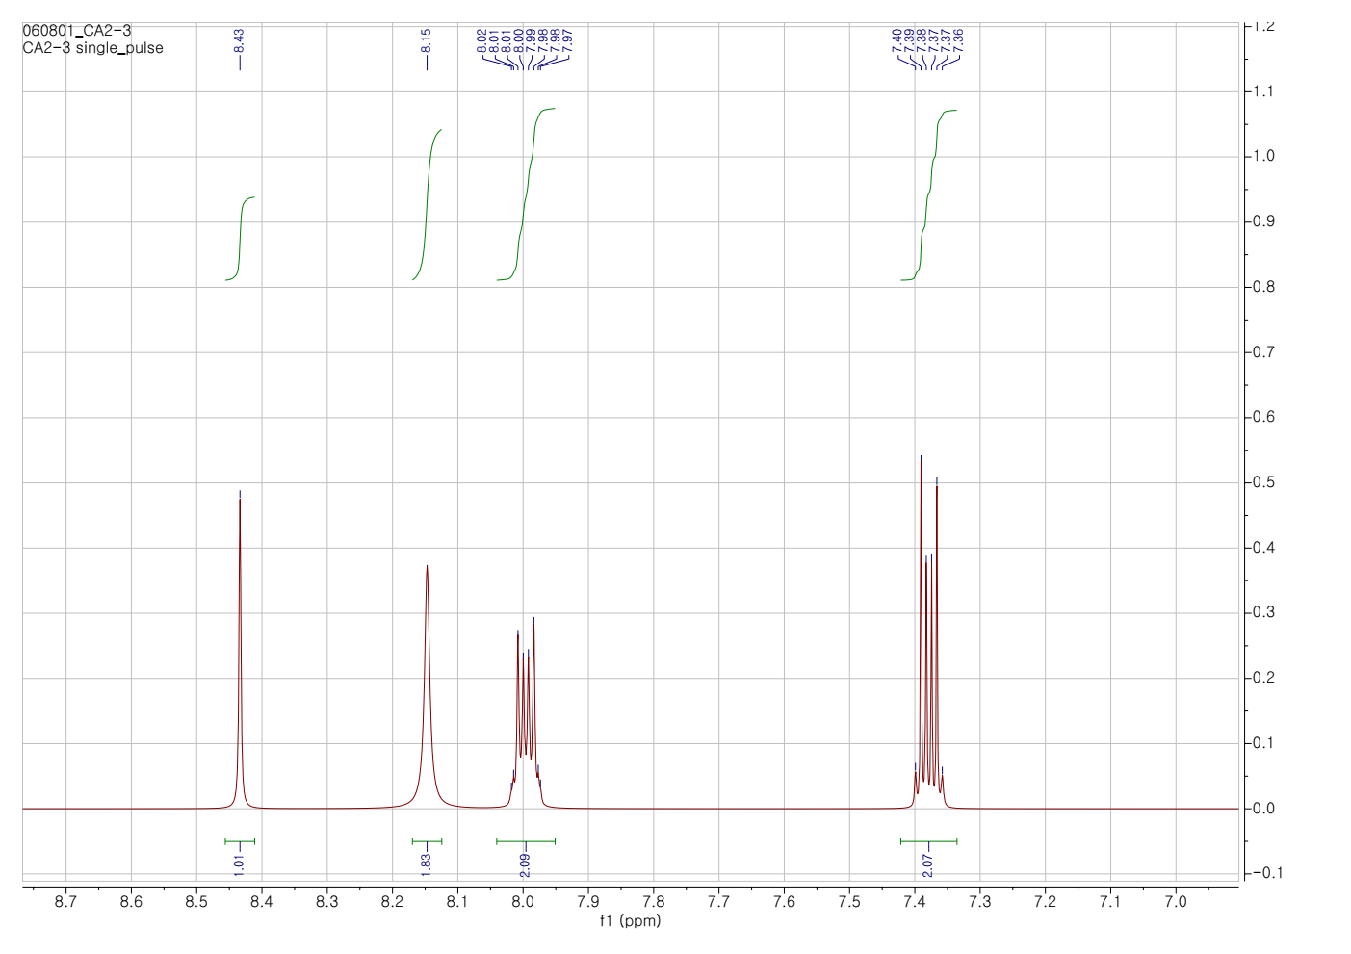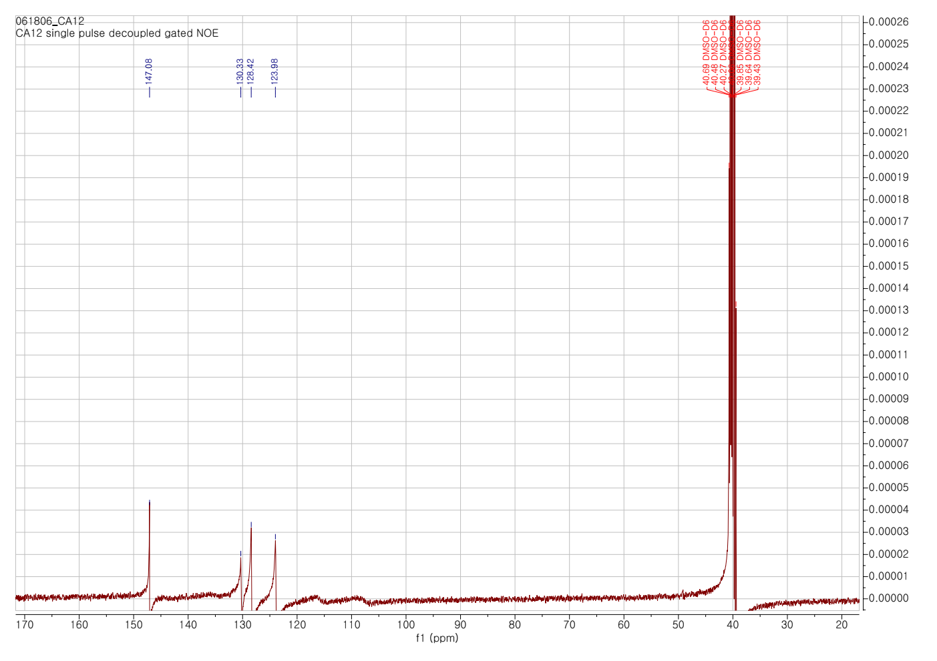
Figure S3. ¹H-NMR and ¹³C-NMR spectra of I in DMSO
_{a) Mass spectra of CBr}  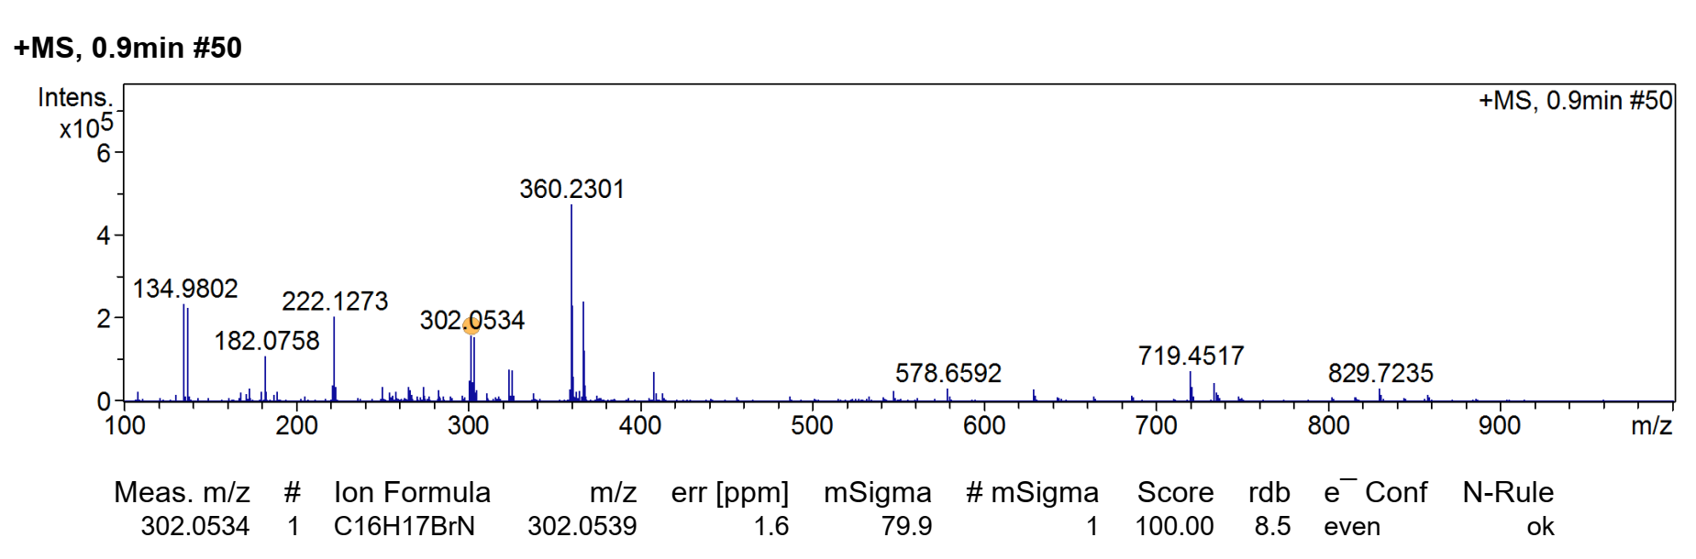 | _{b) Mass spectra of I}  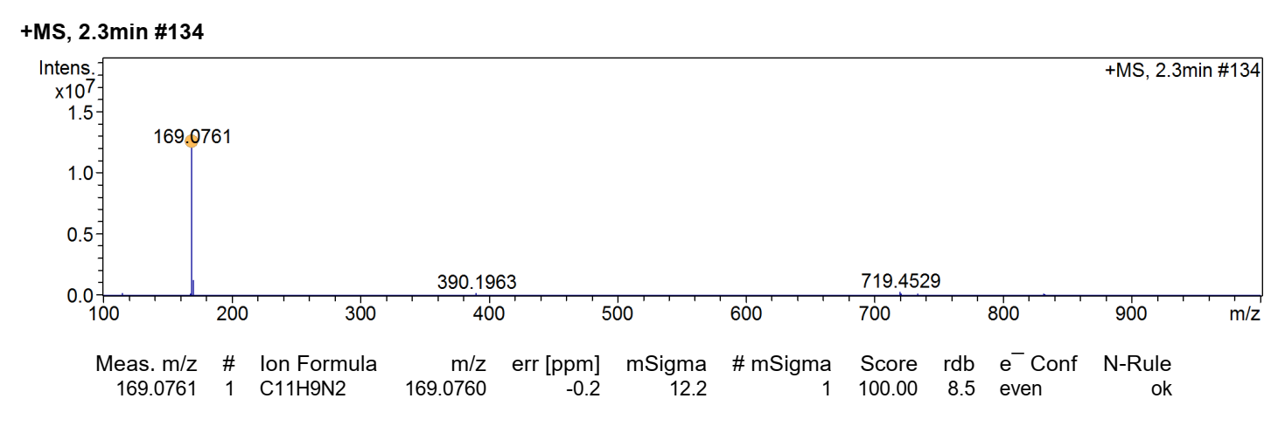
Figure S4. Mass spectra of CBr and I.
a) Mass spectra of BI  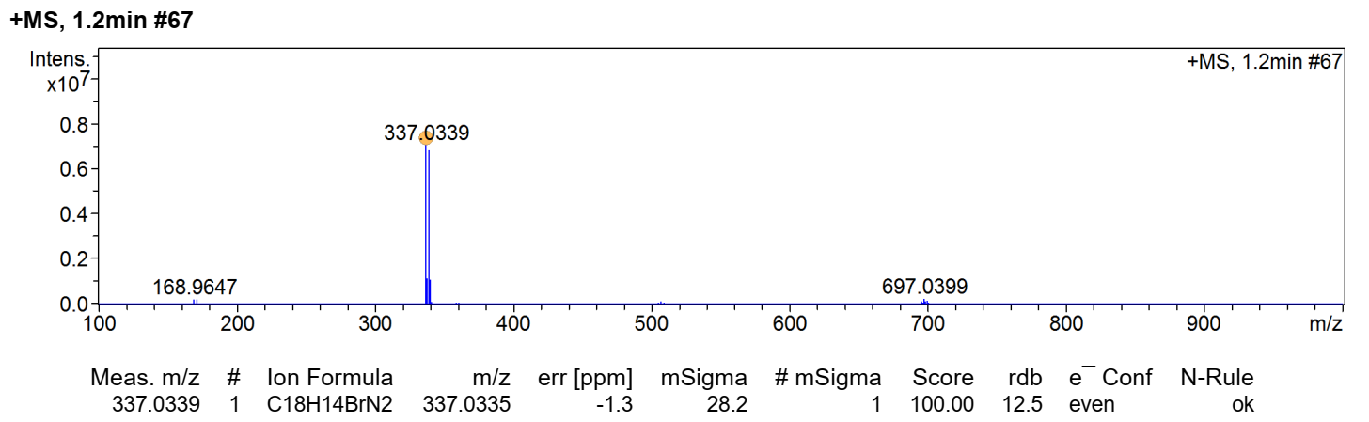 | b) Mass spectra of CI  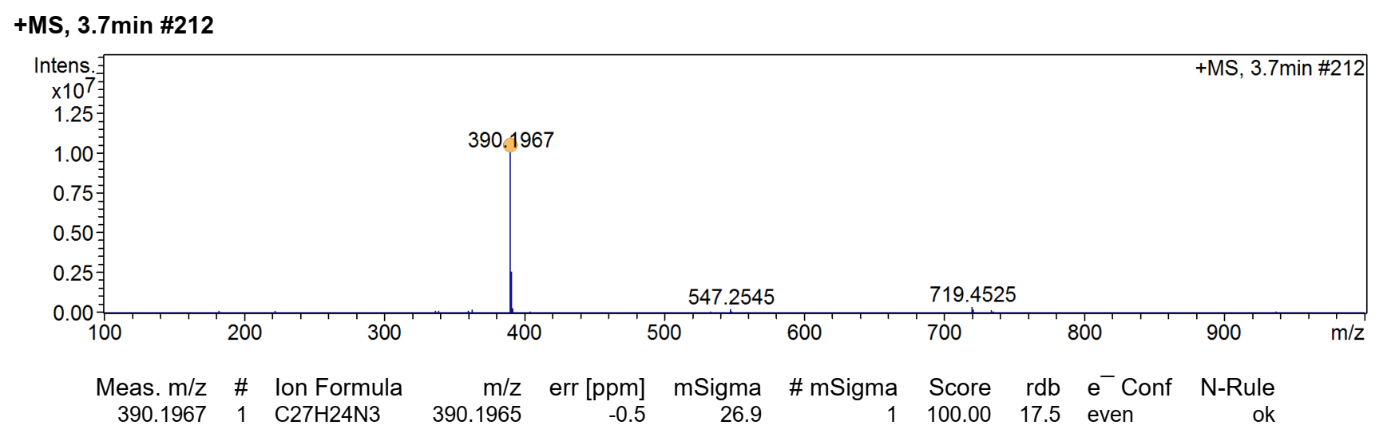
Figue S5. Mass spectra of (a) BI and (b) CI.
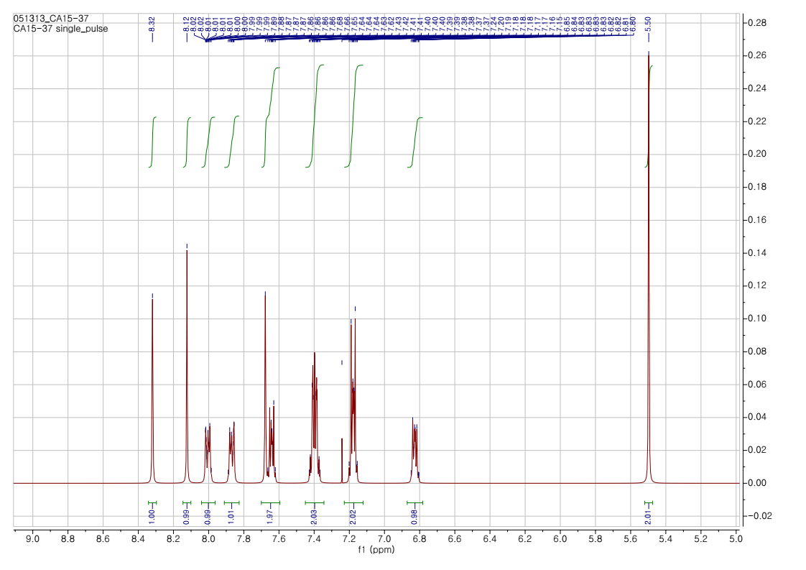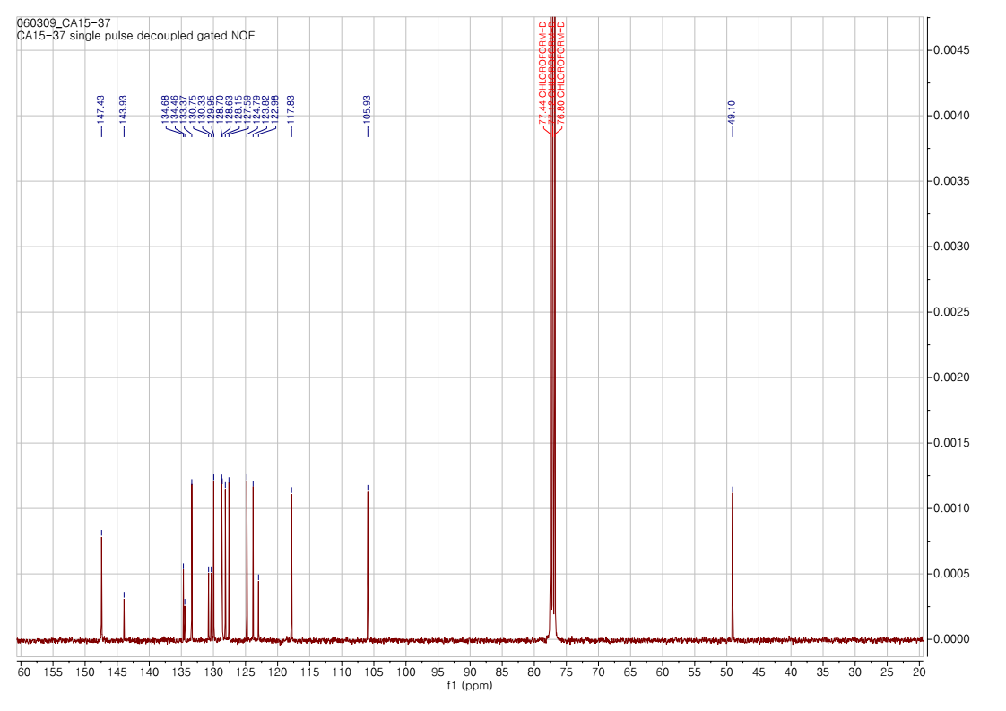
Figure S6. ¹H-NMR and ¹³C-NMR spectra of BI in CDCl₃
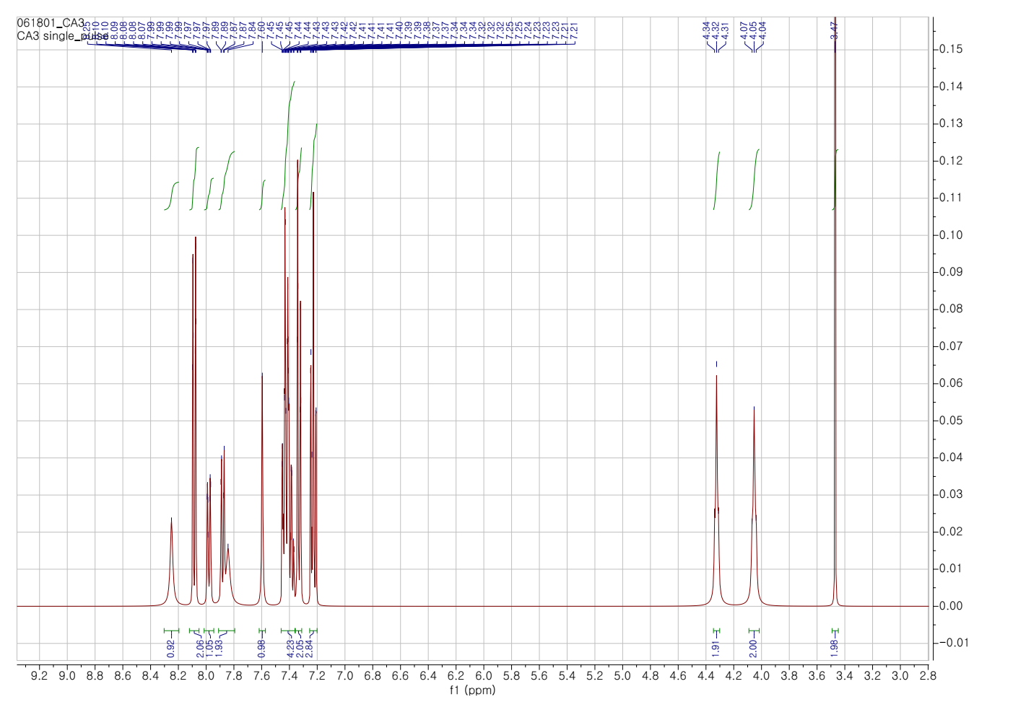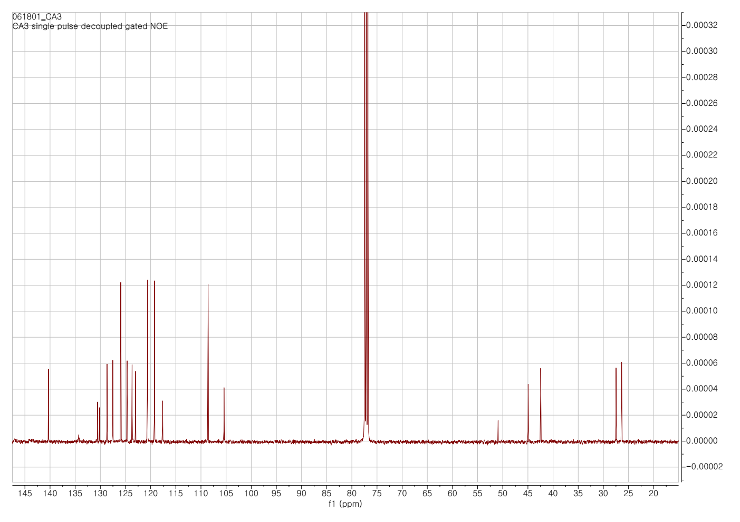
Figure S7. ¹H-NMR and ¹³C-NMR spectra of CI in CDCl₃
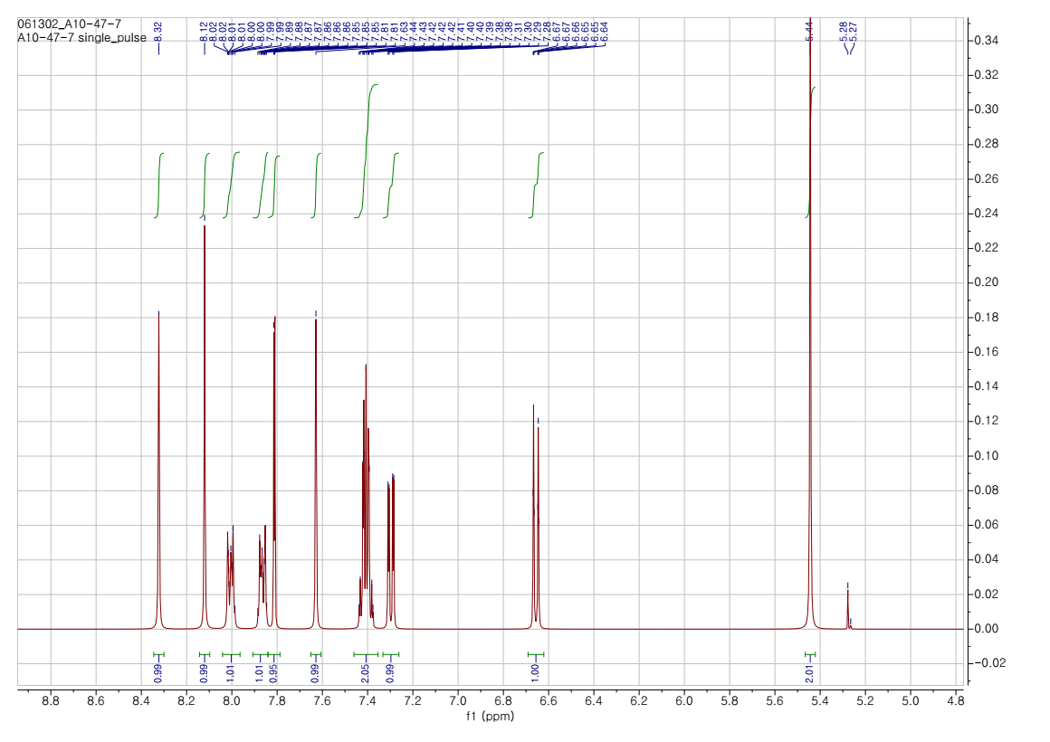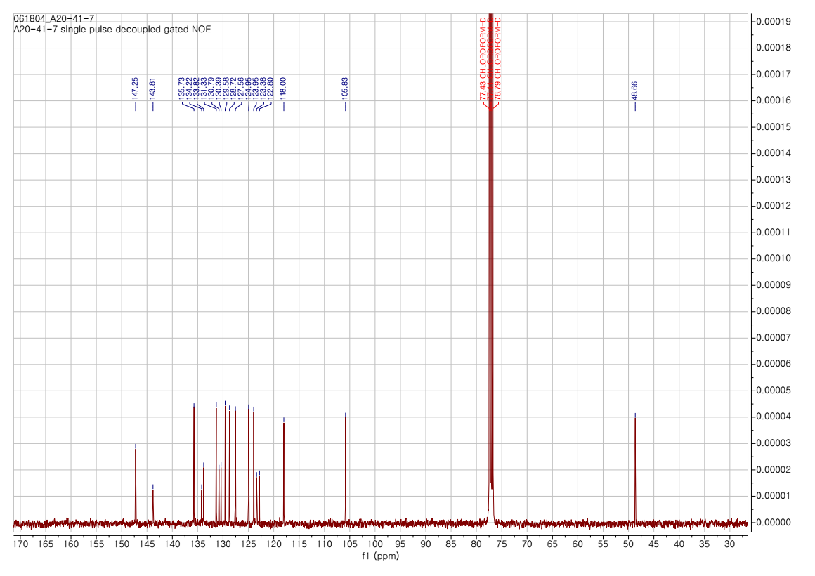
Figure S8. ¹H-NMR and ¹³C-NMR spectra of DI in CDCl₃
a) Mass spectra of DI  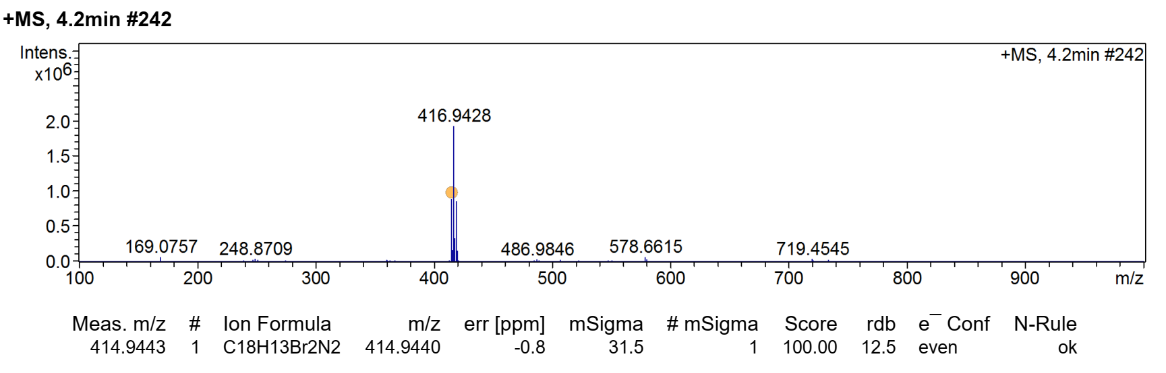 | a) Mass spectra of BIB  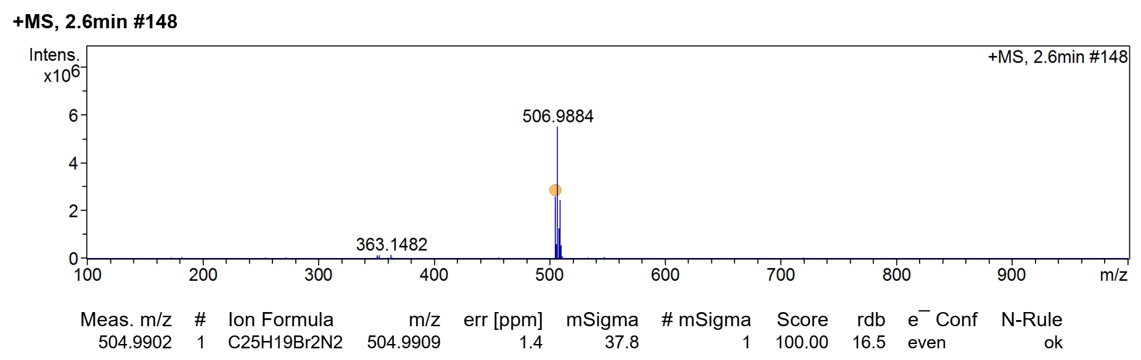
Figue S9. Mass spectra of (a) DI and (b) BIB
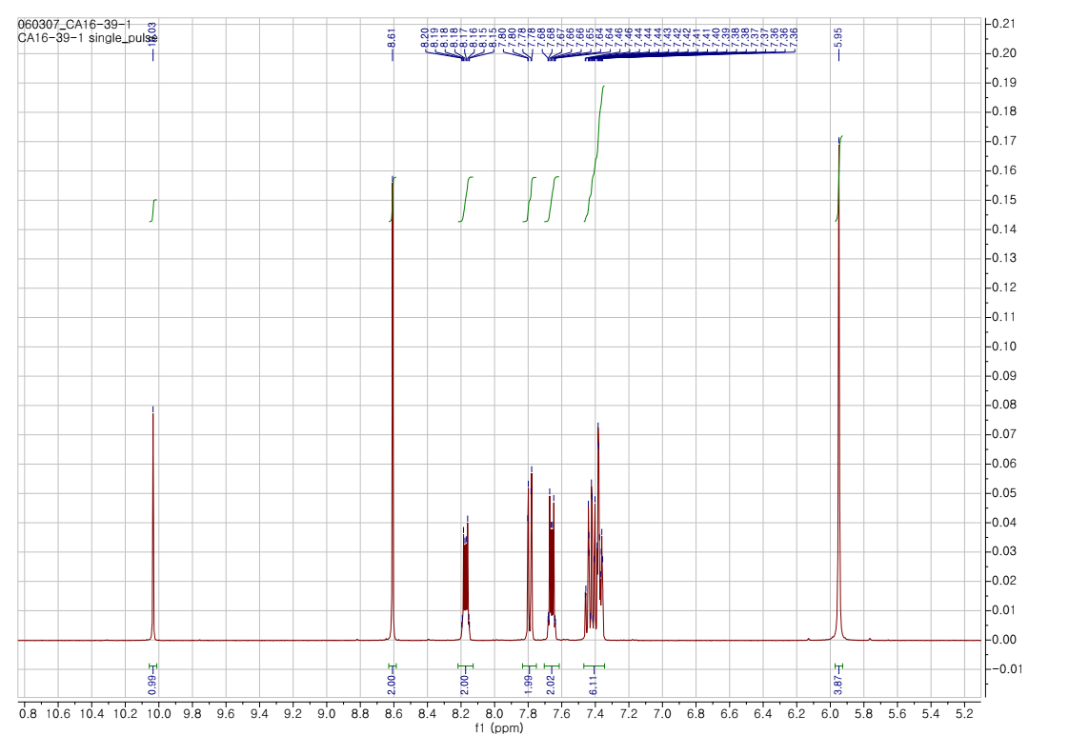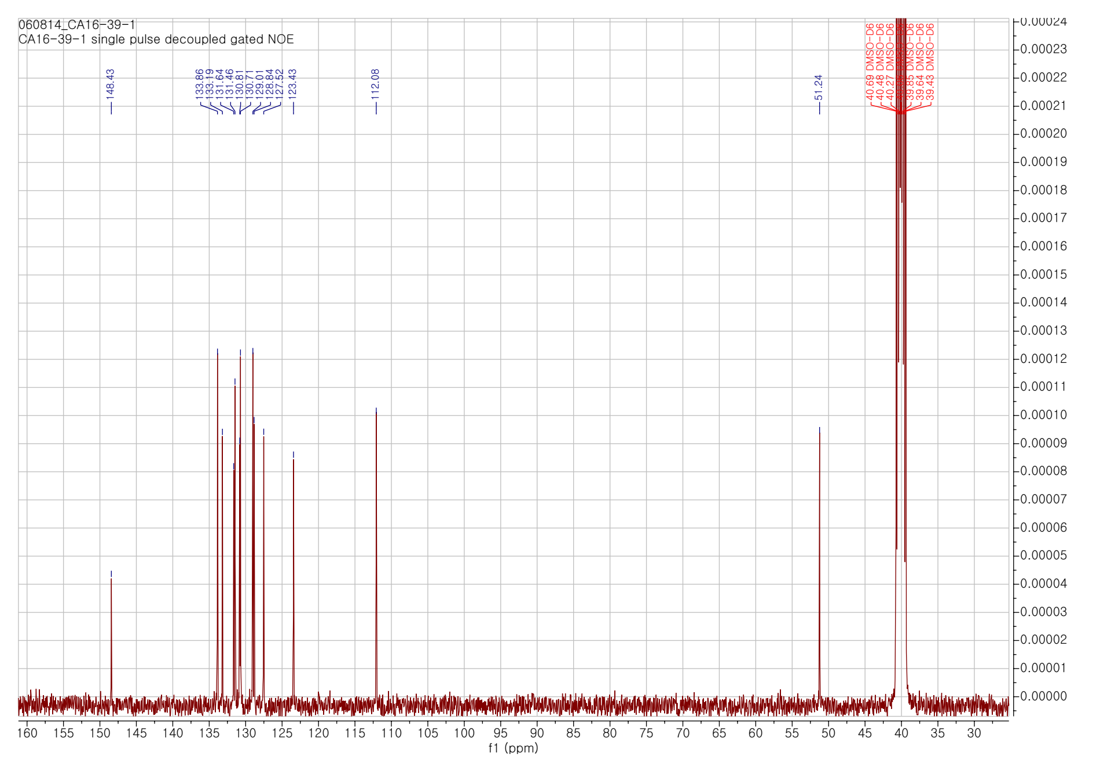
Figure S10. ¹H-NMR and ¹³C-NMR spectra of BIB in DMSO
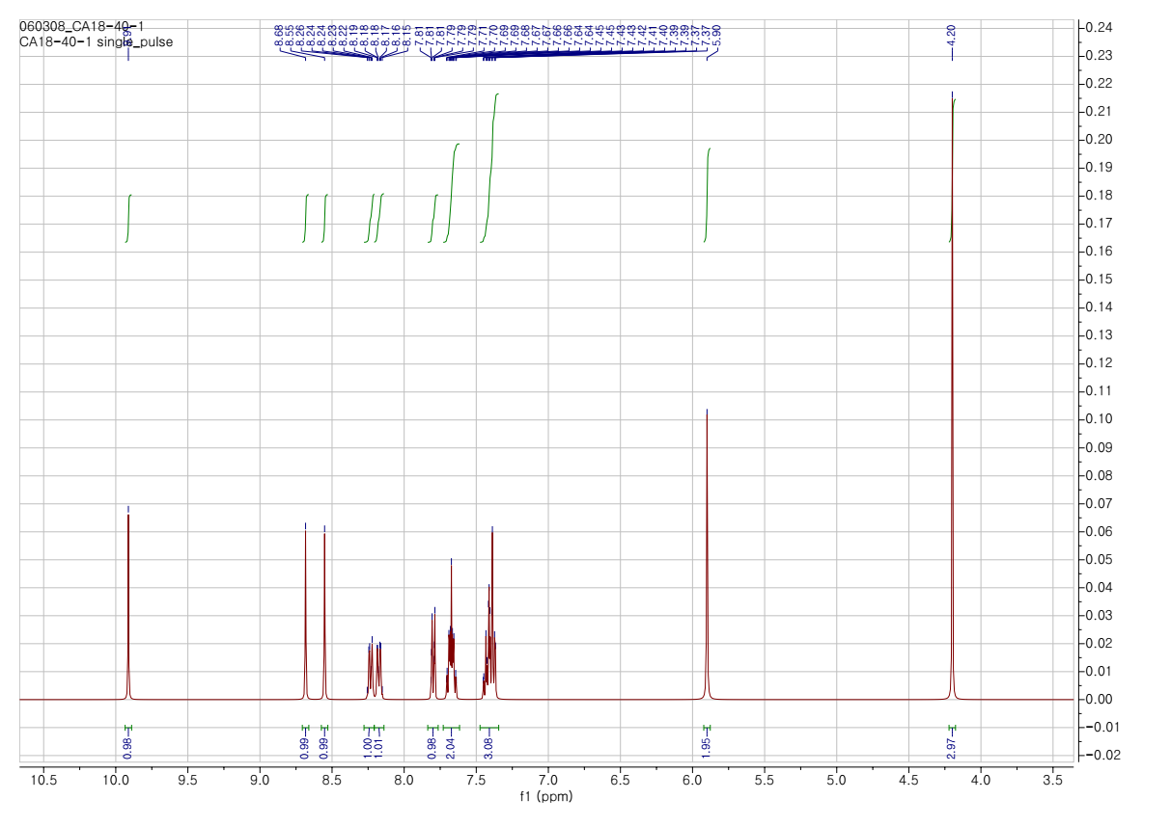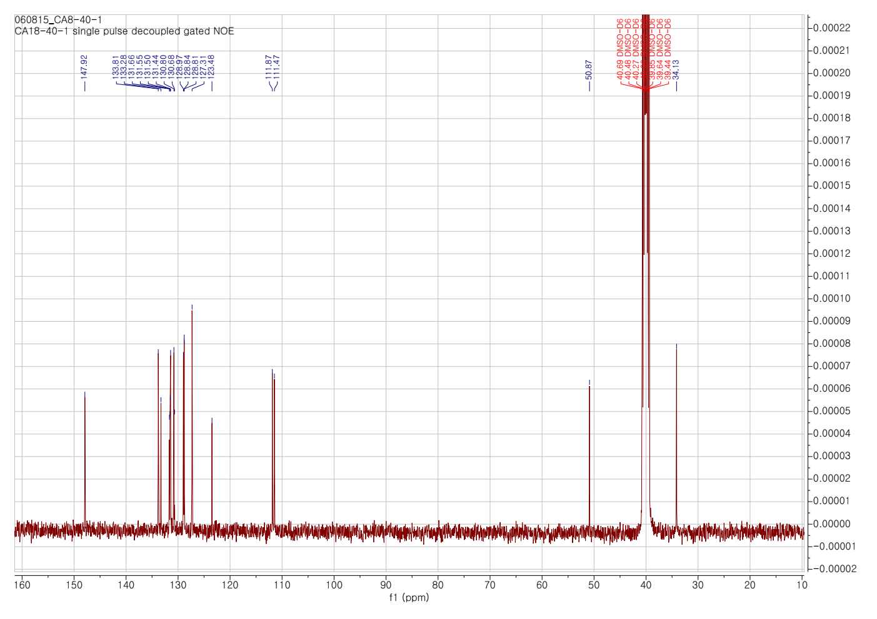
Figure S11. ¹H-NMR and ¹³C-NMR spectra of BIM in DMSO
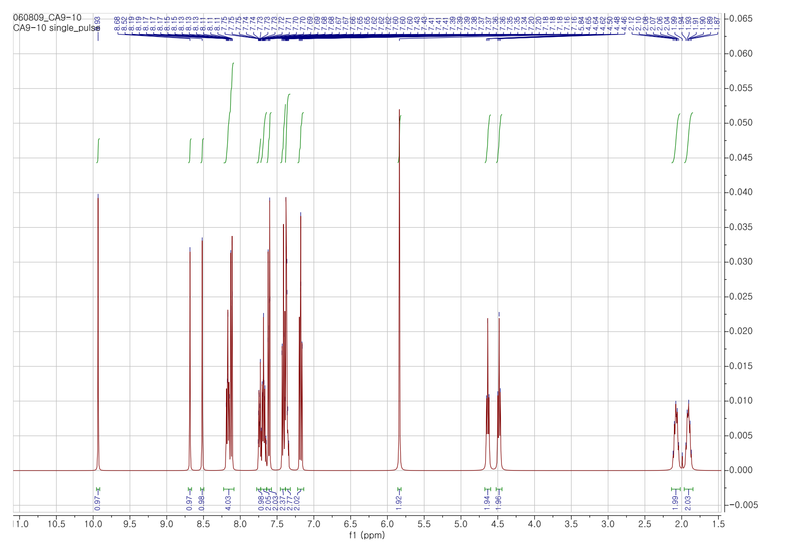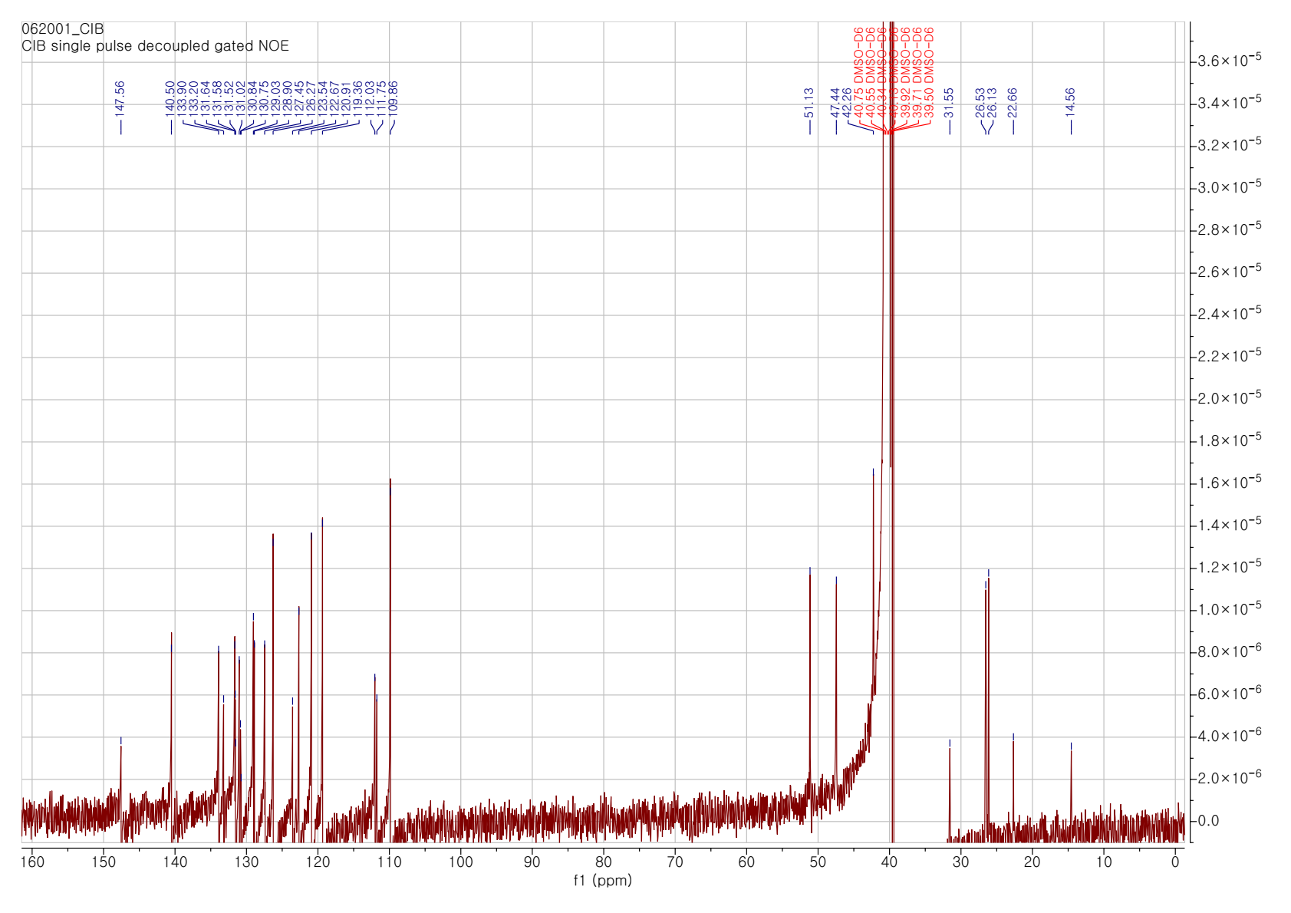
Figure S12. ¹H-NMR and ¹³C-NMR spectra of CIB in DMSO

a) Mass spectra of BIM  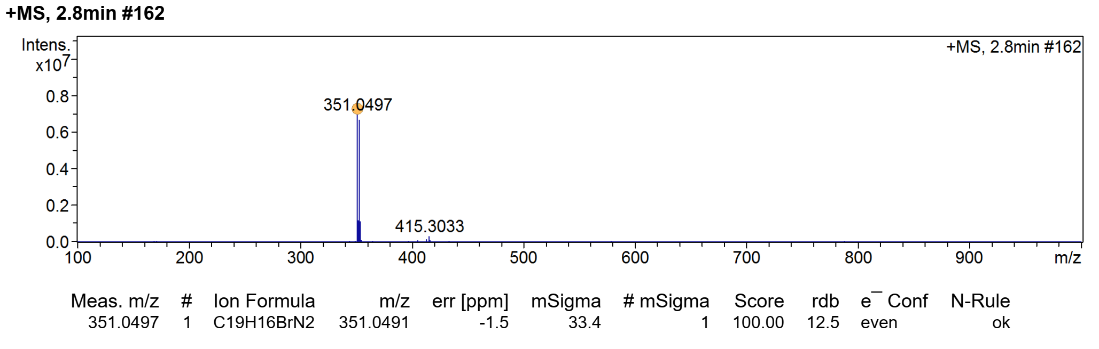 | b) Mass spectra of CIB  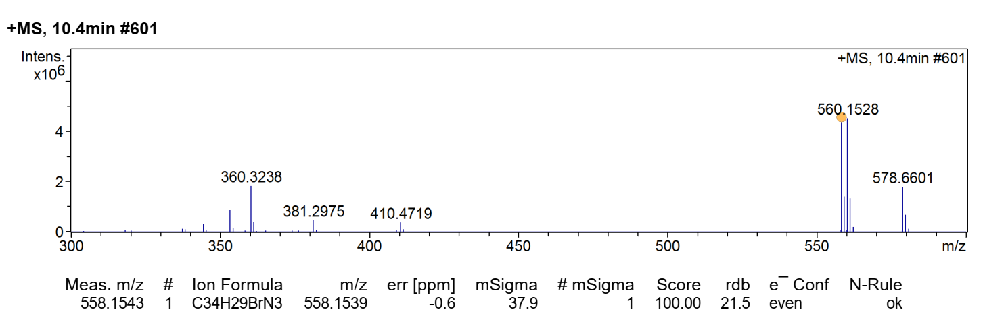
Figue S13. Mass spectra of (a) BIM and (b) CIB
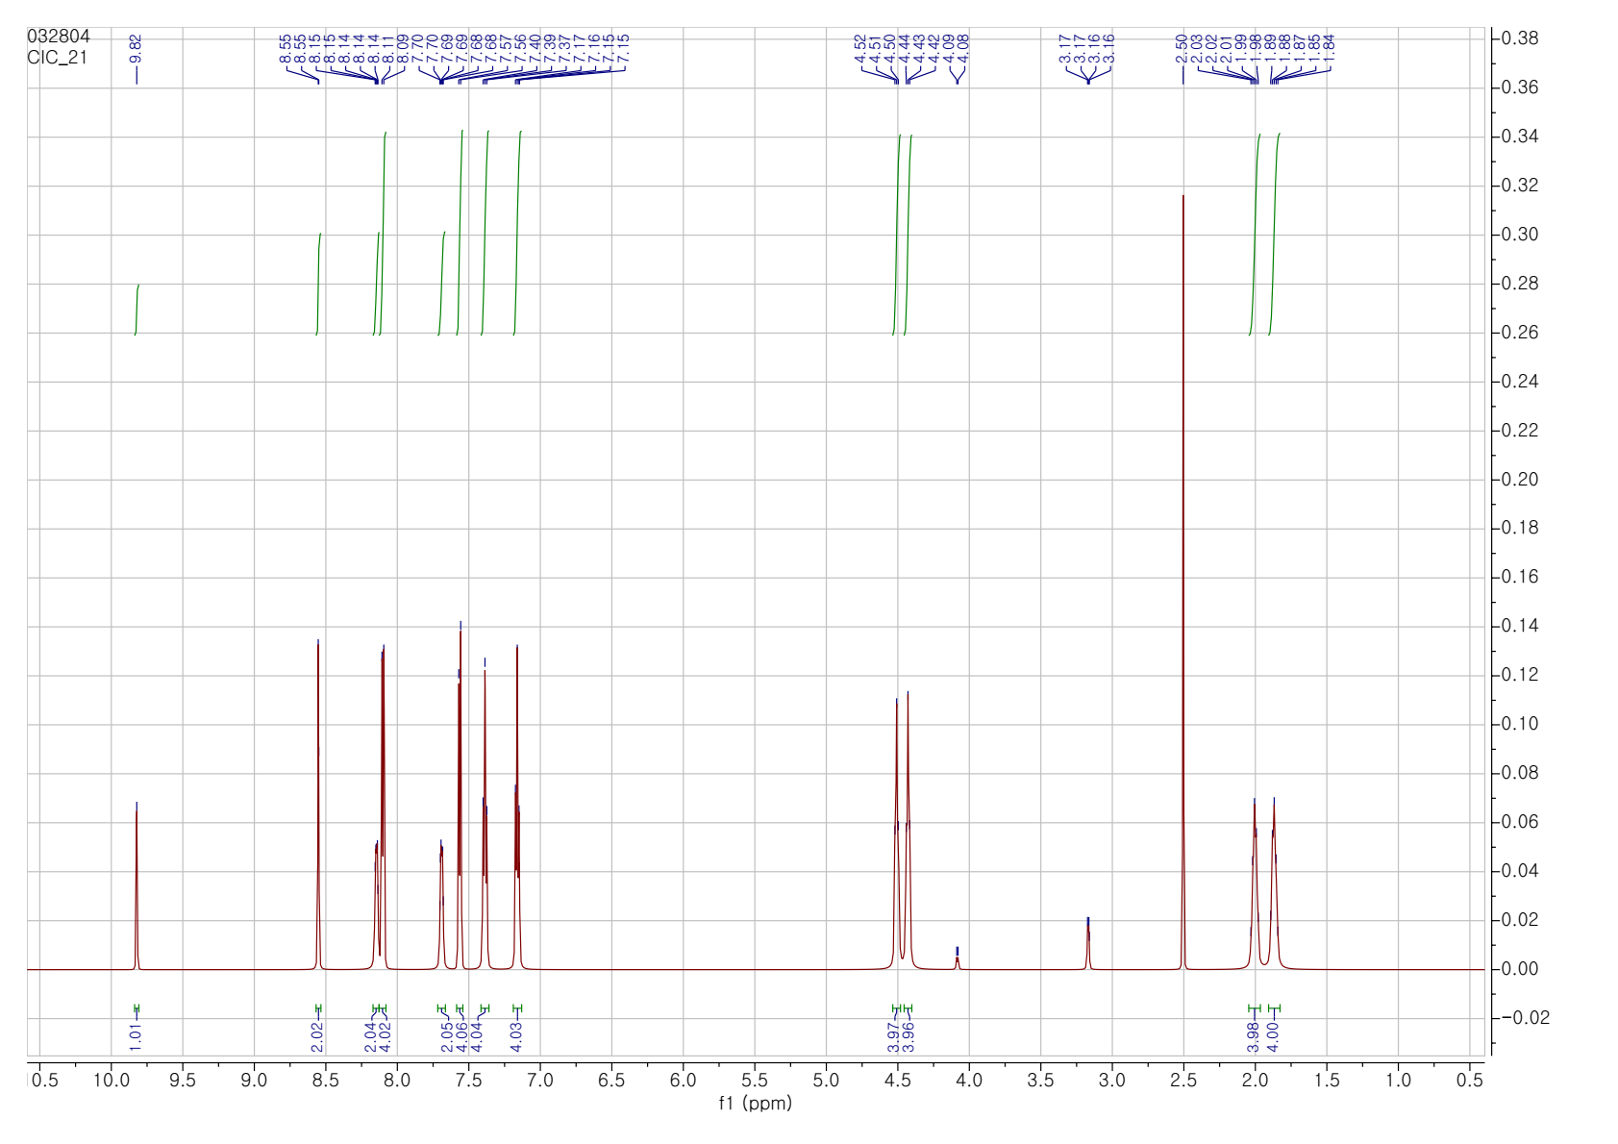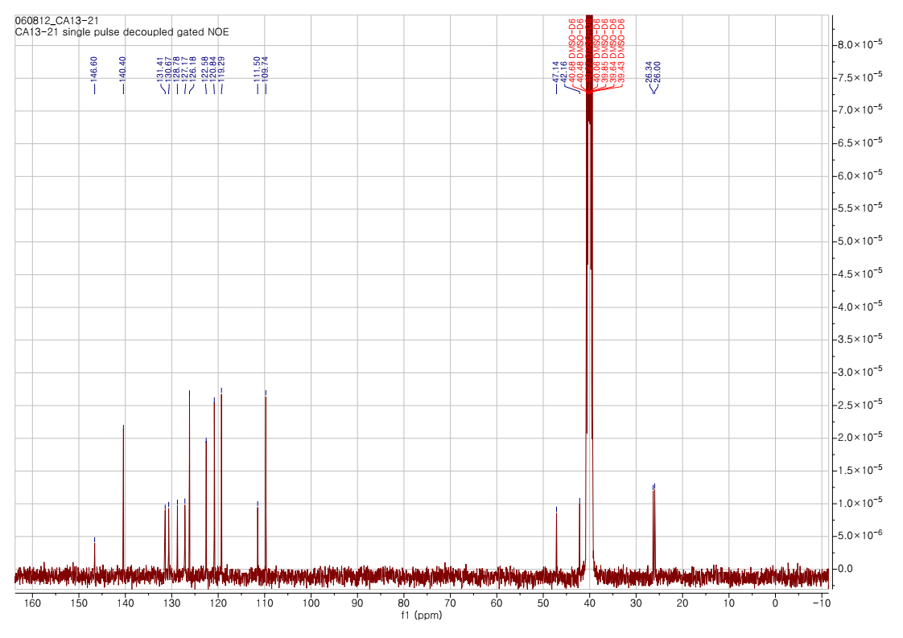
Figure S14. ¹H-NMR and ¹³C-NMR spectra of CIC in DMSO
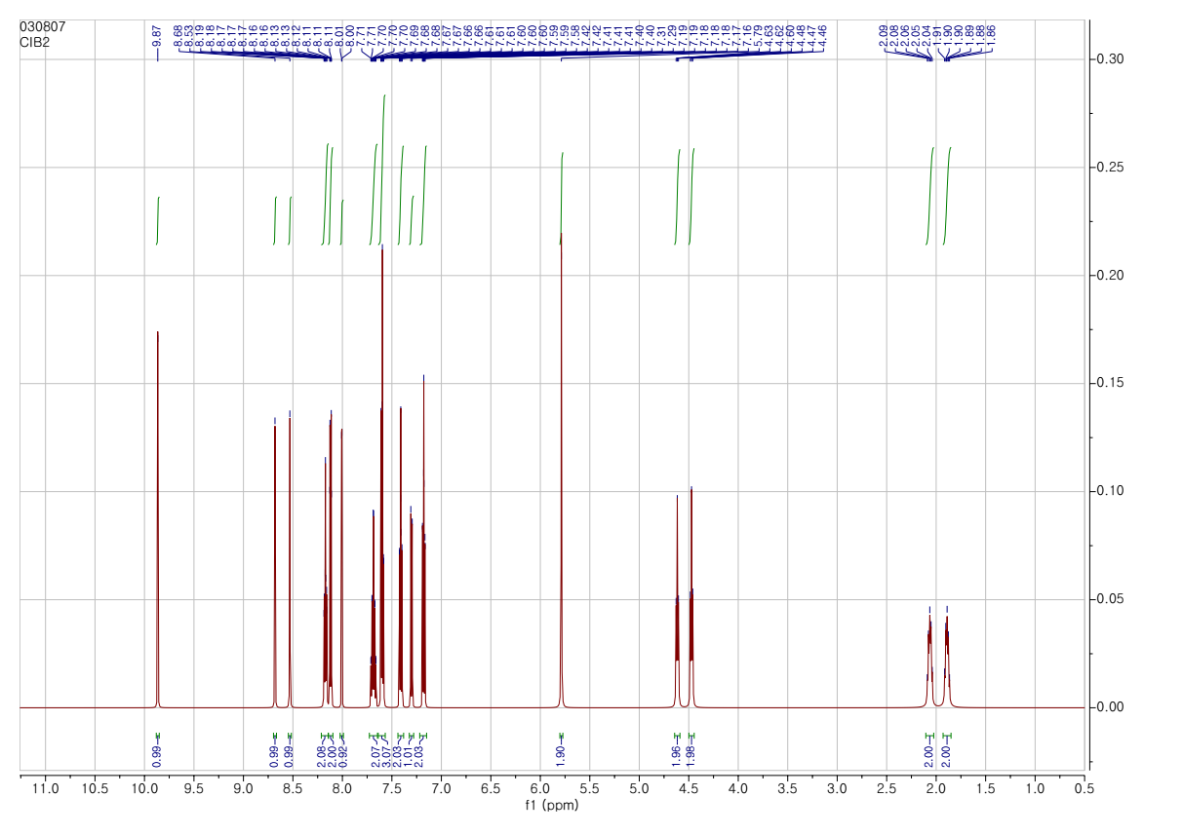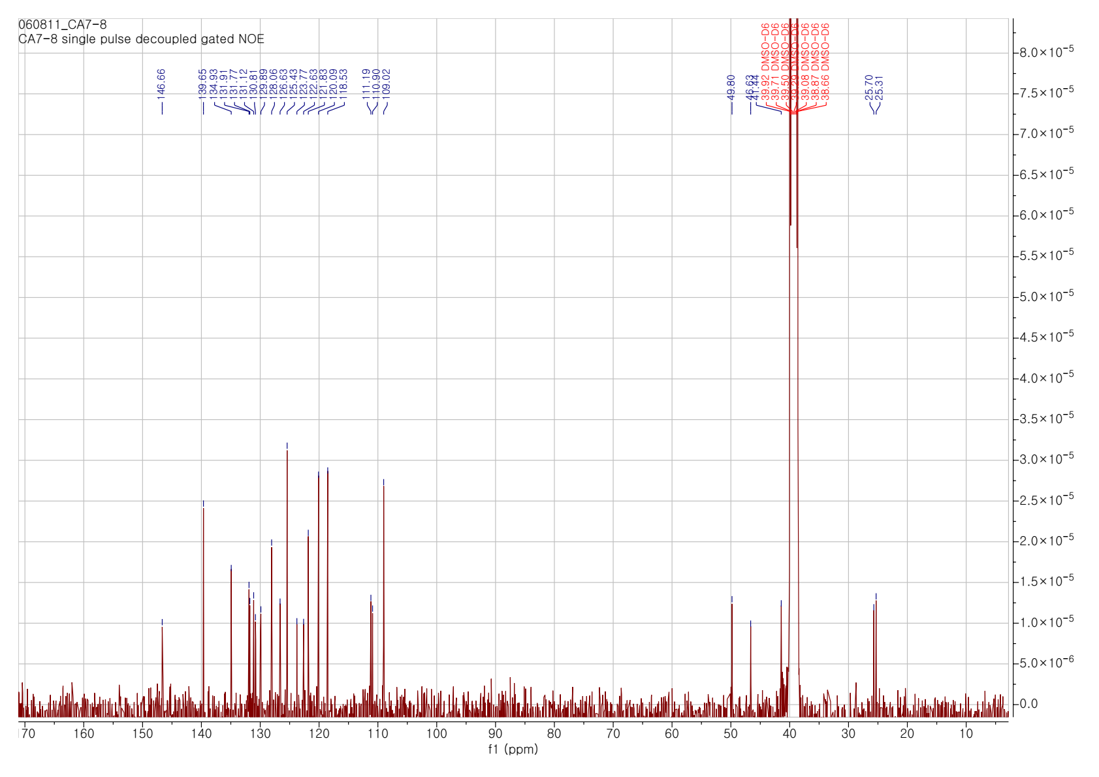
Figure S15. ¹H-NMR and ¹³C-NMR spectra of CID in DMSO

a) Mass spectra of CIC  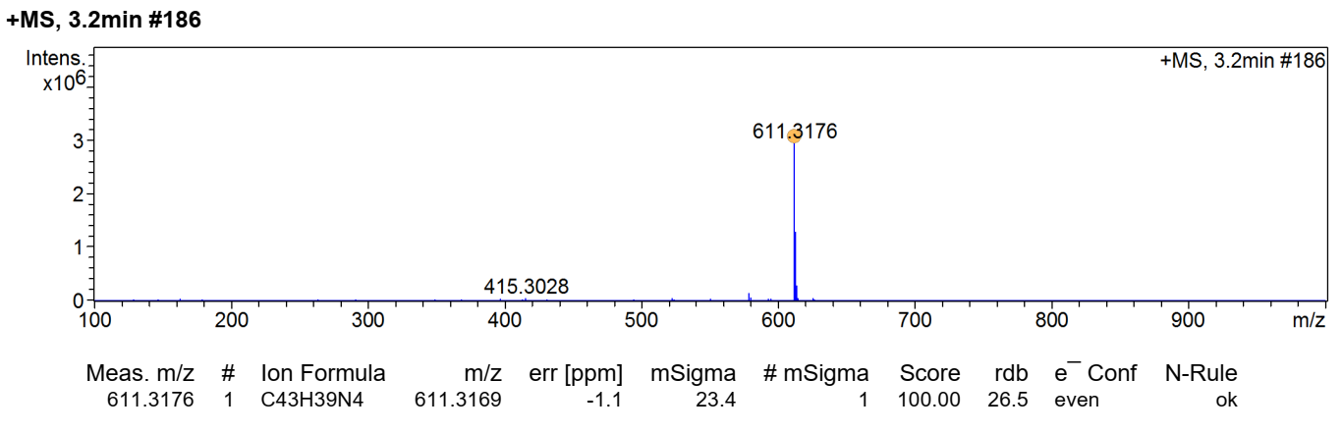 | b) Mass spectra of CID  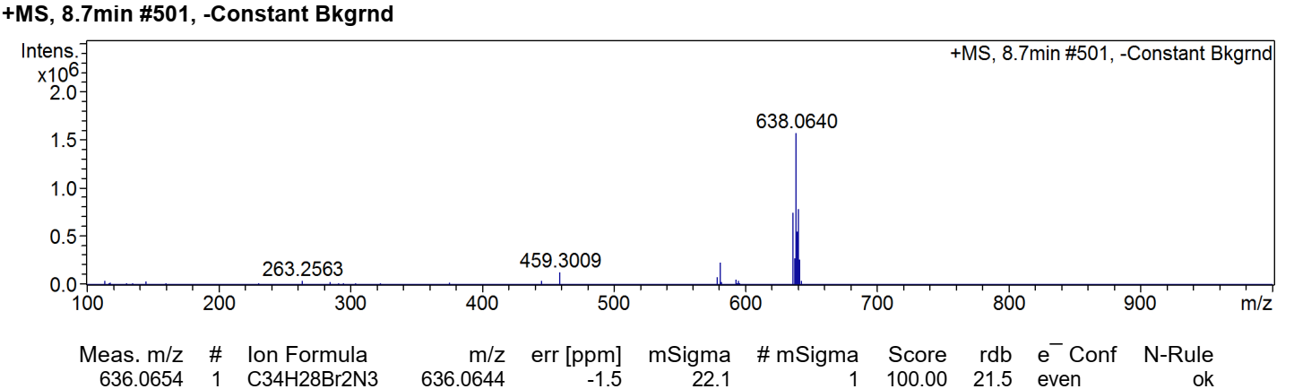
c) Mass spectra of CIM  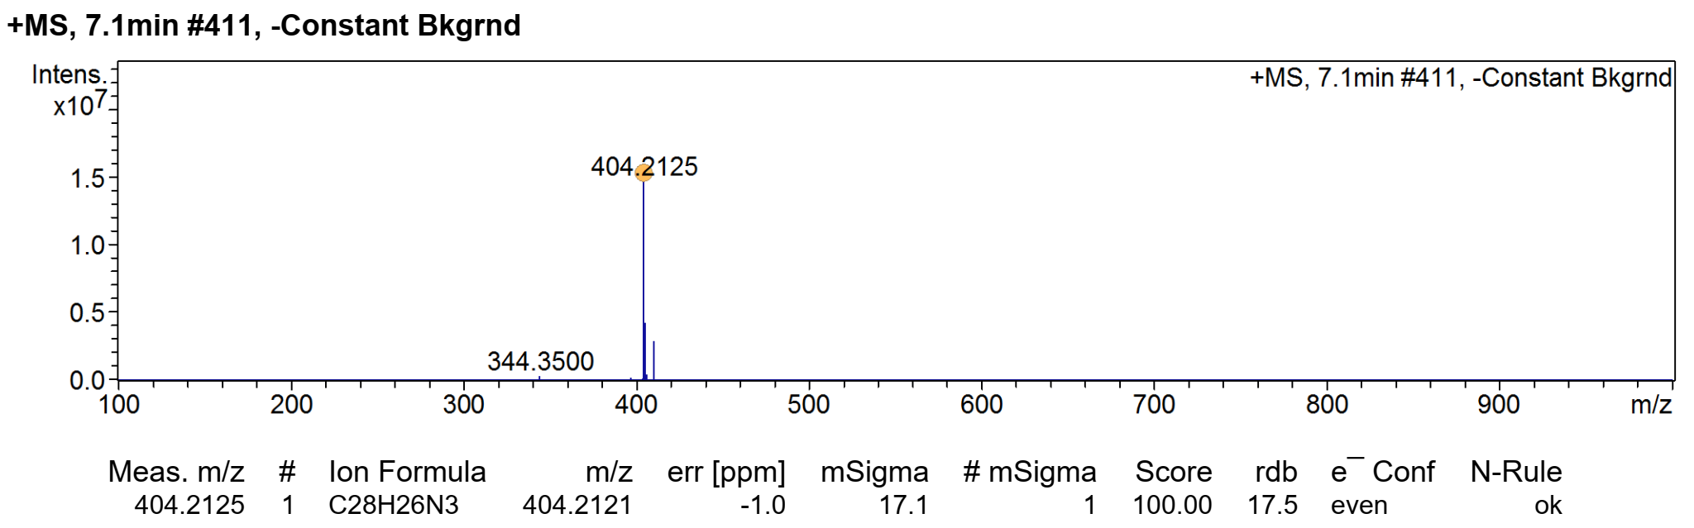 | d) Mass spectra of DIB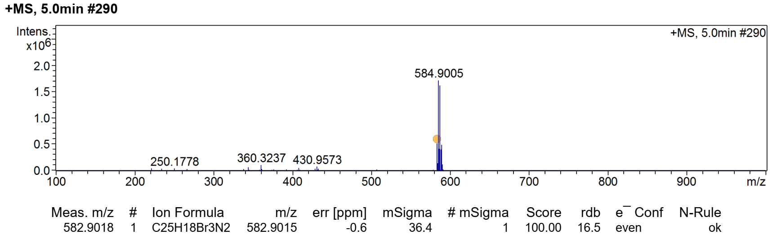
Figue S16. Mass spectra of (a) CIC, (b) CIB, (c) CIM and (d) DIB.
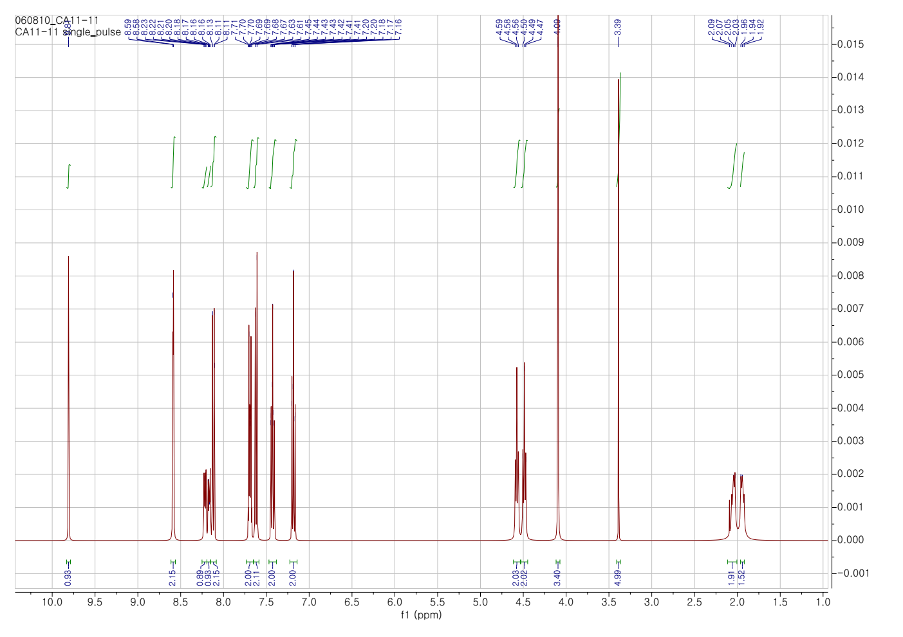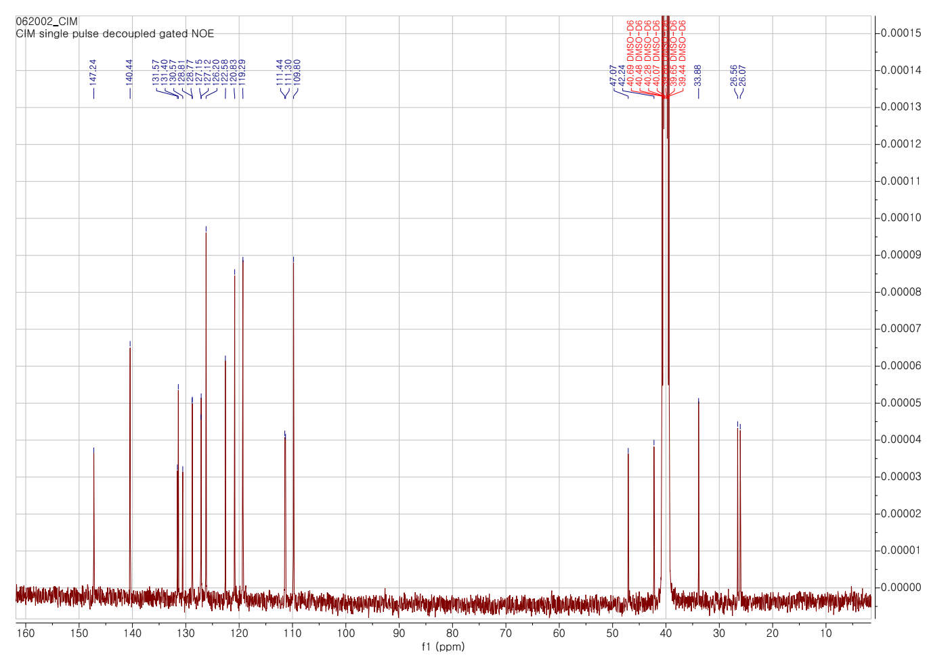
Figure S17. ¹H-NMR and ¹³C-NMR spectra of CIM in DMSO
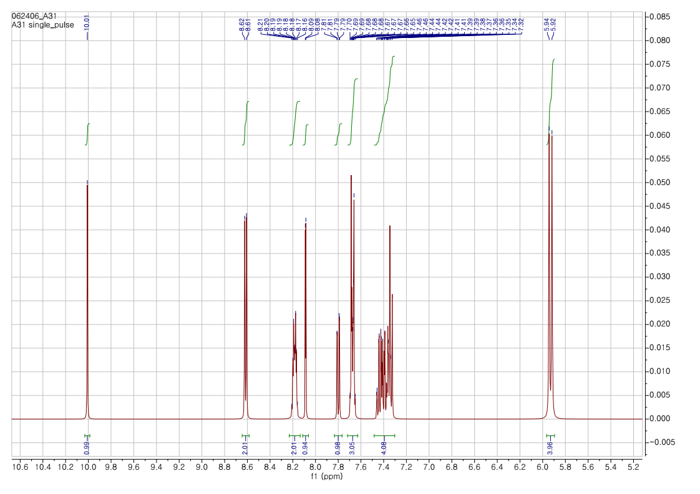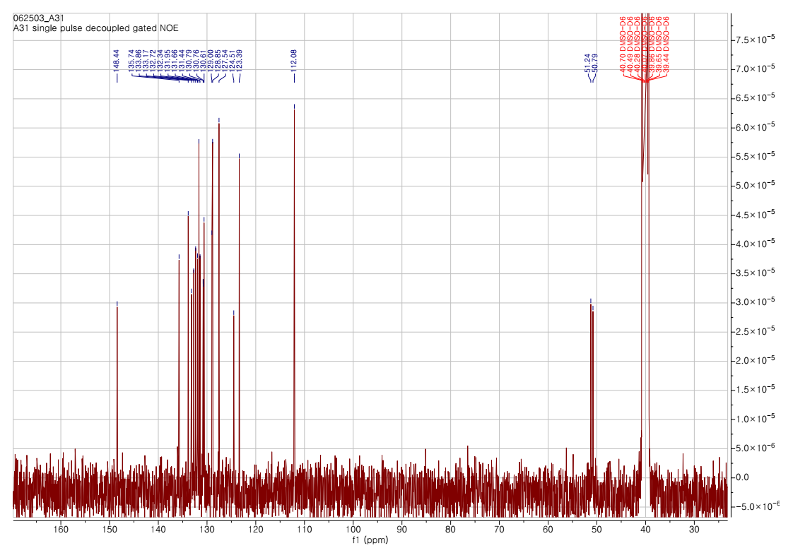
Figure S18. ¹H-NMR and ¹³C-NMR spectra of DIB in DMSO
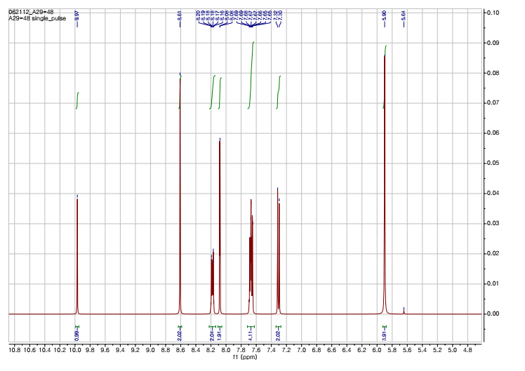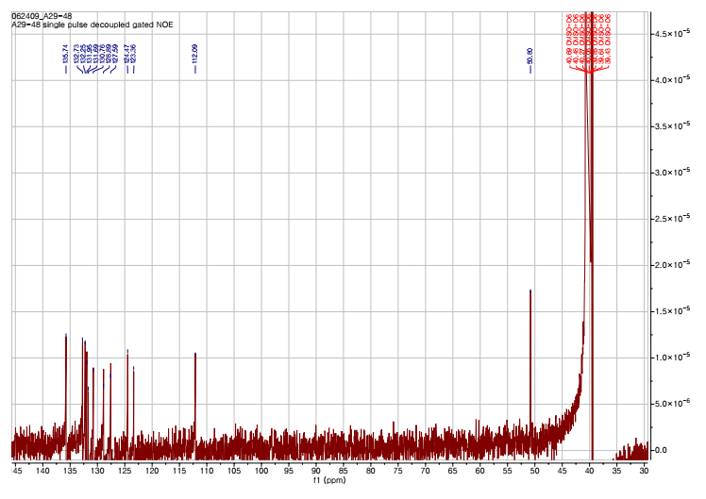
Figure S19. ¹H-NMR and ¹³C-NMR spectra of DID in DMSO

a) Mass spectra of DID  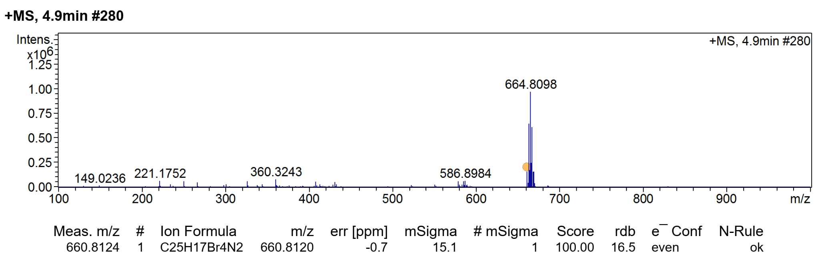 | b) Mass spectra of DIM  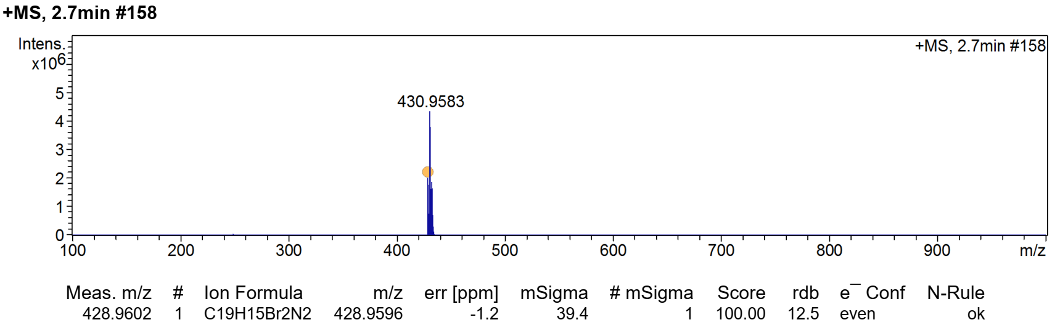
Figure S20. Mass spectra of (a) DID and (b) DIM.
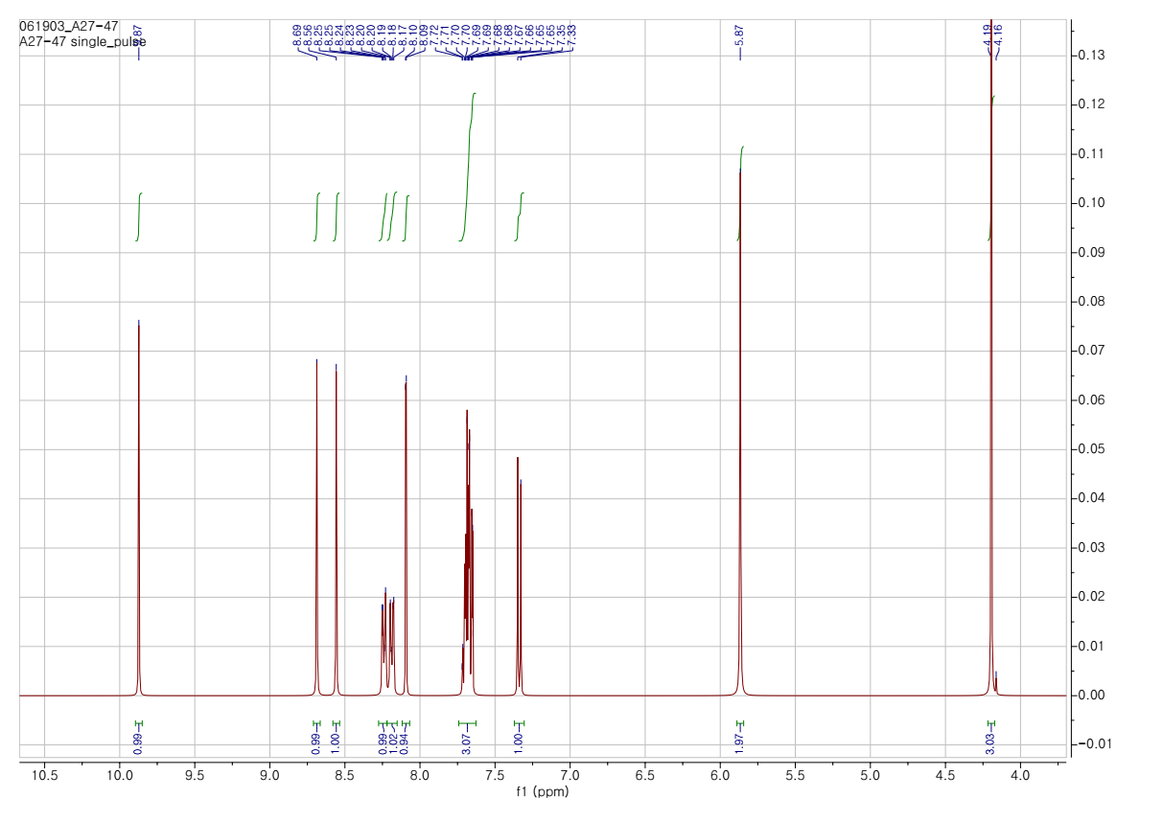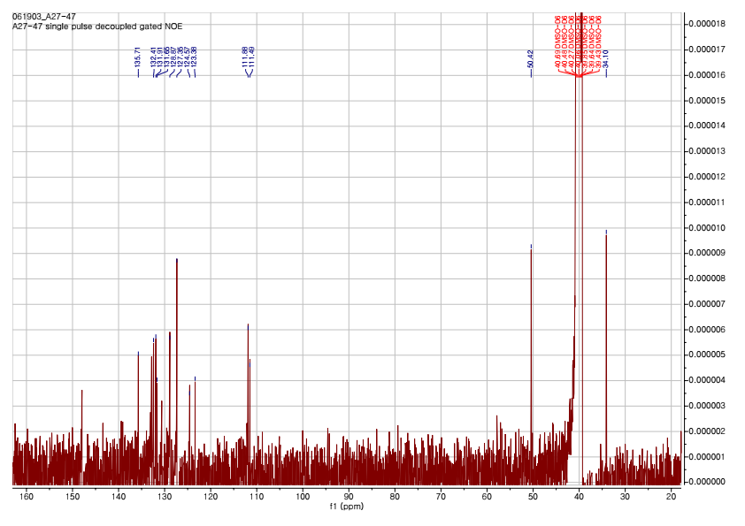
Figure S21. ¹H-NMR and ¹³C-NMR spectra of DIM in DMSO
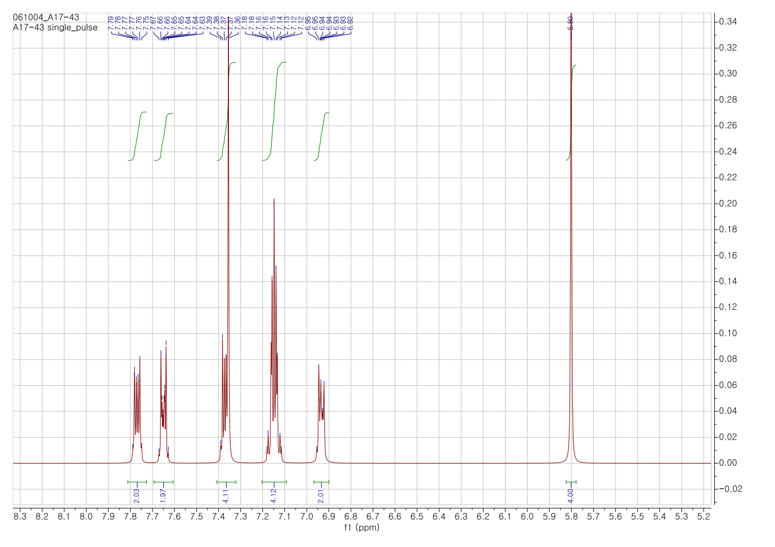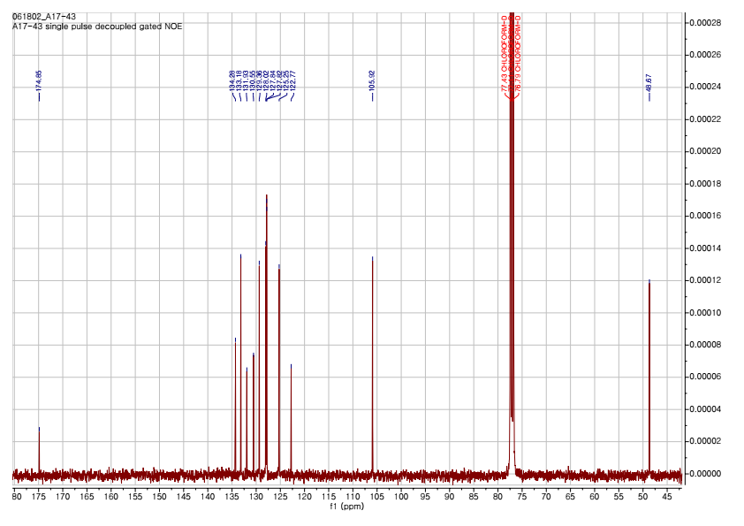
Figure S22. ¹H-NMR and ¹³C-NMR spectra of BSB in CHCl₃
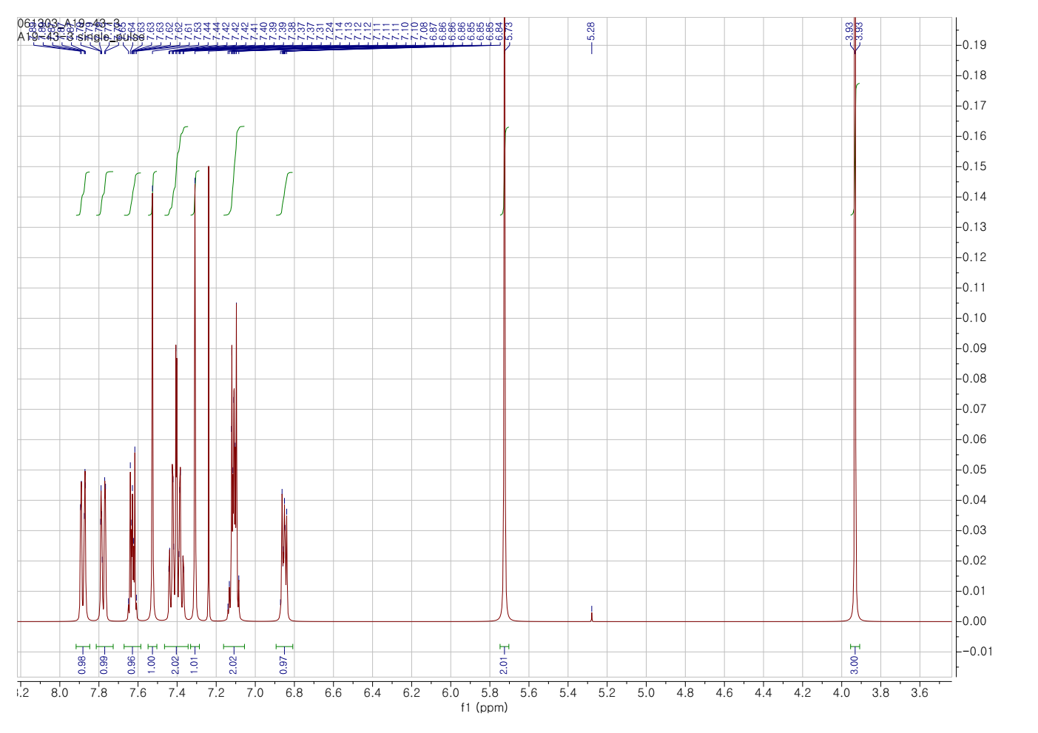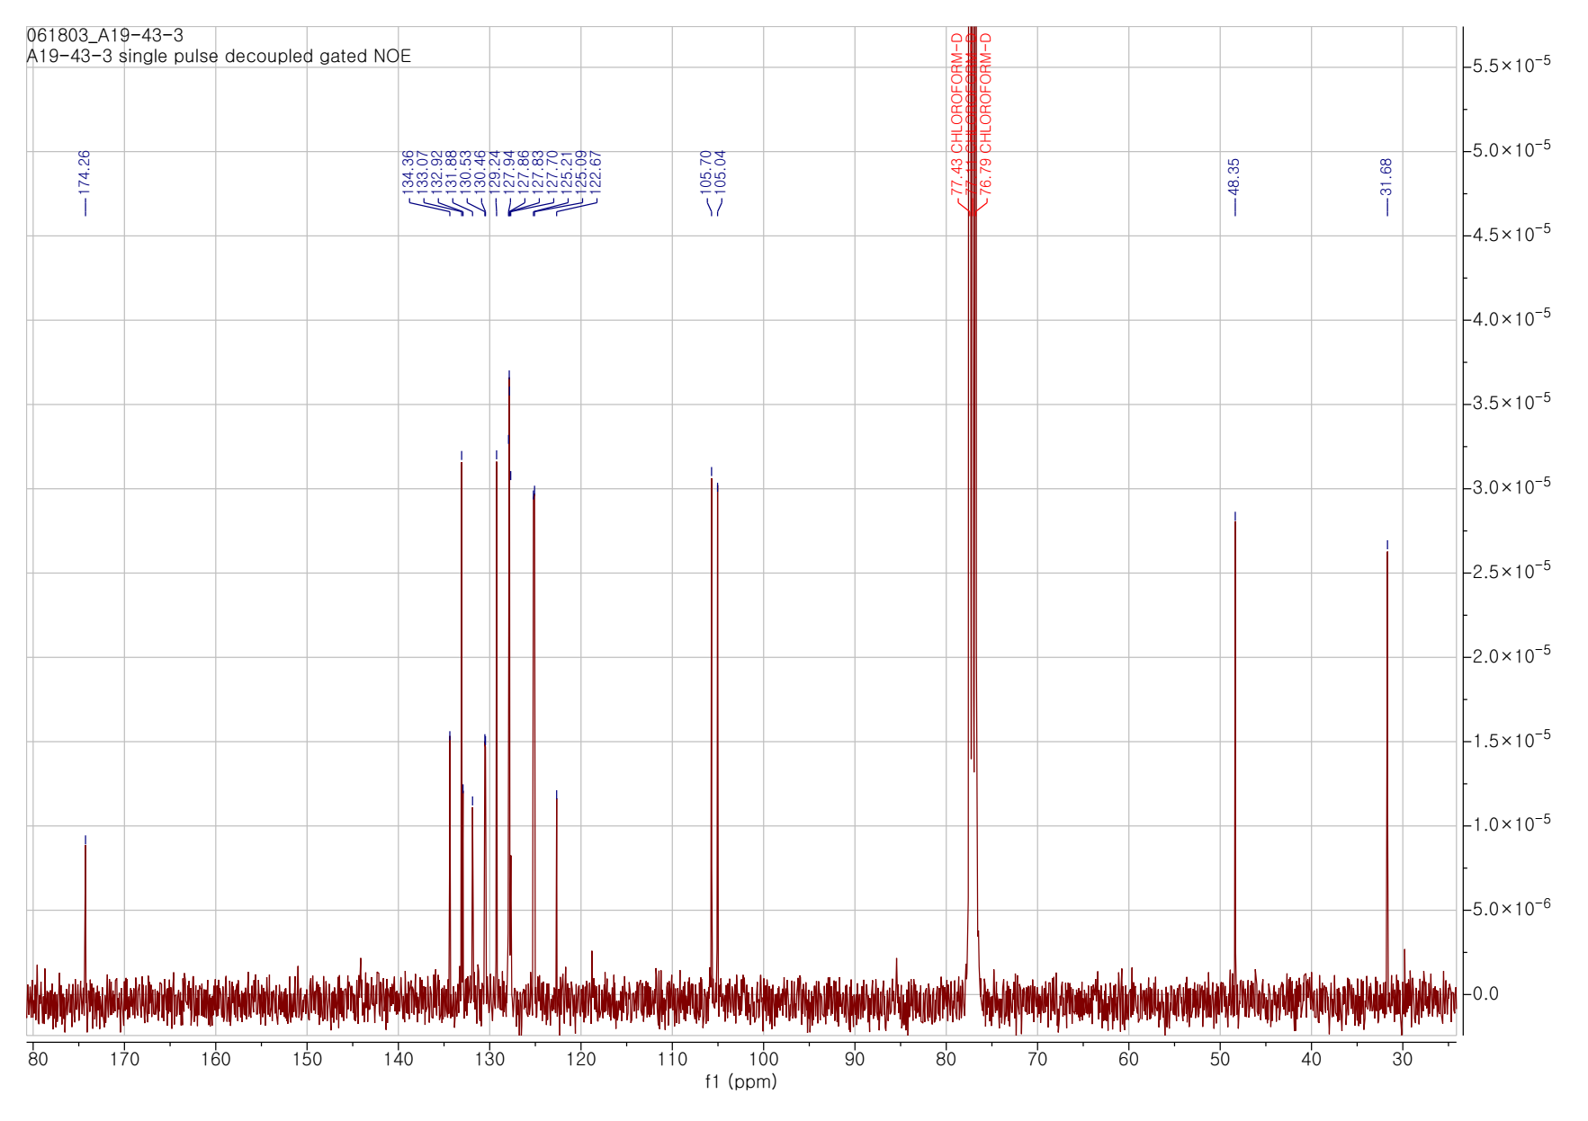
Figure S23. ¹H-NMR and ¹³C-NMR spectra of BSM in CHCl₃
a) Mass spectra of BSB  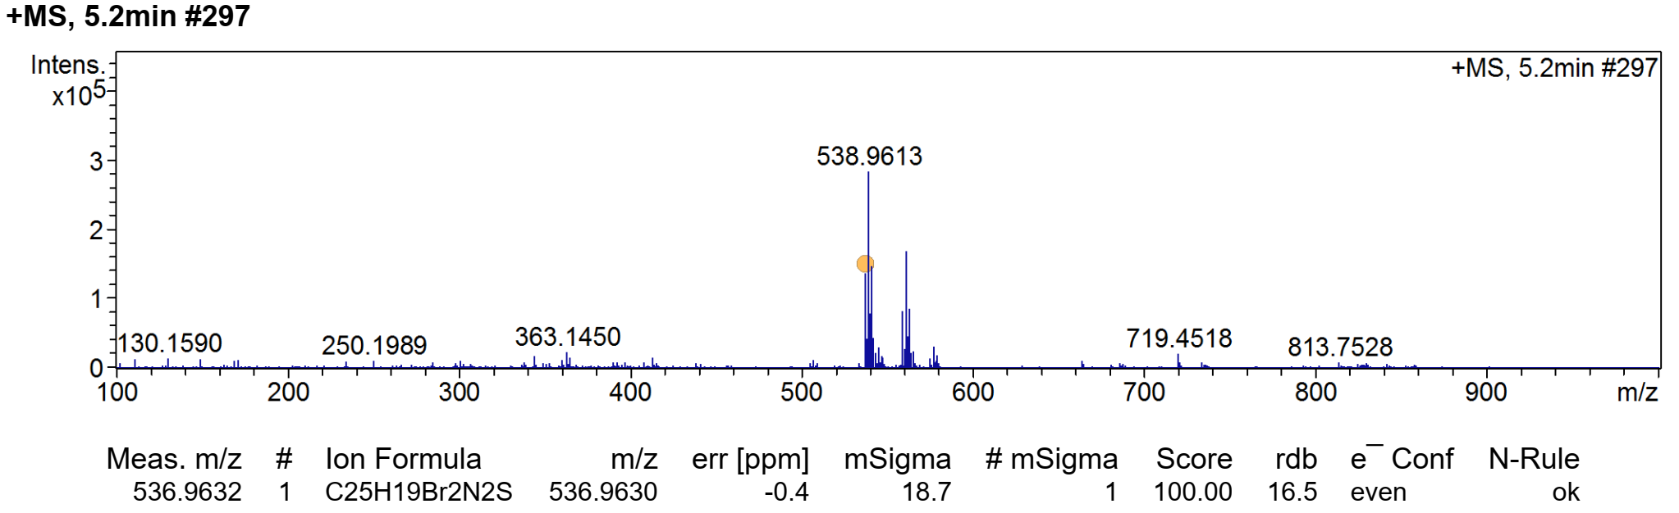 | b) Mass spectra of BSM  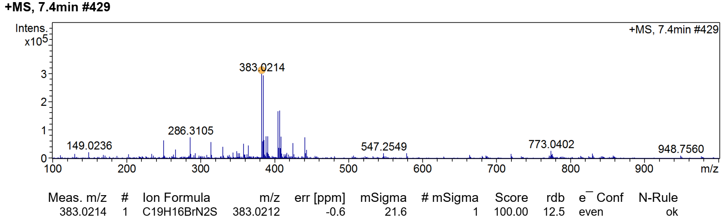
Figure S24. Mass spectra of (a) BSB and (b) BSM.

a) Mass spectra of CSB  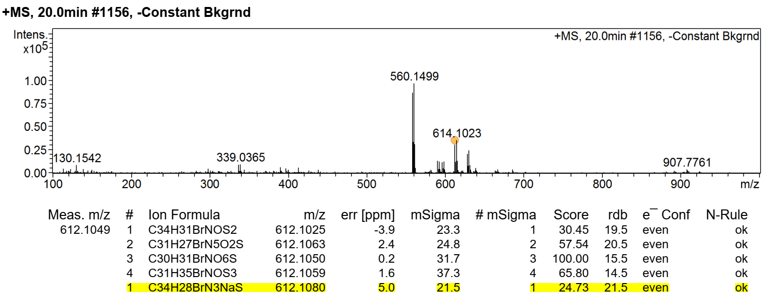 | b) Mass spectra of CSC  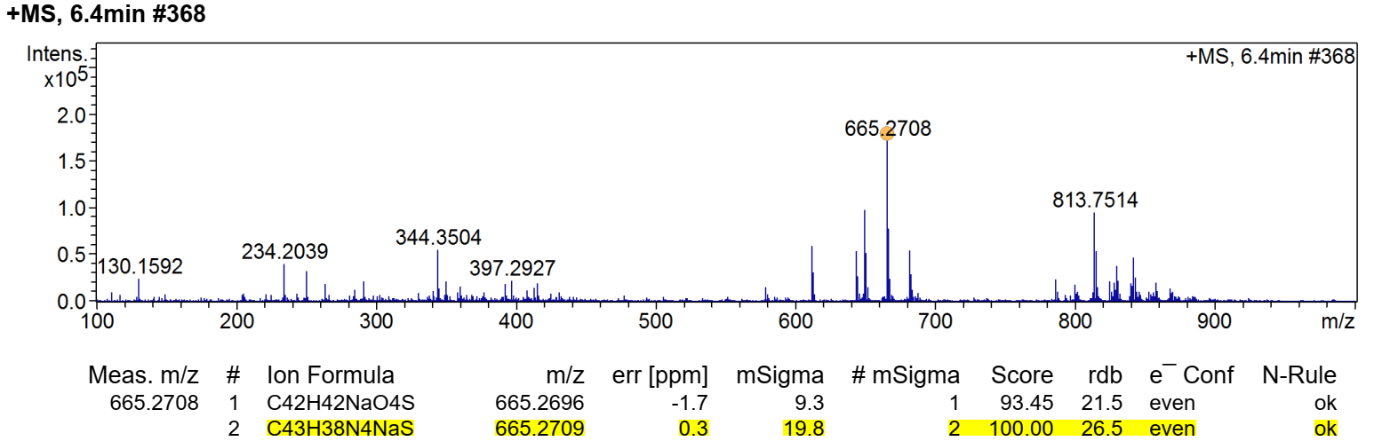
Figure S25. Mass spectra of (a) CSB and (b) CSC.
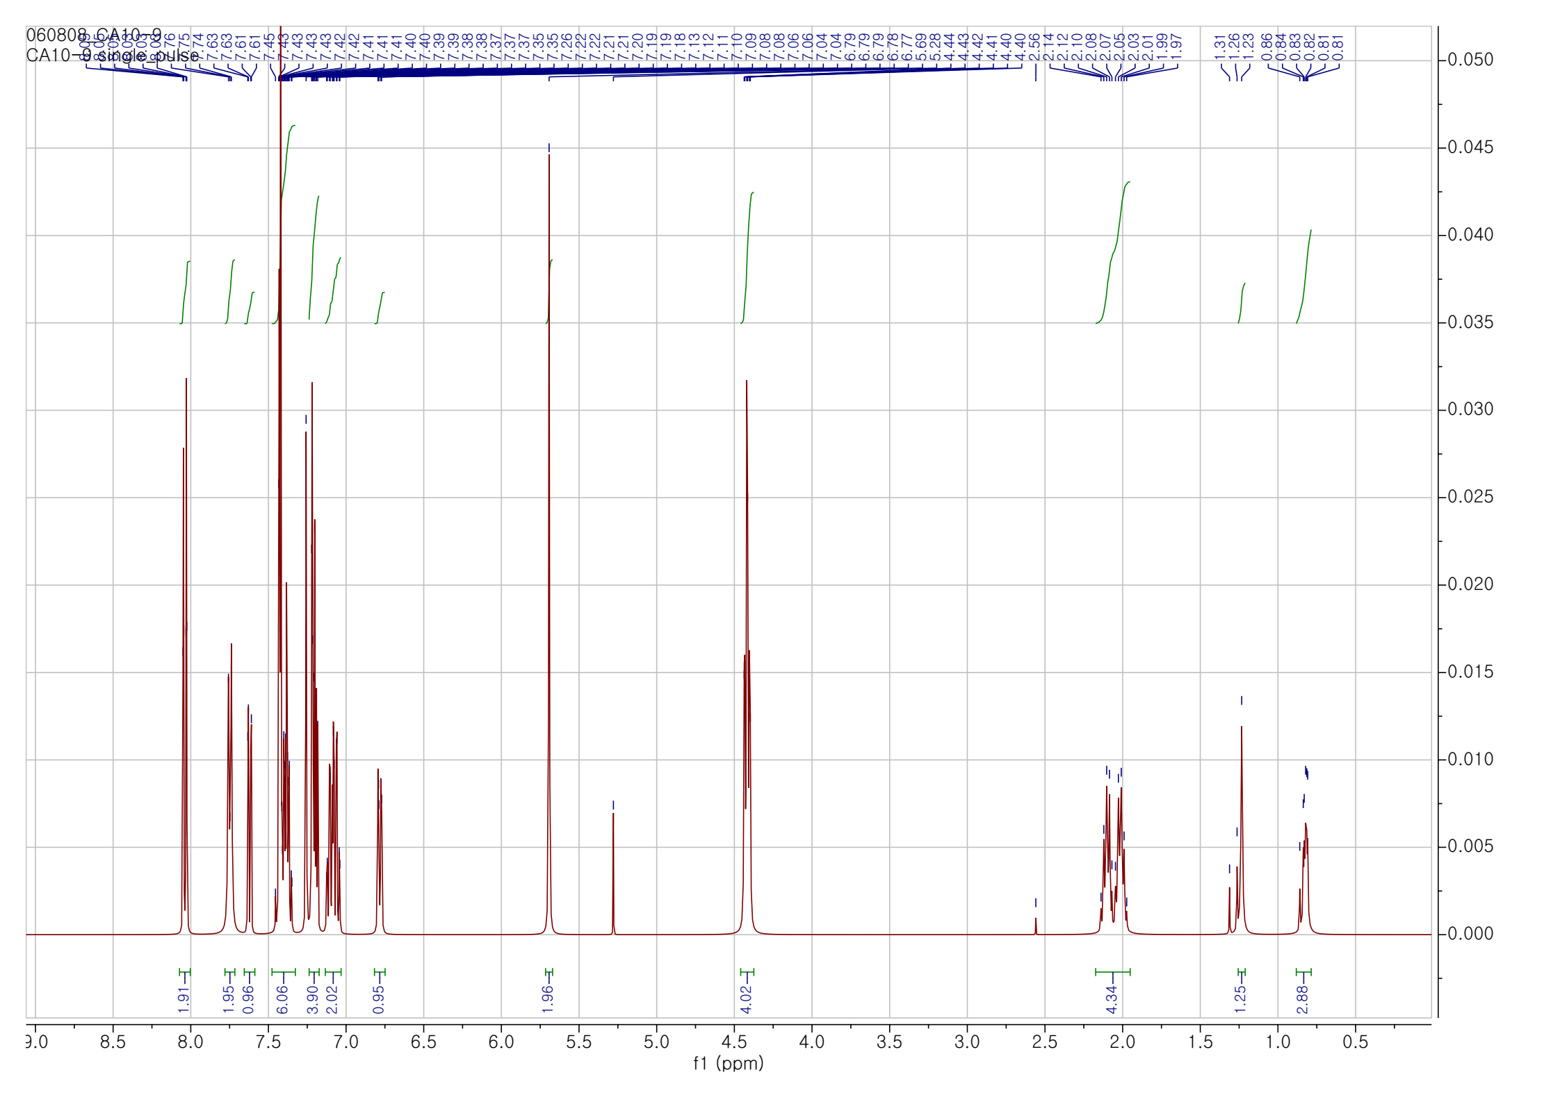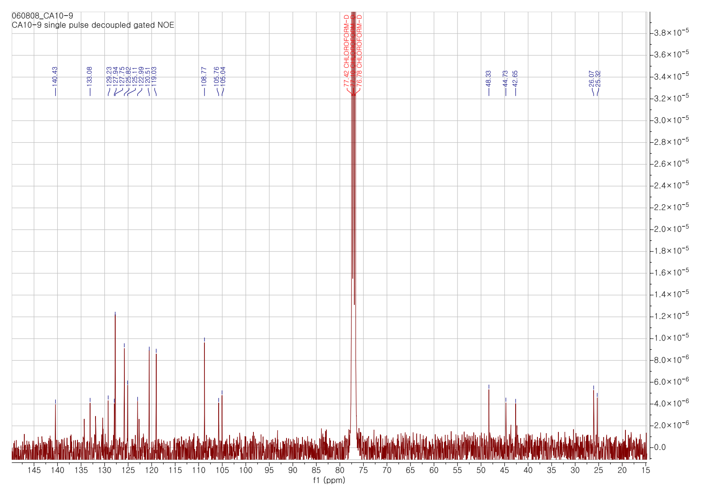
Figure S26. ¹H-NMR and ¹³C-NMR spectra of CSB in CHCl₃
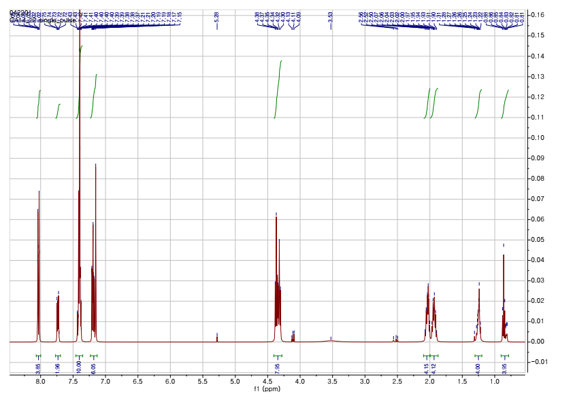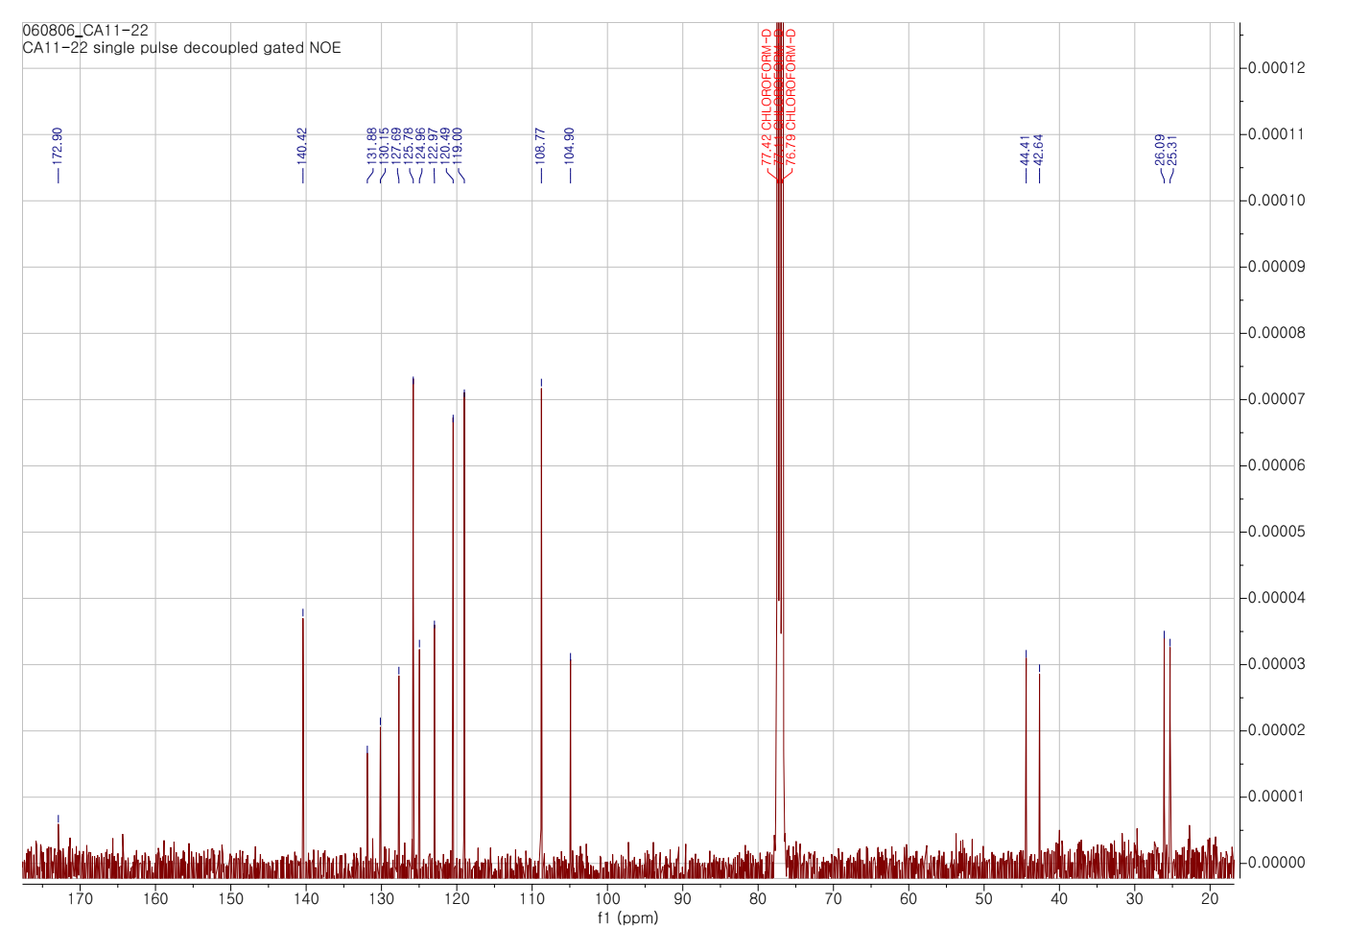
Figure S27. ¹H-NMR and ¹³C-NMR spectra of CSC in CHCl₃
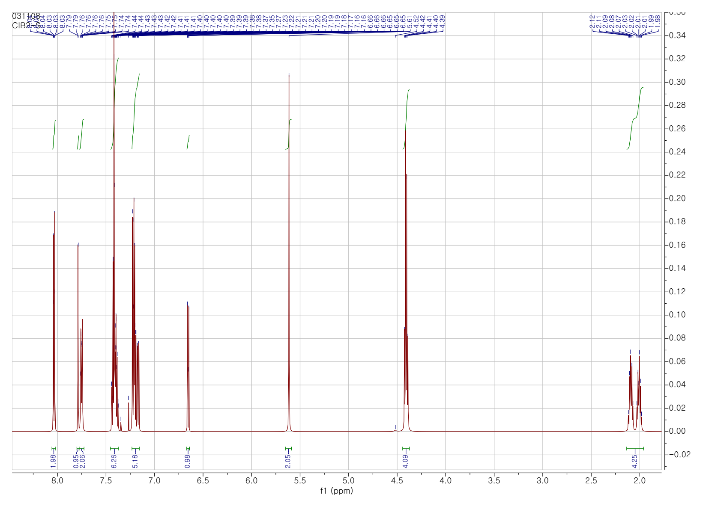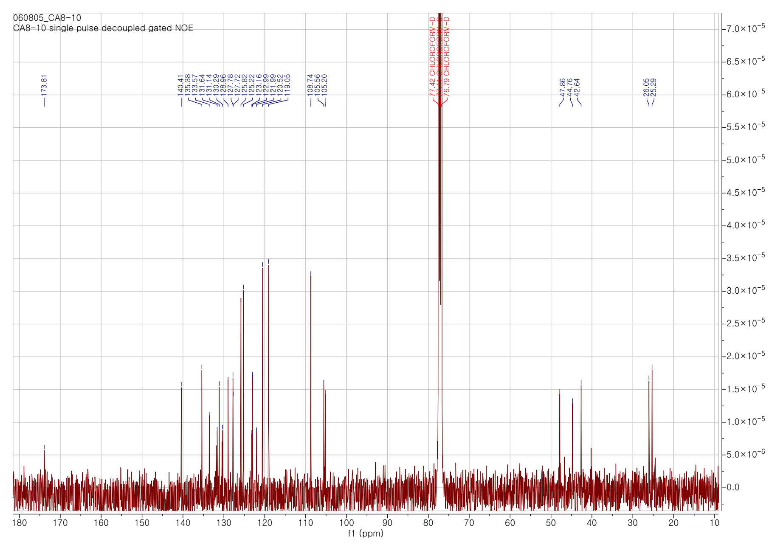
Figure S28. ¹H-NMR and ¹³C-NMR spectra of CSD in CHCl₃
a) Mass spectra of CSD  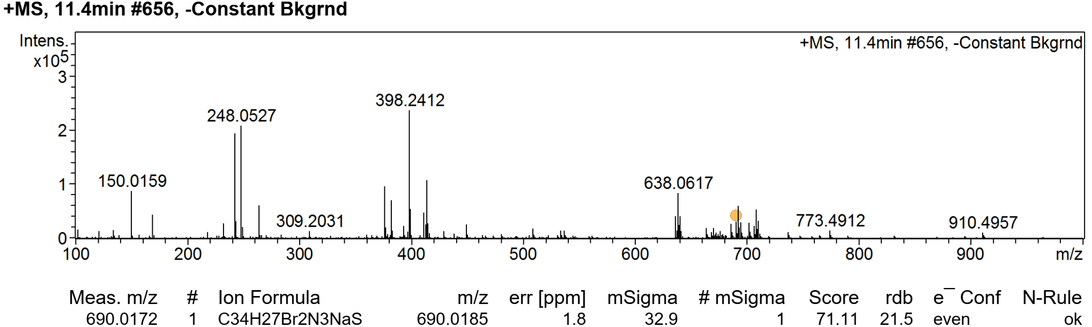 | b) Mass spectra of CSM  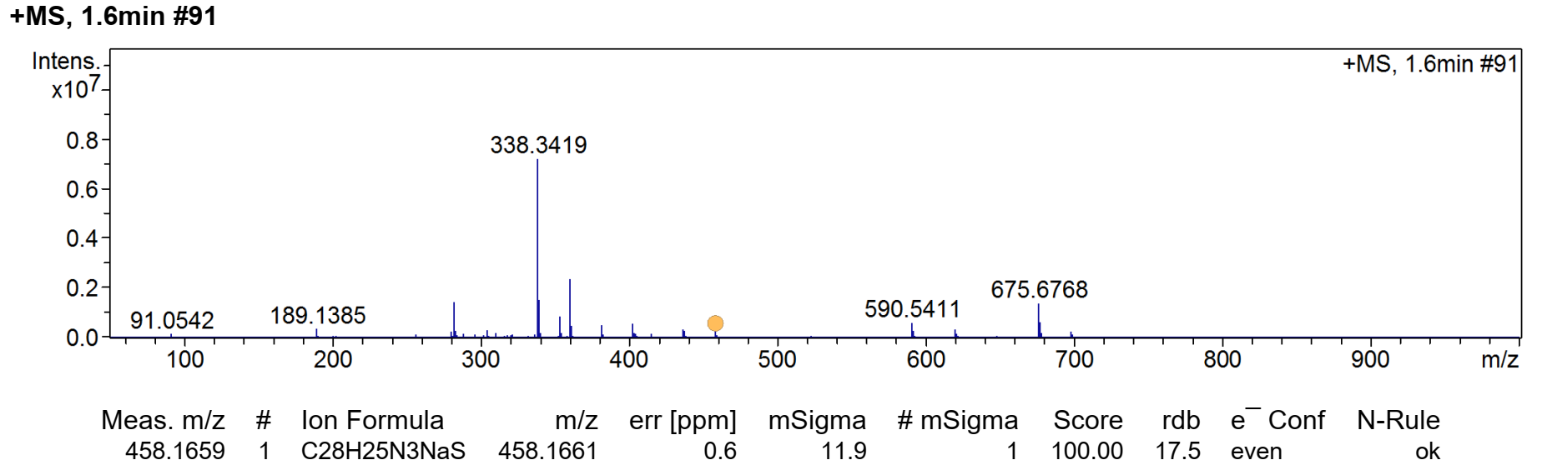
Figure S29. Mass spectra of (a) CSD and (b) CSM.
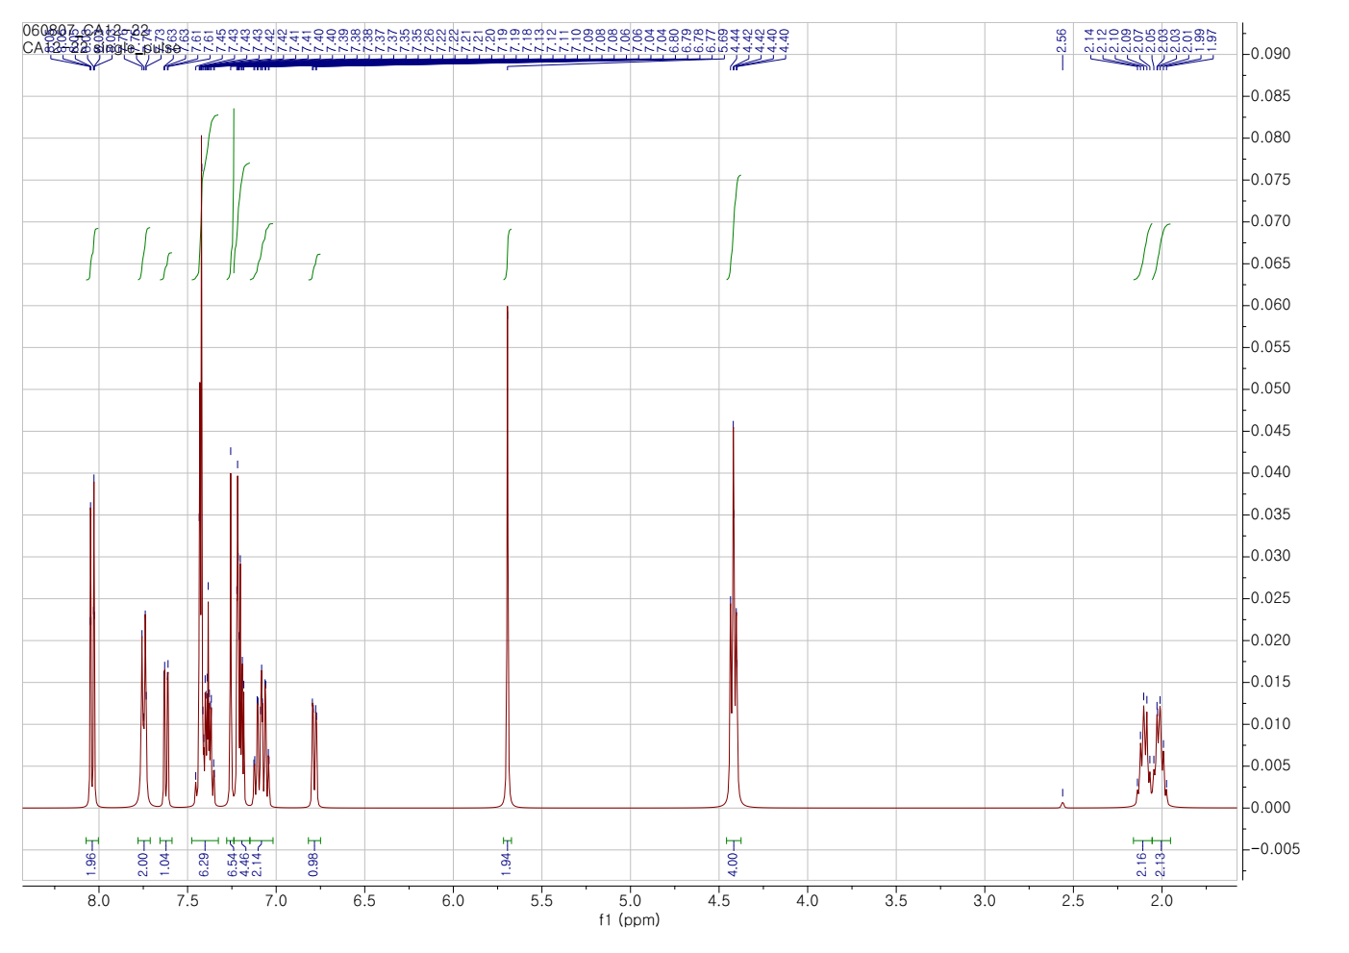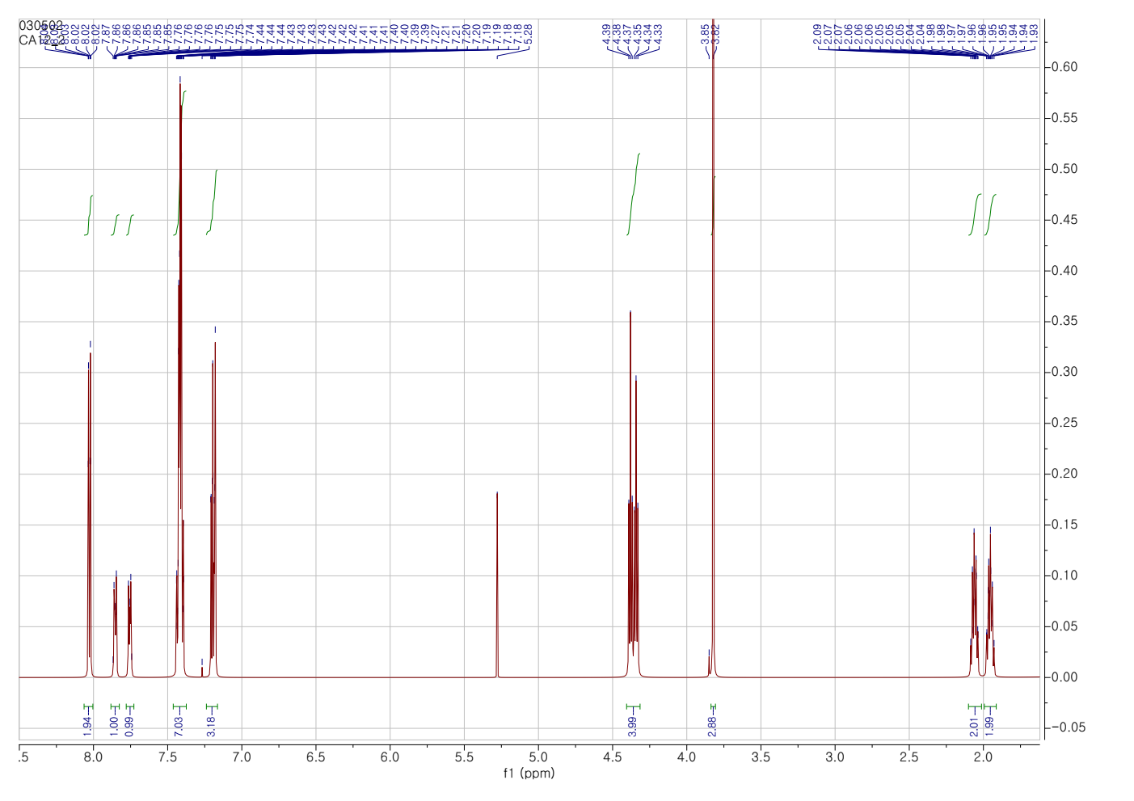
Figure S30. ¹H-NMR and ¹³C-NMR spectra of CSM in CHCl₃
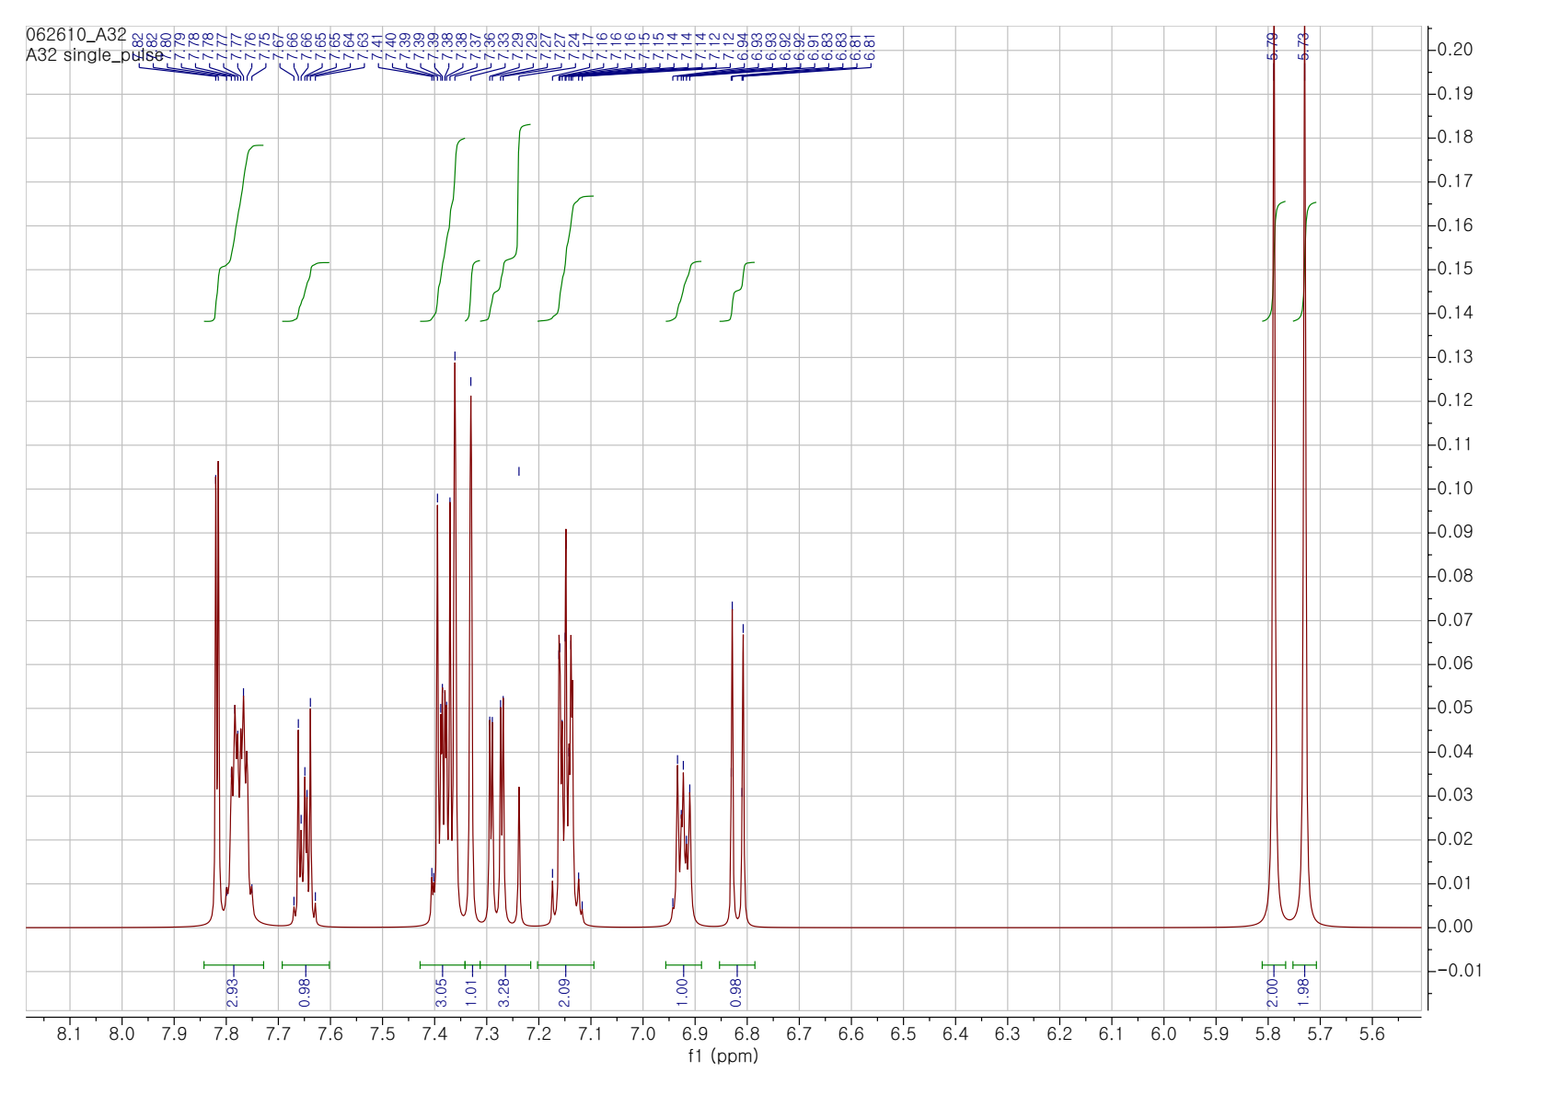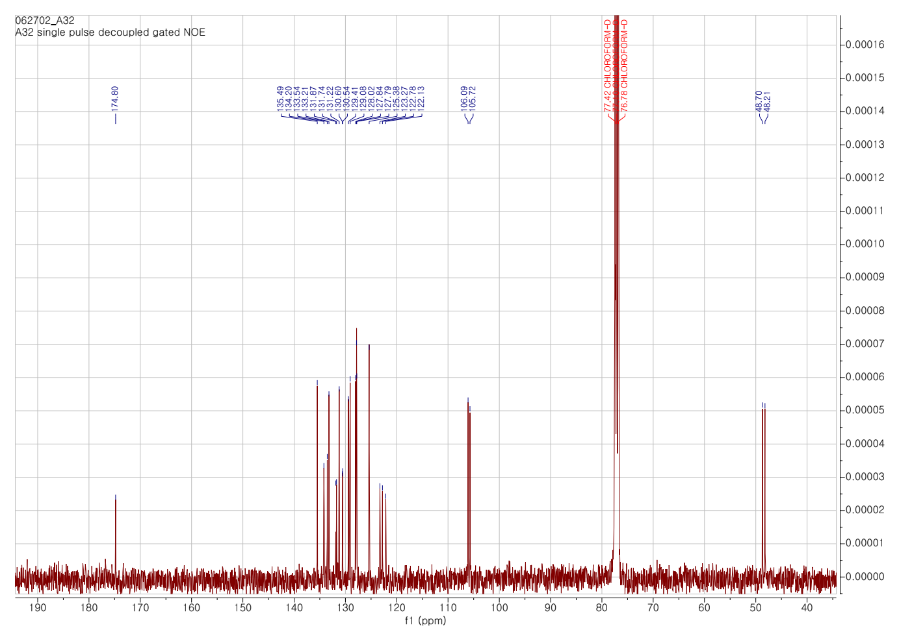
Figure S31. ¹H-NMR and ¹³C-NMR spectra of DSB in CHCl₃
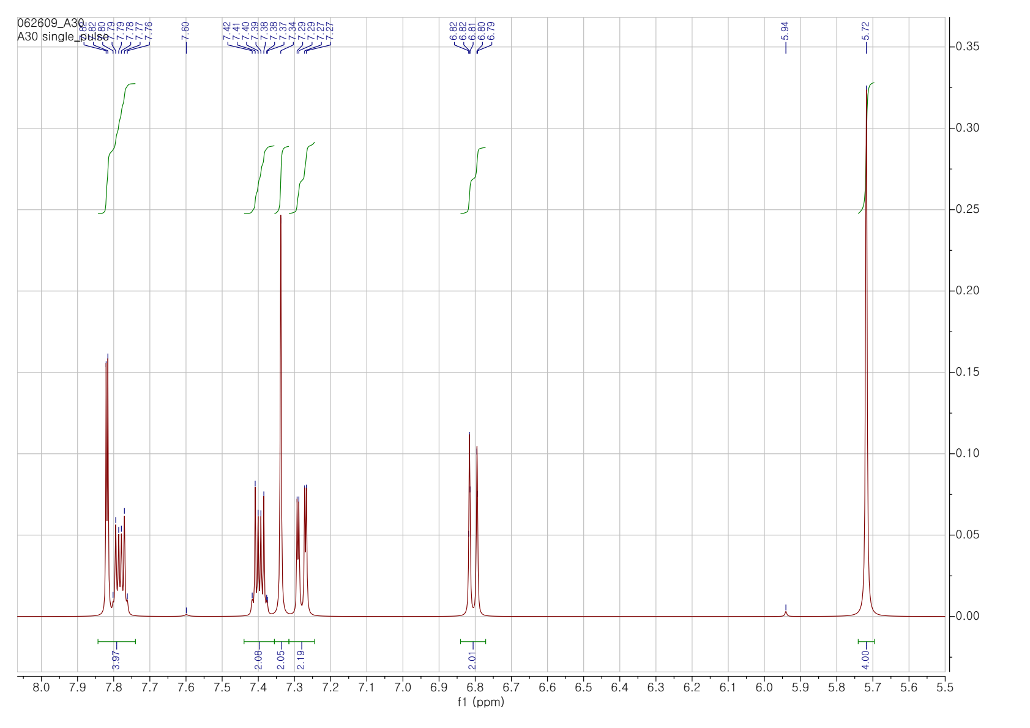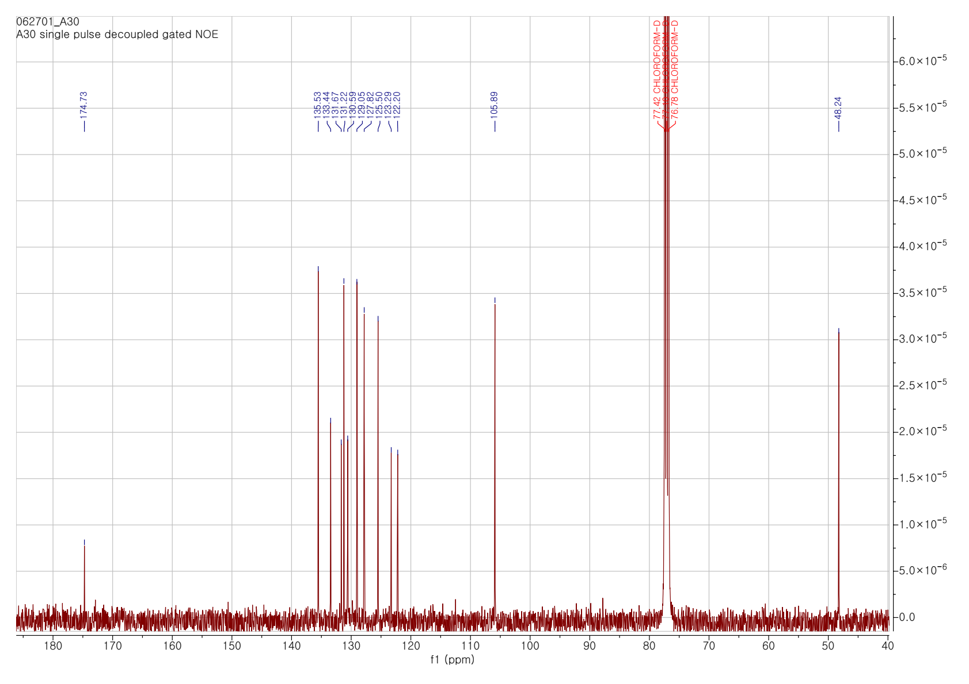
Figure S32. ¹H-NMR and ¹³C-NMR spectra of DSD in CHCl₃
a) Mass spectra of DSB  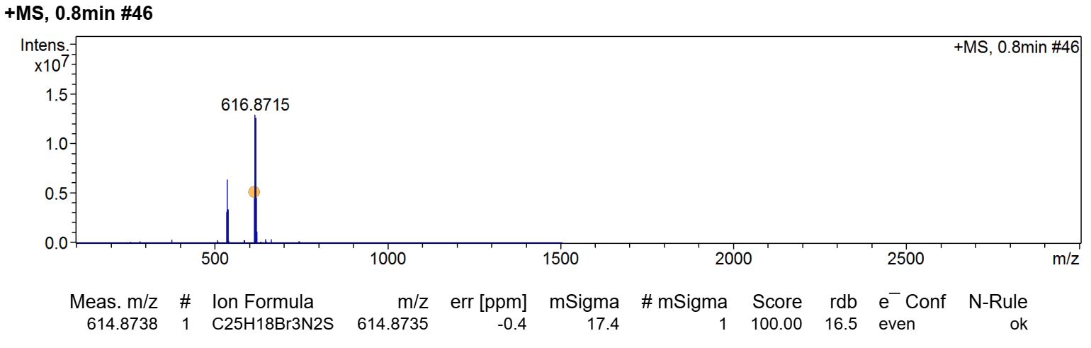 | b) Mass spectra of DSD  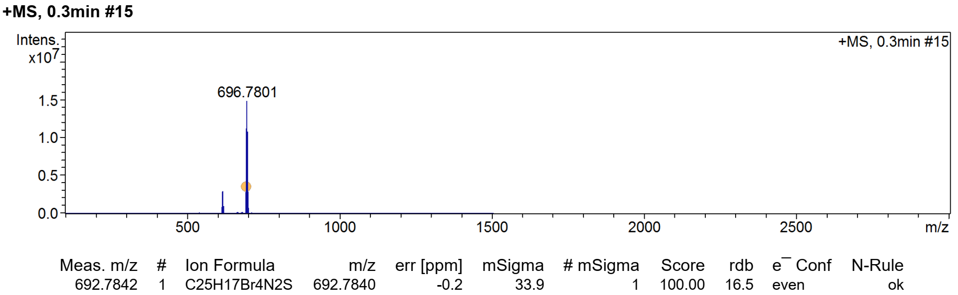
Figure S33. Mass spectra of (a) DSB and (b) DSD.
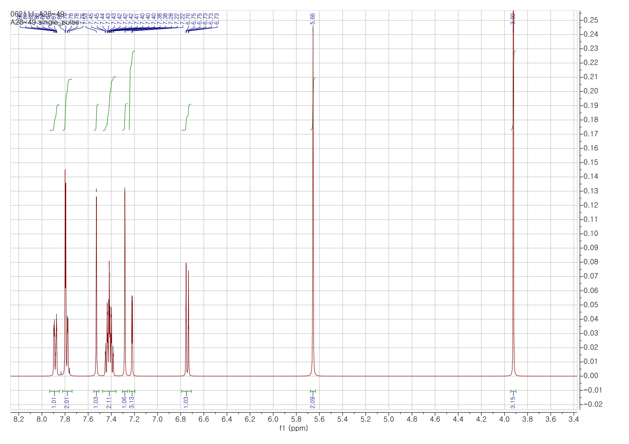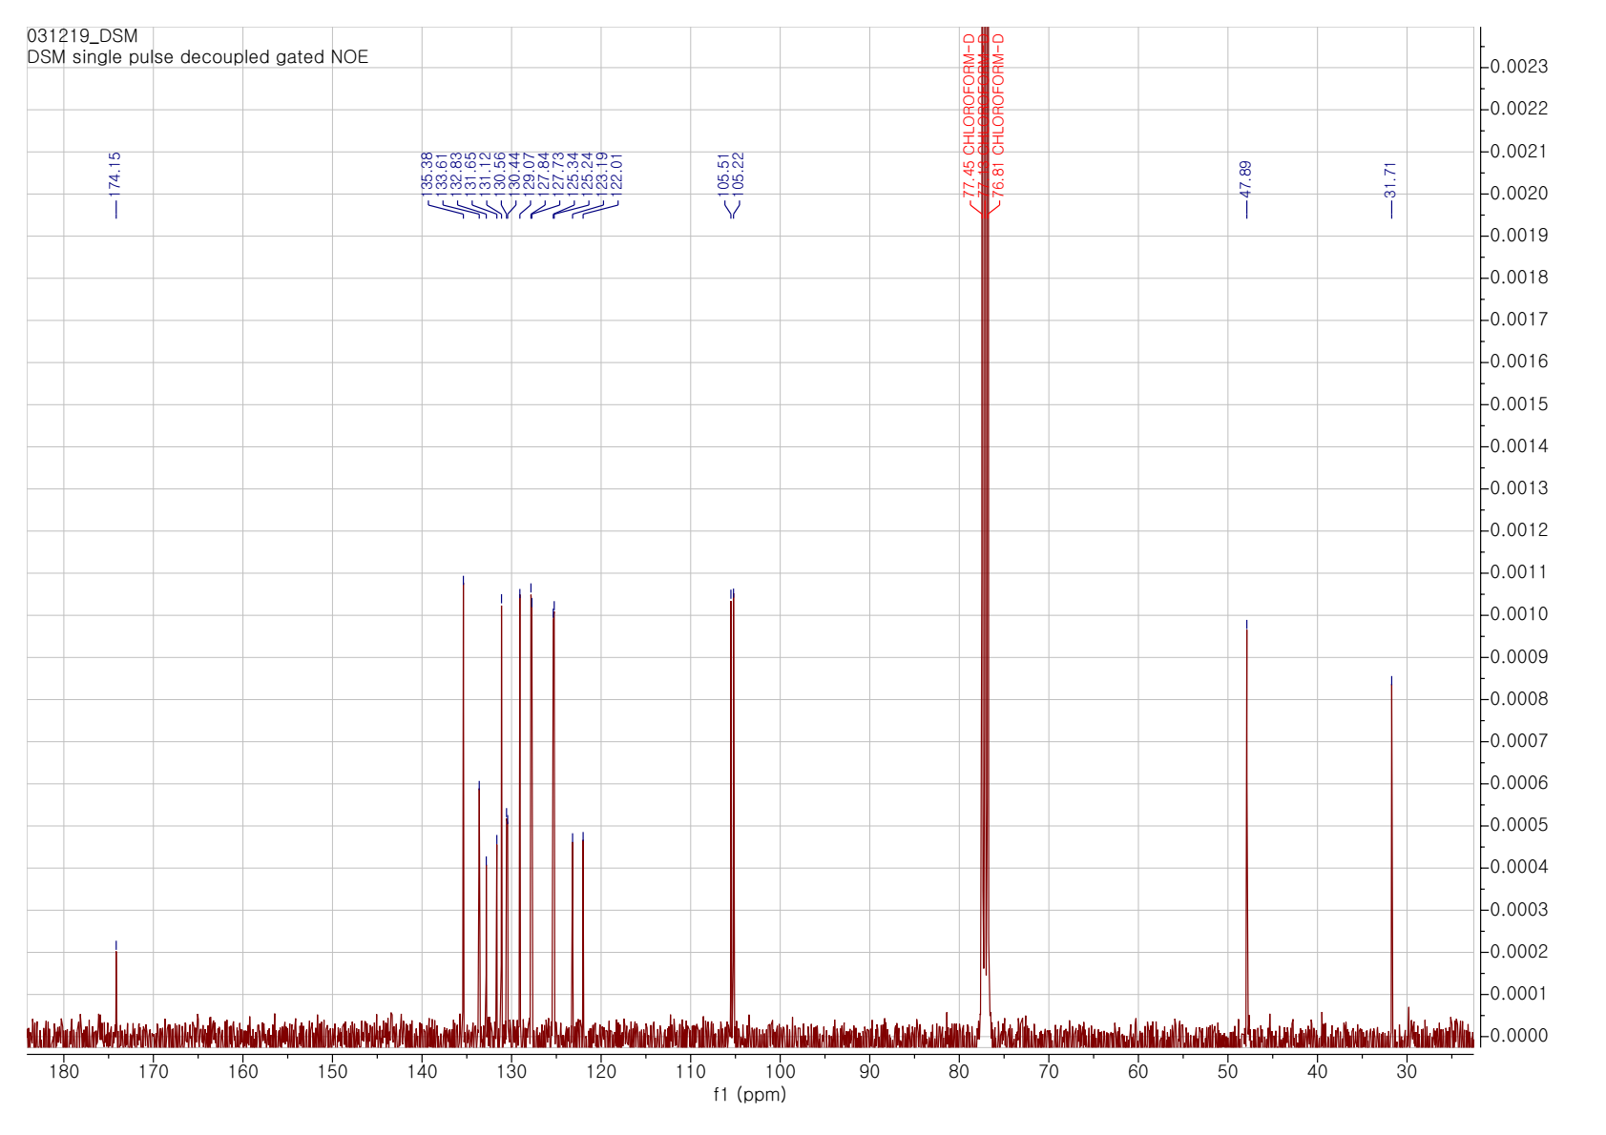
Figure S34. ¹H-NMR and ¹³C-NMR spectra of DSM in CHCl₃
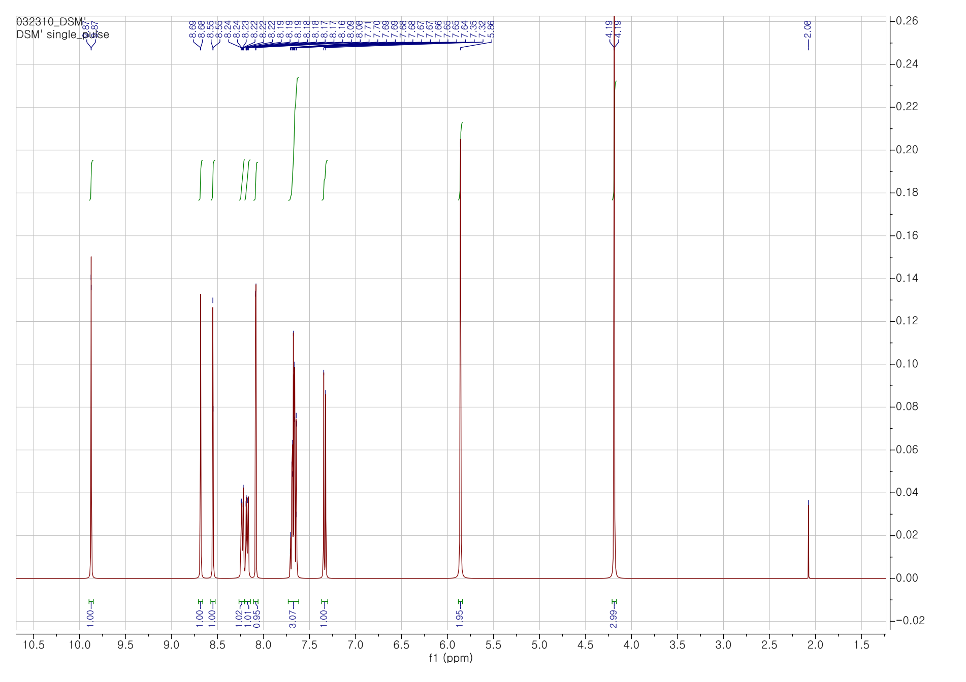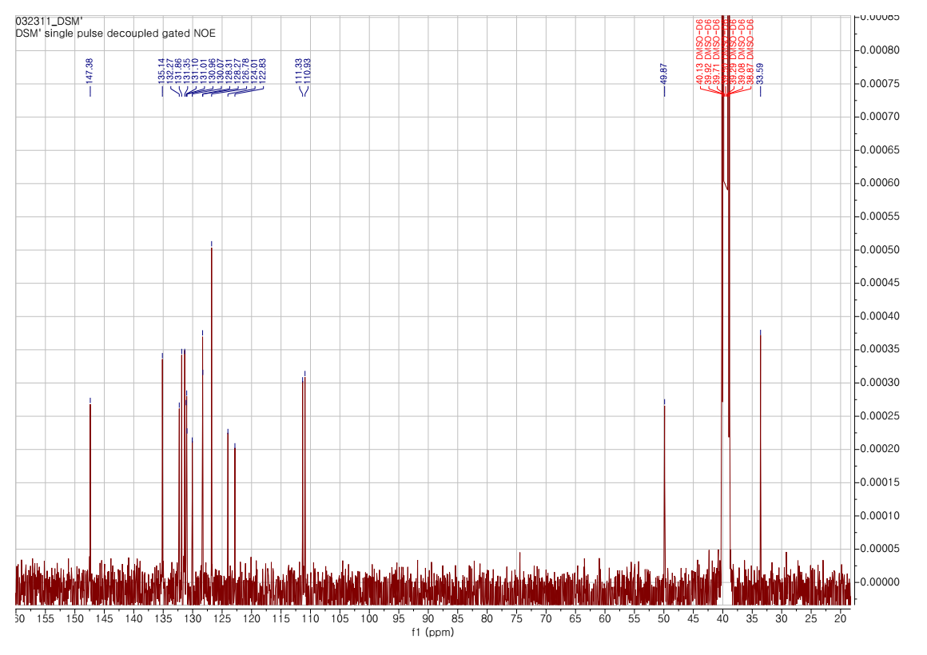
Figure S35. ¹H-NMR and ¹³C-NMR spectra of DSM’ (DIM) in DMSO
a) Mass spectra of DSM  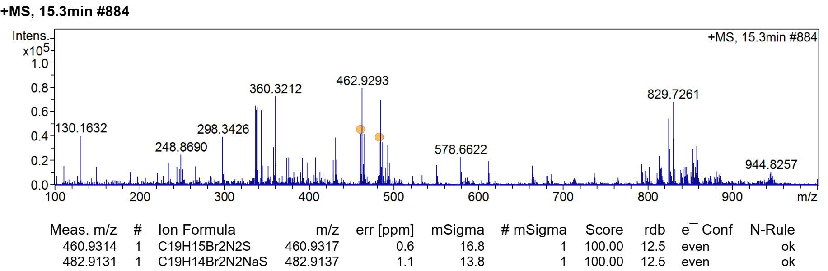 | b) Mass spectra of DSM’ (DIM)  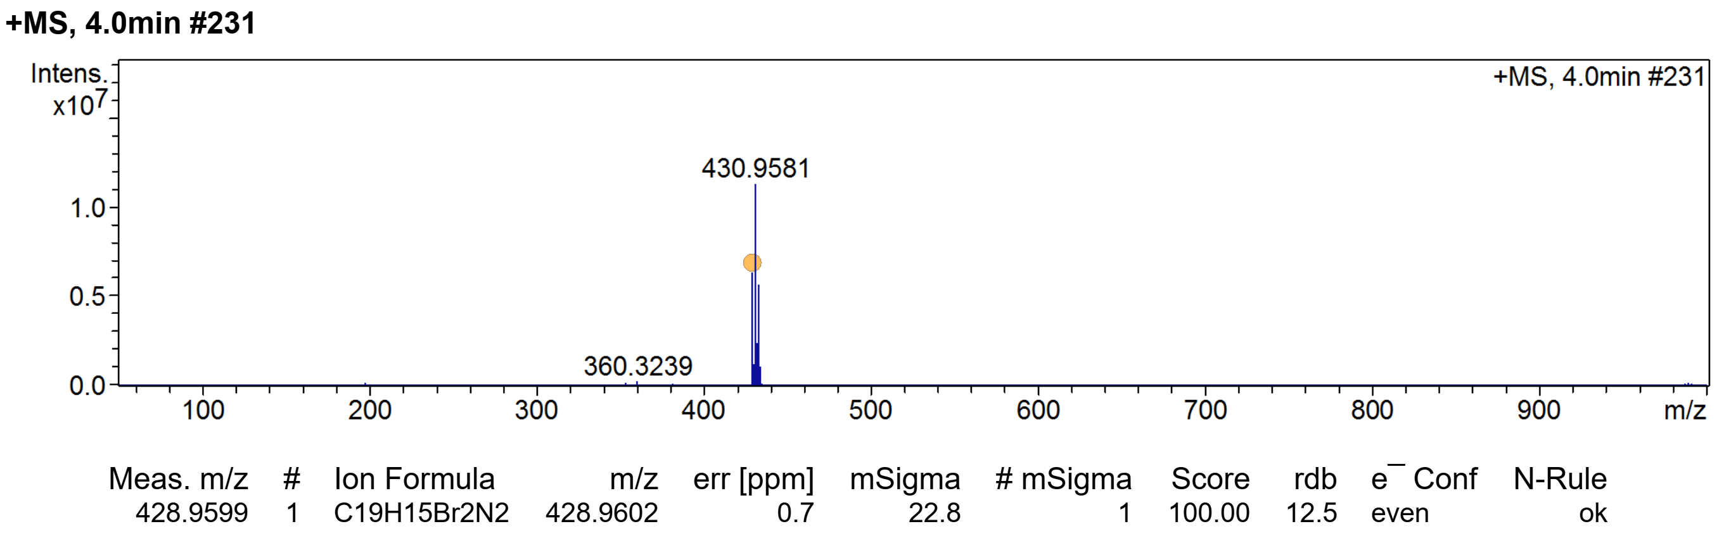
Figure S36. Mass spectra of (a) DSM and (b) DSM’ (DIM).

  - Crystallization data
Table S1. Crystal data of CIM and CIC.
 | CIM | CIC
Empirical formula | C29 H30 I N3 O | C45 H47 Br N4 O2
Formula weight | 563.46 | 755.77
Temperature | 173(2) K | 171(2) K
Wavelength | 0.700 Å | 0.650 Å
Crystal system | Monoclinic | Triclinic
Space group | P2₁ | P-1
Unit cell dimensions | a = 10.308(2) Å α= 90°.  b = 7.8540(16) Å β= 102.96(3)°.  c = 16.040(3) Å γ = 90°. | a = 8.4980(17) Å α= 84.53(3)°.  b = 10.255(2) Å β= 86.87(3)°.  c = 23.313(5) Å γ = 72.93(3)°.
Volume | 1265.5(5) Å3 | 1932.5(7) Å3
Z | 2 | 2
Density (calculated) | 1.479 Mg/m3 | 1.299 Mg/m3
Absorption coefficient | 1.225 mm-1 | 0.880 mm-1
F(000) | 572 | 792
Crystal size | 0.120 x 0.053 x 0.044 mm3 | 0.120 x 0.080 x 0.070 mm3
Theta range for data collection | 2.118 to 27.996°. | 1.606 to 30.000°.
Index ranges | -13<=h<=13, -10<=k<=10, -21<=l<=21 | -13<=h<=13, -15<=k<=15, -35<=l<=35
Reflections collected | 11493 | 29303
Independent reflections | 6350 [R(int) = 0.0633] | 14668 [R(int) = 0.0192]
Completeness to theta = | (24.835°) 99.3 % | (22.955°) 99.8 %
Absorption correction | Empirical | Empirical
Max. and min. transmission | 1.000 and 0.882 | 1.000 and 0.934
Refinement method | Full-matrix least-squares on F2 | Full-matrix least-squares on F2
Data / restraints / parameters | 6350 / 1 / 310 | 14668 / 0 / 474
Goodness-of-fit on F2 | 1.096 | 1.151
Final R indices [I>2sigma(I)] | R1 = 0.0394, wR2 = 0.1146 | R1 = 0.0624, wR2 = 0.1884
R indices (all data) | R1 = 0.0410, wR2 = 0.1156 | R1 = 0.0760, wR2 = 0.1963
Absolute structure parameter | -0.006(8)
Extinction coefficient | n/a | n/a
Largest diff. peak and hole | 1.533 and -0.765 e.Å-3 | 2.352 and -1.296 e.Å-3
CCDC deposition number | 2084935 | 2084931

a)  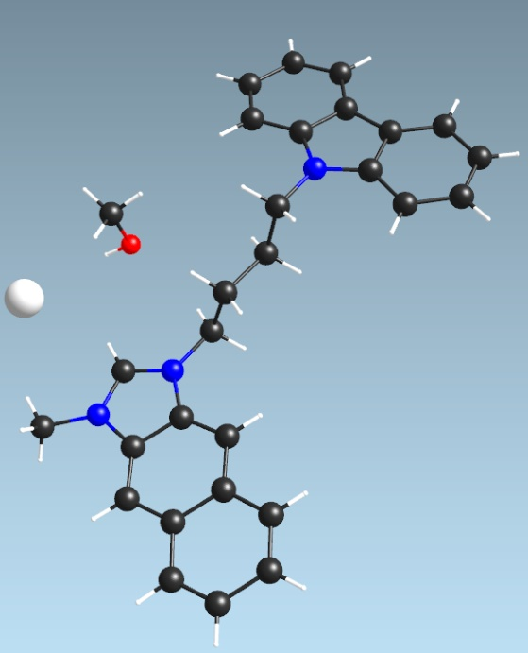 | b)  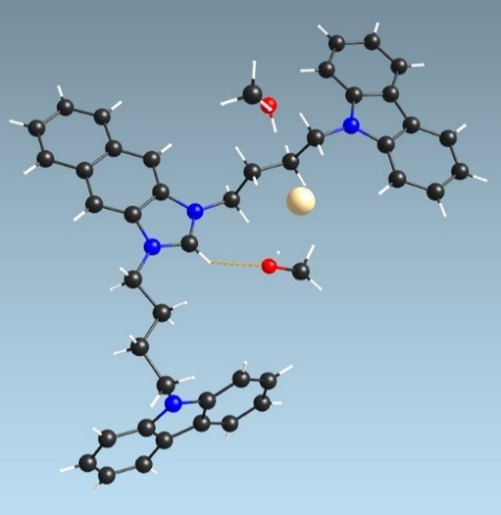
Figure S37. Crystal structure of (a) CIM and (b) CIC
c)  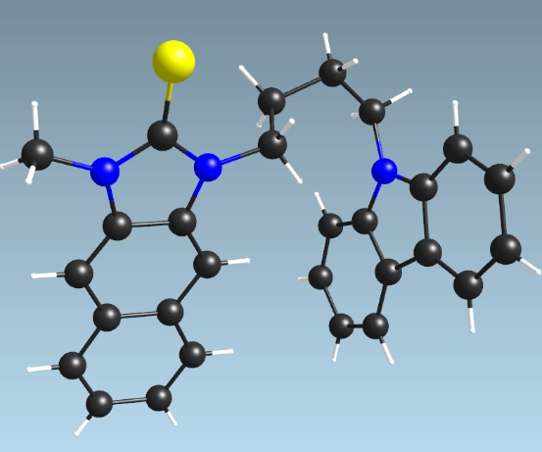 | d)  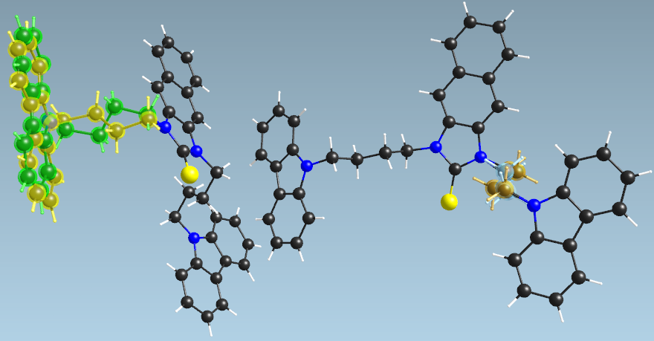
Figure S38. Crystal structure of (a) CSM and (b) CSC

Table S2. Crystal data of CSM and CSC.
 | CSM | CSC
Empirical formula | C28 H25 N3 S | _{C43 H38 N4 S}
Formula weight | 435.57 | 642.83
Temperature | 173(2) K | 173(2) K
Wavelength | 0.650 Å | 0.800 Å
Crystal system | Monoclinic | Triclinic
Space group | P2₁/n | P-1
Unit cell dimensions | a = 9.6770(19) Å α= 90°  b = 14.016(3) Å β= 90.67(3)°  c = 16.317(3) Å γ = 90° | a = 9.3930(19) Å α= 89.06(3)°.  b = 15.420(3) Å β= 86.63(3)°.  c = 23.453(5) Å γ = 84.27(3)°.
Volume | 2213.0(8) Å3 | 3373.9(12) Å3
Z | 4 | 4
Density (calculated) | 1.307 Mg/m3 | 1.266 Mg/m3
Absorption coefficient | 0.133 mm-1 | 0.177 mm-1
F(000) | 920 | 1360
Crystal size | 0.300 x 0.120 x 0.100 mm3 | 0.110 x 0.020 x 0.019 mm3
Theta range for data collection | 2.226 to 25.998°. | 1.494 to 28.000°.
Index ranges | -13<=h<=13, -18<=k<=18, -21<=l<=22 | -11<=h<=11, -18<=k<=18, -27<=l<=27
Reflections collected | 18790 | 22674
Independent reflections | 5588 [R(int) = 0.1117] | 11358 [R(int) = 0.0400]
Completeness to theta | 22.955° - 98.0 % | 28.000° - 99.6 %
Absorption correction | Empirical | Empirical
Max. and min. transmission | 1.000 and 0.923 | 1.000 and 0.859
Refinement method | Full-matrix least-squares on F2 | Full-matrix least-squares on F2
Data / restraints / parameters | 5588 / 0 / 290 | 11358 / 825 / 1009
Goodness-of-fit on F2 | 1.065 | 1.724
Final R indices [I>2sigma(I)] | R1 = 0.0776, wR2 = 0.2205 | R1 = 0.1376, wR2 = 0.4293
R indices (all data) | R1 = 0.0835, wR2 = 0.2291 | R1 = 0.1672, wR2 = 0.4424
Extinction coefficient | n/a | 0.017(4)
Largest diff. peak and hole | 1.023 and -0.422 e.Å-3 | 0.549 and -0.817 e.Å-3
CCDC deposition number | 2084934 | 2084933

  - Photophysical results
a) | b)
Figure S39. UV-Vis (dot line) and Fluorescence emission (dash dot line) spectra of (a) BIB (80 µM, λ_{ex} = 325 nm) and (b) BSB (20 µM, λ_{ex} = 350 nm) in several solvent.
a) | b)
Figure S40. UV-Vis (dot line) and Fluorescence emission (dash dot line) spectra of (a) BIM (80 µM, λ_{ex} = 325 nm) and (b) BSM (10 µM, λ_{ex} = 350 nm) in several solvent.

a) | b)
Figure S41. UV-Vis (dot line) and Fluorescence emission (dash dot line) spectra of (a) CIB (80 µM, λ_{ex} = 325 nm) and (b) CSB (10 µM, λ_{ex} = 350 nm) in several solvent.
a) | b)
Figure S42. UV-Vis (dot line) and Fluorescence emission (dash dot line) spectra of (a) CIC (80 µM, λ_{ex} = 325 nm) and (b) CSC (10 µM, λ_{ex} = 350 nm) in several solvent.

a) | b)
Figure S43. UV-Vis (dot line) and Fluorescence emission (dash dot line) spectra of (a) CID (80 µM, λ_{ex} = 325 nm) and (b) CSD (20 µM, λ_{ex} = 350 nm) in several solvent.
a) | b)
Figure S44. UV-Vis (dot line) and Fluorescence emission (dash dot line) spectra of (a) CIM (80 µM, λ_{ex} = 325 nm) and (b) CSM (20 µM, λ_{ex} = 350 nm) in several solvent.

a) | b)
Figure S45. UV-Vis (dot line) and Fluorescence emission (dash dot line) spectra of (a) DIB (80 µM, λ_{ex} = 325 nm) and (b) DSB (10 µM, λ_{ex} = 350 nm) in several solvent.
a) | b)
Figure S46. UV-Vis (dot line) and Fluorescence emission (dash dot line) spectra of (a) DID (80 µM, λ_{ex} = 325 nm) and (b) DSD (20 µM, λ_{ex} = 350 nm) in several solvent.

a) | b)
Figure S47. UV-Vis (dot line) and Fluorescence emission (dash dot line) spectra of (a) DIM (80 µM, λ_{ex} = 325 nm) and (b) DSM (10 µM, λ_{ex} = 350 nm) in several solvent.
a) | b)  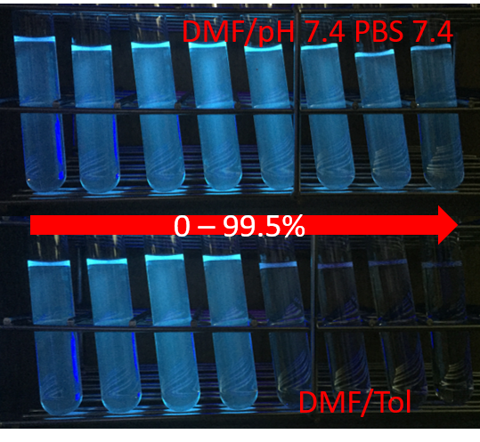
Figure S48. (a) The fluorescence emission spectra of DIM (5 µM) in DMF/pH 7.4 PBS buffer (0 - 99.5%); (b) the emission under UV-365 nm irradiation DIM (5 µM) in DMF/pH 7.4 PBS buffer and DMF/Tol (0 - 99.5%).

a) | b)
c) | d)  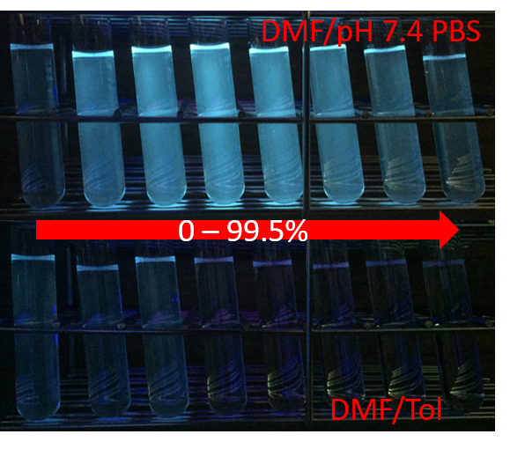
Figure S49. The fluorescence emission spectra of DID (5 µM) in (a) DMF/pH 7.4 PBS buffer and (b) DMF/Tol (0 - 99.5%); (c) the fluorescence emission intensity and (d) the emission under UV-365 nm irradiation of DID (5 µM) in DMF/ pH 7.4 PBS buffer and DMF/Tol (0 - 99.5%).

a) | b)
Figure S50. (a) Fluorescence emission spectra (λ_{ex} = 325 nm; slit 5/5) of DSD (5 µM) upon the treatment of ClO⁻ (0 - 80 µM) in pH 7.4 PBS buffer (0.05 % DMF); (b) Plot of fluorescence intensity of DSM (5 µM) upon the treatment of ClO⁻ (0 - 55 µM) in pH 7.4 PBS buffer (0.05 % DMF).
a) | b)
Figure S51. (a) UV-vis absorbance and (b) fluorescence emission (λ_{ex} = 325 nm, slit 5/5) spectra of DSM (5 µM) upon the treatment of ClO⁻ (50 µM); ROO• (1 mM); NO• (1 mM), H₂O₂ (1 mM), TBHP (1 mM), ONOO⁻ (200 µM) and •OH (200 µM) in pH 7.4 PBS buffer (0.05 % DMF).

  - Computational calculation results
Table S1. Molecular orbital and energies of BIB and BSB, BIM and BSM, CIB and CSB.
 | BIB | BSB | BIM | BSM
LUMO+2 | -3.88 eV | -0.90 eV | -3.83 eV | -0.83 eV
LUMO+1 | -3.91 eV | -0.94 eV | -4.04 eV | -0.89 eV
LUMO | -5.09 eV | -1.75 eV | -5.34 eV | -1.72 eV
HOMO | -8.95 eV | -5.87 eV | -9.13 eV | -5.80 eV
HOMO-1 | -9.75 eV | -6.05 eV | -9.90 eV | -6.02 eV
HOMO-2 | -9.78 eV | -6.20 eV | -10.04 eV | -6.14 eV
Table S2. Molecular orbital and energies of CIB and CSB, CID and CSD.
 | CIB | CSB | CID | CSD
LUMO+2 | -3.82 eV | -0.93 eV | -4.03 eV | -1.15 eV
LUMO+1 | -4.03 eV | 1.11 eV | -4.20 eV | -1.23 eV
LUMO | -5.29 eV | -1.79 eV | -5.35 eV | -1.86 eV
HOMO | -7.30 eV | -5.63 eV | -7.31 eV | -5.65 eV
HOMO-1 | -7.59 eV | -5.88 eV | -7.60 eV | -5.96 eV
HOMO-2 | -8.64 eV | -5.98 eV | -8.65 eV | -6.00 eV
Table S3. Molecular orbital and energies of CIC and CSC
 | CIC | CSC
LUMO+2 | -3.72 eV | -1.12 eV
LUMO+1 | -3.96 eV | -1.13 eV
LUMO | -5.50 eV | -1.82 eV
HOMO | -7.35 eV | -5.63 eV
HOMO-1 | -7.36 eV | -5.64 eV
HOMO-2 | -7.64 eV | -5.89 eV
Table S4. Molecular orbital and energies of CIM and CSM, DIB and DSB.
 | CIM | CSM | DIB | DSB
LUMO+2 | -3.79 eV | -0.58 eV | -3.95 eV | -1.15 eV
LUMO+1 | -4.00 eV | -1.09 eV | -4.10 eV | -1.22 eV
LUMO | -5.57 eV | -1.75 eV | -5.14 eV | -1.82 eV
HOMO | -7.37 eV | -5.61 eV | -9.00 eV | -5.95 eV
HOMO-1 | -7.65 eV | -5.81 eV | -9.67 eV | -6.13 eV
HOMO-2 | -8.70 eV | -5.97 eV | -9.80 eV | -6.29 eV
Table S5. Molecular orbital and energies of DID and DSD, DIM and DSM.
 | DID | DSD | DIM | DSM
LUMO+2 | -4.11 eV | -1.25 eV | -4.04 eV | -1.11 eV
LUMO+1 | -4.15 eV | -1.28 eV | -4.22 eV | -1.19 eV
LUMO | -5.19 eV | -1.90 eV | -5.40 eV | -1.80 eV
HOMO | -9.04 eV | -6.04 eV | -9.17 eV | -5.89 eV
HOMO-1 | -9.69 eV | -6.21 eV | -9.77 eV | -6.10 eV
HOMO-2 | -9.70 eV | -6.38 eV | -10.09 eV | -6.23 eV
Table S6. Excitation energy (eV) with significant oscillator strength (f) for the R₁IR₂ molecules predicted using different DFT functionals with 6-31+G(2d,p) basis set.
 | BIB | BIM | CIB | CIC | CID
Expt. | 3.7754 eV | 3.8267 eV | 3.8149 eV | 3.7800 eV | 3.8126 eV
LSDA | 3.1504 eV  f=0.0485 | 3.9721 eV  f=0.0846 | 3.1343 eV  f=0.0528 | 3.1308 eV  f=0.0611 | 3.1255 eV  f=0.0556
BVP86 | 3.1723 eV  f=0.0495 | 3.9822 eV  f=0.0742 | 3.1572 eV  f=0.0547 | 3.1508 eV  f=0.0628 | 3.1454 eV  f=0.0542
B3LYP | 4.1823 eV  f=0.1082 | 4.1948 eV  f=0.0982 | 4.1895 eV  f=0.0910 | 3.5262 eV  f=0.0977 | 3.5244 eV  f=0.0843
CAM-B3LYP | 3.9624 eV  f=0.1178 | 3.9625 eV  f=0.1229 | 3.9506 eV  f=0.1351 | 3.9413 eV  f=0.1577 | 3.9443 eV  f=0.1357
B3PW91 | 4.2083 eV  f=0.1034 | 4.2223 eV  f=0.0935 | 3.2169 eV  f=0.0870 | 3.5597 eV  f=0.0984 | 3.5556 eV  f=0.0847
MPW1PW91 | 4.2762 eV  f=0.1076 | 4.2830 eV  f=0.0941 | 3.6512 eV  f=0.0922 | 3.6449 eV  f=0.1054 | 4.2758 eV  f=0.0935
PBEPBE | 3.1751 eV  f=0.0485 | 3.9796 eV  f=0.0762 | 3.1570 eV  f=0.0541 | 3.1477 eV  f=0.0627 | 3.1458 eV  f=0.0551
HSEH1PBE | 4.2404 eV  f=0.1012 | 4.2560 eV  f=0.0944 | 3.5955 eV  f=0.0873 | 3.5895 eV  f=0.1021 | 3.5855 eV  f=0.0870
HCTH | 3.9148 eV  f=0.0495 | 4.0018 eV  f=0.0527 | 3.1738 eV  f=0.0553 | 3.1553 eV  f=0.0615 | 3.1797 eV  f=0.0696
TPSSTPSS | 4.0006 eV  f=0.0583 | 4.0127 eV  f=0.0546 | 3.2565 eV  f=0.0628 | 3.2418 eV  f=0.0677 | 3.2409 eV  f=0.0628
𝞈B97XD | 3.9935 eV  f=0.1211 | 3.9985 eV  f=0.1262 | 3.9872 eV  f=0.1391 | 3.9827 eV  f=0.1619 | 3.9817 eV  f=0.1397
APFD | 4.2527 eV  f=0.1077 | 4.2619 eV  f=0.0940 | 3.6181 eV  f=0.0892 | 3.6123 eV  f=0.1028 | 4.2544 eV  f=0.0929
BhandHLYP | 4.0075 eV  f=0.1180 | 4.0062 eV  f=0.1230 | 3.9942 eV  f=0.1346 | 3.9836 eV  f=0.1561 | 3.9872 eV  f=0.1351
LC-𝞈PBE | 4.2624 eV  f=0.1483 | 4.2636 eV  f=0.1541 | 4.2545 eV  f=0.1696 | 4.2483 eV  f=0.1974 | 4.2503 eV  f=0.1706
M06-2X | 3.9941 eV  f=0.1170 | 4.0009 eV  f=0.1224 | 3.9849 eV  f=0.1363 | 3.9797 eV  f=0.1613 | 3.9781 eV  f=0.1369
M06 | 4.1486 eV  f=0.1229 | 4.1562 eV  f=0.1066 | 4.1498 eV  f=0.1008 | 3.8882 eV  f=0.1005 | 4.1465 eV  f=0.1073
M06L | 4.0808 eV  f=0.1175 | 4.0964 eV  f=0.1095 | 3.3206 eV  f=0.0670 | 3.3179 eV  f=0.0724 | 3.3022 eV  f=0.0621
M06HF | 4.3954 eV  f=0.1650 | 4.3953 eV  f=0.1725 | 4.3780 eV  f=0.2021 | 4.3627 eV  f=0.2455 | 4.3738 eV  f=0.2030
 | CIM | DIB | DID | DIM | MAD*
Expt. | 3.8196 eV | 3.8172 eV | 3.8172 eV | 3.8267 eV
LSDA | 3.4456 eV  f=0.0274 | 3.1432 eV  f=0.0470 | 3.1297 eV  f=0.0441 | 3.9456 eV  f=0.0956 | 0.5157
BVP86 | 3.1677 eV  f=0.0585 | 3.1627 eV  f=0.0464 | 3.1555 eV  f=0.0461 | 3.9468 eV  f=0.0879 | 0.5334
B3LYP | 4.3534 eV  f=0.1438 | 4.1803 eV  f=0.1187 | 4.1831 eV  f=0.1230 | 4.1939 eV  f=0.1054 | 0.3691
CAM-B3LYP | 3.9538 eV  f=0.1413 | 3.9607 eV  f=0.1171 | 3.9556 eV  f=0.1160 | 3.9573 eV  f=0.1237 | 0.1442
B3PW91 | 4.3954 eV  f=0.1388 | 4.2063 eV  f=0.1138 | 4.2099 eV  f=0.1186 | 4.2218 eV  f=0.1005 | 0.7396
MPW1PW91 | 4.4556 eV  f=0.1642 | 4.2738 eV  f=0.1148 | 4.2737 eV  f=0.1178 | 4.2812 eV  f=0.0997 | 0.4136
PBEPBE | 3.1661 eV  f=0.0578 | 3.1731 eV  f=0.0493 | 3.1613 eV  f=0.0469 | 3.9473 eV  f=0.0905 | 0.5316
HSEH1PBE | 4.4204 eV  f=0.1466 | 4.2380 eV  f=0.1123 | 4.2411 eV  f=0.1171 | 4.2550 eV  f=0.1015 | 0.3783
HCTH | 3.1724 eV  f=0.0570 | 3.1996 eV  f=0.0520 | 3.1924 eV  f=0.0522 | 3.9540 eV  f=0.1019 | 0.47
TPSSTPSS | 3.2570 eV  f=0.0627 | 3.2679 eV  f=0.0566 | 3.2476 eV  f=0.0487 | 4.0281 eV  f=0.0934 | 0.4403
𝞈B97XD | 3.9948 eV  f=0.1451 | 3.9917 eV  f=0.1204 | 3.9873 eV  f=0.1195 | 3.9939 eV  f=0.1272 | 0.1801
APFD | 4.4347 eV  f=0.1538 | 4.2501 eV  f=0.1155 | 4.2508 eV  f=0.1183 | 4.2603 eV  f=0.0997 | 0.4038
BhandHLYP | 3.9962 eV  f=0.1409 | 4.0054 eV  f=0.1173 | 4.4946 eV  f=0.1165 | 4.0005 eV  f=0.1238 | 0.2428
LC-𝞈PBE | 4.2580 eV  f=0.1768 | 4.2617 eV  f=0.1477 | 4.2588 eV  f=0.1467 | 4.2603 eV  f=0.1554 | 0.4475
M06-2X | 3.9958 eV  f=0.1429 | 3.9918 eV  f=0.1162 | 3.9854 eV  f=0.1148 | 3.9956 eV  f=0.1234 | 0.1796
M06 | 4.2891 eV  f=0.1702 | 4.1455 eV  f=0.1325 | 4.1440 eV  f=0.1367 | 4.1537 eV  f=0.1133 | 0.3257
M06L | 3.3338 eV  f=0.0669 | 3.3120 eV  f=0.0554 | 3.3074 eV  f=0.0565 | 4.1046 eV  f=0.1429 | 0.4245
M06HF | 4.3807 eV  f=0.2115 | 4.3954 eV  f=0.1639 | 4.3910 eV  f=0.1628 | 4.3920 eV  f=0.1741 | 0.5749
*Mean absolute deviations, $MAD=\left(\frac{1}{n}\right)\sum_{i=1}^{n}{\left|E_{cal}-E_{expt}\right|}$

Table S7. Excitation energy (eV) with significant oscillator strength (f) for the R₁IR₂ molecules predicted using different DFT functionals with def2-TZVP basis set.
 | BIB | BIM | CIB | CIC | CID
Expt. | 3.7754 eV | 3.8267 eV | 3.8149 eV | 3.7800 eV | 3.8126 eV
LSDA | 3.1420 eV  f=0.0447 | 3.9675 eV  f=0.0817 | 3.1342 eV  f=0.0547 | 3.1281 eV  f=0.0607 | 3.1191 eV  f=0.0519
BVP86 | 3.8884 eV  f=0.0477 | 3.9804 eV  f=0.0690 | 3.1554 eV  f=0.0556 | 3.1493 eV  f=0.0629 | 3.1429 eV  f=0.0546
B3LYP | 4.1747 eV  f=0.1045 | 4.1890 eV  f=0.0948 | 4.1834 eV  f=0.0889 | 3.5240 eV  f=0.0972 | 3.5225 eV  f=0.0841
CAM-B3LYP | 3.9542 eV  f=0.1171 | 3.9549 eV  f=0.1207 | 3.9422 eV  f=0.1338 | 3.9325 eV  f=0.1550 | 3.9360 eV  f=0.1343
B3PW91 | 4.2005 eV  f=0.1008 | 4.2159 eV  f=0.0914 | 4.2104 eV  f=0.0853 | 3.5557 eV  f=0.0982 | 3.5515 eV  f=0.0849
MPW1PW91 | 4.2712 eV  f=0.1072 | 4.2791 eV  f=0.0925 | 3.6493 eV  f=0.0922 | 3.6436 eV  f=0.1051 | 4.2718 eV  f=0.0926
PBEPBE | 3.1703 eV  f=0.0459 | 3.1738 eV  f=0.0486 | 3.1574 eV  f=0.0554 | 3.1479 eV  f=0.0621 | 3.1456 eV  f=0.0540
HSEH1PBE | 4.2327 eV  f=0.0975 | 4.2503 eV  f=0.0917 | 3.5925 eV  f=0.0875 | 3.5868 eV  f=0.1018 | 3.5827 eV  f=0.0873
HCTH | 3.9099 eV  f=0.0560 | 3.1851 eV  f=0.0484 | 3.1725 eV  f=0.0550 | 3.1550 eV  f=0.0623 | 3.1583 eV  f=0.0545
TPSSTPSS | 4.0004 eV  f=0.0691 | 4.0149 eV  f=0.0611 | 3.2532 eV  f=0.0595 | 3.2448 eV  f=0.0684 | 3.2396 eV  f=0.0596
𝞈B97XD | 3.9837 eV  f=0.1210 | 3.9885 eV  f=0.1249 | 3.9769 eV  f=0.1379 | 3.9721 eV  f=0.1603 | 3.9717 eV  f=0.1390
APFD | 4.2461 eV  f=0.1066 | 4.2561 eV  f=0.0923 | 3.6141 eV  f=0.0893 | 3.6085 eV  f=0.1025 | 4.2488 eV  f=0.0922
BhandHLYP | 4.0007 eV  f=0.1174 | 4.0007 eV  f=0.1215 | 3.9877 eV  f=0.1337 | 3.9773 eV  f=0.1542 | 3.9809 eV  f=0.1341
LC-𝞈PBE | 4.2458 eV  f=0.1463 | 4.2469 eV  f=0.1509 | 4.2376 eV  f=0.1668 | 4.2312 eV  f=0.1932 | 4.2336 eV  f=0.1679
M06-2X | 3.9920 eV  f=0.1161 | 4.0000 eV  f=0.1206 | 3.9834 eV  f=0.1351 | 3.9791 eV  f=0.1593 | 3.9769 eV  f=0.1357
M06 | 4.1346 eV  f=0.1212 | 4.1438 eV  f=0.1035 | 4.1368 eV  f=0.0994 | 3.5255 eV  f=0.0991 | 4.1341 eV  f=0.1063
M06L | 4.0694 eV  f=0.0968 | 4.0809 eV  f=0.1100 | 3.3077 eV  f=0.0643 | 3.3102 eV  f=0.0738 | 3.2964 eV  f=0.0635
M06HF | 4.3782 eV  f=0.1596 | 4.3789 eV  f=0.1655 | 4.3609 eV  f=0.1886 | 4.3461 eV  f=0.2251 | 4.3566 eV  f=0.1901
 | CIM | DIB | DID | DIM | MAD*
Expt. | 3.8196 eV | 3.8172 eV | 3.8172 eV | 3.8267 eV
LSDA | 3.1507 eV  f=0.0566 | 3.1362 eV  f=0.0439 | 3.1248 eV  f=0.0424 | 3.9419 eV  f=0.1031 | 0.5509
BVP86 | 3.1681 eV  f=0.0587 | 3.1586 eV  f=0.0456 | 3.1462 eV  f=0.0438 | 3.9458 eV  f=0.1094 | 0.4808
B3LYP | 4.3656 eV  f=0.1423 | 4.1728 eV  f=0.1158 | 4.1760 eV  f=0.1209 | 4.1883 eV  f=0.1025 | 0.3665
CAM-B3LYP | 3.9455 eV  f=0.1381 | 3.9526 eV  f=0.1163 | 3.9472 eV  f=0.1153 | 3.9499 eV  f=0.1216 | 0.1361
B3PW91 | 4.3994 eV  f=0.1391 | 4.1987 eV  f=0.1121 | 4.2025 eV  f=0.1175 | 4.2156 eV  f=0.0986 | 0.3812
MPW1PW91 | 4.4678 eV  f=0.1637 | 4.2688 eV  f=0.1143 | 4.2687 eV  f=0.1177 | 4.2774 eV  f=0.0984 | 0.4124
PBEPBE | 3.1668 eV  f=0.0575 | 3.1660 eV  f=0.0451 | 3.1533 eV  f=0.0431 | 3.9480 eV  f=0.1063 | 0.5893
HSEH1PBE | 4.4280 eV  f=0.1459 | 4.2305 eV  f=0.1101 | 4.2338 eV  f=0.1156 | 4.2495 eV  f=0.0995 | 0.3764
HCTH | 3.1698 eV  f=0.0561 | 3.1884 eV  f=0.0462 | 3.1761 eV  f=0.0442 | 3.9516 eV  f=0.1111 | 0.5269
TPSSTPSS | 3.2607 eV  f=0.0627 | 3.2594 eV  f=0.0497 | 3.2465 eV  f=0.0475 | 4.0313 eV  f=0.1047 | 0.4417
𝞈B97XD | 3.9843 eV  f=0.1427 | 3.9822 eV  f=0.1204 | 3.9776 eV  f=0.1194 | 3.9843 eV  f=0.1259 | 0.1701
APFD | 4.4413 eV  f=0.1536 | 4.2436 eV  f=0.1145 | 4.2443 eV  f=0.1177 | 4.2546 eV  f=0.0980 | 0.4013
BhandHLYP | 3.9904 eV  f=0.1382 | 3.9988 eV  f=0.1168 | 3.9926 eV  f=0.1157 | 3.9952 eV  f=0.1221 | 0.1816
LC-𝞈PBE | 4.2407 eV  f=0.1719 | 4.2452 eV  f=0.1458 | 4.2421 eV  f=0.1449 | 4.2437 eV  f=0.1522 | 0.4307
M06-2X | 3.9952 eV  f=0.1403 | 3.9895 eV  f=0.1153 | 3.9830 eV  f=0.1142 | 3.9948 eV  f=0.1215 | 0.1782
M06 | 4.3208 eV  f=0.1715 | 4.1315 eV  f=0.1309 | 4.1308 eV  f=0.1350 | 4.1417 eV  f=0.1107 | 0.3354
M06L | 3.3262 eV  f=0.0664 | 3.3043 eV  f=0.0541 | 3.2931 eV  f=0.0525 | 4.0925 eV  f=0.1400 | 0.4264
M06HF | 4.3642 eV  f=0.1950 | 4.3777 eV  f=0.1588 | 4.3737 eV  f=0.1578 | 4.3758 eV  f=0.1672 | 0.558
*Mean absolute deviations, $MAD=\left(\frac{1}{n}\right)\sum_{i=1}^{n}{\left|E_{cal}-E_{expt}\right|}$

Table S8. Excitation energy (eV) with significant oscillator strength (f) for the R₁IR₂ molecules predicted using different DFT functionals with cc-PVTZ basis set.
 | BIB | BIM | CIB | CIC | CID
Expt. | 3.7754 eV | 3.8267 eV | 3.8149 eV | 3.7800 eV | 3.8126 eV
LSDA | 3.1488 eV  f=0.0451 | 3.9763 eV  f=0.0773 | 3.1380 eV  f=0.0533 | 3.1323 eV  f=0.0611 | 3.1253 eV  f=0.0521
BVP86 | 3.8937 eV  f=0.0487 | 3.9901 eV  f=0.0630 | 3.1586 eV  f=0.0547 | 3.1523 eV  f=0.0628 | 3.1465 eV  f=0.0545
B3LYP | 4.1823 eV  f=0.1053 | 4.1966 eV  f=0.0950 | 4.1905 eV  f=0.0894 | 3.5307 eV  f=0.0975 | 3.5299 eV  f=0.0848
CAM-B3LYP | 3.9633 eV  f=0.1182 | 3.9647 eV  f=0.1212 | 3.9513 eV  f=0.1345 | 3.9414 eV  f=0.1555 | 3.9450 eV  f=0.1351
B3PW91 | 4.2066 eV  f=0.1013 | 4.2219 eV  f=0.0916 | 3.5664 eV  f=0.0857 | 3.5608 eV  f=0.0986 | 3.5570 eV  f=0.0856
MPW1PW91 | 4.2774 eV  f=0.1076 | 4.2857 eV  f=0.0927 | 3.6559 eV  f=0.0932 | 3.6501 eV  f=0.1059 | 3.6468 eV  f=0.0932
PBEPBE | 3.8979 eV  f=0.0470 | 3.9931 eV  f=0.0625 | 3.1625 eV  f=0.0545 | 3.1524 eV  f=0.0627 | 3.1500 eV  f=0.0532
HSEH1PBE | 4.2401 eV  f=0.0986 | 4.2576 eV  f=0.0922 | 3.5997 eV  f=0.0882 | 3.5931 eV  f=0.1022 | 3.5898 eV  f=0.0881
HCTH | 3.9179 eV  f=0.0569 | 3.1925 eV  f=0.0487 | 3.1780 eV  f=0.0546 | 3.1589 eV  f=0.0615 | 3.1645 eV  f=0.0539
TPSSTPSS | 4.0084 eV  f=0.0744 | 4.0231 eV  f=0.0669 | 3.2580 eV  f=0.0597 | 3.2495 eV  f=0.0685 | 3.2447 eV  f=0.0588
𝞈B97XD | 3.9912 eV  f=0.1220 | 3.9966 eV  f=0.1254 | 3.9844 eV  f=0.1388 | 3.9794 eV  f=0.1606 | 3.9790 eV  f=0.1397
APFD | 4.2527 eV  f=0.1069 | 4.2629 eV  f=0.0924 | 4.2568 eV  f=0.0875 | 3.6145 eV  f=0.1030 | 4.2550 eV  f=0.0930
BhandHLYP | 4.0102 eV  f=0.1185 | 4.0111 eV  f=0.1223 | 3.9974 eV  f=0.1347 | 3.9867 eV  f=0.1549 | 3.9905 eV  f=0.1352
LC-𝞈PBE | 4.2525 eV  f=0.1475 | 4.2541 eV  f=0.1515 | 4.2444 eV  f=0.1676 | 4.2378 eV  f=0.1935 | 4.2403 eV  f=0.1687
M06-2X | 3.9931 eV  f=0.1179 | 4.0021 eV  f=0.1218 | 3.9850 eV  f=0.1363 | 3.9809 eV  f=0.1598 | 3.9785 eV  f=0.1369
M06 | 4.1338 eV  f=0.1146 | 4.1429 eV  f=0.0977 | 4.3412 eV  f=0.1646 | 3.5388 eV  f=0.0996 | 4.1332 eV  f=0.1006
M06L | 4.0528 eV  f=0.0583 | 4.0818 eV  f=0.1047 | 3.3169 eV  f=0.0648 | 3.3211 eV  f=0.0735 | 3.3056 eV  f=0.0642
M06HF | 4.3629 eV  f=0.1621 | 4.3649 eV  f=0.1670 | 4.3463 eV  f=0.1885 | 4.3318 eV  f=0.2221 | 4.3421 eV  f=0.1900
 | CIM | DIB | DID | DIM | MAD*
Expt. | 3.8196 eV | 3.8172 eV | 3.8172 eV | 3.8267 eV
LSDA | 3.1555 eV  f=0.0559 | 3.1428 eV  f=0.0440 | 3.1293 eV  f=0.0424 | 3.9480 eV  f=0.1017 | 0.5484
BVP86 | 3.1707 eV  f=0.0577 | 3.1630 eV  f=0.0458 | 3.1508 eV  f=0.0439 | 3.9512 eV  f=0.1084 | 0.4806
B3LYP | 4.3869 eV  f=0.1386 | 4.1803 eV  f=0.1164 | 4.1834 eV  f=0.1216 | 4.1959 eV  f=0.1027 | 0.3722
CAM-B3LYP | 3.9552 eV  f=0.1384 | 3.9615 eV  f=0.1173 | 3.9560 eV  f=0.1164 | 3.9596 eV  f=0.1222 | 0.1453
B3PW91 | 4.4161 eV  f=0.1356 | 4.2048 eV  f=0.1124 | 4.2085 eV  f=0.1179 | 4.2216 eV  f=0.0989 | 0.3689
MPW1PW91 | 4.4859 eV  f=0.1600 | 4.2750 eV  f=0.1147 | 4.2747 eV  f=0.1182 | 4.2839 eV  f=0.0986 | 0.3838
PBEPBE | 3.1713 eV  f=0.0569 | 3.1714 eV  f=0.0457 | 3.1585 eV  f=0.0440 | 3.9545 eV  f=0.1062 | 0.4791
HSEH1PBE | 3.6087 eV  f=0.0920 | 4.2379 eV  f=0.1110 | 4.2413 eV  f=0.1168 | 4.2569 eV  f=0.1002 | 0.334
HCTH | 3.1759 eV  f=0.0553 | 3.1942 eV  f=0.0462 | 3.1817 eV  f=0.0447 | 3.9592 eV  f=0.1119 | 0.5242
TPSSTPSS | 3.2667 eV  f=0.0630 | 3.2638 eV  f=0.0501 | 3.2502 eV  f=0.0478 | 4.0378 eV  f=0.1052 | 0.441
𝞈B97XD | 3.9924 eV  f=0.1428 | 3.9895 eV  f=0.1214 | 3.9847 eV  f=0.1204 | 3.9922 eV  f=0.1264 | 0.1777
APFD | 4.4595 eV  f=0.1498 | 4.2502 eV  f=0.1148 | 4.2508 eV  f=0.1181 | 4.2613 eV  f=0.0983 | 0.4338
BhandHLYP | 4.0008 eV  f=0.1388 | 4.0081 eV  f=0.1179 | 4.0018 eV  f=0.1170 | 4.0054 eV  f=0.1230 | 0.1913
LC-𝞈PBE | 4.2480 eV  f=0.1721 | 4.2517 eV  f=0.1470 | 4.2486 eV  f=0.1462 | 4.2509 eV  f=0.1528 | 0.4376
M06-2X | 3.9978 eV  f=0.1409 | 3.9905 eV  f=0.1171 | 3.9840 eV  f=0.1160 | 3.9970 eV  f=0.1227 | 0.1798
M06 | 4.3416 eV  f=0.1674 | 4.1308 eV  f=0.1235 | 4.1296 eV  f=0.1277 | 4.1409 eV  f=0.1044 | 0.3583
M06L | 3.3382 eV  f=0.0675 | 3.3107 eV  f=0.0551 | 3.2989 eV  f=0.0537 | 4.0932 eV  f=0.1343 | 0.4188
M06HF | 4.3506 eV  f=0.1936 | 4.3624 eV  f=0.1615 | 4.3583 eV  f=0.1607 | 4.3618 eV  f=0.1687 | 0.5434
*Mean absolute deviations, $MAD=\left(\frac{1}{n}\right)\sum_{i=1}^{n}{\left|E_{cal}-E_{expt}\right|}$

Table S9. Excitation energy (eV) with significant oscillator strength (f) for the R₁SR₂ molecules predicted using different DFT functionals with 6-31+G(2d,p) basis set.
 | BSB | BSM | CSB | CSC | CSD
Expt. | 3.5751 eV | 3.5689 eV | 3.5123 eV | 3.5587 eV | 3.5648 eV
LSDA | 3.4135 eV  f=0.3907 | 3.3816 eV  f=0.4068 | 3.3919 eV  f=0.3553 | 3.3786 eV  f=0.3739 | 3.3874 eV  f=0.2782
BVP86 | 3.4440 eV  f=0.3972 | 3.4133 eV  f=0.3722 | 3.4182 eV  f=0.2726 | 3.4095 eV  f=0.3078 | 3.4145 eV  f=0.2423
B3LYP | 3.7942 eV  f=0.4352 | 3.7789 eV  f=0.4017 | 3.7705 eV  f=0.3558 | 3.7563 eV  f=0.3683 | 3.7721 eV  f=0.3456
CAM-B3LYP | 4.0883 eV  f=0.5032 | 4.0751 eV  f=0.5497 | 4.0726 eV  f=0.4805 | 4.0613 eV  f=0.4746 | 4.0749 eV  f=0.4763
B3PW91 | 3.8154 eV  f=0.4318 | 3.7994 eV  f=0.3948 | 3.7908 eV  f=0.3514 | 3.7760 eV  f=0.3666 | 3.7925 eV  f=0.3414
MPW1PW91 | 3.8985 eV  f=0.4842 | 3.8790 eV  f=0.4222 | 3.8942 eV  f=0.3336 | 3.8508 eV  f=0.4234 | 3.8952 eV  f=0.3381
PBEPBE | 3.4367 eV  f=0.3949 | 3.4068 eV  f=0.3872 | 3.4134 eV  f=0.3084 | 3.4024 eV  f=0.3706 | 3.4100 eV  f=0.2727
HSEH1PBE | 3.8498 eV  f=0.4569 | 3.8319 eV  f=0.4107 | 3.8226 eV  f=0.3642 | 3.8082 eV  f=0.4181 | 3.8243 eV  f=0.3520
HCTH | 3.4589 eV  f=0.4081 | 3.4303 eV  f=0.3852 | 3.4340 eV  f=0.3228 | 3.4206 eV  f=0.3534 | 3.4329 eV  f=0.2867
TPSSTPSS | 3.5516 eV  f=0.3909 | 3.5387 eV  f=0.2849 | 3.5380 eV  f=0.2760 | 3.5193 eV  f=0.3039 | 3.5401 eV  f=0.2707
𝞈B97XD | 4.1226 eV  f=0.4883 | 4.1095 eV  f=0.5310 | 4.1078 eV  f=0.4652 | 4.0977 eV  f=0.4600 | 4.1102 eV  f=0.4612
APFD | 3.8659 eV  f=0.4688 | 3.8474 eV  f=0.4193 | 3.8483 eV  f=0.3685 | 3.7994 eV  f=0.2237 | 3.8492 eV  f=0.3569
BhandHLYP | 4.2197 eV  f=0.5256 | 4.2006 eV  f=0.4951 | 4.1953 eV  f=0.3976 | 4.1902 eV  f=0.4940 | 4.1966 eV  f=0.3901
LC-𝞈PBE | 4.2368 eV  f=0.4508 | 4.2261 eV  f=0.4905 | 4.2255 eV  f=0.4353 | 4.2157 eV  f=0.4221 | 4.2278 eV  f=0.4322
M06-2X | 4.0734 eV  f=0.5182 | 4.0640 eV  f=0.5880 | 4.0587 eV  f=0.5026 | 4.0469 eV  f=0.4953 | 4.0614 eV  f=0.4969
M06 | 3.8296 eV  f=0.4312 | 3.7892 eV  f=0.1459 | 3.8158 eV  f=0.3435 | 3.7869 eV  f=0.4096 | 3.7790 eV  f=0.1607
M06L | 3.6964 eV  f=0.4004 | 3.6764 eV  f=0.3974 | 3.6818 eV  f=0.2131 | 3.6693 eV  f=0.3549 | 3.6873 eV  f=0.2065
M06HF | 4.1608 eV  f=0.3477 | 4.1806 eV  f=0.6170 | 4.1654 eV  f=0.4520 | 4.1659 eV  f=0.4904 | 4.1659 eV  f=0.4311
 | CSM | DSB | DSD | DSM | MAD*
Expt. | 3.5587 eV | 3.5283 eV | 3.5772 eV | 3.5730 eV
LSDA | 3.3686 eV  f=0.4228 | 3.4086 eV  f=0.3414 | 3.4103 eV  f=0.3106 | 3.3758 eV  f=0.3578 | 0.1667
BVP86 | 3.4007 eV  f=0.3977 | 3.4413 eV  f=0.3322 | 3.4417 eV  f=0.3215 | 3.4080 eV  f=0.3322 | 0.1362
B3LYP | 3.7695 eV  f=0.4818 | 3.7963 eV  f=0.4173 | 3.7982 eV  f=0.4161 | 3.7796 eV  f=0.3780 | 0.2221
CAM-B3LYP | 4.0637 eV  f=0.5336 | 4.0906 eV  f=0.4997 | 4.0927 eV  f=0.4941 | 4.0775 eV  f=0.5462 | 0.52
B3PW91 | 3.7897 eV  f=0.4761 | 3.8176 eV  f=0.4132 | 3.8195 eV  f=0.4122 | 3.8000 eV  f=0.3723 | 0.2427
MPW1PW91 | 3.8749 eV  f=0.3341 | 3.9007 eV  f=0.4580 | 3.9031 eV  f=0.4683 | 3.8798 eV  f=0.4026 | 0.3288
PBEPBE | 3.3953 eV  f=0.4019 | 3.4312 eV  f=0.1806 | 3.4361 eV  f=0.3284 | 3.4032 eV  f=0.3476 | 0.1424
HSEH1PBE | 3.8207 eV  f=0.4861 | 3.8519 eV  f=0.4198 | 3.8541 eV  f=0.4378 | 3.8325 eV  f=0.3867 | 0.2754
HCTH | 3.4160 eV  f=0.3245 | 3.4584 eV  f=0.3392 | 3.4610 eV  f=0.3579 | 3.4291 eV  f=0.3551 | 0.1195
TPSSTPSS | 3.5020 eV  f=0.2911 | 3.5500 eV  f=0.3605 | 3.5528 eV  f=0.3145 | 3.5411 eV  f=0.2505 | 0.0309
𝞈B97XD | 4.0992 eV  f=0.5162 | 4.1250 eV  f=0.4848 | 4.1270 eV  f=0.4795 | 4.1117 eV  f=0.5279 | 0.5549
APFD | 3.8416 eV  f=0.4370 | 3.8682 eV  f=0.4473 | 3.8704 eV  f=0.4514 | 3.8482 eV  f=0.3983 | 0.2913
BhandHLYP | 4.1929 eV  f=0.5428 | 4.2219 eV  f=0.5174 | 4.2243 eV  f=0.5175 | 4.2017 eV  f=0.4812 | 0.6474
LC-𝞈PBE | 4.2164 eV  f=0.4722 | 4.2391 eV  f=0.4477 | 4.2406 eV  f=0.4437 | 4.2285 eV  f=0.4881 | 0.6711
M06-2X | 4.0526 eV  f=0.5668 | 4.0755 eV  f=0.5124 | 4.0769 eV  f=0.5007 | 4.0672 eV  f=0.5828 | 0.5066
M06 | 3.8009 eV  f=0.5001 | 3.8316 eV  f=0.4216 | 3.8328 eV  f=0.4083 | 3.8275 eV  f=0.4249 | 0.2529
M06L | 3.6233 eV  f=0.1348 | 3.6954 eV  f=0.3830 | 3.6994 eV  f=0.3385 | 3.6796 eV  f=0.3564 | 0.1213
M06HF | 4.1760 eV  f=0.5996 | 4.1599 eV  f=0.3211 | 4.2392 eV  f=0.3379 | 4.1832 eV  f=0.6014 | 0.62
*Mean absolute deviations, $MAD=\left(\frac{1}{n}\right)\sum_{i=1}^{n}{\left|E_{cal}-E_{expt}\right|}$

Table S10. Excitation energy (eV) with significant oscillator strength (f) for the R₁SR₂ molecules predicted using different DFT functionals with def2-TZVP basis set.
 | BSB | BSM | CSB | CSC | CSD
Expt. | 3.5751 eV | 3.5689 eV | 3.5123 eV | 3.5587 eV | 3.5648 eV
LSDA | 3.3939 eV  f=0.3686 | 3.3666 eV  f=0.3916 | 3.3751 eV  f=0.3464 | 3.3786 eV  f=0.3739 | 3.3689 eV  f=0.3029
BVP86 | 3.4282 eV  f=0.3731 | 3.4032 eV  f=0.3861 | 3.4081 eV  f=0.3365 | 3.3963 eV  f=0.3615 | 3.4041 eV  f=0.2984
B3LYP | 3.7859 eV  f=0.3185 | 3.7841 eV  f=0.4473 | 3.7650 eV  f=0.2847 | 3.7502 eV  f=0.2474 | 3.7672 eV  f=0.2857
CAM-B3LYP | 4.0931 eV  f=0.4605 | 4.0837 eV  f=0.5003 | 4.0787 eV  f=0.4377 | 4.0690 eV  f=0.4308 | 4.0807 eV  f=0.4342
B3PW91 | 3.8063 eV  f=0.3454 | 3.8006 eV  f=0.4266 | 3.7842 eV  f=0.3019 | 3.7688 eV  f=0.2754 | 3.7863 eV  f=0.3010
MPW1PW91 | 3.8982 eV  f=0.4321 | 3.8850 eV  f=0.4247 | 3.8568 eV  f=0.2458 | 3.8554 eV  f=0.3986 | 3.9015 eV  f=0.2439
PBEPBE | 3.4258 eV  f=0.3760 | 3.4006 eV  f=0.3895 | 3.4053 eV  f=0.3146 | 3.3932 eV  f=0.3594 | 3.4018 eV  f=0.3063
HSEH1PBE | 3.8429 eV  f=0.3705 | 3.8352 eV  f=0.4420 | 3.8186 eV  f=0.3304 | 3.8026 eV  f=0.3389 | 3.8208 eV  f=0.3263
HCTH | 3.4524 eV  f=0.3760 | 3.4293 eV  f=0.3881 | 3.4310 eV  f=0.3472 | 3.4166 eV  f=0.3605 | 3.4294 eV  f=0.3189
TPSSTPSS | 3.5455 eV  f=0.3864 | 3.5112 eV  f=0.3093 | 3.5130 eV  f=0.1587 | 3.5118 eV  f=0.3177 | 3.5358 eV  f=0.1838
𝞈B97XD | 4.1246 eV  f=0.4518 | 4.1146 eV  f=0.4871 | 4.1110 eV  f=0.4273 | 4.1025 eV  f=0.4208 | 4.1130 eV  f=0.4245
APFD | 3.8616 eV  f=0.4055 | 3.8507 eV  f=0.4290 | 3.8483 eV  f=0.3030 | 3.8105 eV  f=0.3202 | 3.8490 eV  f=0.3083
BhandHLYP | 4.2267 eV  f=0.4856 | 4.2102 eV  f=0.4379 | 4.2027 eV  f=0.3504 | 4.1998 eV  f=0.4523 | 4.2038 eV  f=0.3456
LC-𝞈PBE | 4.2362 eV  f=0.4223 | 4.2279 eV  f=0.4554 | 4.2259 eV  f=0.4056 | 4.2173 eV  f=0.3913 | 4.2279 eV  f=0.4028
M06-2X | 4.0819 eV  f=0.4645 | 4.0771 eV  f=0.5373 | 4.0690 eV  f=0.4545 | 4.0596 eV  f=0.4497 | 4.0713 eV  f=0.4494
M06 | 3.8194 eV  f=0.3610 | 3.8055 eV  f=0.2505 | 3.7908 eV  f=0.2589 | 3.7836 eV  f=0.3452 | 3.7923 eV  f=0.2520
M06L | 3.6814 eV  f=0.4041 | 3.6252 eV  f=0.1464 | 3.6706 eV  f=0.3807 | 3.6574 eV  f=0.3682 | 3.6729 eV  f=0.3627
M06HF | 4.1931 eV  f=0.2820 | 4.2211 eV  f=0.5809 | 4.2044 eV  f=0.4178 | 4.2102 eV  f=0.4661 | 4.2040 eV  f=0.3933
 | CSM | DSB | DSD | DSM | MAD*
Expt. | 3.5587 eV | 3.5283 eV | 3.5772 eV | 3.5730 eV
LSDA | 3.3543 eV  f=0.4035 | 3.3893 eV  f=0.3353 | 3.3902 eV  f=0.3049 | 3.3603 eV  f=0.3406 | 0.1822
BVP86 | 3.3914 eV  f=0.4056 | 3.4250 eV  f=0.3398 | 3.4272 eV  f=0.3161 | 3.3986 eV  f=0.3456 | 0.1483
B3LYP | 3.7680 eV  f=0.2861 | 3.7880 eV  f=0.3143 | 3.7890 eV  f=0.3059 | 3.7852 eV  f=0.4271 | 0.2184
CAM-B3LYP | 4.0732 eV  f=0.4818 | 4.0951 eV  f=0.4567 | 4.0968 eV  f=0.4515 | 4.0858 eV  f=0.4978 | 0.5266
B3PW91 | 3.7866 eV  f=0.3359 | 3.8086 eV  f=0.3407 | 3.8096 eV  f=0.3296 | 3.8015 eV  f=0.4024 | 0.2373
MPW1PW91 | 3.8634 eV  f=0.2932 | 3.9004 eV  f=0.4243 | 3.9020 eV  f=0.4149 | 3.8858 eV  f=0.4060 | 0.3257
PBEPBE | 3.3883 eV  f=0.4049 | 3.4221 eV  f=0.3441 | 3.4242 eV  f=0.3176 | 3.3960 eV  f=0.3494 | 0.1511
HSEH1PBE | 3.8187 eV  f=0.3681 | 3.8453 eV  f=0.3654 | 3.8465 eV  f=0.3535 | 3.8361 eV  f=0.4182 | 0.2722
HCTH | 3.4143 eV  f=0.3978 | 3.4509 eV  f=0.3534 | 3.4540 eV  f=0.3323 | 3.4270 eV  f=0.3583 | 0.1236
TPSSTPSS | 3.5038 eV  f=0.3916 | 3.5438 eV  f=0.3550 | 3.5462 eV  f=0.3222 | 3.5074 eV  f=0.2836 | 0.0368
𝞈B97XD | 4.1054 eV  f=0.4697 | 4.1267 eV  f=0.4488 | 4.1284 eV  f=0.4445 | 4.1165 eV  f=0.4845 | 0.5584
APFD | 3.8462 eV  f=0.3534 | 3.8638 eV  f=0.3992 | 3.8652 eV  f=0.3877 | 3.8516 eV  f=0.4089 | 0.2922
BhandHLYP | 4.2036 eV  f=0.4727 | 4.2287 eV  f=0.4774 | 4.2309 eV  f=0.4787 | 4.2110 eV  f=0.4266 | 0.6556
LC-𝞈PBE | 4.2190 eV  f=0.4355 | 4.2383 eV  f=0.4196 | 4.2396 eV  f=0.4163 | 4.2300 eV  f=0.4536 | 0.6717
M06-2X | 4.0668 eV  f=0.5156 | 4.0835 eV  f=0.4576 | 4.0840 eV  f=0.4422 | 4.0799 eV  f=0.5333 | 0.5173
M06 | 3.8034 eV  f=0.3571 | 3.8203 eV  f=0.2951 | 3.8215 eV  f=0.3374 | 3.8057 eV  f=0.2470 | 0.2473
M06L | 3.6240 eV  f=0.1466 | 3.6811 eV  f=0.3942 | 3.6850 eV  f=0.3671 | 3.6696 eV  f=0.3400 | 0.1056
M06HF | 4.2201 eV  f=0.5684 | 4.2695 eV  f=0.3264 | 4.1799 eV  f=0.2007 | 4.2226 eV  f=0.5604 | 0.6564
*Mean absolute deviations, $MAD=\left(\frac{1}{n}\right)\sum_{i=1}^{n}{\left|E_{cal}-E_{expt}\right|}$

Table S11. Excitation energy (eV) with significant oscillator strength (f) for the R₁SR₂ molecules predicted using different DFT functionals with cc-PVTZ basis set.
 | BSB | BSM | CSB | CSC | CSD
Expt. | 3.5751 eV | 3.5689 eV | 3.5123 eV | 3.5587 eV | 3.5648 eV
LSDA | 3.4046 eV  f=0.3650 | 3.3780 eV  f=0.3904 | 3.3861 eV  f=0.3460 | 3.3786 eV  f=0.3739 | 3.3804 eV  f=0.3030
BVP86 | 3.4395 eV  f=0.3717 | 3.4142 eV  f=0.3811 | 3.4195 eV  f=0.3313 | 3.4077 eV  f=0.3498 | 3.4153 eV  f=0.2917
B3LYP | 3.8023 eV  f=0.3420 | 3.7981 eV  f=0.4320 | 3.7810 eV  f=0.3016 | 3.7661 eV  f=0.2791 | 3.7830 eV  f=0.3005
CAM-B3LYP | 4.1075 eV  f=0.4597 | 4.0975 eV  f=0.4957 | 4.0924 eV  f=0.4346 | 4.0820 eV  f=0.4268 | 4.0945 eV  f=0.4313
B3PW91 | 3.8204 eV  f=0.3656 | 3.8121 eV  f=0.4074 | 3.7977 eV  f=0.3140 | 3.7825 eV  f=0.2996 | 3.7997 eV  f=0.3108
MPW1PW91 | 3.9119 eV  f=0.4410 | 3.8968 eV  f=0.4063 | 3.9112 eV  f=0.2631 | 3.8675 eV  f=0.3961 | 3.9126 eV  f=0.2750
PBEPBE | 3.4375 eV  f=0.3694 | 3.4131 eV  f=0.3848 | 3.4182 eV  f=0.3394 | 3.4056 eV  f=0.3510 | 3.4143 eV  f=0.3015
HSEH1PBE | 3.8581 eV  f=0.3896 | 3.8481 eV  f=0.4249 | 3.8332 eV  f=0.3375 | 3.8178 eV  f=0.3542 | 3.8352 eV  f=0.3316
HCTH | 3.4657 eV  f=0.3711 | 3.4431 eV  f=0.3831 | 3.4447 eV  f=0.3430 | 3.4299 eV  f=0.3232 | 3.4425 eV  f=0.3110
TPSSTPSS | 3.5564 eV  f=0.3785 | 3.5231 eV  f=0.3027 | 3.5468 eV  f=0.2635 | 3.5248 eV  f=0.3545 | 3.5483 eV  f=0.2347
𝞈B97XD | 4.1372 eV  f=0.4480 | 4.1265 eV  f=0.4795 | 4.1229 eV  f=0.4217 | 4.1137 eV  f=0.4143 | 4.1249 eV  f=0.4190
APFD | 3.8756 eV  f=0.4176 | 3.8627 eV  f=0.4124 | 3.8607 eV  f=0.3229 | 3.8195 eV  f=0.2780 | 3.8615 eV  f=0.3221
BhandHLYP | 4.2414 eV  f=0.4838 | 4.2240 eV  f=0.4234 | 4.2161 eV  f=0.3363 | 4.2131 eV  f=0.4477 | 4.2171 eV  f=0.3321
LC-𝞈PBE | 4.2485 eV  f=0.4197 | 4.2395 eV  f=0.4503 | 4.2374 eV  f=0.4014 | 4.2280 eV  f=0.3862 | 4.2395 eV  f=0.3987
M06-2X | 4.0965 eV  f=0.4723 | 4.0909 eV  f=0.5441 | 4.0824 eV  f=0.4593 | 4.0719 eV  f=0.4535 | 4.0847 eV  f=0.4542
M06 | 3.8365 eV  f=0.3970 | 3.8177 eV  f=0.2605 | 3.8051 eV  f=0.2427 | 3.8009 eV  f=0.3712 | 3.8062 eV  f=0.2356
M06L | 3.6835 eV  f=0.3951 | 3.6692 eV  f=0.3373 | 3.6732 eV  f=0.3683 | 3.6599 eV  f=0.3549 | 3.6753 eV  f=0.3510
M06HF | 4.2852 eV  f=0.4149 | 4.2392 eV  f=0.5358 | 4.2163 eV  f=0.3506 | 4.2246 eV  f=0.4421 | 4.2150 eV  f=0.3199
 | CSM | DSB | DSD | DSM | MAD*
Expt. | 3.5587 eV | 3.5283 eV | 3.5772 eV | 3.5730 eV
LSDA | 3.3654 eV  f=0.3977 | 3.4004 eV  f=0.3335 | 3.4007 eV  f=0.3016 | 3.3713 eV  f=0.3380 | 0.1724
BVP86 | 3.4025 eV  f=0.3952 | 3.4361 eV  f=0.3360 | 3.4379 eV  f=0.3129 | 3.4095 eV  f=0.3402 | 0.1372
B3LYP | 3.7830 eV  f=0.3245 | 3.8046 eV  f=0.3379 | 3.8054 eV  f=0.3279 | 3.7989 eV  f=0.4076 | 0.2339
CAM-B3LYP | 4.0862 eV  f=0.4763 | 4.1097 eV  f=0.4566 | 4.1112 eV  f=0.4520 | 4.0995 eV  f=0.4932 | 0.5404
B3PW91 | 3.7991 eV  f=0.3660 | 3.8229 eV  f=0.3608 | 3.8238 eV  f=0.3499 | 3.8127 eV  f=0.3842 | 0.2504
MPW1PW91 | 3.8928 eV  f=0.2910 | 3.9142 eV  f=0.4312 | 3.9158 eV  f=0.4253 | 3.8975 eV  f=0.3883 | 0.3448
PBEPBE | 3.4007 eV  f=0.3952 | 3.4347 eV  f=0.3409 | 3.4361 eV  f=0.3137 | 3.4086 eV  f=0.3452 | 0.1387
HSEH1PBE | 3.8327 eV  f=0.3869 | 3.8606 eV  f=0.3843 | 3.8617 eV  f=0.3726 | 3.8696 eV  f=0.1380 | 0.2889
HCTH | 3.4283 eV  f=0.3640 | 3.4643 eV  f=0.3479 | 3.4670 eV  f=0.3276 | 3.4405 eV  f=0.3522 | 0.1101
TPSSTPSS | 3.5159 eV  f=0.3871 | 3.5557 eV  f=0.3504 | 3.5575 eV  f=0.3175 | 3.5191 eV  f=0.2776 | 0.0326
𝞈B97XD | 4.1165 eV  f=0.4611 | 4.1393 eV  f=0.4455 | 4.1410 eV  f=0.4418 | 4.1283 eV  f=0.4775 | 0.5704
APFD | 3.8572 eV  f=0.3753 | 3.8780 eV  f=0.4107 | 3.8793 eV  f=0.4014 | 3.8635 eV  f=0.3928 | 0.3046
BhandHLYP | 4.2170 eV  f=0.4565 | 4.2435 eV  f=0.4725 | 4.2455 eV  f=0.4772 | 4.2247 eV  f=0.4126 | 0.6695
LC-𝞈PBE | 4.2298 eV  f=0.4296 | 4.2507 eV  f=0.4173 | 4.2519 eV  f=0.4145 | 4.2416 eV  f=0.4487 | 0.6833
M06-2X | 4.0794 eV  f=0.5201 | 4.0982 eV  f=0.4658 | 4.0986 eV  f=0.4488 | 4.0936 eV  f=0.5403 | 0.531
M06 | 3.8152 eV  f=0.3733 | 3.8389 eV  f=0.3522 | 3.8394 eV  f=0.3784 | 3.8180 eV  f=0.2551 | 0.2623
M06L | 3.6533 eV  f=0.3174 | 3.6833 eV  f=0.3873 | 3.6874 eV  f=0.3601 | 3.6728 eV  f=0.3132 | 0.1157
M06HF | 4.2380 eV  f=0.5696 | 4.2861 eV  f=0.4312 | 4.2863 eV  f=0.4657 | 4.2398 eV  f=0.4831 | 0.6904
*Mean absolute deviations, $MAD=\left(\frac{1}{n}\right)\sum_{i=1}^{n}{\left|E_{cal}-E_{expt}\right|}$

Table S12. Calculated electronic transition with significant oscillator strength (f) of R₁IR₂ (CAM-B3LYP/Def-2-TZVP).
 | BIB | BIM | CIB | CIC | CID
S₁ | 3.9542 eV; f=0.1171 | 3.9549 eV; f=0.1207  [H]→[L]: 96.4% | 3.9422 eV; f=0.1338  [H]→[L]: 95.9% | 3.9325 eV; f=0.1550  [H-5] → [L+3]: 2.7%  [H-4] → [L]: 95.5% | 3.9360 eV; f=0.1343  [H-3] → [L+4]: 2.3%  [H-2] → [L]: 95.8%
S₂ | 4.3794 eV; f=0.0870 | 4.3819 eV; f=0.0768 | 4.1921 eV; f=0.0623 | 4.1919 eV; f=0.1110 | 4.1916 eV; f=0.0624
 | CIM | DIB | DID | DIM
S₁ | 3.9455 eV; f=0.1381  [H-3] → [L+2]: 2.8%  [H-2] → [L]: 96.0% | 3.9526 eV; f=0.1163  [H]→[L]: 96.2% | 3.9472 eV; f=0.1153  [H]→[L]: 96.1% | 3.9499 eV; f=0.1216  [H-1] → [L+3]: 2.2%  [H]→[L]: 96.3%
S₂ | 4.1923 eV; f=0.0613 | 4.3787 eV; f=0.0922 | 4.3779 eV; f=0.0958 | 4.3806 eV; f=0.0815
Table S13. Calculated electronic transition with significant oscillator strength (f) of R₁IR₂ (TPSSTPSS/6-31+G(2d,p)).
 | BSB | BSM | CSB | CSC | CSD
S₁ | 3.4480 eV; f=0.0379 | 3.4359 eV; f=0.0100 | 2.7423 eV; f=0.0011 | 2.7811 eV; f=0.0012 | 2.7313 eV; f=0.0011
S₂ | 3.5150 eV; f=0.0636 | 3.5064 eV; f=0.2238 | 3.2048 eV; f=0.0000 | 2.7837 eV; f=0.0009 | 3.1943 eV; f=0.0000
S₃ | 3.5516 eV; f=0.3909  [H-2] → [L]:13.5%  [H-1] → [L]:75.5%  [H] → [L+1]:2.5%  [H] → [L+6]:3.3% | 3.5387 eV; f=0.2849  [H-2] → [L]:9.5%  [H-1] → [L]:81.9%  [H] → [L+3]:3.9% | 3.4190 eV; f=0.0563 | 3.2454 eV; f=0.0000 | 3.2845 eV; f=0.0000
S₄ | 3.9183 eV; f=0.0001 | 3.8746 eV; f=0.0099 | 3.5034 eV; f=0.0861 | 3.2454 eV; f=0.0000 | 3.3404 eV; f=0.0000
S₅ |  |  | 3.5278 eV; f=0.0581 | 3.2821 eV; f=0.0000 | 3.4250 eV; f=0.0604
S₆ |  |  | 3.5380 eV; f=0.2761  [H-4] → [L]: 13.6%  [H-2] → [L]: 60.1%  [H-1] → [L]:2.0%  [H-1] → [L+4]: 2.8%  [H] → [L+2]: 13.8% | 3.2821 eV; f=0.0000 | 3.4597 eV; f=0.0007
S₇ |  |  | 3.5432 eV; f=0.0490 | 3.3894 eV; f=0.0614 | 3.5011 eV; f=0.0894
S₈ |  |  |  | 3.4972 eV; f=0.0746 | 3.5300 eV; f=0.0647
S₉ |  |  |  | 3.5142 eV; f=0.0633 | 3.5401 eV; f=0.2707  [H-4] → [L]:15.1%  [H-2] → [L]:66.7%  [H-2] → [L+2]:2.6%  [H-1] → [L+5]:4.8%  [H] → [L+1]:3.0%
S₁₀ |  |  |  | 3.5147 eV; f=0.0259 | 3.6199 eV; f=0.0218
S₁₁ |  |  |  | 3.5193 eV; f=0.3039  [H-6] → [L]:21.5%  [H-3] → [L]:61.0%  [H-2] → [L+2]:3.1%  [H-2] → [L+3]:4.8%  [H-1] → [L+1]:2.6%  [H] → [L+2]:2.5%
S₁₂ |  |  |  | 3.5641 eV; f=0.0002
 | CSM | DSB | DSD | DSM
S₁ | 2.7856 eV; f=0.0011 | 3.4523 eV; f=0.0393 | 3.4570 eV; f=0.0464 | 3.4413 eV; f=0.0103
S₂ | 3.2493 eV; f=0.0000 | 3.5063 eV; f=0.0599 | 3.5053 eV; f=0.0597 | 3.5023 eV; f=0.2185
S₃ | 3.4044 eV; f=0.0243 | 3.5500 eV; f=0.3605  [H-2] → [L]:13.4%  [H-1] → [L]: 71.7%  [H] → [L+1]:3.7%  [H-2] → [L+7]:2.3% | 3.5528 eV; f=0.3145  [H-2] → [L]:16.5%  [H-1] → [L]: 64.3%  [H-1] → [L+2]:2.2%  [H] → [L+1]:9.4%  [H] → [L+7]:9.4% | 3.5411 eV; f=0.2505  [H-2] → [L]:10.7%  [H-1] → [L]: 76.9%  [H] → [L+4]:5.1%
S₄ | 3.5020 eV; f=0.2911  [H-2] → [L]:32.1%  [H-2] → [L+2]:2.3%  [H-1] → [L]:56.5%  [H-1] → [L+2]:2.4%  [H] → [L+1]:2.6% | 3.6781 eV; f=0.0346 | 3.6855 eV; f=0.0750 | 3.6219 eV; f=0.0176
S₅ | 3.5144 eV; f=0.0239
Table S14. Calculated natural orbitals (NTOs) of R₁SR₂ for most excitation channels.
 | BSB | BSM | CSB | CSC | CSD
LUTO | 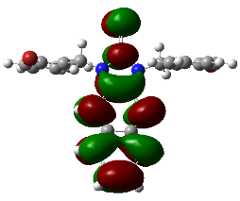 | 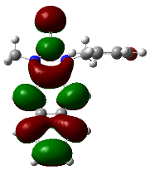 | 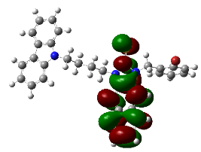 | 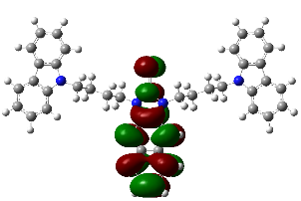 | 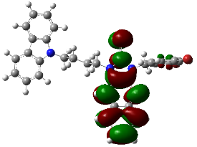
HOTO | 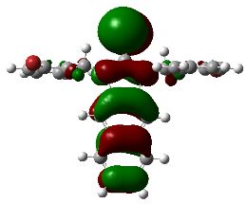 | 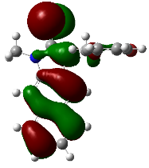 | 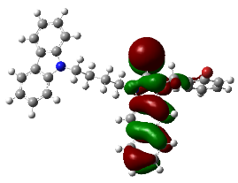 | 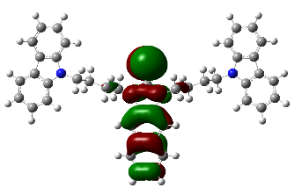 | 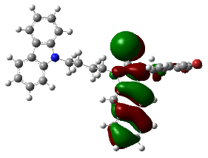
 | S₀ → S₃ | S₀ → S₃ | S₀ → S₆ | S₀ → S₁₁ | S₀ → S₉
 | CSM |  | DSB | DSD | DSM
LUTO | 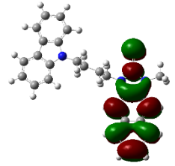 |  | 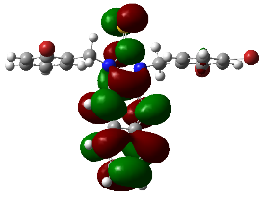 | 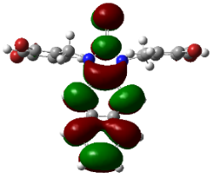 | 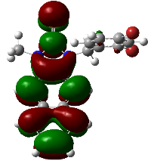
HOTO | 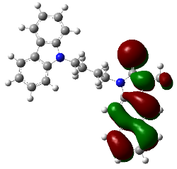 |  | 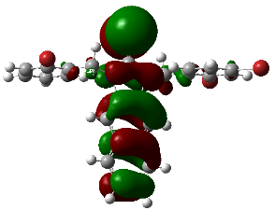 | 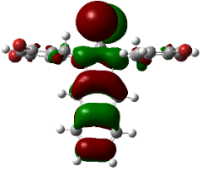 | 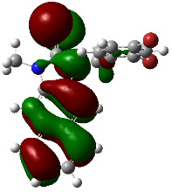
 | S₀ → S₄ |  | S₀ → S₃ | S₀ → S₃ | S₀ → S₃

  - Bacterial experiments results
a) | b)
Figure S52. The CFU percentage of bacteria in the presence of (a) BIB and (b) BSB (1 – 128 µM).
a) | b)
Figure S53. The CFU percentage of bacteria in the presence of (a) BIM and (b) BSM (1 – 128 µM).

a) | b)
Figure S54. The CFU percentage of bacteria in the presence of (a) CIB and (b) CSB (1 – 128 µM).
a) | b)
Figure S55. The CFU percentage of bacteria in the presence of (a) CIC and (b) CSC (1 – 128 µM).

a) | b)
Figure S56. The CFU percentage of bacteria in the presence of (a) CID and (b) CSD (1 – 128 µM).
a) | b)
Figure S57. The CFU percentage of bacteria in the presence of (a) CIM and (b) CSM (1 – 128 µM).

a) | b)
Figure S58. The CFU percentage of bacteria in the presence of (a) DIB and (b) DSB (1 – 128 µM).
a) | b)
Figure S59. The CFU percentage of bacteria in the presence of (a) DID and (b) DSD (1 – 128 µM).
a) | b)
Figure S60. The CFU percentage of bacteria in the presence of (a) DIM and (b) DSM (1 – 128 µM).
- Reference
1. Brouwer, A. M., Standards for photoluminescence quantum yield measurements in solution (IUPAC Technical Report). Pure and Applied Chemistry 2011, 83 (12), 2213-2228.
2. Halliwell, B.; Evans, P.; Whiteman, M., [35] Assessment of peroxynitrite scavengers in Vitro. Methods in enzymology 1999, 301, 333-342.
3. Shrivastava, A.; Gupta, V., Methods for the determination of limit of detection and limit of quantitation of the analytical methods. Chronicles of Young Scientists 2011, (2), 21.
4. Beck, A. D., Density-functional thermochemistry. III. The role of exact exchange. J. Chem. Phys 1993, 98 (7), 5648-6.
5. Lee, C.; Yang, W.; Parr, R. G. J. P. r. B., Development of the Colle-Salvetti correlation-energy formula into a functional of the electron density. Physical review B 1988, 37 (2), 785.
6. Adamo, C.; Jacquemin, D., The calculations of excited-state properties with Time-Dependent Density Functional Theory. Chem. Soc. Rev. 2013, 42 (3), 845-856.
7. Martin, R. L., Natural transition orbitals. The Journal of chemical physics 2003, 118 (11), 4775-4777.

