Supplementary Material

Supplementary Figures and Tables

Supplementary Figures
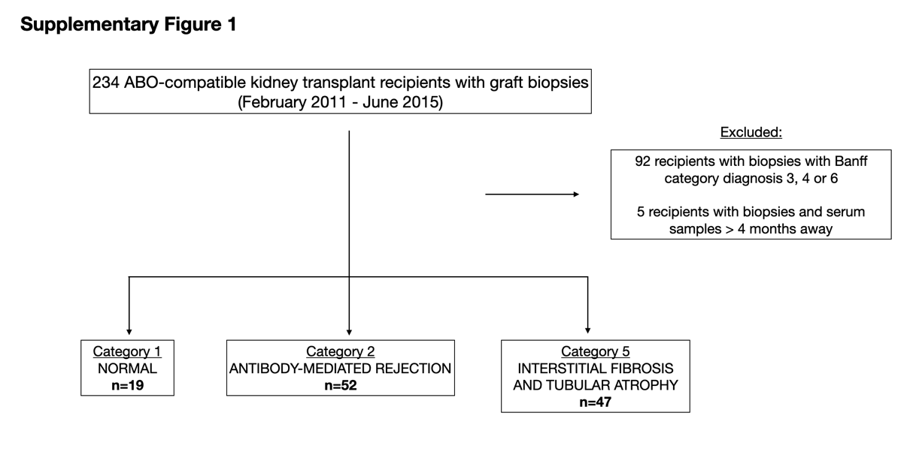
Supplementary Figure 1. Patient flow-chart.
Supplementary Figure 2. Death censored graft survival in patients with normal, ABMR_{h} and IFTA biopsies. Kaplan-Meier survival curves representing death censored graft survival. ABMR_{h}: antibody-mediated rejection histology; IFTA: interstitial fibrosis and tubular atrophy.

Supplementary Tables

Supplementary Table 1.
(A) Comparison of post-transplant non-HLA antibodies between ABMR_{h}DSA_{pos} and ABMR_{h}DSA_{neg} cases.
 | ABMR_{h}DSA_{pos} (n=38) | ABMR_{h}DSA_{neg} (n=14) | p-value
Post-transplant AT₁R-Ab (yes, %) | 10 (26.3%) | 2 (14.3%) | 0.48
Post-transplant ETAR-Ab (yes, %) | 6 (15.8%) | 1 (7.1%) | 0.66
Post-transplant MICA-Ab (yes, %) | 6 (15.8%) | 2 (14.3%) | 1.00
Post-transplant EC-XM (positive, %) $ | 4 (13.3%) | 0 (0%) | 0.30
$ From 30 ABMR_{h}DSA_{pos} and 13 ABMR_{h}DSA_{neg} cases.
ABMR_{h}: antibody-mediated rejection histology; AT₁R-Ab: antibodies against angiotensin II type 1 receptor; EC-XM: crossmatch with primary aortic endothelial cells; ETAR-Ab: antibodies against endothelin-1 type A receptor; MICA-Ab: antibodies against major histocompatibility complex class I related chain A.

(B) Comparison of post-transplant HLA and non-HLA antibodies between ABMR_{h}DSA_{pos} and non-ABMR_{h}DSA_{pos} cases (normal histology, IFTA and ABMR_{h}DSA_{neg} cases).
 | ABMR_{h}DSA_{pos} (n=38) | No ABMR_{h}DSA_{pos} (n=80) | p-value
Post-transplant HLA-DSA (yes, %) | 38 (100%) | 11 (13.8%) | <0.001
Post-transplant AT₁R-Ab (yes, %) | 10 (26.3%) | 20 (25%) | 0.88
Post-transplant ETAR-Ab (yes, %) | 6 (15.8%) | 13 (16.3%) | 0.95
Post-transplant MICA-Ab (yes, %) | 6 (15.8%) | 9 (11.3%) | 0.56
Post-transplant EC-XM (positive, %) # | 4 (13.3%) | 4 (5.5%) | 0.23
#30 ABMR_{h}DSA_{pos} and 73 non-ABMR_{h}DSA_{pos} cases.
AT₁R-Ab: antibodies against angiotensin II type 1 receptor; EC-XM: crossmatch with primary aortic endothelial cells; ETAR-Ab: antibodies against endothelin-1 type A receptor; HLA-DSA: HLA donor-specific antibodies; MICA-Ab: antibodies against major histocompatibility complex class I related chain A.

