Tables

Table S1. General information of AAV patients
Items | AKI (n=147) | Non-AKI (n=245)
Age, Median (IQR) | 60.0(51.0, 68.0) | 65.0(56.0,73.0)
Male, n (%) | 66(44.9) | 101(41.2)
Smoke, n (%) | 37(25.2) | 53(21.6)
AKI stage, n (%)
Stage 1 | 43(30.5) | /
Stage 2 | 44(31.2) | /
Stage 3 | 54(38.3) | /
Extrarenal organ involvement, n (%)
Lung | 46(31.3) | 64(26.1)
Joints | 22(15.0) | 17(7.0) **
Ear-Nose-Throat | 10 (7.1) | 19(8.1)
Skin | 20(13.6) | 18(7.4) *
Eye | 5(3.4) | 9(3.7)
Central nervous system | 6(4.1) | 19(7.8)
Abdomen | 16(11.0) | 27(11.1)
Scr at admission, mol/l, Median (IQR) | 274.0(163.0, 420.5) | 156(77.5, 371.0) **
BVAS, mean±std. | 16.3±4.0 | 13.7±5.5**
*:P<0.05; **:P<0.01
Table S2. Distribution of AKI stage and outcomes defined by urine output or serum creatinine

 | Patient number, n (%) | Renal endpoints n (%) | Death, n (%)
Defined by urine output | 22 (100%) | 9 (40.9%) | 5 (22.7%)
AKI Stage 1 | 3 (13.6%) | 1 (33.3 %) | 0 (0%)
AKI Stage 2 | 3 (13.6%) | 1 (33.3 %) | 0 (0%)
AKI Stage 3 | 16(72.7%) | 7 (43.8%) | 5 (31.2%)
Defined by serum creatinine change | 119 (100%) | 27 (22.7%) | 17 (14.3%)
AKI Stage 1 | 40 (33.6%) | 7 (17.5%) | 4 (10.0%)
AKI Stage 2 | 41 (34.5%) | 8 (19.5%) | 5 (12.2%)
AKI Stage 3 | 38 (31.9%) | 12 (31.6%) | 8 (21.1%)
AKI, acute kidney injury.

Table S3. Pathological characteristics of G1 and G2 subgroups
 | G1(n=64) | G2(n=32) | P-value
Global sclerosis¹, Median (IQR) | 16.7(9.1,34.7) | 23.2(11.9,38.5) | 0.265
Crescent¹, Median (IQR) | 16.1(10.0,36.1) | 18.9(9.4，39.6) | 0.456
Cellular crescent¹, Median (IQR) | 9.7(0.0,19.5) | 9.2(3.2,21.9) | 0.402
Necrosis, n (%) | 28 (43.8) | 14 (43.8) | 0.934
Mesangial proliferation, n (%) | 64 (100.0) | 31 (96.9) | 0.302
Endocapillary hypercellularity, n (%) | 23 (35.9) | 15 (46.9) | 0.302
Tubular infiltration, n (%) | 27 (42.2) | 19 (59.4) | 0.112
Interstitial fibrosis, n (%) |  |  | 0.230
0-50% | 44 (68.8) | 26 (81.2)
＞50% | 20 (31.2) | 6 (18.8)
Interstitial infiltration, n (%) |  |  | 0.727
0-20% | 17 (26.6) | 6 (18.8)
20-50% | 19 (29.7) | 11 (34.4)
＞50% | 28 (43.8) | 15 (46.9)

Table S4. Number and percentage of patients with pulmonary hemorrhage

Massive hemoptysis / alveolar hemorrhage | AKI stage 1 | AKI stage 2 | AKI stage 3 | P-Value
Yes | 14 (32.6%) | 5 (11.4%) | 9 (16.7%) | 0.035
No | 29 (67.4%) | 39 (88.6%) | 45 (83.3%)

2.Caliberations
Calibrations for renal outcome model
(1-,3-5-year)

Calibrations for renal outcome model
(1-,3-5-year)

3. CRP& Serum albumin
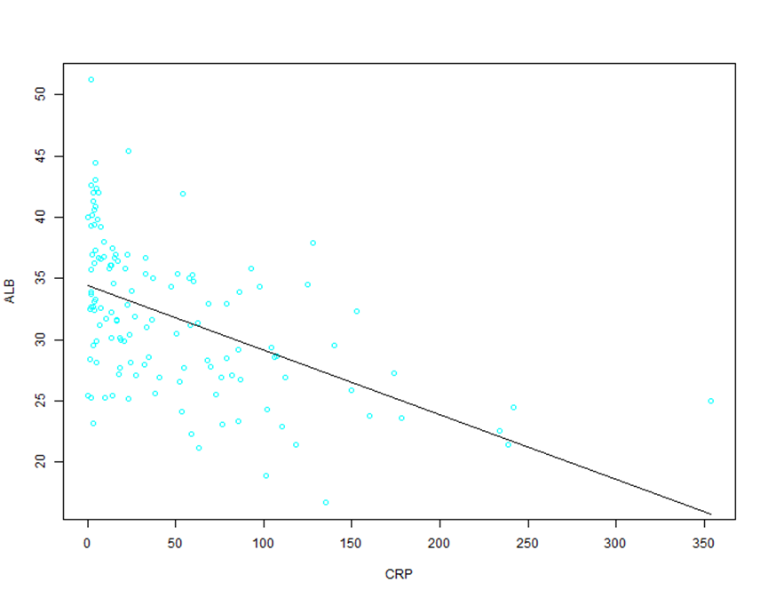
R=-0.537, P<0.001

