Towards unifying evolutionary ecology and genomics to understand positive plant-plant interactions within wild species

Harihar Jaishree Subrahmaniam^{1*}, Dominique Roby¹ and Fabrice Roux^{1*}

¹LIPME, Université de Toulouse, INRAE, CNRS, Castanet-Tolosan, France

* To whom correspondence should be addressed. E-mail: jaishree.subrahmaniam@gmail.com, fabrice.roux@inrae.fr

Supplementary Figure 1. Stacked barplots illustrating the different outcomes of GxG based on the mode of seed dispersal of the studied species (with and without Arabidopsis thaliana). The number of studies found supporting each type of interaction are indicated within each stack.
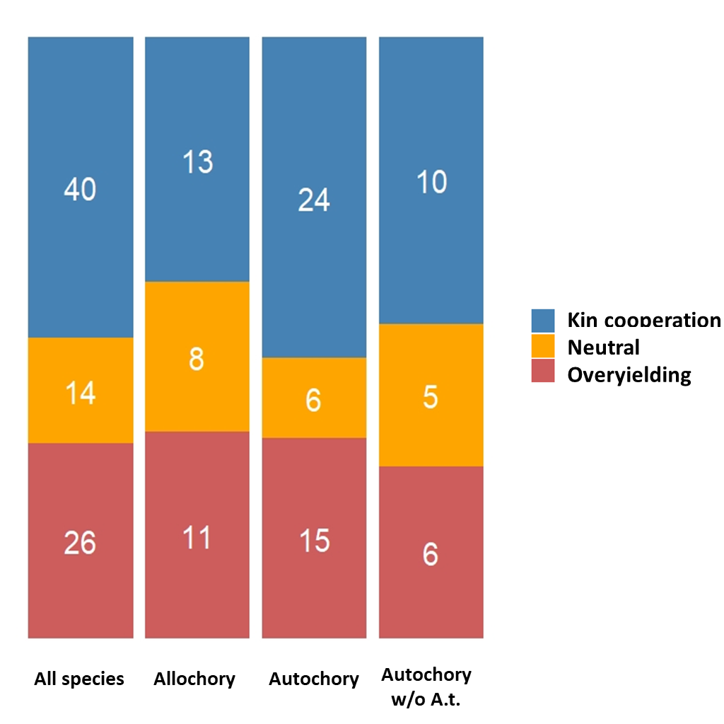

Supplementary Figure 2. Stacked barplots illustrating the different outcomes of GxG based on the geographic scale of sampling (genotypes collected from one population vs. multiple populations: with and without Arabidopsis thaliana). The number of studies found supporting each type of interaction are indicated within each stack.
