Afatinib in EGFR TKI-Naïve Patients with Locally Advanced or Metastatic EGFR Mutation-Positive Non-Small Cell Lung Cancer: A Pooled Analysis of Three Phase IIIb Studies

Antonio Passaro, et al.
Category | Patient subgroup
All patients
N | 1108
Median DOR, months (95% CI) | 13.2 (12.2–14.4)
Median DDC, months (95% CI) | 14.1 (13.6–14.8)
EGFR mutation type† | Common† |  | Uncommon‡
N | 909 |  | 198
Median DOR, months (95% CI) | 13.6 (12.5–14.8) |  | 10.2 (8.4–12.9)
Median DDC, months (95% CI) | 14.7 (13.9–15.9) |  | 9.1 (8.1–11.4)
ECOG PS | 0/1 |  | 2
N | 1058 |  | 49
Median DOR, months (95% CI) | 13.2 (12.2–14.8) |  | 8.3 (5.0–13.0)
Median DDC, months (95% CI) | 14.3 (13.7–15.2) |  | 9.9 (7.4–13.9)
ECOG PS (patients with common mutations)† | 0/1 |  | 2
N | 869 |  | 40
Median DOR, months (95% CI) | 13.8 (12.5–14.9) |  | 12.4 (5.0–14.1)
Median DDC, months (95% CI) | 14.8 (14.1–16.3) |  | 9.9 (6.2–13.9)
Afatinib line of therapy | First-line | Second-line |  | >Second-line
N | 770 | 261 |  | 77
Median DOR, months (95% CI) | 13.4 (12.2–14.8) | 12.6 (11.1–16.6) |  | 12.5 (8.3–18.7)
Median DDC, months (95% CI) | 14.5 (13.7–15.9) | 13.7 (12.9–15.7) |  | 12.0 (8.3–14.5)
Brain metastases at screening§ | Yes |  | No
N | 213 |  | 894
Median DOR, months (95% CI) | 11.1 (8.3–12.3) |  | 14.1 (13.0–15.4)
Median DDC, months (95% CI) | 11.7 (10.2–13.8) |  | 14.7 (13.9–16.1)
Age, years | <75 years |  | ≥75 years
N | 989 |  | 119
Median DOR, months (95% CI) | 13.0 (12.0–14.1) |  | 16.5 (10.3–21.2)
Median DDC, months (95% CI) | 14.1 (13.6–15.0) |  | 14.1 (12.6–21.4)
Age, years | <65 years |  | ≥65 years
N | 685 |  | 423
Median DOR, months (95% CI) | 12.5 (11.3–13.8) |  | 14.2 (12.4–17.3)
Median DDC, months (95% CI) | 13.7 (12.8–14.5) |  | 15.0 (13.8–17.3)
SUPPLEMENTARY TABLE 1 | Post-hoc analysis of duration of objective response and duration of disease control for specified subgroups.
CI, confidence interval; DDC, duration of disease control; DOR, duration of objective response; ECOG PS, Eastern Cooperative Oncology Group performance status; EGFR, epidermal growth factor receptor. †Patients with EGFR mutation categories of Del19 only or L858R only. ‡Patients with EGFR mutation categories other than Exon19 only and L858R only. §Asymptomatic.

 | T790M  (n = 8) | Exon 20 ins  (n = 36) | Major  (n = 62) | Compound  (n = 12) | Compound with Major  (n = 8) | Other  (n = 5)
Patients with objective response, n (%) | 1 (12.5) | 9 (25.0) | 28 (45.2) | 6 (50.0) | 4 (50.0) | 2 (40.0)
Median DOR, months (95% CI) | 1.1 (NE–NE) | 9.1 (5.6–21.2) | 11.1 (7.1–17.2) | 17.9 (10.2–35.3) | 17.9 (10.2–35.3) | 4.7 (2.7–6.8)
SUPPLEMENTARY TABLE 2 | Objective response rate and duration of objective response in patients with uncommon EGFR mutations.
CI, confidence interval; DOR, duration of objective response; NE, not evaluable.

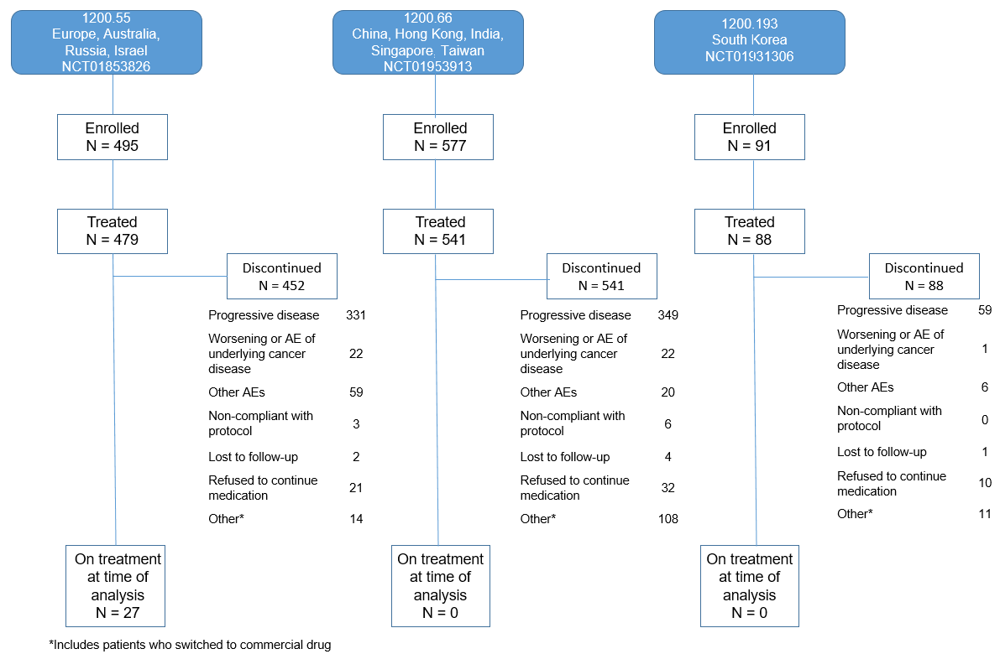
SUPPLEMENTARY FIGURE 1 | Patient disposition. AEs, adverse events.

SUPPLEMENTARY FIGURE 2 | TTSP in (A) all patients, (B) patients with tumors harboring common versus uncommon mutations, (C) patients with ECOG PS 0/1 versus 2, (D) patients with common mutations and ECOG PS 0/1 versus 2, (E) patients with vs without baseline brain metastases, (F) patients treated with afatinib in first, second and later lines of therapy, (G) patients aged <65 or ≥65 years, and (H) patients aged <75 or ≥75 years. Abbreviations: CI, confidence interval; ECOG PS, Eastern Cooperative Oncology Group performance status; TTSP, time to symptomatic progression.
