Supplementary Material

Supplementary Figures and Tables

Supplementary Figure

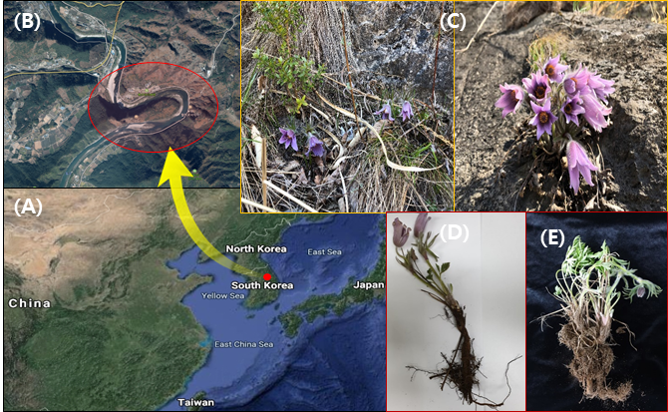
Figure 1. Sampling sites and long-sepal Donggang pasque-flower plant. The location of the endemic plant distribution (red dot) in karst topography of Kangwon-do province, South Korea (A and B). The plants were mostly collected from cracks between rocks (C) of slopes at the Donggang River located at an altitude of 200-300 m (red circle in B). The plants were collected from native (D) and cultivated (E) areas for microbe profiling.

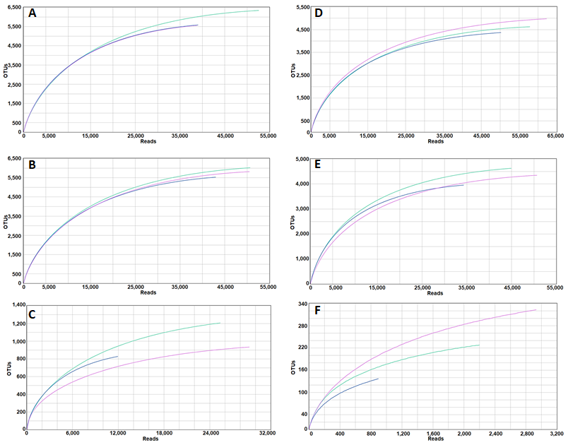
Figure 2. Rarefaction curves for bacterial operational taxonomic units (OTUs) of long-sepal Donggang pasque-flower plant. Rarefaction curves of bulk soil (A, D), rhizosphere (B, E), and endophytes (C, F) in wild habitats and cultivated areas, respectively, with the cut-off value at 97% similarity. The vertical axis indicates the number of OTUs expected after sampling the number of sequences denoted in the horizontal axis.

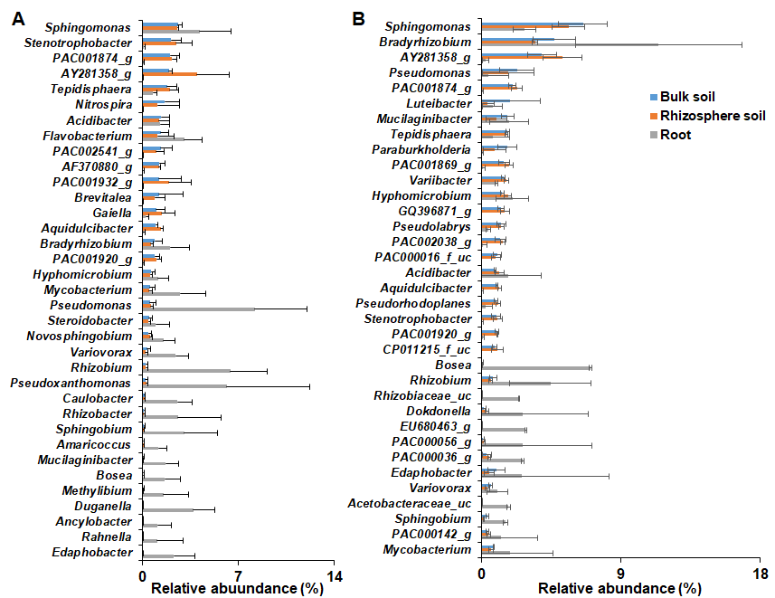
Figure 3. Relative abundance (%) of bacterial genera in bulk soil, rhizosphere, and roots of Donggang pasque-flower plants. The bacterial genera with relative abundance above 1% in each rhizocompartment of (A) wild and (B) cultivated habitats were compared. Bars illustrate the mean relative abundance (>1%) per compartment of each dominant phylum ± standard deviation.

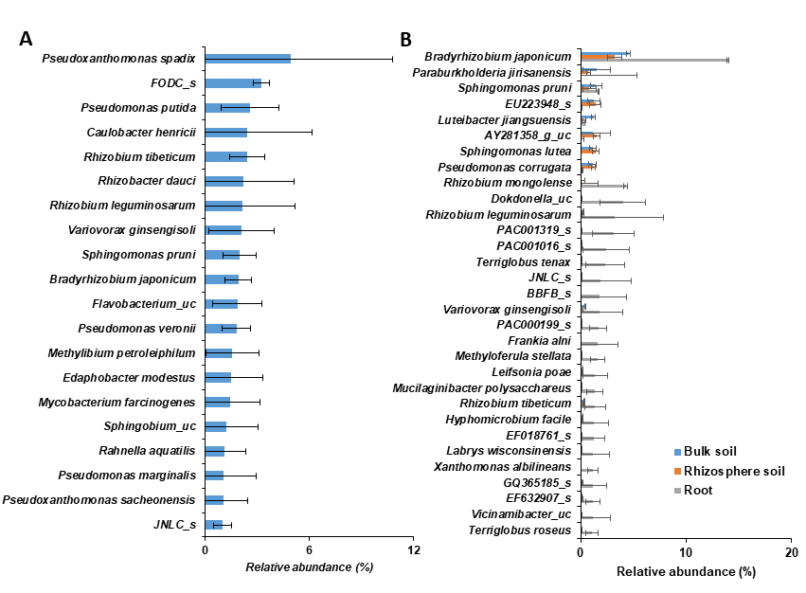
Figure 4. Relative abundance of bacterial species in bulk soil, rhizosphere, and root of long-sepal Donggang pasque-flower plants. The bacterial species with relative abundance >1% were compared between bulk soil, rhizosphere, and root of wild (A) and cultivated (B) habitats. Note: since none of the identified species exceeded 1% in bulk soil and rhizosphere of the wild area, (A) shows species detected in roots.

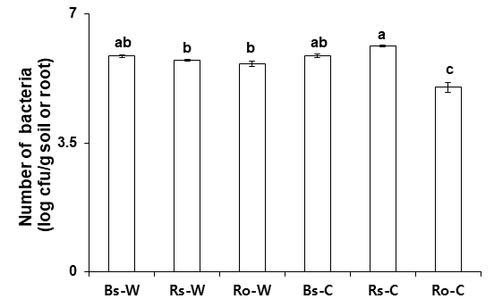
Figure 5. Total number of culturable bacteria in rhizosphere and root of long-sepal Donggang pasque-flower plant. Bacterial colonies were assessed from bulk soil (Bs), rhizosphere soil (Rs), and root (Ro) of long-sepal Donggang pasque-flower plants collected from wild (-W) and cultivated (-C) areas. Data presented as the mean ± SD, and bars with same letter(s) do not differ significantly at P=0.05.

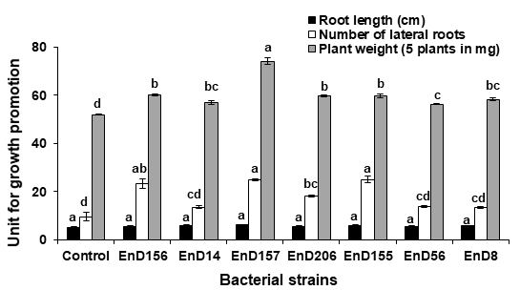
Figure 6. Effect of selected strains on growth of Arabidopsis thaliana. The seeds of A. thaliana Col-0 were bacterized with each strain and placed on half-strength MS medium for 10 days. Data represent the average ± SD of root length, number of lateral roots, and fresh weight of plants. Bars with same letter(s) do not differ significantly at P=0.05. The experiment was performed three times, each with three replicates, and each replicate consisted of five plants each. Note: Refer to Table 1 for scientific names of each strain.

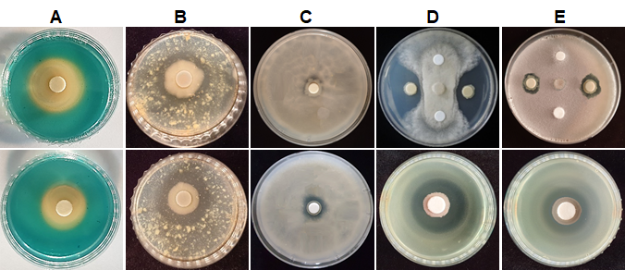
Figure 7. Growth-stimulating and antimicrobial activities of bacterial strains isolated from the rhizosphere and root of long-sepal Donggang pasque-flower plants. Siderophore production (A) was assessed from Pseudomonas fluorescens strains EnD56 and EnD210 (from upper to low panel) based on a change in the color of CAS medium from blue to orange. Protease activity (B) of the strains Bacillus subtilis EnD14 and P. fluorescens EnD56 was determined using skim milk agar medium based on the presence of a clear zone around colonies. Phosphate solubilization (C) of the strains B. subtilis EnD14 and P. fluorescens EnD56 was determined using Pikovskaya’s agar medium based on the formation of a clear zone around the colonies. Antagonistic activity of B. subtilis EnD-14 (D) against the fungal pathogen Botrytis cinerea and bacterial pathogen Xanthomonas oryzae pv. oryzae. Antifungal and antibacterial activity of P. fluorescens EnD56 (E) against Pyricularia oryzae and Xanthomonas axonopodis pv. glycines, respectively.

Supplementary Tables

Table 1. Estimated OTU richness and diversity indices in the bulk soil, rhizosphere soil, and roots from plants in wild areas
Sample |  | Valid reads | OTUs | Ace | Chao1 | Jackknife | Shannon | Simpson | Goods Library Coverage (%)
Bulk soil | 1 | 52,606 | 6,340 | 6663.7 | 6470.0 | 7,035 | 7.70 | 0.001 | 98.68
 | 2 | 39,040 | 5,584 | 5969.5 | 5762.1 | 6,347 | 7.71 | 0.001 | 98.05
 | 3 | 38,833 | 5,553 | 5927.8 | 5728.4 | 6,308 | 7.71 | 0.001 | 98.06
Rhizosphere soil | 1 | 50,683 | 6,019 | 6399.6 | 6190.1 | 6,786 | 7.60 | 0.002 | 98.49
 | 2 | 42,987 | 5,528 | 5931.2 | 5713.9 | 6,301 | 7.58 | 0.002 | 98.20
 | 3 | 50,513 | 5,818 | 6124.2 | 5943.8 | 6,469 | 7.52 | 0.002 | 98.71
Root | 1 | 25,393 | 1,206 | 1393.3 | 1325.5 | 1,476 | 4.73 | 0.034 | 98.94
 | 2 | 11,950 | 828 | 963.9 | 912.4 | 1,023 | 4.66 | 0.044 | 98.37
 | 3 | 29,209 | 934 | 1055.3 | 999.9 | 1,109 | 4.82 | 0.022 | 99.40

Table 2. Estimated OTU richness and diversity indices in the bulk soil, rhizosphere soil, and roots from plants in cultivated areas
Sample |  | Valid reads | OTUs | Ace | Chao1 | Jackknife | Shannon | Simpson | Goods Library Coverage (%)
Bulk soil | 1 | 50,217 | 4,370 | 4,637.5 | 4,508.7 | 4,914 | 6.67 | 0.008 | 98.92
 | 2 | 62,273 | 4,976 | 5,249.5 | 5,113.4 | 5,546 | 6.96 | 0.005 | 99.08
 | 3 | 57,852 | 4,626 | 4,837.4 | 4,712.0 | 5,085 | 6.67 | 0.009 | 99.21
Rhizosphere soil | 1 | 44,946 | 4,627 | 4,932.1 | 4,784.3 | 5,229 | 7.19 | 0.003 | 98.66
 | 2 | 34,290 | 3,955 | 4,215.4 | 4,084.4 | 4,467 | 7.21 | 0.003 | 98.51
 | 3 | 50,673 | 4,348 | 4,588.3 | 4,460.1 | 4,848 | 6.64 | 0.012 | 99.01
Root | 1 | 897 | 137 | 201.3 | 213.6 | 353.1 | 4.03 | 0.032 | 94.09
 | 2 | 2,934 | 323 | 408.0 | 408.4 | 443.0 | 4.50 | 0.028 | 96.59
 | 3 | 2,202 | 228 | 282.0 | 266.5 | 288 | 4.46 | 0.023 | 97.28

Table 3. Physiochemical properties of soils
Area  (Replication) | Properties
 | pH | Electrical conductivity  (dS/m) | Ca²⁺  (cmol/Kg) | K⁺  (cmol/Kg) | Mg² ⁺  (cmol/Kg) | Na⁺  (cmol/Kg)
Wild area
1 | 7.67±0.02 | 0.60±0.01 | 15.47±0.01 | 0.45±0.01 | 1.25±0.01 | 2.04±0.06
2 | 7.57±0.03 | 0.66±0.00 | 13.77±0.37 | 0.52±0.00 | 1.39±0.03 | 1.52±0.05
3 | 7.70±0.04 | 0.60±0.01 | 14.01±0.07 | 0.42±0.01 | 1.18±0.00 | 1.88±0.04
Cultivated area
1 | 6.73±0.04 | 0.53±0.02 | 8.09±0.10 | 0.26±0.01 | 1.56±0.00 | 5.69±0.13
2 | 6.75±0.01 | 0.43±0.00 | 8.21±0.01 | 0.27±0.02 | 1.63±0.01 | 5.25±0.18
3 | 6.76±0.01 | 0.42±0.04 | 10.35±0.03 | 0.44±0.01 | 2.43±0.01 | 3.48±0.08

