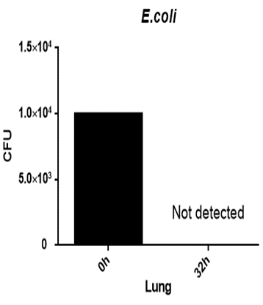
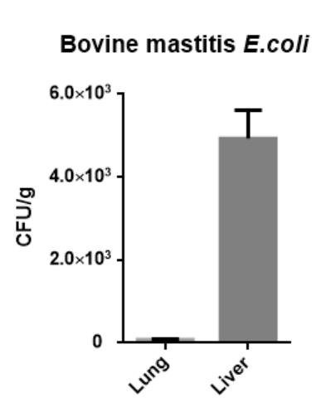
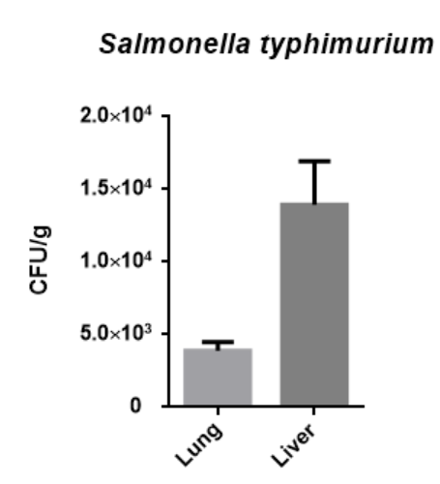
Supplementary Figure S2. A. The bacteria load of the mouse lung after infected with 10⁴ CFU log-phase growth DH5α for 32h. B. The bacteria density of the mouse lung and liver infection with 10⁴ CFU log-phase growth bovine mastitis E. coli and Salmonella typhimurium for 48h.
A
B

