Supplementary Material

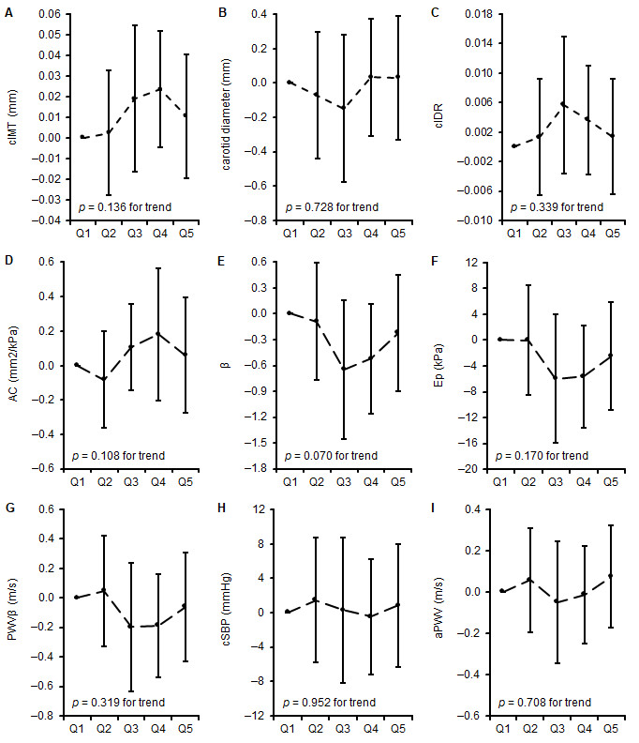
Supplementary Figure 1. Differences in measures of vascular properties: mean difference to the lowest quintile of training duration in girls. A - C represent differences in carotid arterial structure, D represents differences in carotid arterial elasticity, E-G represents differences in carotid arterial stiffness, H-I represents differences in central vascular function across quintiles of training duration. * when p < 0.05. cIMT, carotid intima-media thickness; cIDR, carotid intima-media thickness:carotid diameter-ratio; AC, arterial compliance; β, beta stiffness index; Ep, elastic modulus, PWVβ, carotid pulse wave velocity; cSBP, central systolic blood pressure; aPWV, aortic pulse wave velocity.

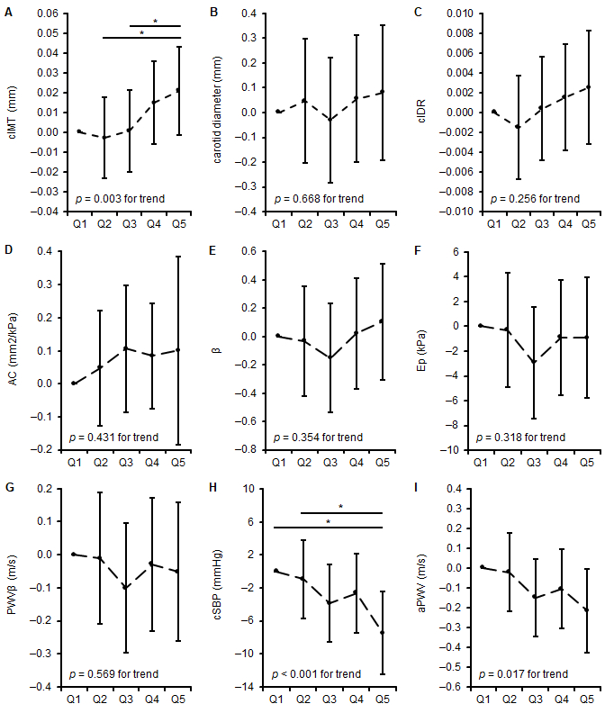
Supplementary Figure 2. Differences in measures of vascular properties: mean difference to the lowest quintile of training duration in boys. A - C represent differences in carotid arterial structure, D represents differences in carotid arterial elasticity, E-G represents differences in carotid arterial stiffness, H-I represents differences in central vascular function across quintiles of training duration. * when p < 0.05. cIMT, carotid intima-media thickness; cIDR, carotid intima-media thickness:carotid diameter-ratio; AC, arterial compliance; β, beta stiffness index; Ep, elastic modulus, PWVβ, carotid pulse wave velocity; cSBP, central systolic blood pressure; aPWV, aortic pulse wave velocity.

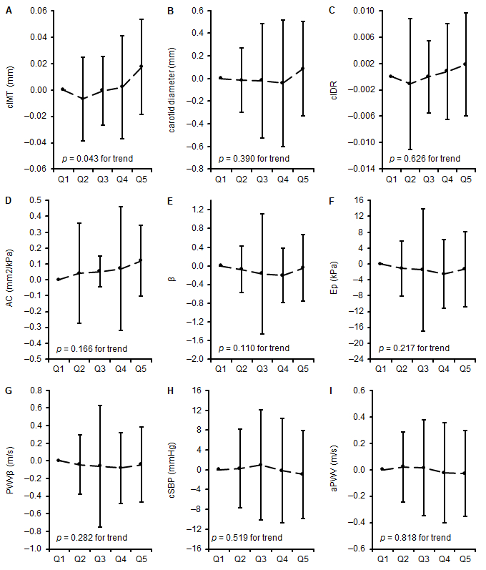
Supplementary Figure 3. Differences in measures of vascular properties: mean difference to the lowest quintile of training intensity in girls. A - C represent differences in carotid arterial structure, D represents differences in carotid arterial elasticity, E-G represents differences in carotid arterial stiffness, H-I represents differences in central vascular function across quintiles of training duration. * when p < 0.05. cIMT, carotid intima-media thickness; cIDR, carotid intima-media thickness:carotid diameter-ratio; AC, arterial compliance; β, beta stiffness index; Ep, elastic modulus, PWVβ, carotid pulse wave velocity; cSBP, central systolic blood pressure; aPWV, aortic pulse wave velocity.

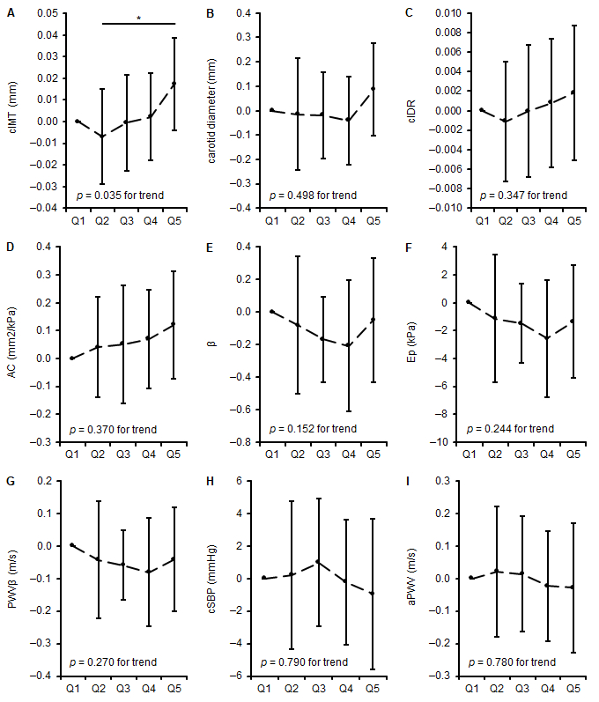
Supplementary Figure 4. Differences in measures of vascular properties: mean difference to the lowest quintile of training intensity in boys. A - C represent differences in carotid arterial structure, D represents differences in carotid arterial elasticity, E-G represents differences in carotid arterial stiffness, H-I represents differences in central vascular function across quintiles of training duration. * when p < 0.05. cIMT, carotid intima-media thickness; cIDR, carotid intima-media thickness:carotid diameter-ratio; AC, arterial compliance; β, beta stiffness index; Ep, elastic modulus, PWVβ, carotid pulse wave velocity; cSBP, central systolic blood pressure; aPWV, aortic pulse wave velocity.

