The Effectiveness and Safety of Immune Checkpoint Inhibitors in Non-Small Cell Lung Cancer Patients with Stage III/IV

Supplementary Appendix

Table of Contents
Table S1. Studies related to efficacy and safety of cancer immunotherapies (Clinical Trials) 2
Table S2. Demographic characteristic of ICIs patients before matching 3
Table S3. Basic characteristics of both ICIs and Chemo groups by treatment lines before matching 4
Table S4. Overall survival analysis between ICIs and Chemo group by treatment lines after matching 5
Table S5. Treatment-related adverse events in both ICIs and Chemo groups 6
Figure S1. Treatment-related adverse events by time 7

Table S1. Studies related to efficacy and safety of cancer immunotherapies (Clinical Trials)
Name of Trial | Drug name | Author | PD L1, % | With chemo | Line | N_E | N_C | Study Time | RR, % | Median OS, (month) | Median PFS, (month) | ≥Grade 3 AE, %
KEYNOTE-021 | Pembrolizumab | Langer (2016) | All | V | 1st | 60 | 63 | 2014.11-2016.01 | 55 vs. 29 | - | 13 vs. 8.9 | 39 vs. 26
IMpower150 | Atezolizumab | Socinski (2018) | - | V | 1st | 400 | 400 | 2015.03-2016.12 | 63.5 vs. 48 | 19.2 vs. 17.4 | 8.3 vs. 6.8 | 55.7 vs. 47.7
KEYNOTE-407 | Pembrolizumab | Paz-Ares (2018) | All | V | 1st | 278 | 281 | 2016.08-2017.12 | 57.9 vs. 38.4 | 15.9 vs. 11.3 | 6.4 vs. 4.8 | 69.2 vs. 68.2
KEYNOTE-189 | Pembrolizumab | Gandhi (2018) | All | V | 1st | 410 | 206 | 2016.02-2017.03 | 47.6 vs. 18.9 | NR vs. 11.3 | 8.8 vs. 4.9 | 67.2 vs. 65.8
KEYNOTE-024 | Pembrolizumab | Reck (2016) | ≥50% | X | 1st | 154 | 151 | 2014.09-2015.10 | 44.8 vs. 27.8 | - | 10.3 vs. 6 | 26.6 vs. 53.3
KEYNOTE-042 | Pembrolizumab | Mok (2019) | ≥50%, ≥20%, ≥1% | V | 1st | 637 | 637 | 2014.12-2017.03 | - | 20.0 vs. 12.2;  17.7 vs. 13.0  16.7 vs. 12.1 | 7.1 vs. 6.4  6.2 vs. 6.6  5.4 vs. 6.5 | 17.8 vs. 41.0
CheckMate-026 | Nivolumab | Carbone (2017) | ≥1% | X | 1st | 271 | 270 | 2014.03-2015.04 | 26 vs. 33 | 14.4 vs. 13.2 | 4.2 vs. 5.9 | 18 vs. 51
OAK | Atezolizumab | Rittmeyer (2017) | All | X | 2nd | 425 | 425 | 2014.03-2015.04 | 14 vs. 13 | 13.8 vs. 9.6 | 2.8 vs. 4 | 15 vs. 43
CheckMate-017 | Nivolumab | Brahmer (2015) | All | X | 2nd | 135 | 137 | 2012.10-2013.12 | 20 vs. 9 | 9.2 vs. 6 | 3.5 vs. 2.8 | 7 vs. 55
CheckMate -057 | Nivolumab | Borghaei (2015) | All | X | 2nd | 292 | 290 | 2012.11-2013.12 | 19 vs. 12 | 12.2 vs. 9.4 | 2.3 vs. 4.2 | 10 vs. 54
KEYNOTE-010 | Pembrolizumab | Herbst (2016) | >1% | X | 2nd | 344(2mg/kg); 346(10mg/kg) | 343 | 2013.08-2015.02 | - | 10.42(2mg/kg); 12.7(10mg/kg) vs. 8.5 | 3.9(2mg/kg); 4(10mg/kg) vs. 4 | 13(2mg/kg); 16(10mg/kg) vs. 35
Note: N_E, number of experimental group; N_C, number of control group; RR, response rate; OS, overall survival; PFS, progress-free survival; AE, adverse events;

Table S2. Demographic characteristic of ICIs patients before matching
Variables | Immune checkpoint inhibitors,  n = 91, N (%) | Variables | Immune checkpoint inhibitors,  n = 91, N (%)
Age |  | Smoking status
Mean (SD) | 62.87 (11.54) | Current | 17 (18.7)
30-39 | 2 (2.2) | Never | 74 (81.3)
40-49 | 11 (12.1) | HBsAg
50-59 | 22 (24.2) | Positive | 12 (13.2)
60-69 | 29 (31.9) | Negative | 74 (81.3)
70-79 | 21 (23.1) | Missing | 5 (5.5)
80-89 | 6 (6.6) | HCVAb
Sex |  | Positive | 2 (2.2)
Male | 58 (63.7) | Negative | 82 (90.1)
Female | 33 (36.3) | Missing | 7 (7.7)
Performance status |  | Lung cancer surgery history
0-1 | 79 (86.8) | Yes | 16 (17.6)
2-4 | 12 (13.2) | No | 75 (82.4)
EGFR/ALK mutation |  | Steroid use^{c}
Positive | 22 (24.2) | Yes | 19 (20.9)
Negative | 68 (74.7) | No | 72 (79.1)
Treatment linesª |  | ICIs types
First-line | 30 (33) | Pembrolizumab | 37 (40.7)
Second-line | 17 (18.7) | Nivolumab | 42 (46.2)
Third-line and over | 44 (48.4) | Atezolizumab | 12 (13.2)
Histology |  | Median treatment duration, month
Squamous | 15 (16.5) | Pembrolizumab | 2.07
Non-squamous | 76 (83.5) | Nivolumab | 3.44
Tumor stage^{b} |  | Atezolizumab | 3.45
III | 7 (7.7) | Combined with chemotherapy
IV | 84 (92.3) | Yes | 41 (45.1)
Brain metastasis |  | No | 50 (54.9)
Yes | 27 (29.7) | Combined with radiotherapy
No | 64 (70.3) | Yes | 10 (11)
PD-L1 expression |  | No | 81 (89)
Positive | 46 (50.5) | Grade 3 and over of AE
Negative | 8 (8.8) | Yes | 11 (12.1)
Missing | 37 (40.7) | No | 80 (87.9)
Note: ªTreatment lines, represents the line of treatment with medications.
^{b}Tumor stage, represents the stage of patients at the time of cancer diagnosis.
^{c}Steroid used, represents the patients who used steroid drugs more than a week (7 days) at the time of cancer treatment.

Table S3. Basic characteristics of both ICIs and Chemo groups by treatment lines before matching
Variables | First-lineª |  |  | Second-lineª |  |  | Third-line and overª
 | Immune checkpoint inhibitors  n = 30, N (%) | Chemotherapy  n = 130, N (%) | p-value^{b} | Immune checkpoint inhibitors  n = 17, N (%) | Chemotherapy  n = 92, N (%) | p-value^{b} | Immune checkpoint inhibitors  n = 44, N (%) | Chemotherapy  n = 78, N (%) | p-value^{b}
Age |  |  | 0.155 |  |  | 0.127 |  |  | 0.339
Mean (SD) | 66.6 (12.2) | 62.02 (11.1) | 0.047 | 62 (9.5) | 67.4 (11.1) | 0.063 | 60.05 (11.3) | 63.79 (11.0) | 0.075
30-39 | 1 (3.3) | 5 (3.8) |  | 0 (0) | 1 (1.1) |  | 2 (4.5) | 1 (1.3)
40-49 | 1 (3.3) | 10 (7.7) |  | 2 (11.8) | 5 (5.4) |  | 7 (15.9) | 5 (6.4)
50-59 | 8 (26.7) | 33 (25.4) |  | 3 (17.6) | 17 (15.8) |  | 12 (27.3) | 25 (32.1)
60-69 | 6 (20) | 51 (39.2) |  | 10 (58.8) | 28 (30.4) |  | 12 (27.3) | 20 (25.6)
70-79 | 10 (33.3) | 24 (18.5) |  | 2 (11.8) | 29 (31.5) |  | 10 (22.7) | 21 (26.9)
80-89 | 4 (13.3) | 7 (5.4) |  | 0 (0) | 12 (13) |  | 1 (2.3) | 6 (7.7)
Sex |  |  | 0.815 |  |  | 0.552 |  |  | 0.751
Male | 23 (76.7) | 97 (74.6) |  | 10 (58.8) | 61 (66.3) |  | 25 (56.8) | 42 (53.8)
Female | 7 (23.3) | 33 (25.4) |  | 7 (41.2) | 31 (33.7) |  | 19 (43.2) | 36 (46.2)
Histology |  |  | 0.517 |  |  | 0.897 |  |  | 0.983
Squamous | 7 (23.3) | 38 (29.2) |  | 4 (23.5) | 23 (25) |  | 4 (9.1) | 7 (9)
Non-squamous | 23 (76.7) | 92 (70.8) |  | 13 (76.5) | 69 (75) |  | 40 (90.9) | 71 (91)
Stage |  |  | 0.004 |  |  | 0.374 |  |  | 0.185
III | 1 (3.3) | 37 (28.5) |  | 2 (11.8) | 20 (21.7) |  | 4 (9.1) | 14 (17.9)
IV | 29 (96.7) | 93 (71.5) |  | 15 (88.2) | 72 (78.3) |  | 40 (90.9) | 64 (82.1)
Performance status |  |  | 0.324 |  |  | 0.430 |  |  | 0.062
0-1 | 26 (86.7) | 120 (92.3) |  | 14 (82.4) | 63 (68.5) |  | 39 (88.6) | 55 (70.5)
2-4 | 4 (13.3) | 10 (7.7) |  | 3 (17.7) | 23 (25) |  | 5 (11.4) | 19 (24.4)
EGFR/ALK mutation |  |  | 0.630 |  |  | 0.825 |  |  | 0.125
Positive | 0 (0) | 1 (0.8) |  | 4 (23.5) | 24 (26.1) |  | 18 (40.9) | 44 (56.4)
Negative | 30 (100) | 129 (99.2) |  | 13 (76.5) | 68 (73.9) |  | 25 (56.8) | 34 (43.6)
PD-L1 expression |  |  | <0.001 |  |  | 0.027 |  |  | 0.012
Positive | 23 (76.7) | 35 (26.9) |  | 9 (52.9) | 20 (21.7) |  | 11 (25) | 16 (20.5)
Negative | 1 (3.3) | 10 (7.7) |  | 1 (5.9) | 7 (7.6) |  | 6 (13.6) | 1 (1.3)
Missing | 6 (20) | 85 (65.4) |  | 7 (41.2) | 65 (70.7) |  | 27 (61.4) | 61 (78.2)
Note: ªTreatment lines, represents the initial line of treatment with medications.
^{b}p-value was calculated using Student t test with continuous variables and chi-square or Fisher exact test with category variables.

Table S4. Overall survival analysis between ICIs and Chemo group by treatment lines after matching
 | Unadjusted |  | Adjusted
 | HR (95% CI) | p-value | HR (95% CI) | p-value
All line | 0.96 (0.64-1.44) | 0.838 | 0.93 (0.64-1.44) | 0.838
First-line | 1.1 (0.51-2.35) | 0.812 | 1.11 (0.51-2.43) | 0.796
Second-line | 1.04 (0.35-3.12) | 0.947 | 0.95 (0.28-3.19) | 0.931
Third-line and over | 0.75 (0.43-1.32) | 0.319 | 0.81 (0.45-1.45) | 0.477
Note: The adjusted hazard ratio was adjusted for histological types, Tumor stage, Brain metastasis, and PD-L1 expression variables

Table S5. Treatment-related adverse events in both ICIs and Chemo groups
Adverse event types | Immune checkpoint inhibitors  n = 79, N (%) | Chemotherapy  n = 79, N (%)
Overall | 10 (12.7) | 17 (21.5)
Pneumonitis | 5 (6.3) | 0
Hepatitis | 1 (1.3) | 0
Hyperthyroidism | 1 (1.3) | 0
Multiple arthralgia | 1 (1.3) | 0
Pruritus | 1 (1.3) | 0
Encephalitis | 1 (1.3) | 0
Chronic inflammatory | 1 (1.3) | 0
Demyelinating polyneuropathy
Fatigue | 2 (2.5) | 2 (2.5)
Skin rash | 3 (3.8) | 0
Neutropenia | 0 | 10 (12.7)
Alopecia | 0 | 3 (3.8)
Anemia | 0 | 2 (2.5)
Diarrhea | 0 | 1 (1.3)
Nausea | 0 | 1 (1.3)
Vomiting | 0 | 1 (1.3)
Numbness | 0 | 1 (1.3)
Septic cardiomyopathy | 0 | 1 (1.3)
Septic shock | 0 | 1 (1.3)
Anorexia | 0 | 1 (1.3)

A.
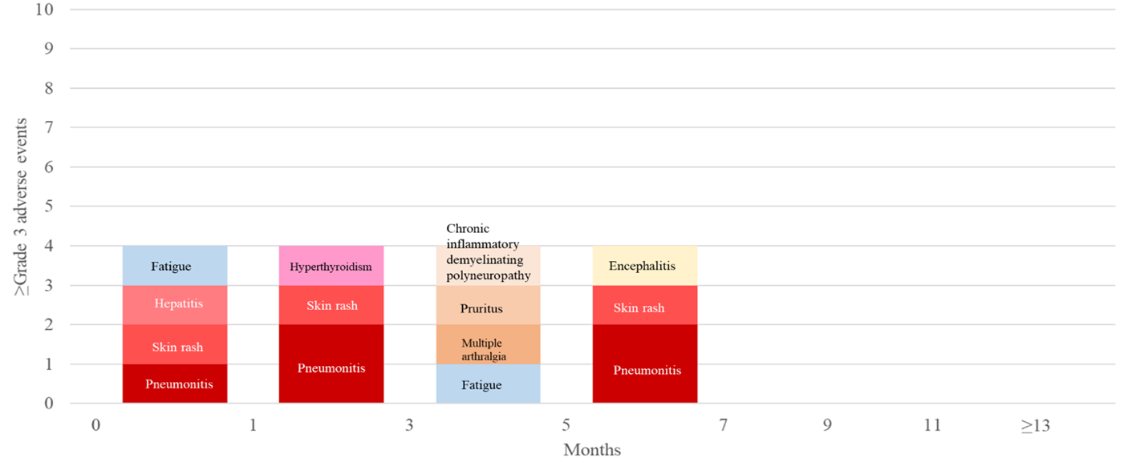
B.
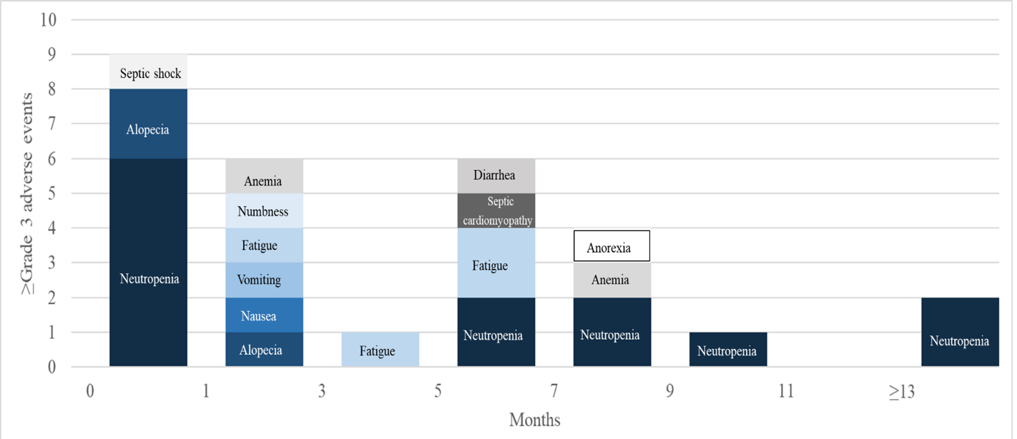

Figure S1. Treatment-related adverse events by time
Note: A, ICIs drugs group; B, Chemotherapy drugs group

