Supplementary Material

Supplementary Figures
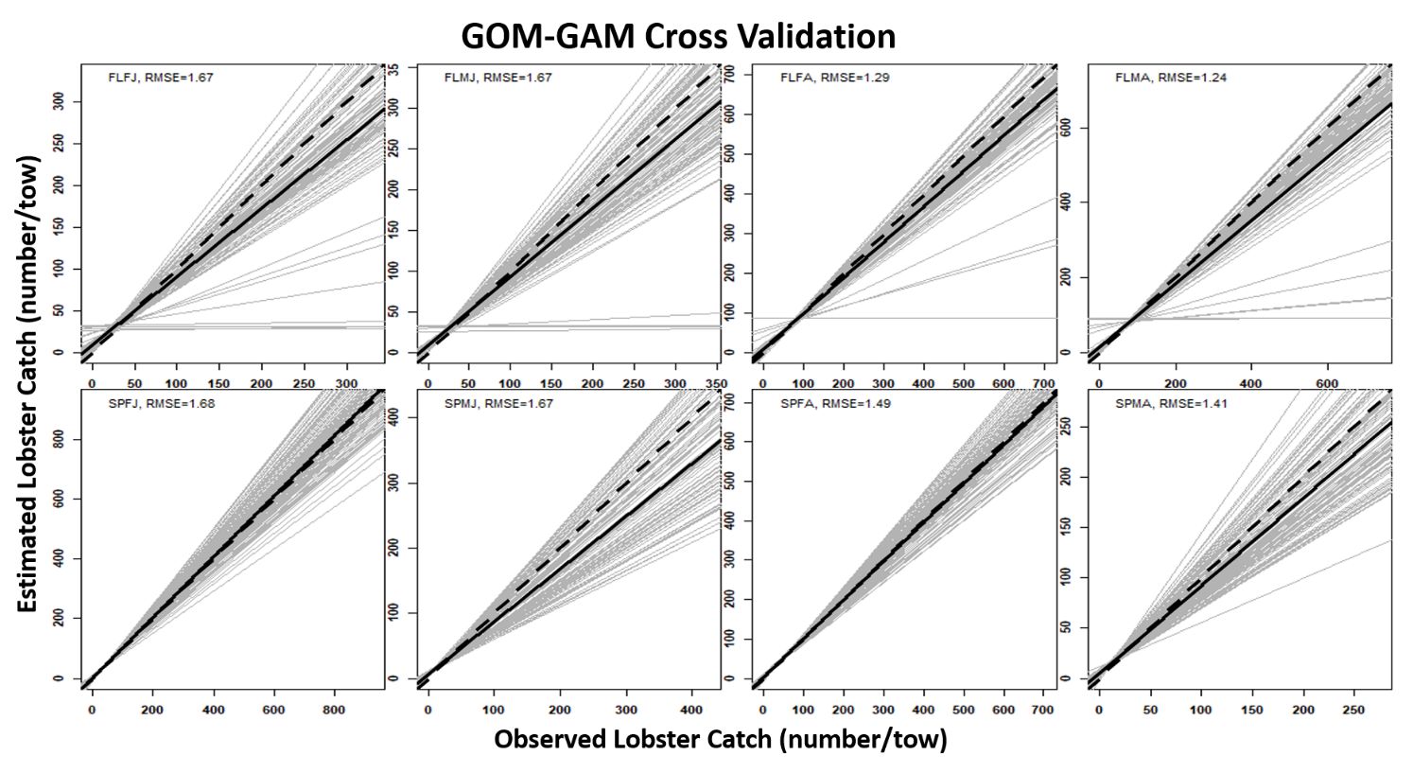
Supplementary Figure 1. Observed versus predicted catch cross validation results from GOM-GAM for each season, sex, and size group. Light gray lines represent 100 iterations of cross validation. Solid black lines represent the mean of the 100 linear regression lines. The dashed black line represents the 1:1 ratio line between observed and estimated catch or in other words, the ideal model performance.

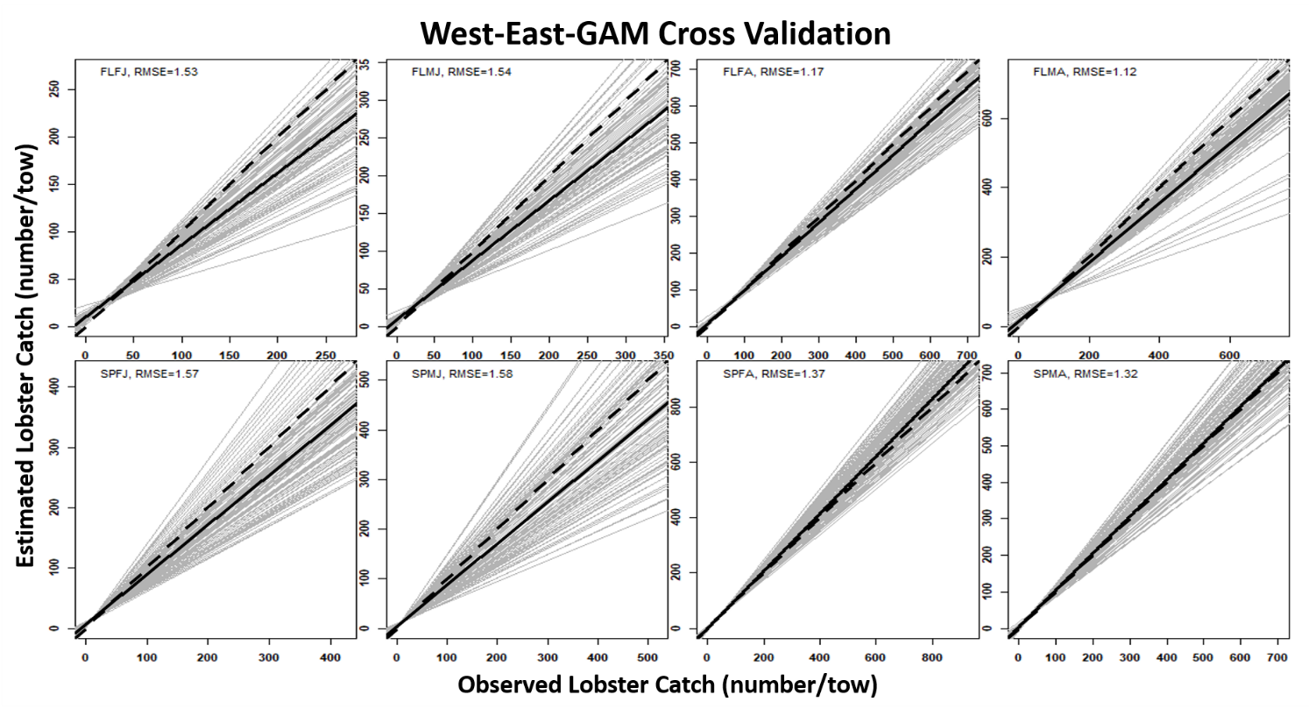
Supplementary Figure 2. Observed versus predicted catch cross validation results from the West-East-GAM for each season, sex, and size group. Light gray lines represent 100 iterations of cross validation. Solid black lines represent the mean of the 100 linear regression lines. The dashed black line represents the 1:1 ratio line between observed and estimated catch or in other words, the ideal model performance.

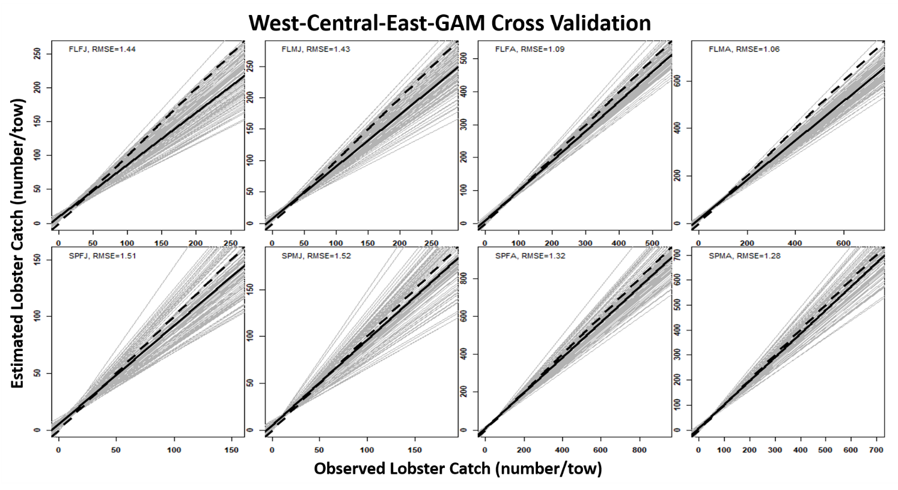
Supplementary Figure 3. Observed versus predicted catch cross validation results from the West-Central-East-GAM for each season, sex, and size group. Light gray lines represent 100 iterations of cross validation. Solid black lines represent the mean of the 100 linear regression lines. The dashed black line represents the 1:1 ratio line between observed and estimated catch or in other words, the ideal model performance.

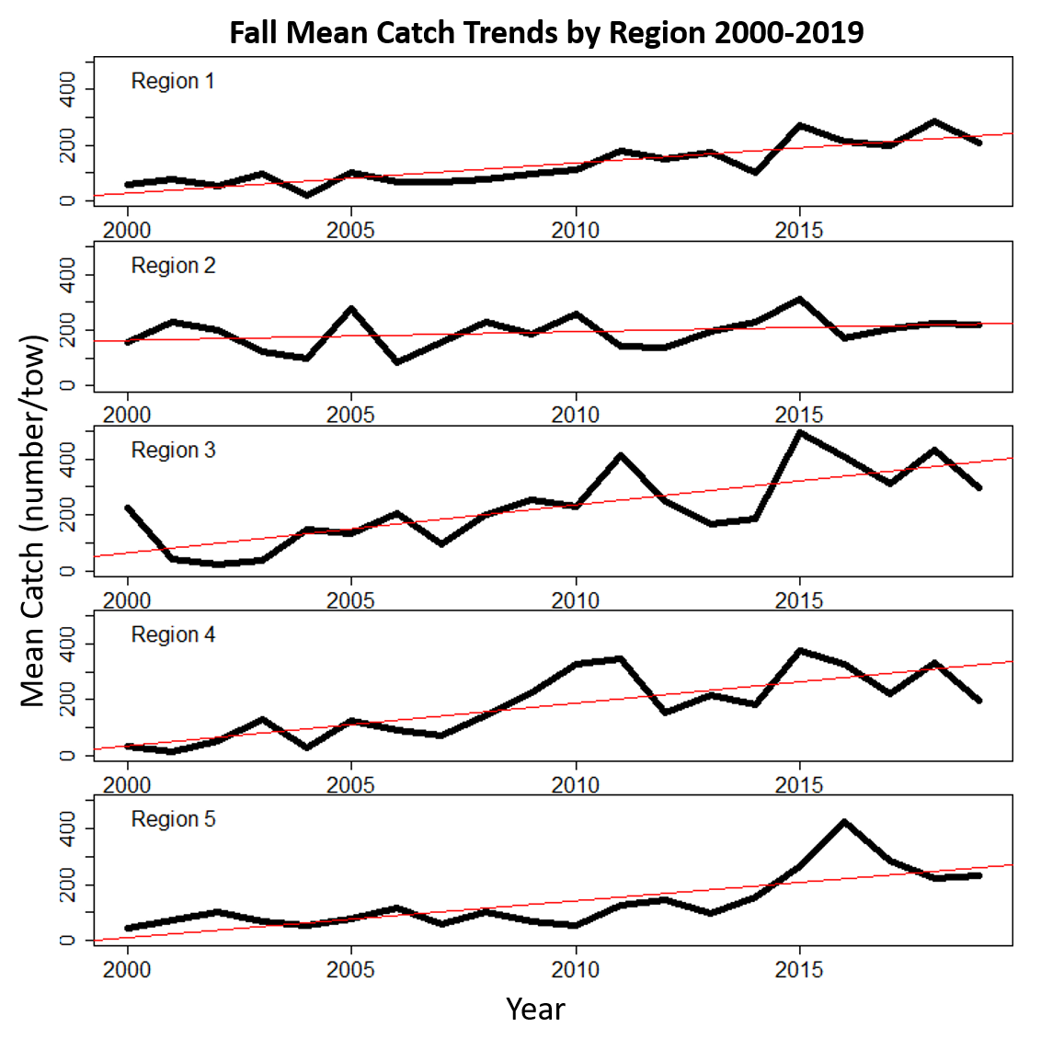

Supplementary Figure 4. Fall mean catch trends by Maine-New Hampshire Inshore Bottom Trawl Survey regions from 2000-2019. Black lines in each plot represent the mean catch (reported in number of lobsters/tow) and red lines represent respective trendlines.
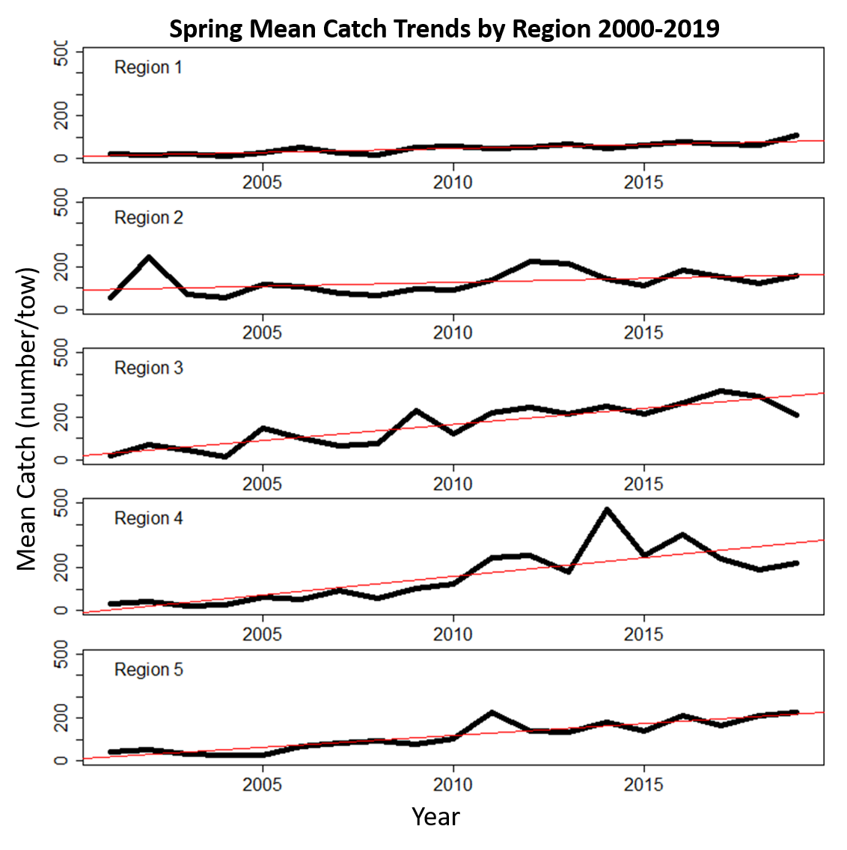
Supplementary Figure 5. Spring mean catch trends by Maine-New Hampshire Inshore Bottom Trawl Survey regions from 2000-2019. Black lines in each plot represent the mean catch (reported in number of lobsters/tow) and red lines represent respective trendlines.

