Geniposide combined with notoginsenoside R1 attenuates inflammation and apoptosis in atherosclerosis via the AMPK/mTOR/Nrf2 signaling pathway
Xiaoyu Liu^{1†}, Yuling Xu², Saibo Cheng¹, Xinghong Zhou¹, Fenghua Zhou¹, Peikun He¹, Fang Hu¹, Lifang Zhang¹, Yuyao Chen¹, Yuyua Jia^{1*}
¹College of traditional Chinese medicine, Southern Medical University, Guangzhou, China
²College of Health, Fujian Medical University, Fuzhou, China
* Correspondence:
Yuhua Jia
yuhuajia_smu@126.com

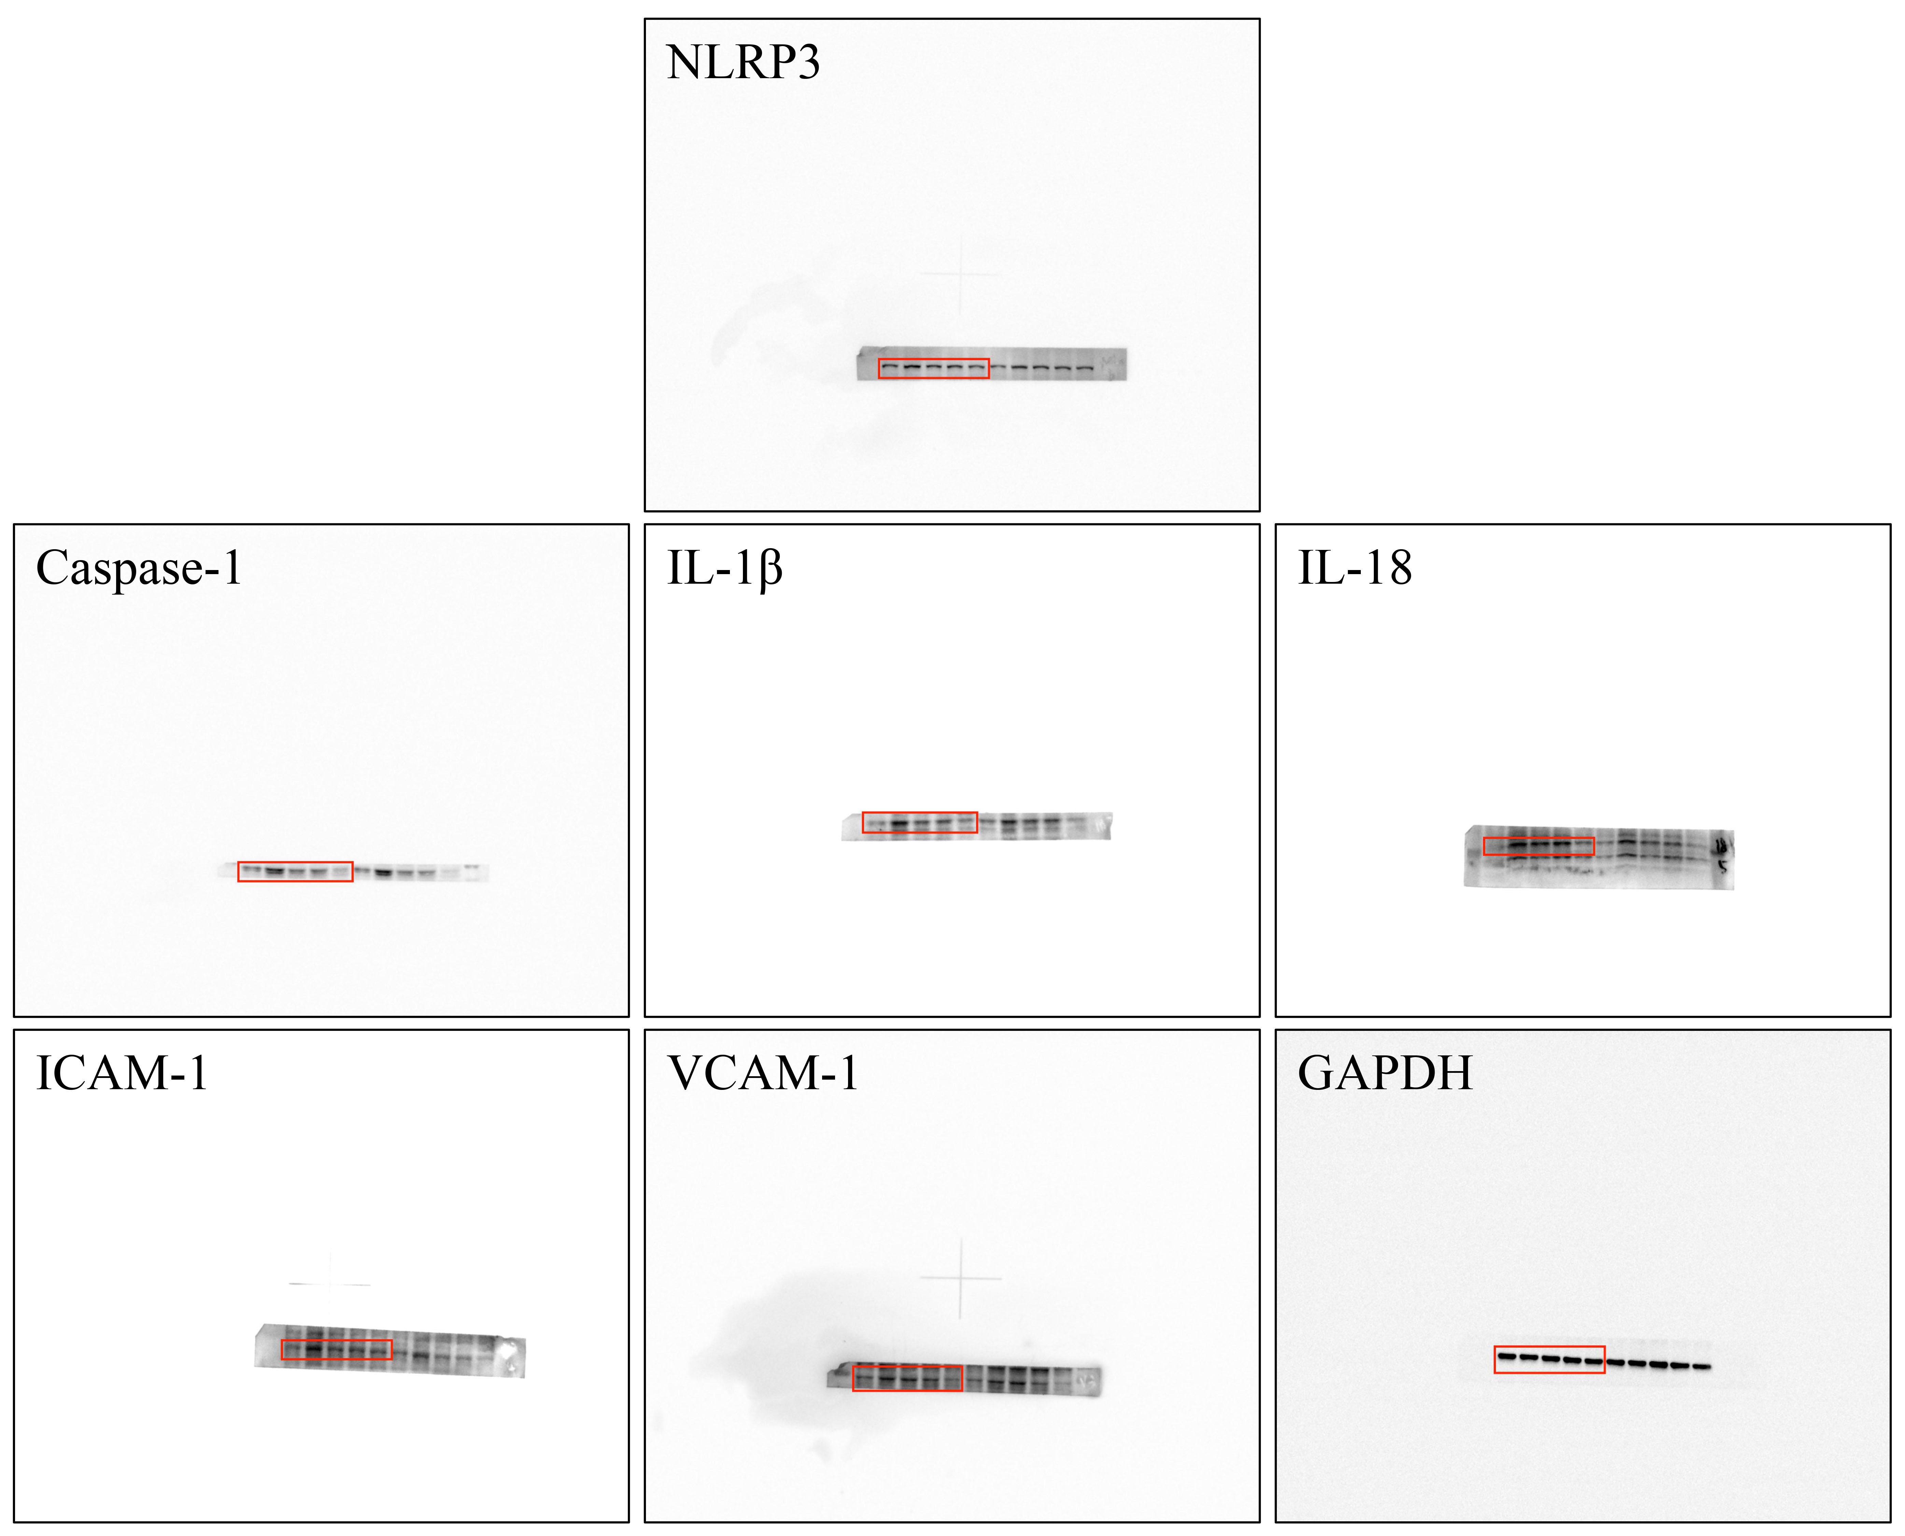

Figure S1. The uncropped western blot results of NLRP3, Caspase-1, IL-1β, IL-18, ICAM-1, VCAM-1 and GAPDH in aortic tissues of ApoE^{-/-} mice from different treatment groups.

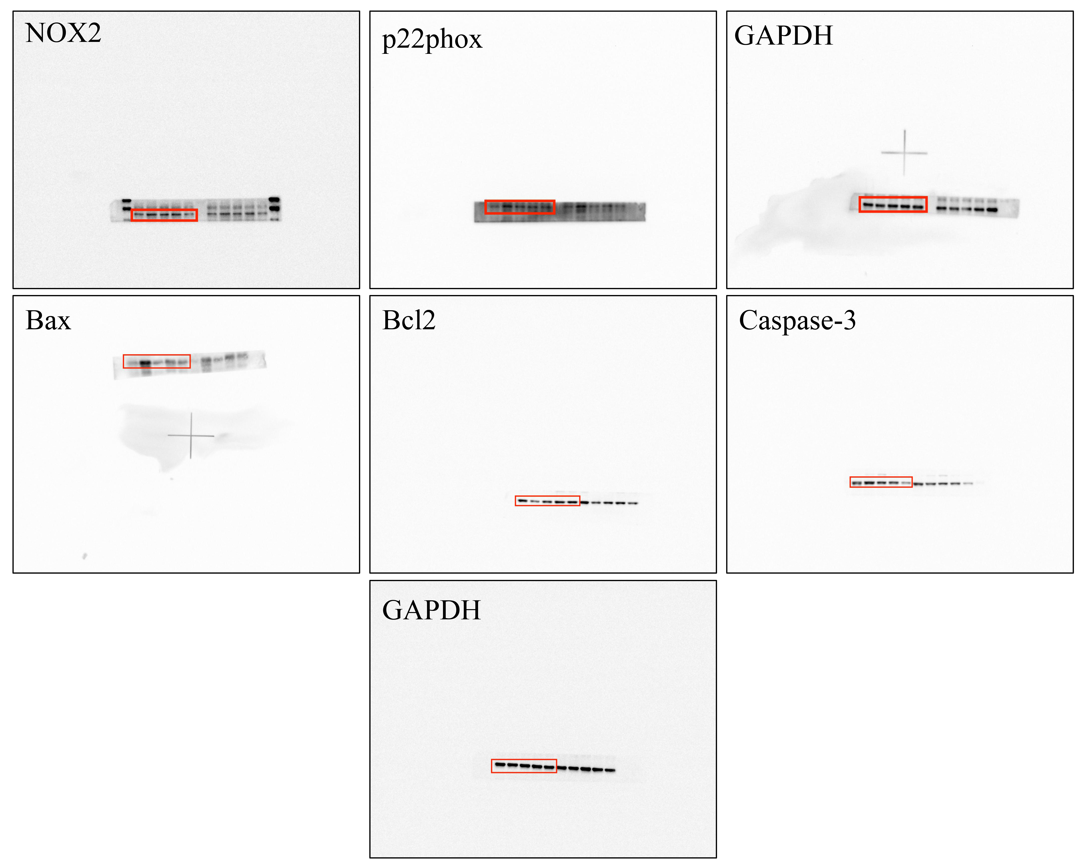

Figure S2. The uncropped western blot results of NOX2, p22phox, Bax, Bcl2, Caspase-3 and GAPDH in aortic tissues of ApoE^{-/-} mice from different treatment groups.
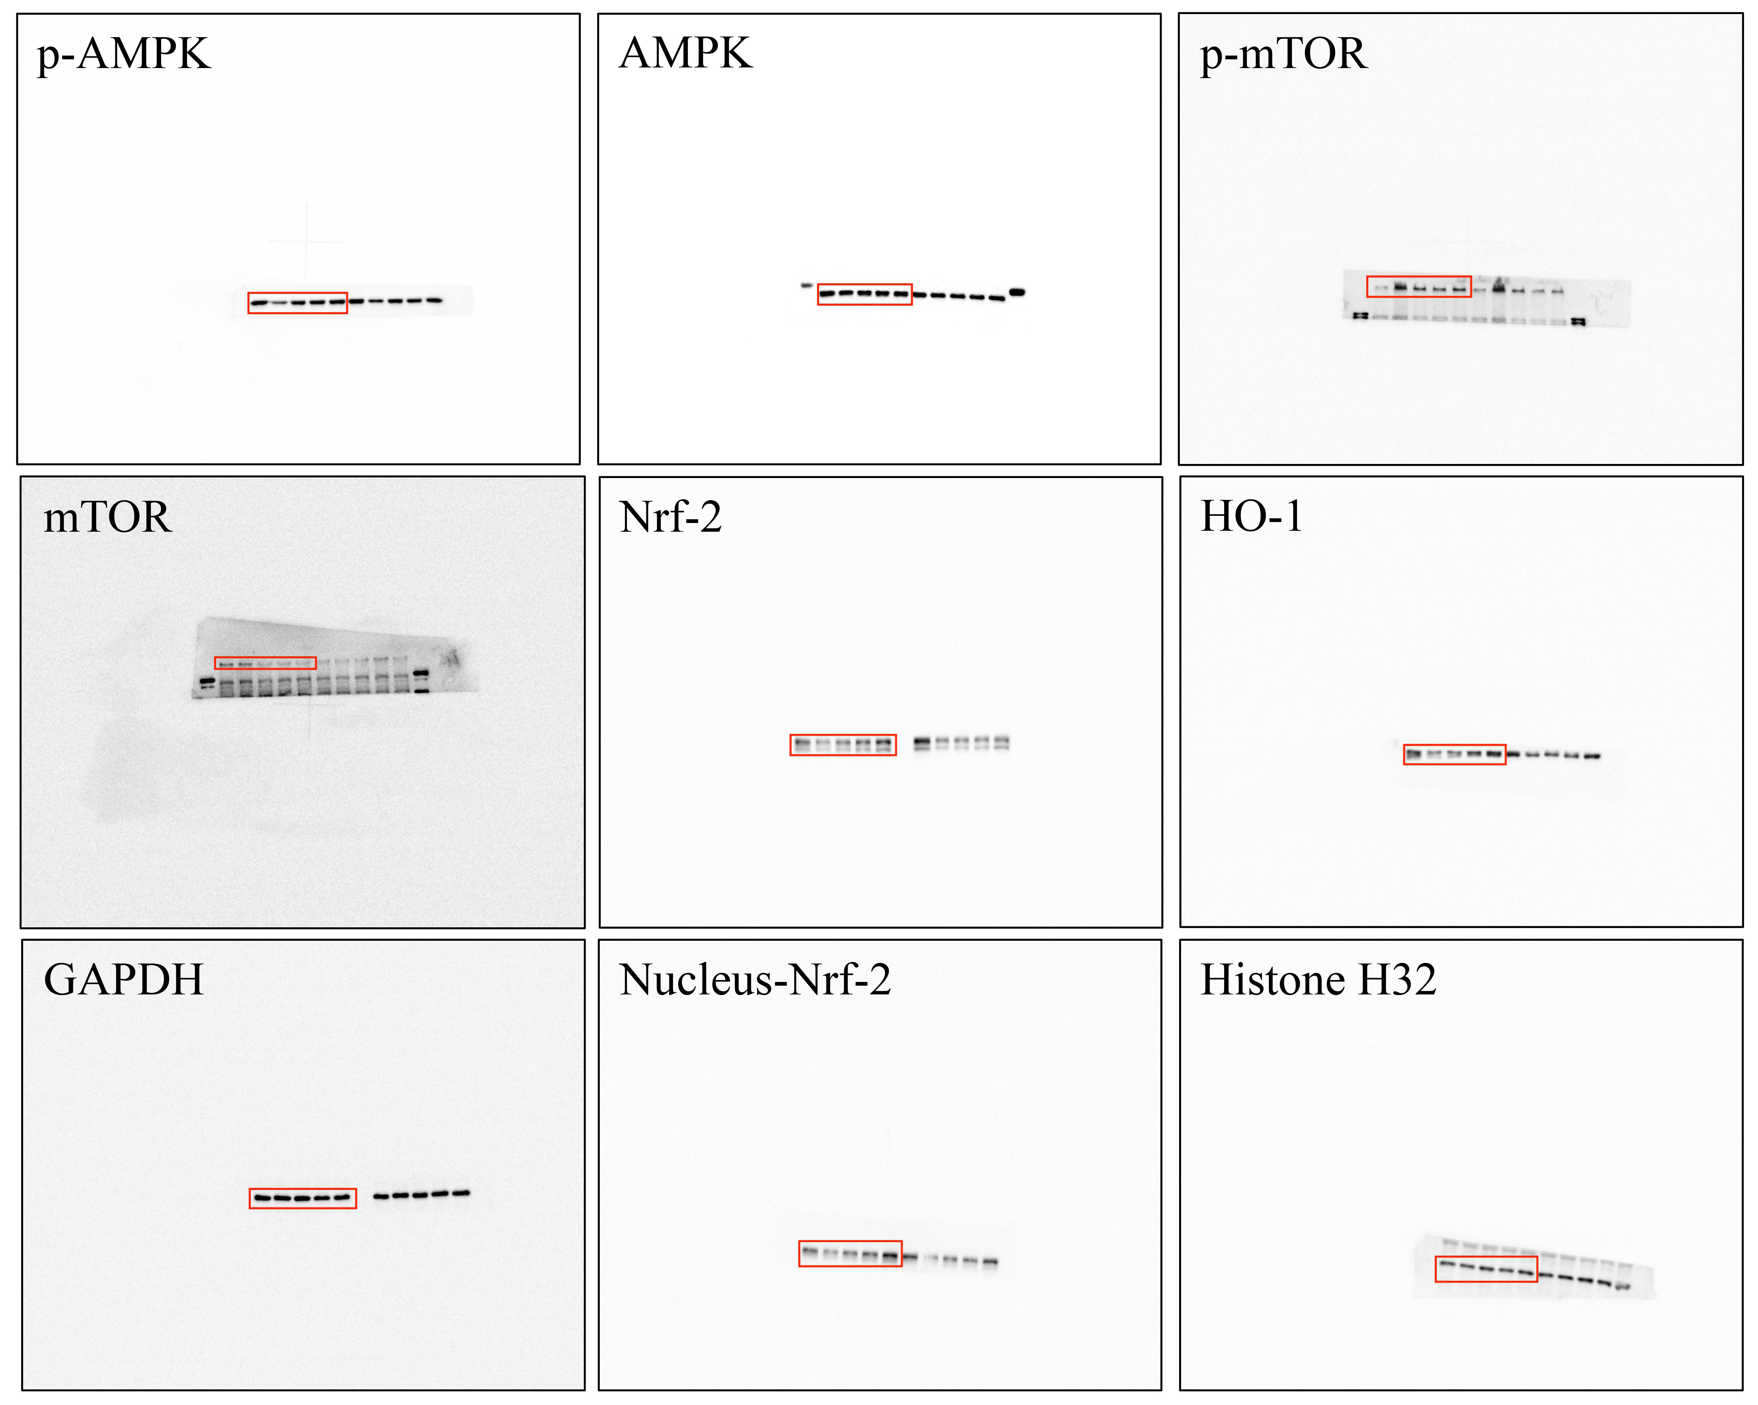

Figure S3. The uncropped western blot results of p-AMPK, AMPK, p-mTOR, mTOR, Nrf-2, HO-1, GAPDH, Nucleus-Nrf-2 and Histone H32 in aortic tissues of ApoE^{-/-} mice from different treatment groups.

.
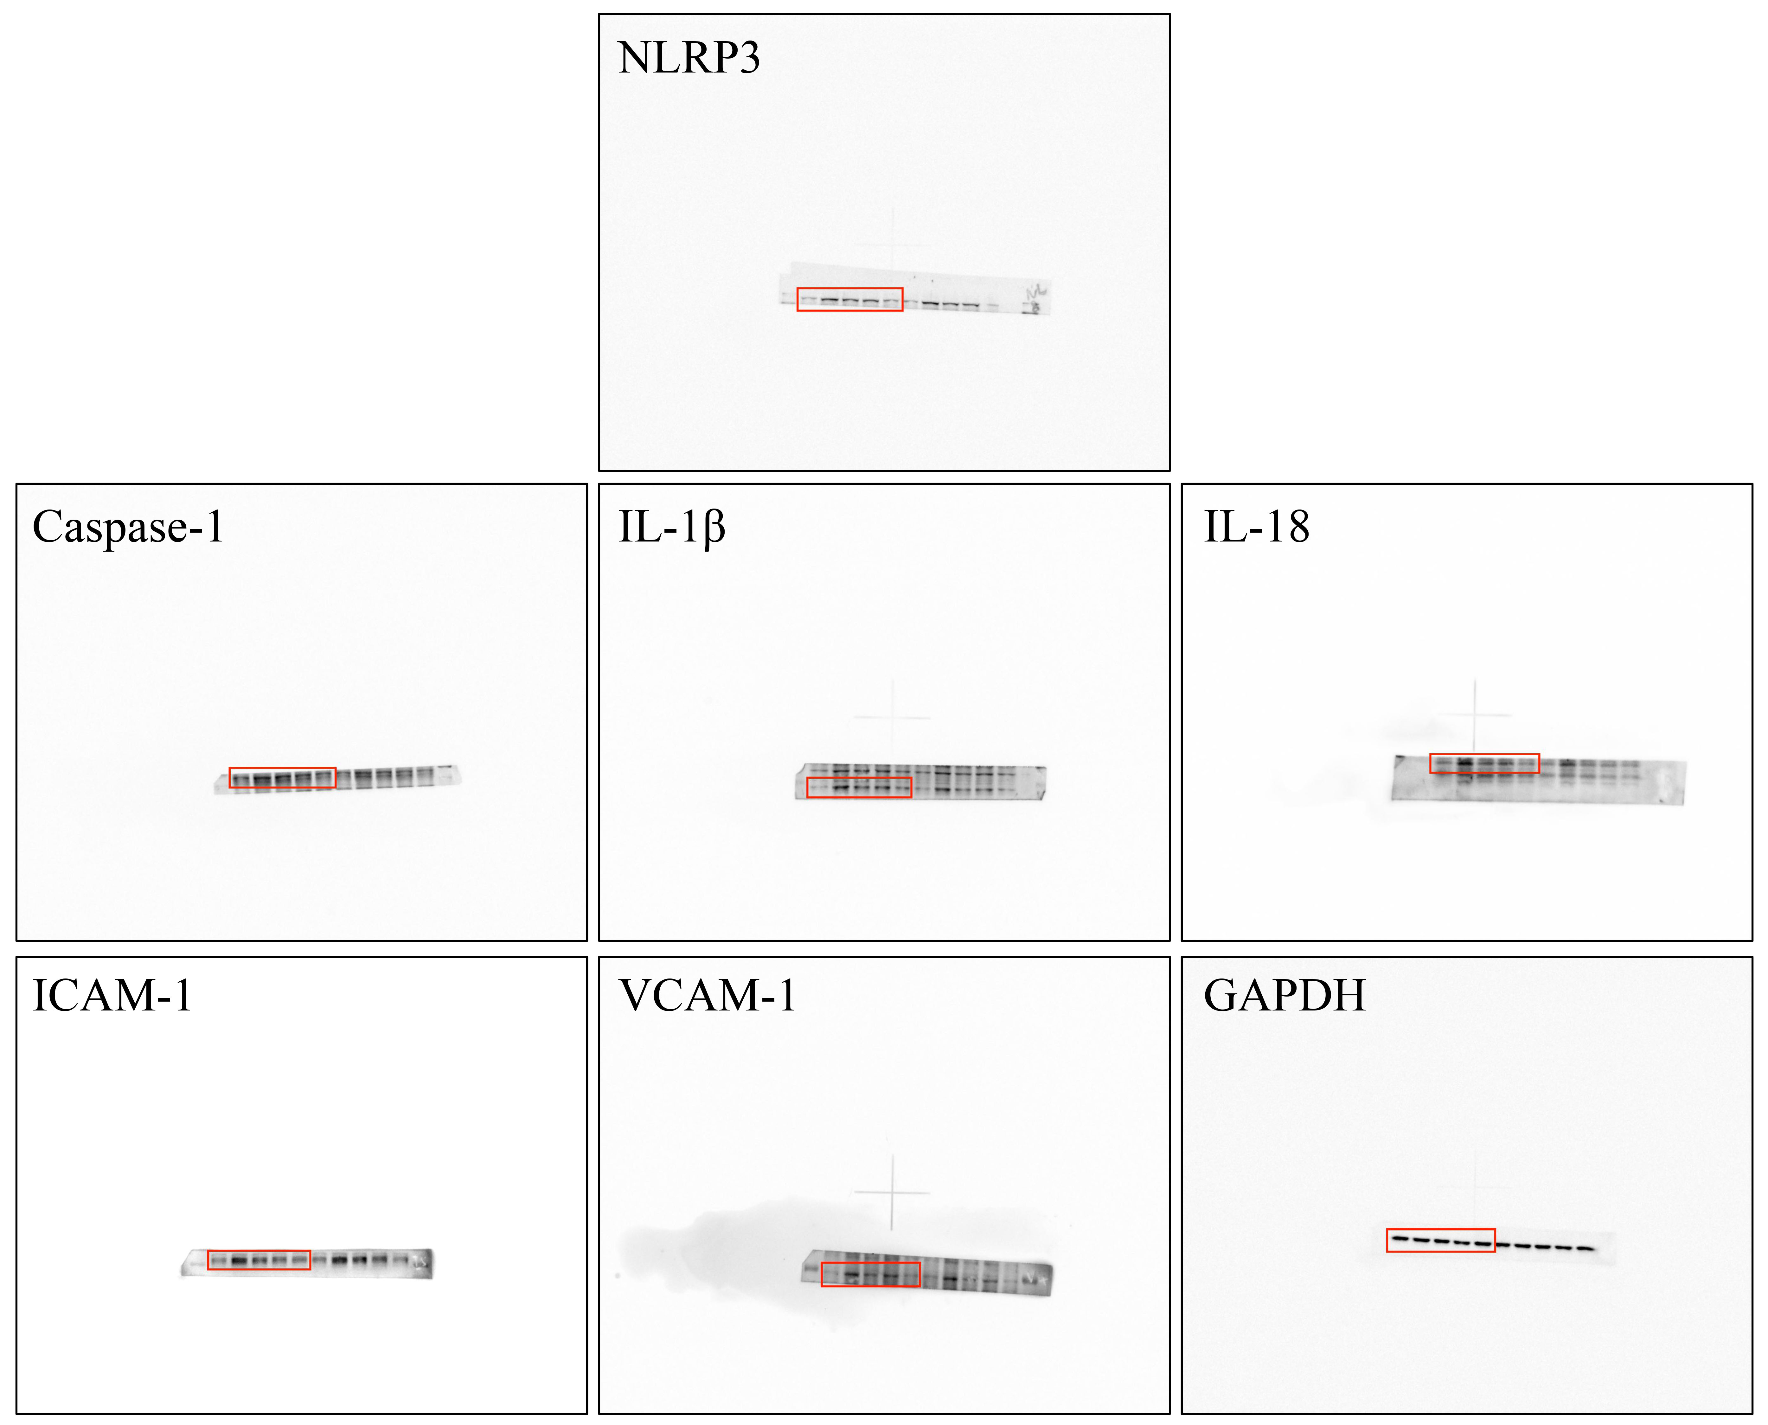

Figure S4. The uncropped western blot results of NLRP3, Caspase-1, IL-1β, IL-18, ICAM-1, VCAM-1 and GAPDH in HUVECs treated with GN combination from different treatment groups.

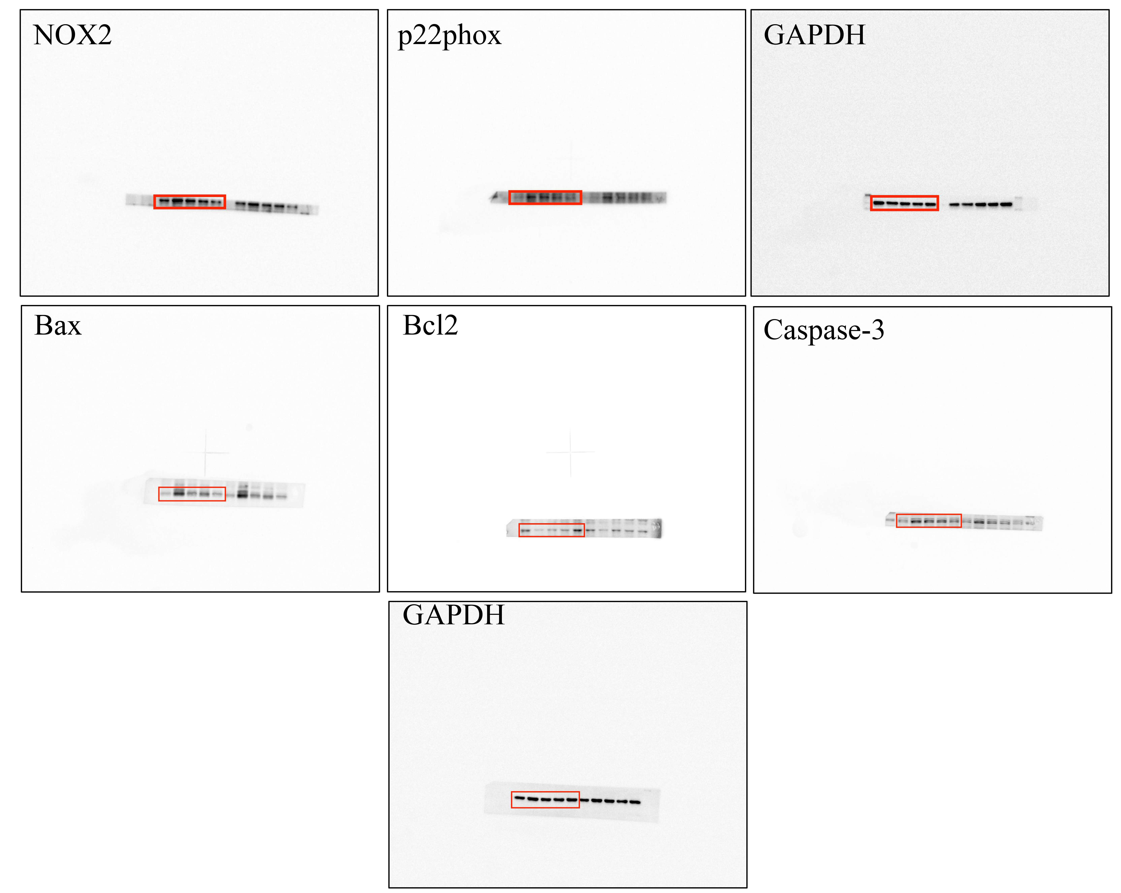

Figure S5. The uncropped western blot results of NOX2, p22phox, Bax, Bcl2, Caspase-3 and GAPDH in HUVECs treated with GN combination from different treatment groups.

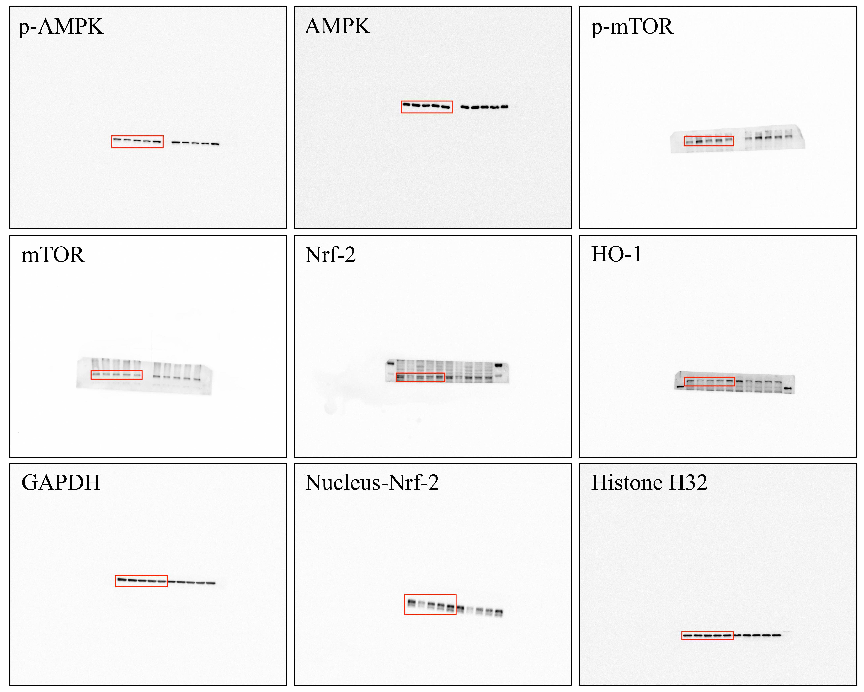

Figure S6. The uncropped western blot results of p-AMPK, AMPK, p-mTOR, mTOR, Nrf-2, HO-1, GAPDH, Nucleus-Nrf-2 and Histone H32 in HUVECs treated with GN combination from different treatment groups.

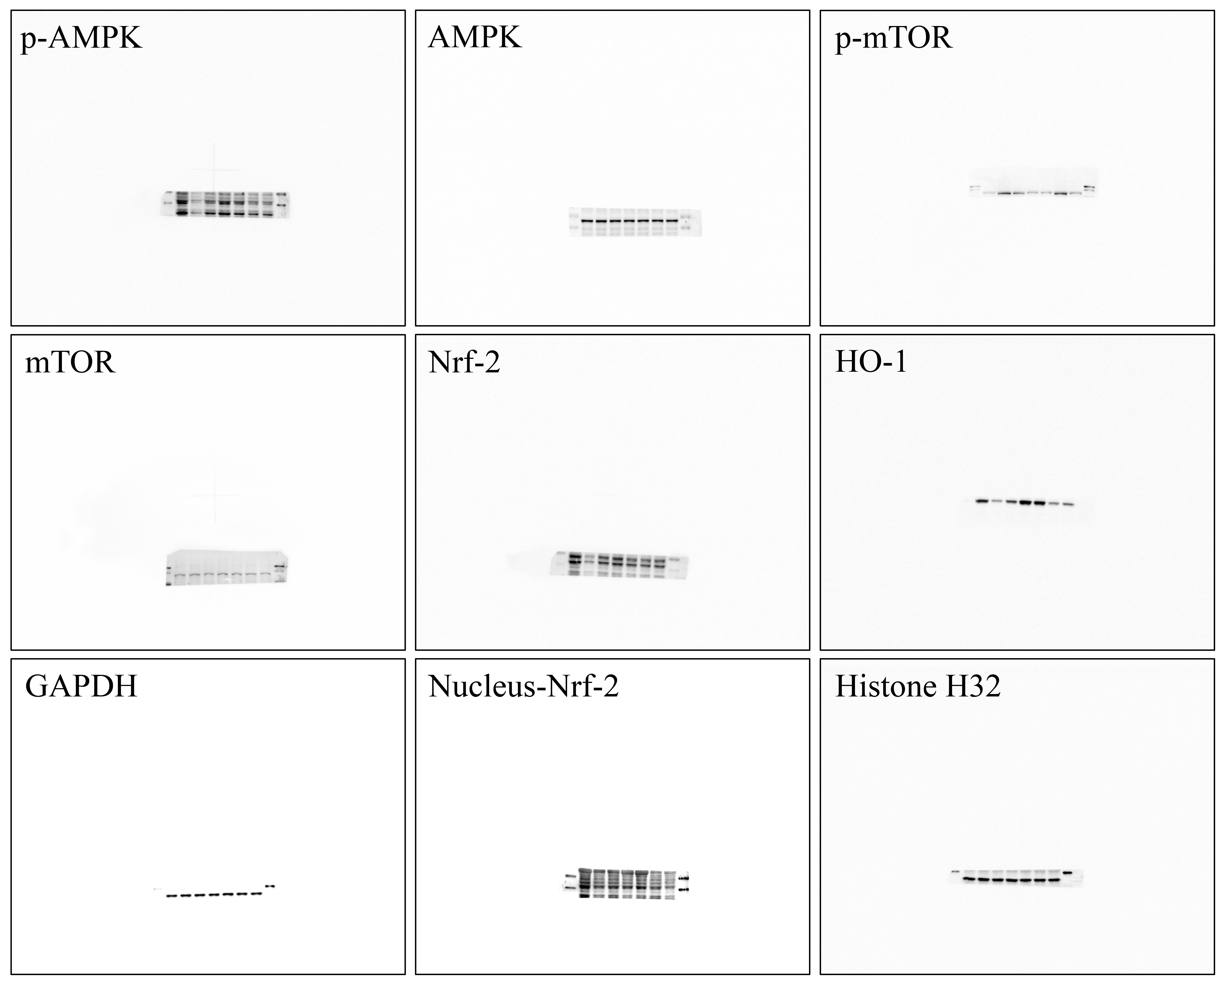

Figure S7. The uncropped western blot results of p-AMPK, AMPK, p-mTOR, mTOR, Nrf-2, HO-1, GAPDH, Nucleus-Nrf-2 and Histone H32 in HUVECs treated with AICAR or dorsomorphin from different treatment groups.

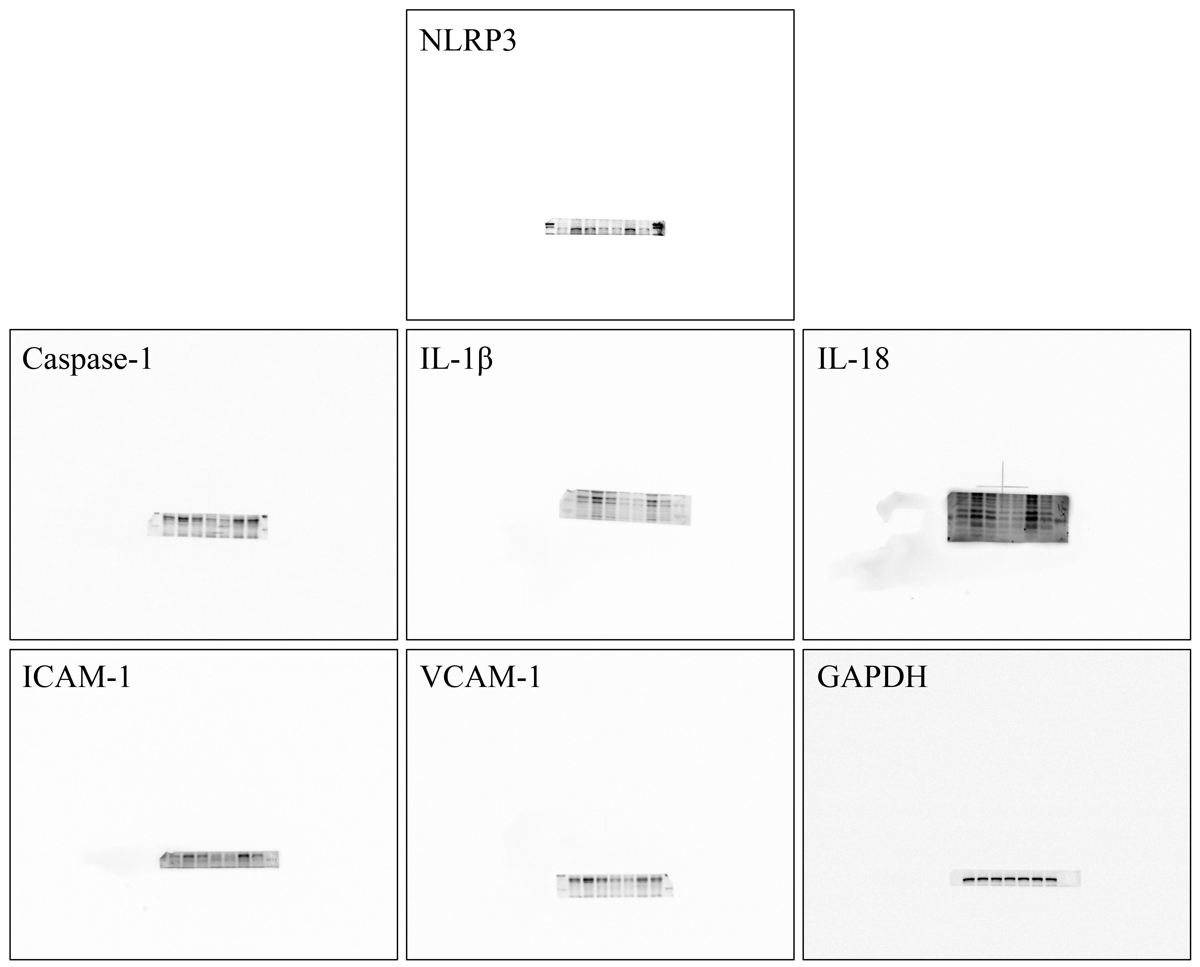

Figure S8. The uncropped western blot results of NLRP3, Caspase-1, IL-1β, IL-18, ICAM-1, VCAM-1 and GAPDH in HUVECs treated with AICAR or dorsomorphin from different treatment groups.

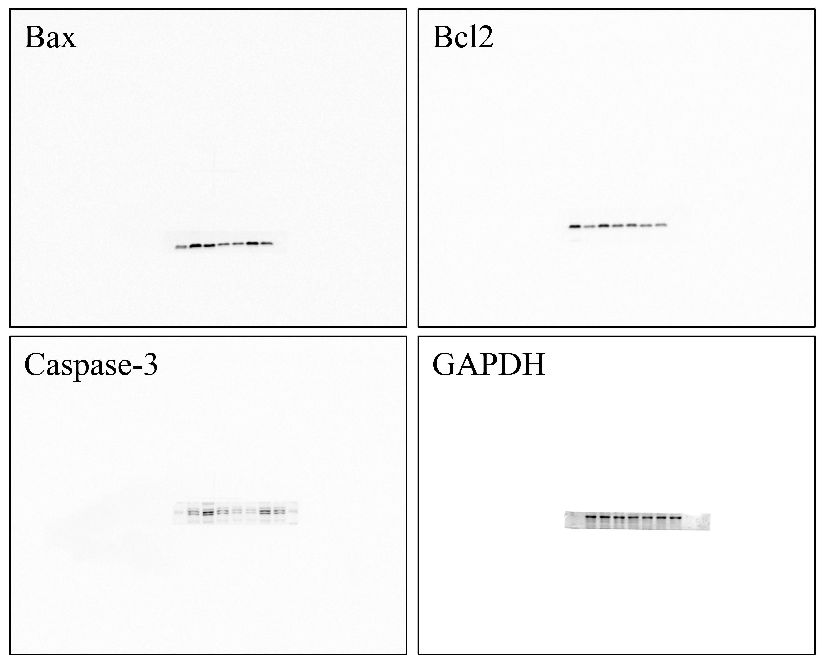

Figure S9. The uncropped western blot results of Bax, Bcl2, Caspase-3 and GAPDH in HUVECs treated with AICAR or dorsomorphin from different treatment groups.

