Supplementary information

Supplementary Figures

Supplementary Figure 1. SDS-PAGE analysis ofpurified Cas12a. M indicates protein molecular marker; lane 1 represents His-MBP-taggedCas12apurified using Ni-NTA Agarose; lane 2 representsrecombinantCas12a protein after treatment with TEV protease; lane 3represents the purifiedCas12a proteinafter removing of the His-MBP tag.Specifically, 40 μL of protein samples were mixed with 10 μL 5×SDS loading buffer, and incubated for 10 mins in a boiling water bath. 10 μLof samples were analyzed by 15% SDS-PAGE (Sangon Biotech, China) in running buffer (50 mM HEPES, 0.1% SDS, 2 mM EDTA) at 160 volts.

Supplementary Figure 2. Performance of Cas12a alone detection. (A) Schematic view of Cas12a detection of genomic DNA. (B) LOD of Cas12a detection of four target genes of Y. pestiswas determined using genomic DNA at different concentrations (3×10¹to 3×10⁴fM). Bar graphs showedthe endpoint fluorescence intensities after the 2 hours incubation. Data are represented as mean with standard deviation(SD)(n=3).

Supplementary Figure 3. Optimization of the reporter used in fluorescence-read out Cas12a detection. ssDNA reporters containing a homoploymer of A, T, G or C bases were analyzed.

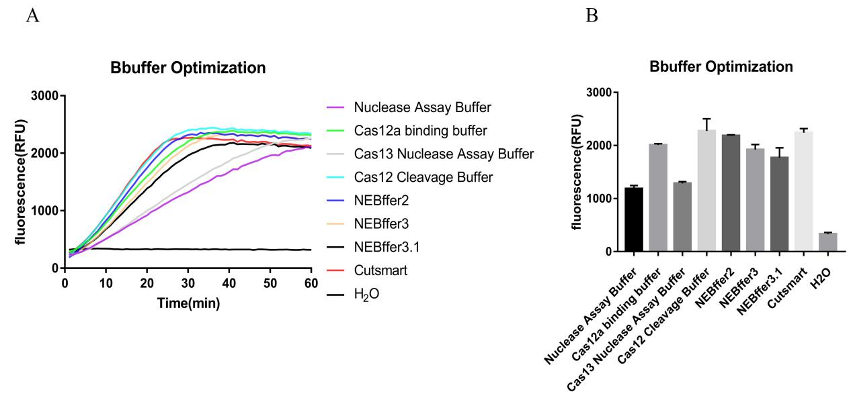

Supplementary Figure 4. Optimization of reaction buffer for Cas12a detection. Buffers of different compositionswere tested for their performance on Cas12a alone detection of plagene using pUC19-plaassamples. (A) Real-time curvesof fluorescence signals using different reaction buffer. (B) Bar graphs showedthe endpoint fluorescence intensitiesdetected at30 min for the different reaction buffer. Data are represented as mean with SD(n=3).

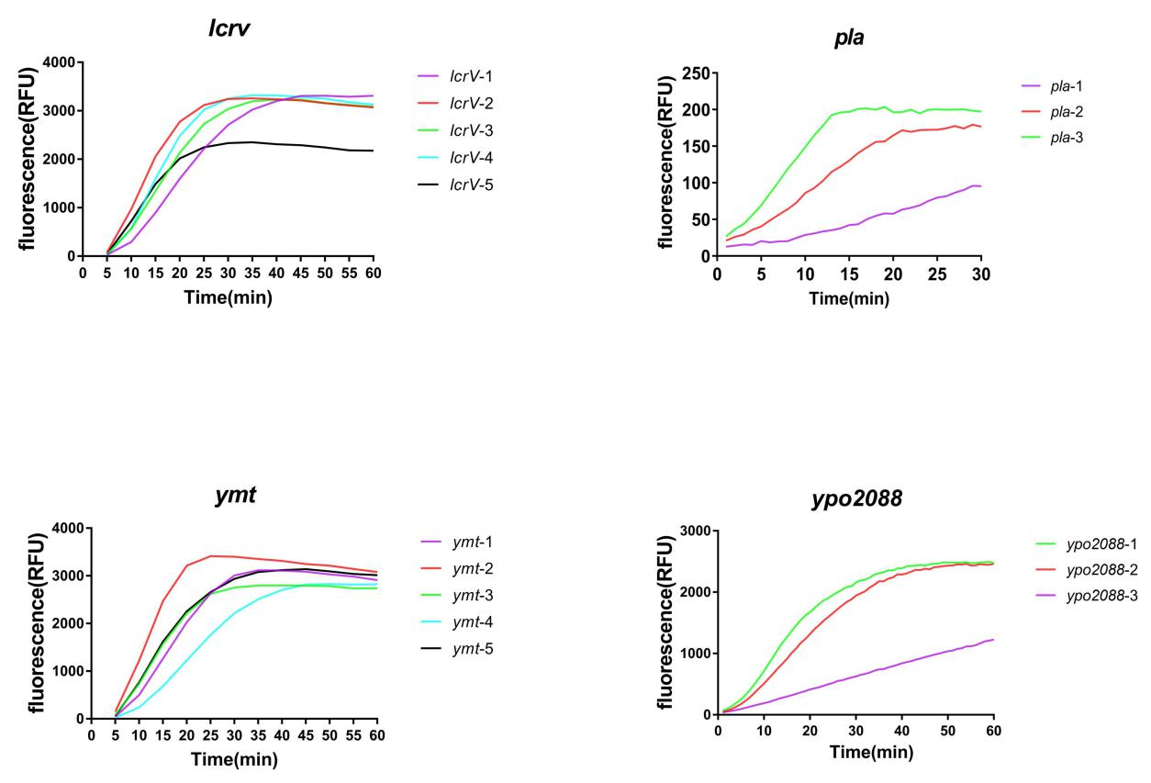
Supplementary Figure 5. Screening the optimized crRNA for the four target genes used in this study.3μL of PCR products were added into the Cas12a reaction mixtures. The reactionswere performed at 37 °C andreal-time curves showed the fluorescence signals taken every minute within 1 hourusingSpectraMax.

Supplementary Figure 6. LOD of qPCR for the detection of plainY. pestis genomic DNA samples. The concentrations of Y. pestis genomic DNA were from 3×10⁻¹ to 3×10⁵aM.

Supplementary Figure7. LOD of qPCR for the detection of plainY. pestisspiked blood samples.The concentrations of Y. pestis were from 10⁷ to 10 CFU per 100 μL blood.

SupplementaryTables

Supplementary Table1．Nucleotide sequence of primers and reporters used in this study.
Name | Sequence （5’ to 3’） | Usage
pla-f | GATTACGCCAAGCTTGAGATTAAGGGTGTCT | Construction of pUC19-pla
pla-r | GTACCCGGGGATCCGGGAGGATGAAAAGAG | Construction of pUC19-pla
pla-Taq-f | GTAATAGGTTATAACCAGCGCTT | Real time PCR assay of pla
pla-Taq-r | AGACTTTGGCATTAGGTGTG | Real time PCR assay of pla
pla-Taq-probe | FAM-ATGCCATATATTGGACTTGCAGGCCAGT-BHQ1 | Real time PCR assay of pla
pla-PCR-f | GTCCGGGAGTGCTAATGCAG | PCR amplification of pla
pla-PCR-r | GTCTGAGTACCTCCTTTGCCC | PCR amplification of pla
ymt-PCR-f | ACGTGTATCCTGATTTCCCACC | PCR amplification of ymt
ymt-PCR-r | CTTGATGCGGGGGTTTTTCC | PCR amplification of ymt
lcrV-PCR-f | AGCCTACGAACAAAACCCACA | PCR amplification of lcrV
lcrV--PCR-r | GGACTTATCCGAGCAGGTGG | PCR amplification of lcrV
yop2088-PCR-f | ATGACACTGCGTGAATGCCT | PCR amplification of ypo2088
ypo2088-PCR-r | TACTGCGTTGTTGGCCTCAG | PCR amplification of ypo2088
ypo2088-f | AAATTAGTCATCAGGGCAACAATGGGATTTGGTTC | RPA amplification of ypo2088
ypo2088-r | CGTTGAAACTGTGTCATGGTCTAACATGCATTGG | RPA amplification of ypo2088
pla-f | ATATAGTTATAATAATGGAGCTTATACCGGAAACT | RPA amplification of pla
pla-r | TATTCTTATCAATGGTCTGAGTACCTCCTTTG | RPA amplification of pla
lcrV-f | TGCGAGGGCAAATTATTTAATATGATTAGAGCCTA | RPA amplification of lcrV
lcrV-r | ACGCCCGCAATTCCCATTGTGTATTCGGCGATGAT | RPA amplification of lcrV
ymt-f | TGTATCCTGATTTCCCACCAATCAACGATACAAGA | RPA amplification of ymt
ymt-r | TTTCATGCAAGTTGAGTAGGTCCTCTTGCCGTTGC | RPA amplification of ymt
FAM-C-BHQ1 | FAM-CCCCC-BHQ1 | Cas12a detection reporter  Cas12a detection reporter
FAM-T-BHQ1 | FAM-TTTTT-BHQ1
FAM-A-BHQ1 | FAM-AAAAA-BHQ1 | Cas12a detection reporter
FAM-G-BHQ1 | FAM-GGGGG-BHQ1 | Cas12a detection reporter

Supplementary Table2．Nucleotide sequence of crRNA used in this study
Name | Sequence （5’ to 3’）
ymt-crRNA-1 | UAAUUUCUACUAAGUGUAGAUAAAGCAACAAAGTCAGGGGA
ymt-crRNA-2* | UAAUUUCUACUAAGUGUAGAUGTAAATCTGAATTACATGAC
ymt-crRNA-3 | UAAUUUCUACUAAGUGUAGAUAGCGGATCTTCAGGCTTATC
ymt-crRNA-4 | UAAUUUCUACUAAGUGUAGAUTACTCTTCCATGTTTTCGTA
ymt-crRNA-5 | UAAUUUCUACUAAGUGUAGAUCCTACTGATAAAACTCTGTC
lcrV-crRNA-1 | UAAUUUCUACUAAGUGUAGAUTCTTTGACTAACTGAACCAA
lcrV-crRNA-2* | UAAUUUCUACUAAGUGUAGAUATGGAAATATCTATATTTTT
lcrV-crRNA-3 | UAAUUUCUACUAAGUGUAGAUAGAATGGCATCCTCGGGTAG
lcrV-crRNA-4 | UAAUUUCUACUAAGUGUAGAUCTCGCTTGATGCCATTTTG
lcrV-crRNA-5 | UAAUUUCUACUAAGUGUAGAUATTCGGCGGTAAGCTCAGCT
ypo2088-crRNA-1* | UAAUUUCUACUAAGUGUAGAUAGGCATCCTTGCCCAAAGGT
ypo2088-crRNA-2 | UAAUUUCUACUAAGUGUAGAUCTGCTTTTGCCAGCCTGTAA
ypo2088-crRNA-3 | UAAUUUCUACUAAGUGUAGAUCCTAATGTTTTGTCTGGGAG
pla-crRNA-1 | UAAUUUCUACUAAGUGUAGAUUAAUUCUCAUCCUGGAGUAA
pla-crRNA-2 | UAAUUUCUACUAAGUGUAGAUACUCAAAAUCAUUAAUGCGA
pla-crRNA-3* | UAAUUUCUACUAAGUGUAGAUCUGUAUGUAAAUUCCGCAAA
*：crRNAs finally used inRPA-Cas12a and Cas12a-UPTFLA platform were labeled withasterisk.

Supplemental Table 3. component of different reaction buffer
Name | Component
Nuclease Assay Buffer | 60 mM NaCl, 40 mM Tris-HCl, 6 mM MgCl₂, pH7.5
Cas12a binding buffer | 20 mM Tris-HCl, 5 mM MgCl_{2,} 100 mM KCl, 1 mM DTT, 5% Glycerol, 50 µg/mL HeparinpH7.5
Cas13 Nuclease Assay Buffer | 60 mM NaCl, 20 mM HEPES, 6 mM MgCl₂, pH6.8
Cas12 Cleavage Buffer | 150 mM KCl, 20 mM HEPES, 10 mM MgCl₂, 0.5 mM DTT, 1% Glycerol, pH7.5
NEBffer2 | 50 mM NaCl, 10 mM Tris-HCl, 10 mM MgCl₂, 1 mM DTT, pH7.9
NEBffer3 | 100 mM NaCl, 50 mM Tris-HCl, 10 mM MgCl₂, 1 mM dithiothreitol pH 7.9
Cutsmart | 50mM Potassium Acetate, 20mM Tris-acetate, 10mM Magnesium Acetate, 100μg/ml BSA, pH 7.9
NEBffer3.1 | 100 mM NaCl, 50 mM Tris-HCl, 10 mM MgCl₂, 100 μg/ml BSA, pH 7.9

