Appendix 1. Identified balance recovery strategies for each perturbation trial. The overall initial and recovery strategies are also tabulated. Abbreviations: an – ankle, kn – knee, hi – hip, sp – step, fi – fighting stance, sq – squat, su – surfer, n.a. – not applicable.
Volunteers | Lowest braking |  | Baseline |  | Highest Jerk |  | Highest Acceleration |  | Highest Braking |  | Initial | Recovery
 | F | R | F | R | F | R | F | R | F | R | Strategy | Strategy
1 (M) | An|n.a. | Kn-An | Fi | Kn-An|Fi | An|Sp* | Kn-An|Sp | An|Sp* | Kn-An|Sp* | An|Sp* | Kn-An|Fi | An-Hi|Sp* | An-Kn | Step
2 (M) | An-Hi|n.a. | An|Sp* | An|Sp* | An|Sp* | An|Sp* | An|Sp* | An|Sp* | An|Sp* | n.a. | n.a. | Ankle | Step
3 (M) | An|n.a. | An|Sp | An-Kn|Sp | An|Sp* | An-Kn |Sp | An|Fi | An-Kn |Sp* | An|Sp* | n.a. | n.a. | Ankle | Step
4 (F) | An|Sp | An|Sp | An|Sp | An|Sp | An-Hi|Fi | An|Fi | An-Kn|Sp* | An|Sp* | An-Kn|Sp | An|Sp* | Ankle | Step
5 (F) | An|Sp | An|Sp* | An|Sp* | An|Sp* | An|Sp* | An|Sp* | An|Sp* | An|Sp* | An|Sp* | An|Sp* | Ankle | Step
6 (F) | An|Kn | Kn-An|Sp | An-Kn|Sp | An|Sp | An-Kn|Fi | An|Sp | An-Kn|Sp* | An|Sp* | An-Kn|Sp | An|Sp | An-Kn | Step
7 (M) | An|Sp | An|Fi | An|Fi | An|Fi | An|Fi | An|Fi | An|Sp* | An|Fi* | An|Fi | An|Fi | Ankle | Fight
8 (F) | An|n.a. | An|Sp | An|Fi | An|Sp | An|Fi | An|Sp | An|Sp* | An|Sp* | An|Fi | An|Sp* | Ankle | Step
9 (F) | Kn-An|n.a. | An|Sp | An|Fi | An|Fi | Hi-An|Fi | An|Fi | Kn-An|Sp* | An-Kn|Fi* | An|Fi | An|Fi | Ankle | Fight
10 (F) | An|Sp | An|Sp* | An|Sp* | An|Sp* | An|Sp* | n.a. | An|Sp* | n.a. | n.a. | n.a. | Ankle | Step
11 (M) | Kn|Kn | An|Fi | An-Hi|Fi | An|Fi | An-Hi|Fi | An|Fi | An-Kn|Sp | An|Fi* | An-Kn|Fi | An|Sp* | Ankle | Fight
12 (M) | An-Kn|Fi | An|Fi | An-Kn|Fi | An|Fi | An-Kn|Fi | An|Fi | An-Kn|Fi | Kn-An|Fi* | An-Kn|Fi | Kn-An|Fi | An-kn | Fight
13 (F) | An-Hi(?)|Sp | Hi-An|Sp | An|Sp | An|Sp | An|Sp | An|Sp | An|Sp* | An|Sp* | An|Sp | Hi|Fi | Ankle | Step
14 (F) | An-Sp | An-Hi|Sp | An|Sp* | An|Sp* | An|Sp* | An|Sp* | An|Sp* | An|Sp* | n.a. | n.a. | Ankle | Step
15 (F) | Kn-Kn | Hi-An-Kn|Sp | An|Fi | Hi|Fi | An|Fi | An|Fi | An|Sp* | An|Sp* | n.a. | n.a. | Ankle | Fight
16 (F) | An-Fi | Kn-Sp|Fi | An-Kn|Fi | An|Fi | An|Fi | An|Fi | An-Kn|Sp* | An-Hi|Sp* | Kn|Fi | Kn|Fi* | Ankle | Fight
17 (M) | - | An|Fi | An|Fi | An|Fi | An|Fi | An|Fi | An|Sp* | An|Sp* | An|Fi | An|Fi | Ankle | Fight
18 (M) | Sp|Fi | Sp|Fi | An-Sp|Fi | An|Fi | An|Fi | An|Fi | An|Fi | An|Fi* | An|Fi | An-Kn|Fi | Ankle | Fight
19 (M) | Hi-An|Sp* | Sq|Su* | An|Su | An|Su | An|Su | An|Su | Kn-An|Su* | An|Su* | An|Su | -|Su* | Ankle | Surfer
20 (M) | An|Fi | An|Fi | An|Fi | An|Fi | An|Fi | An|Fi | An|Fi* | An|Sp* | An|Sp | An|Sp* | Ankle | Fight
21 (M) | An|Fi | An|Sp* | An|Sp | An|Sp* | An|Sp | An|Sp* | An|Sp* | An|Sp* | An|Sp* | An|Sp* | Ankle | Step
22 (M) | An|Sp | An|Sp* | An|Sp* | An|Sp* | An-Kn|Sp* | An|Sp* | An|Sp* | An|Sp* | An-Kn|Sp* | An|Sp* | Ankle | Step
23 (M) | An|Sp | An|Sp | An|Fi | An|Fi | An|Fi | An|Fi | An|Fi* | An|Fi* | An|Fi | An|Fi | Ankle | Fight
24 (F) | An|Fi | An|Sp | n.a. | Hi-Kn|Sq-Sp | Hi|Sq-sp | An|Sq-sp | Hi|Sq-sp | An|Sq-sp | n.a. | n.a. | Ankle | Squat-step

Appendix 2. Fighting stance variations among volunteers.
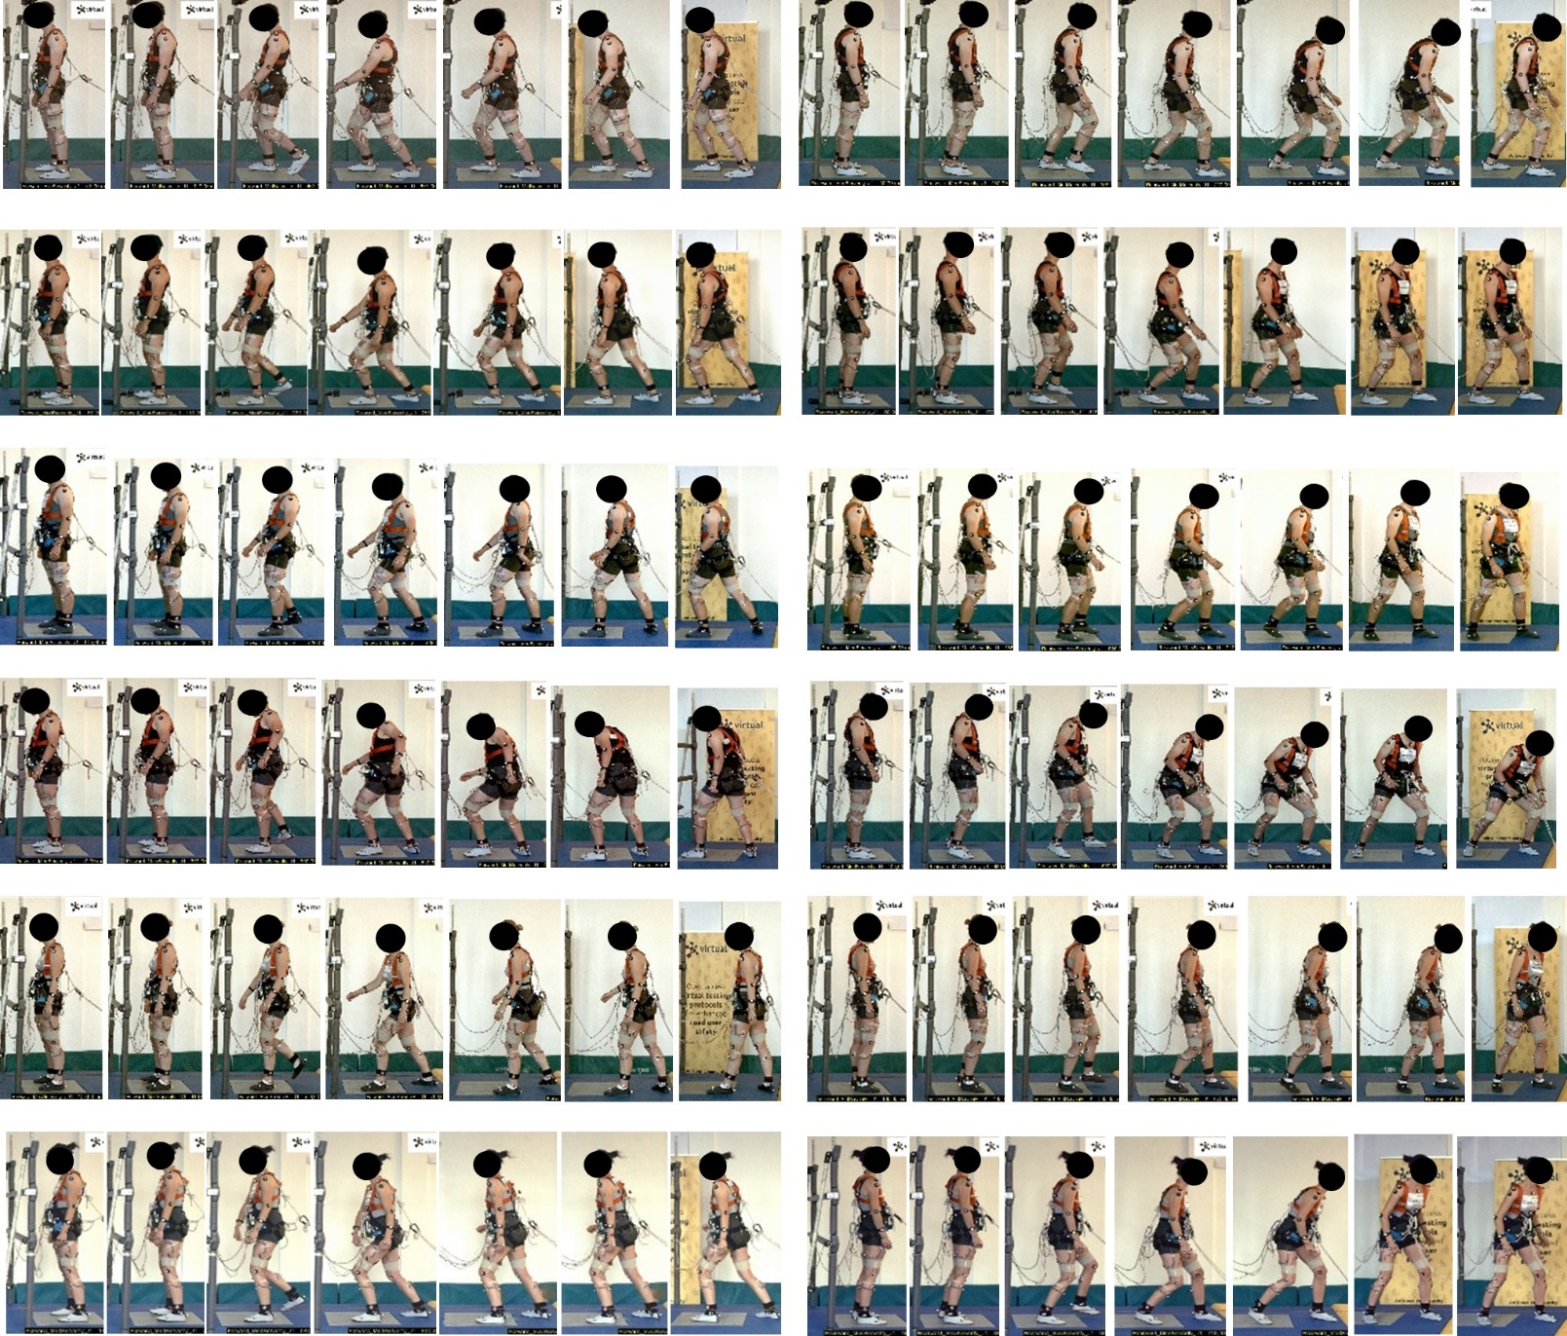
Appendix 3. Stepping variations among volunteers.
