Supplementary Material
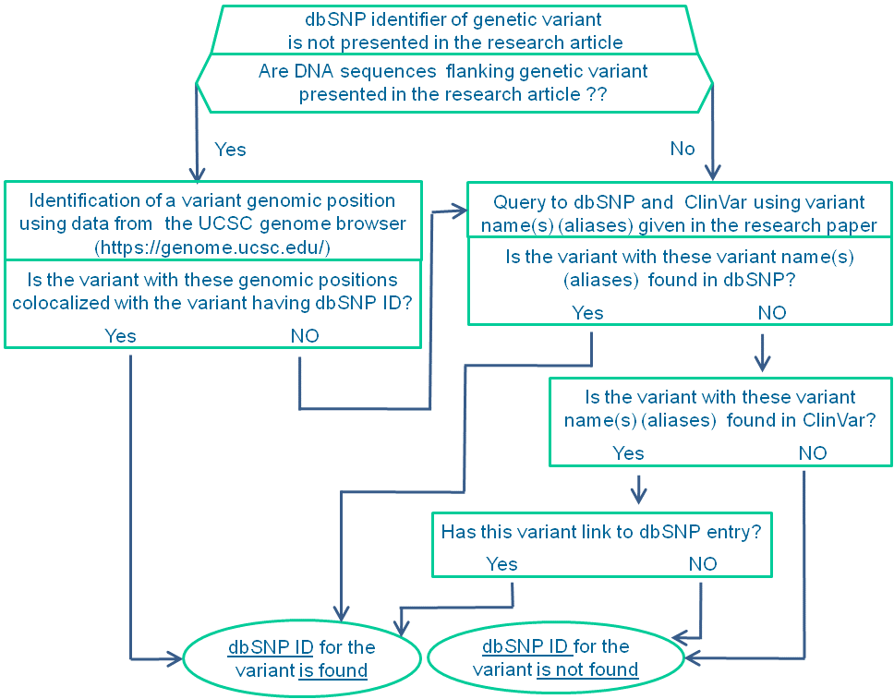
Supplementary Figure 1. Search for dbSNP identifiers for those genetic variants for which dbSNP identifiers were not indicated in the research articles.

Supplementary Material
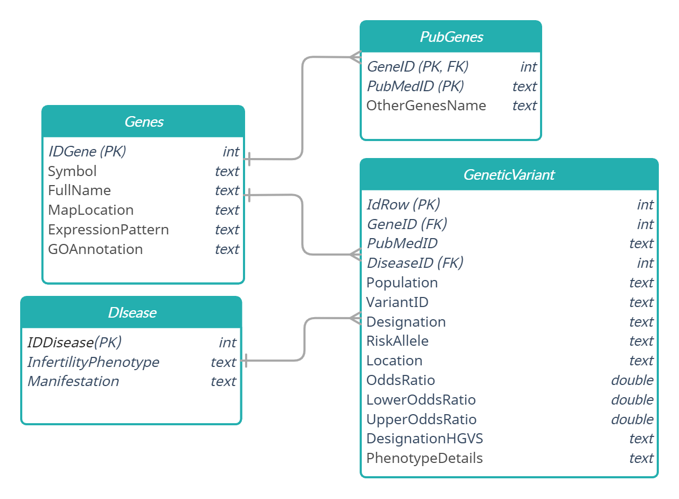
Supplementary Figure 2. General scheme of the сatalog (ER-model of the database). The primary and foreign keys are marked PK and FK, accordingly.

2
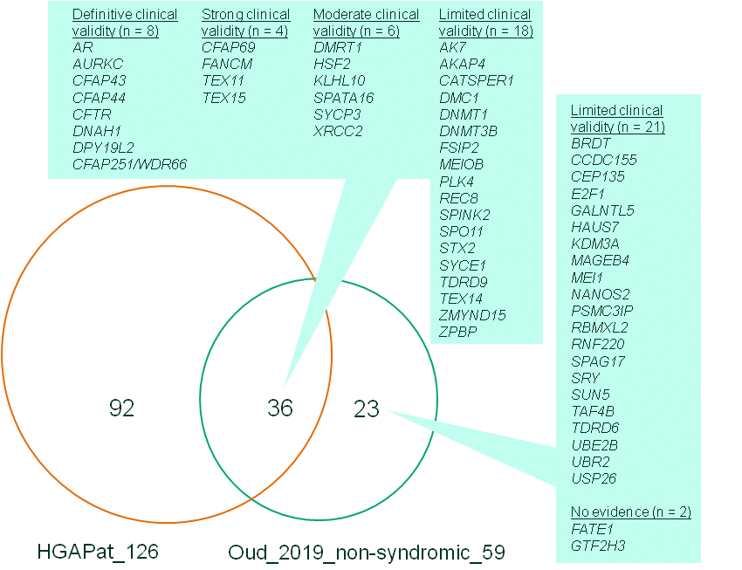
Supplementary Figure 3. Intersection between two lists of genes. HGAPat_126 designates all 126 genes from the catalog HGAPat presented in the current report. Oud_2019_non-syndromic_59 designates the list of 59 genes from [Oud et al. 2019] that have at least one potentially pathogenic variant described and had relationships with non-syndromic forms of pathologies manifested in decreased quality of semen (pathologies are listed in Table S1). These 59 genes were extracted from the TableSIV published by [Oud et al. 2019]. This figure demonstrates that (1) HGAPat contains more genes that meet the above criteria; (2) according to [Oud et al. 2019], genes that were not found in HGAPat, but were present in the [Oud et al. 2019], have low clinical validity.
References
1. Oud, M.S., Volozonoka, L., Smits, R.M., Vissers, L.E., Ramos, L., Veltman, J.A. (2019). A systematic review and standardized clinical validity assessment of male infertility genes. Human Reproduction. 34(5), 932-941. doi: 10.1093/humrep/dez022.

3

