Supplementary Material

Supplementary Figures

Figure S1|Mean log₂(FKPM+1) of 3,804 housekeeping genes between GTEx normal pancreas and TCGA-PAAD tumor tissues. Pearson correlation coefficient (R = 0.89) is presented. FKPM, Fragments Per Kilobase of transcript per Million mapped reads; GTEx, Genotype-Tissue Expression project; TCGA, The Cancer Genome Atlas; PAAD, pancreatic adenocarcinoma.

Figure S2|Distributions of risk scores and survival status of PAAD patients in the GSE57495 dataset (A,C) and ICGC dataset (B,D), respectively. ROC curves of LM-PS for predicting the 1-, 2-, and 3-year OS in the GSE57495 (E) and ICGC datasets (F), respectively. PAAD, pancreatic adenocarcinoma; ICGC, International Cancer Genome Consortium; ROC, receiver operating characteristic curves; LM-PS, liver-metastasis-related genes prognostic signature; OS, overall survival.

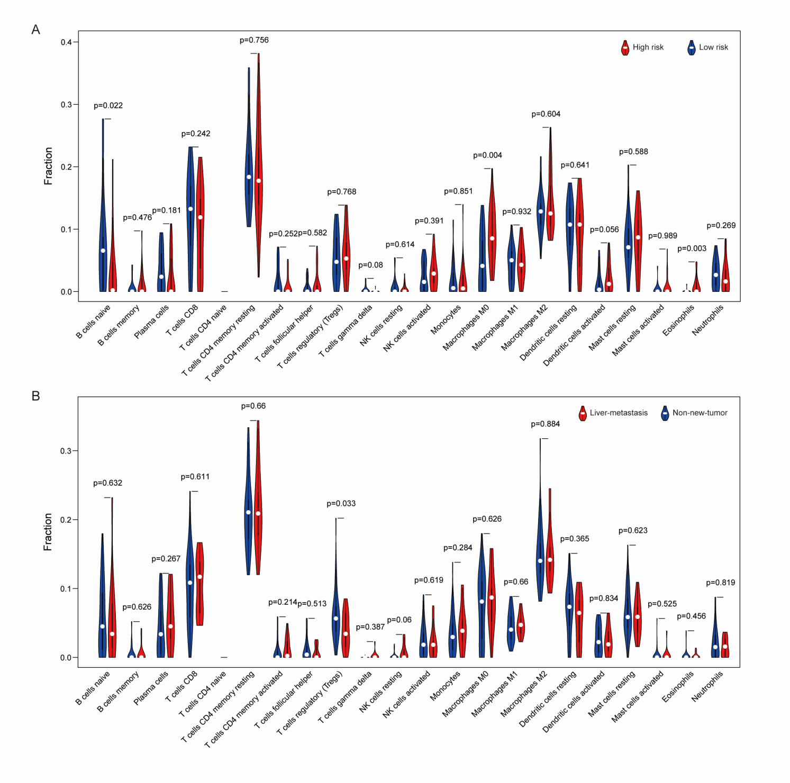
Figure S3|Violin plots visualizing the differentially infiltrated immune cells between low-risk (blue) and high-risk (red) subgroups (A) and between non-new-tumor (blue) and liver-metastasis (red) subgroups (B).

Figure S4|Correlation analysis between the expressions of ANO1 (A), FAM83A (B), GPR87 (C), ITGB6 (D), KLK10 (E), SMIM32 (F), and SERPINE1 in pancreatic adenocarcinoma.

Figure S5|(A) The cBioPortal oncoprint and heatmap of the 7 LM-PS genes in the TCGA-PAAD cohort. (B) OS comparison between patients with LM-PS genes altered (at least with one alteration of amplification/deletion/high mRNA) and those with no LM-PS gene altered in the TCGA-PAAD dataset. (C) The OS comparison between PAAD-TCGA patients with alteration of FAM83A and those without alteration. (D) The OS comparison between PAAD-TCGA patients with alteration of ITGB6 and those without alteration. (E) The OS comparison between PAAD-TCGA patients with alteration of SMIM32 and those without alteration. (F) Comparison of the most frequent altered genes between patients with at least one LM-PS gene altered and those with no LM-PS gene altered in the TCGA-PAAD dataset. LM-PS, liver-metastasis-related prognostic signature; TCGA, The Cancer Genome Atlas; PAAD, pancreatic adenocarcinoma; OS, overall survival.

Supplementary Tables
Table S1|The thirty-three prognostic mRNAs in the univariate Cox regression analysis.
Gene Symbol | P | HR (95% CI)
ANO1 | 3.45E-04 | 2.478 (1.508-4.073)
ANXA1 | 1.13E-03 | 1.743 (1.247-2.435)
ANXA8 | 1.21E-03 | 1.798 (1.260-2.564)
CDH3 | 3.63E-03 | 1.707 (1.191-2.448)
CLIC3 | 8.51E-03 | 1.359 (1.081-1.707)
CST6 | 2.25E-02 | 1.265 (1.034-1.548)
FAM83A | 8.82E-05 | 1.593 (1.262-2.011)
FGFBP1 | 1.47E-02 | 1.322 (1.056-1.654)
FN1 | 3.28E-03 | 1.331 (1.100-1.611)
GPR87 | 1.63E-04 | 1.771 (1.316-2.384)
ITGB4 | 2.27E-03 | 1.732 (1.217-2.465)
ITGB6 | 1.58E-04 | 1.677 (1.283-2.193)
KLK10 | 3.32E-03 | 1.486 (1.141-1.935)
KLK6 | 3.71E-03 | 1.316 (1.093-1.585)
KRT6A | 6.08E-04 | 1.317 (1.125-1.542)
LAMC2 | 5.46E-03 | 1.348 (1.092-1.664)
LYPD3 | 7.65E-03 | 1.546 (1.122-2.129)
MELTF | 1.45E-02 | 1.478 (1.080-2.021)
MS4A8 | 9.32E-03 | 0.600 (0.408-0.882)
PLAU | 8.12E-04 | 1.584 (1.210-2.073)
PMEPA1 | 1.51E-02 | 1.431 (1.072-1.910)
PTGES | 1.05E-02 | 1.375 (1.077-1.754)
S100A2 | 2.34E-03 | 1.314 (1.102-1.566)
SCEL | 4.29E-04 | 1.629 (1.242-2.137)
SDC4 | 7.18E-03 | 1.577 (1.131-2.198)
SEMA3C | 1.09E-03 | 1.656 (1.224-2.241)
SERPINE1 | 1.69E-02 | 1.289 (1.047-1.588)
SMIM32 | 6.80E-03 | 0.395 (0.201-0.774)
SNCG | 1.33E-02 | 1.274 (1.052-1.544)
TGM2 | 3.39E-03 | 1.562 (1.159-2.104)
TNS4 | 1.44E-02 | 1.306 (1.055-1.616)
TRIM29 | 5.55E-03 | 1.461 (1.118-1.910)
ZNF185 | 0.000287075 | 1.826 (1.319-2.527)
HR, hazard ratio; CI, confidence interval.

Table S2|Clinicopathological factors of the PAAD patients in GSE57495 dataset.
Clinical features | n (%)
Survival status, n (%)
Alive | 21 (33.3)
Dead | 42 (66.7)
Pathologic stage, n (%)
Stage I | 1 (1.6)
Stage IB | 12 (19.0)
Stage IIA | 17 (27.0)
Stage IIB | 33 (52.5)
Table S3|Comparison of the genomic alteration frequency between the high- and low-risk subgroups.
Genes | High-risk (n = 31) | Low-risk (n = 32) | P
ANO1 | 3(9.7) | 0 | 0.067
FAM83A | 12(38.7) | 2(6.1) | 0.002
GPR87 | 6(19.4) | 1(3.0) | 0.037
ITGB6 | 5(16.1) | 1(3.0) | 0.072
KLK10 | 4(12.9) | 1(3.0) | 0.141
SERPINE1 | 4(12.9) | 5(15.2) | 0.796
SMIM32 | 0 | 5(15.2) | 0.024

