SUPPLEMENTARY MATERIAL

Table S1 Water temperature in the mesocosms system, in the first and second daily cycle, in relation to total, attenuated, and low radiation treatments, and air temperature in the surroundings of the mesocosm.

 | time | total | attenuated | low | Air
DC. 1 | 08:00 a.m. | 8.57 ± 0.01 | 8.50 ± 0.01 | 8.81 ± 0.02 | 8.83 ± 0.16
 | 13:00 p.m. | 13.22 ± 0.32 | 12.59 ± 0.23 | 12.44 ± 0.23 | 17.53 ± 0.3
 | 17:00 p.m. | 13.45 ± 0.1 | 12.83 ± 0.06 | 13.15 ± 0.07 | 12.56 ± 0.28
DC. 2 | 08:00 am | 5.64 ± 0.05 | 5.66 ± 0.08 | 6.21 ± 0.04 | 1.90 ± 0.11
 | 13:00 p.m. | 10.70 ± 0.32 | 10.08 ± 0.23 | 10.29 ± 0.24 | 15.61 ± 1.34
 | 17:00 p.m. | 10.94 ± 0.13 | 10.31 ± 0.11 | 10.88 ± 0.11 | 8.84 ± 0.31

Table S2 nitrate concentration (µM) in the mesocosms system along to the water column, in wintertime.

water column | Average | SE
high | 4.693293 | 0.082575
middle | 5.133974 | 0.231716
low | 4.189417 | 0.212336

Table S3 ANOVA results after experimental period testing for the effect of Treatments, time, and Part of thalli of the phenolic compounds, antioxidant activity, chlorophyll a, chlorophyll c1+c2, fucoxanthin, ratio carbon: nitrogen, carbon, y nitrogen of Macrocystis pyrifera in two dayle cycles. Significant differences at α < 0.05 are shown in asterisk.

Macrocystis pyrifera
 |  | DC 1 |  |  |  | DC 2
 |  | df | MS | F | P |  | df | MS | F | P
Phenolics | Treatments (T) | 2 | 165.02 | 15.99 | * |  | 2 | 142.43 | 6.15 | *
compounds | time (t) | 2 | 25.60 | 2.48 | * |  | 2 | 77.55 | 3.35 | *
 | Part of thalli (Pt) | 2 | 146.14 | 14.16 | * |  | 2 | 59.84 | 2.59 | *
 | T*t | 4 | 29.77 | 2.88 | * |  | 4 | 20.07 | 0.87
 | T*Pt | 4 | 10.21 | 0.99 |  |  | 4 | 12.69 | 0.55
 | t*Pt | 4 | 1.36 | 0.13 |  |  | 4 | 29.66 | 1.28
 | T*t*Pt | 8 | 23.59 | 2.29 | * |  | 8 | 11.62 | 0.50
 | Res | 81 | 10.32 |  |  |  | 81 | 23.14
AA% | Treatments (T) | 2 | 781.80 | 5.71 | * |  | 2 | 2212.07 | 9.26 | *
 | time (t) | 2 | 35.64 | 0.26 |  |  | 2 | 118.1623 | 0.49
 | Part of thalli (Pt) | 2 | 123.93 | 0.91 |  |  | 2 | 404.9011 | 1.69
 | T*t | 4 | 119.95 | 0.88 |  |  | 4 | 60.62978 | 0.25
 | T*Pt | 4 | 131.47 | 0.96 |  |  | 4 | 202.3236 | 0.85
 | t*Pt | 4 | 64.28 | 0.47 |  |  | 4 | 64.15835 | 0.27
 | T*t*Pt | 8 | 120.13 | 0.88 |  |  | 8 | 30.79988 | 0.13
 | Res | 81 | 136.80 |  |  |  | 81 | 239.0043
Chla | Treatments (T) | 2 | 0.04 | 2.15 |  |  | 2 | 0.01 | 0.02
 | time (t) | 2 | 0.10 | 5.70 | * |  | 2 | 287.54 | 578.26 | *
 | Part of thalli (Pt) | 2 | 0.20 | 11.19 | * |  | 2 | 572.27 | 1150.85 | *
 | T*t | 4 | 0.03 | 1.88 |  |  | 4 | 11.91 | 23.94 | *
 | T*Pt | 4 | 0.03 | 1.58 |  |  | 4 | 0.36 | 0.72
 | t*Pt | 4 | 0.07 | 4.00 | * |  | 4 | 186.32 | 374.70 | *
 | T*t*Pt | 8 | 0.06 | 3.38 | * |  | 8 | 9.97 | 20.05 | *
 | Res | 81 | 0.02 |  |  |  | 81 | 0.50
Chl_{c1+c2} | Treatments (T) | 2 | 0.06 | 0.57 |  |  | 2 | 0.01 | 0.15
 | time (t) | 2 | 0.19 | 1.66 |  |  | 2 | 0.02 | 0.46
 | Part of thalli (Pt) | 2 | 0.03 | 0.26 |  |  | 2 | 0.01 | 0.27
 | T*t | 4 | 0.09 | 0.76 |  |  | 4 | 0.01 | 0.31
 | T*Pt | 4 | 0.01 | 0.08 |  |  | 4 | 0.01 | 0.23
 | t*Pt | 4 | 0.02 | 0.22 |  |  | 4 | 0.00 | 0.04
 | T*t*Pt | 8 | 0.04 | 0.32 |  |  | 8 | 0.01 | 0.15
 | Res | 81 | 0.11 |  |  |  | 81 | 0.04
Fuco | Treatments (T) | 2 | 0.01 | 0.25 |  |  | 2 | 0.00 | 0.27
 | time (t) | 2 | 0.03 | 1.11 |  |  | 2 | 0.00 | 0.44
 | Part of thalli (Pt) | 2 | 0.01 | 0.27 |  |  | 2 | 0.00 | 0.33
 | T*t | 4 | 0.00 | 0.07 |  |  | 4 | 0.00 | 0.30
 | T*Pt | 4 | 0.00 | 0.16 |  |  | 4 | 0.00 | 0.24
 | t*Pt | 4 | 0.00 | 0.12 |  |  | 4 | 0.00 | 0.06
 | T*t*Pt | 8 | 0.00 | 0.08 |  |  | 8 | 0.00 | 0.15
 | Res | 81 | 0.03 |  |  |  | 81 | 0.01
C:N | Treatments (T) | 2 | 1.57 | 2.29 |  |  | 2 | 19.40 | 17.59 | *
 | time (t) | 2 | 0.20 | 0.30 |  |  | 2 | 3.27 | 2.96 | *
 | Part of thalli (Pt) | 2 | 11.89 | 17.41 | * |  | 2 | 6.43 | 5.83 | *
 | T*t | 4 | 0.30 | 0.44 |  |  | 4 | 1.40 | 1.27
 | T*Pt | 4 | 0.65 | 0.95 |  |  | 4 | 1.54 | 1.39
 | t*Pt | 4 | 2.28 | 3.34 | * |  | 4 | 1.63 | 1.48
 | T*t*Pt | 8 | 1.77 | 2.60 |  |  | 8 | 1.65 | 1.49
 | Res | 54 | 0.68 |  |  |  | 54 | 1.10
C | Treatments (T) |  |  |  |  |  | 2 | 570.71 | 7.27 | *
 | time (t) | 2 | 24.91 | 0.51 |  |  | 2 | 886.63 | 11.30 | *
 | Part of thalli (Pt) | 2 | 25.10 | 0.52 |  |  | 2 | 351.64 | 4.48 | *
 | T*t | 4 | 17.86 | 0.37 |  |  | 4 | 44.96 | 0.57
 | T*Pt | 4 | 325.55 | 6.69 | * |  | 4 | 179.69 | 2.29
 | t*Pt | 4 | 345.99 | 7.11 | * |  | 4 | 272.55 | 3.47 | *
 | T*t*Pt | 8 | 64.97 | 1.34 | * |  | 8 | 22.10 | 0.28 | *
 | Res | 54 | 48.64 |  |  |  | 54 | 78.49
N | Treatments (T) | 2 | 8.27 | 3.13 |  |  | 2 | 34.55 | 10.95 | *
 | time (t) | 2 | 0.54 | 0.20 |  |  | 2 | 0.41 | 0.13
 | Part of thalli (Pt) | 2 | 42.21 | 15.95 | * |  | 2 | 24.38 | 7.72 | *
 | T*t | 4 | 1.15 | 0.43 |  |  | 4 | 3.63 | 1.15
 | T*Pt | 4 | 2.55 | 0.96 |  |  | 4 | 4.28 | 1.36
 | t*Pt | 4 | 10.93 | 4.13 | * |  | 4 | 8.66 | 2.74 | *
 | T*t*Pt | 8 | 7.19 | 2.72 | * |  | 8 | 3.57 | 1.13 | *
 | Res | 54 | 2.65 |  |  |  | 54 | 3.16
ETRin situ | Treatments (T) | 2 | 15160.1 | 25.7 | * |  | 2 | 9310.3 | 63.2 | *
 | time (t) | 2 | 1804521.8 | 3060.8 | * |  | 2 | 1007803.2 | 6836.8 | *
 | Part of thalli (Pt) | 2 | 624644.8 | 1059.5 | * |  | 2 | 423648.8 | 2874.0 | *
 | T*t | 4 | 10947.5 | 18.6 | * |  | 4 | 5588.5 | 37.9 | *
 | T*Pt | 4 | 10188.6 | 17.3 | * |  | 4 | 4056.2 | 27.5 | *
 | t*Pt | 4 | 454068.6 | 770.2 | * |  | 4 | 266821.6 | 1810.1 | *
 | T*t*Pt | 8 | 8515.8 | 14.4 | * |  | 8 | 2799.6 | 19.0 | *
 | Res | 945 | 589.6 |  |  |  | 945 | 147.4
Res: Residual

Table S4 Pearson correlation of the first daily cycle (average of the treatments), respect to the PC, Chla, Chlc1+c2, Fux, AA%, ETR_{in situ}, C and N.

 | PC | Chla | Chl _{c1+c2} | Fuc | AA% | ETR_{in situ} | C | N
PC |  | -0.267 | 0.00575 | 0.0249 | 0.534 | -0.161 | 0.039 | -0.219
 |  | 0.0161 | 0.959 | 0.825 | 2.8E-07 | 0.15 | 0.729 | 0.05
Chla |  |  | 0.341 | 0.304 | -0.314 | 0.0503 | 0.0367 | 0.145
 |  |  | 0.00183 | 0.0058 | 0.00433 | 0.656 | 0.745 | 0.196
Chl _{c1+c2} |  |  |  | 0.998 | -0.197 | -0.00101 | -0.223 | -0.0323
 |  |  |  |  | 0.0774 | 0.993 | 0.0451 | 0.775
Fuc |  |  |  | -0.171 | -0.0134 | -0.223 | -0.0356
 |  |  |  |  | 0.127 | 0.906 | 0.0456 | 0.752
AA% |  |  |  |  |  | -0.0968 | 0.0885 | -0.105
 |  |  |  |  |  | 0.39 | 0.432 | 0.35
ETR_{in situ} |  |  |  |  |  |  | -0.0392 | -0.114
 |  |  |  |  |  |  | 0.728 | 0.309
C |  |  |  |  |  |  |  | 0.397
 |  |  |  |  |  |  |  | 0.000244

Table S5 Pearson correlation of the second daily cycle (average of the treatments), respect to the PC, Chla, Chl_{c1+c2}, Fuc, AA%, ETR_{in situ}, C and N.

 | PC | Chla | Chl_{c1+c2} | Fuc | AA% | ETR_{in situ} | C | N
PC |  | 0.0262 | -0.0633 | -0.0829 | 0.579 | -0.198 | -0.0371 | -0.0433
 |  | 0.816 | 0.575 | 0.462 | 1.47E-08 | 0.0768 | 0.742 | 0.701
Chla |  |  | 0.454 | 0.426 | -0.168 | -0.0717 | -0.0135 | 0.208
 |  |  | 0.0000205 | 0.0000737 | 0.135 | 0.525 | 0.905 | 0.0627
Chl_{c1+c2} |  |  |  | 0.958 | -0.118 | 0.00967 | 0.0524 | 0.144
 |  |  |  | 1.29E-41 | 0.295 | 0.932 | 0.642 | 0.2
Fuc |  |  |  |  | -0.0895 | 0.0178 | 0.0428 | 0.114
 |  |  |  |  | 0.427 | 0.875 | 0.705 | 0.309
AA% |  |  |  |  |  | -0.0858 | 0.00124 | -0.0795
 |  |  |  |  |  | 0.446 | 0.991 | 0.481
ETR_{in situ} |  |  |  |  |  |  | 0.153 | -0.0732
 |  |  |  |  |  |  | 0.171 | 0.516
C |  |  |  |  |  |  |  | 0.288
 |  |  |  |  |  |  |  | 0.00923

Figure S1 Internal carbon content in Macrocystis pyrifera fronds in the (A) first daily cycle and (B) second daily cycle experiment under different solar irradiance treatments: total, attenuated, and low radiation at 8:00, 13:00, and 17:00 h. The C was determined in three zones of the alga: canopy, middle, and down (mean ± SE, n = 3). Lower-case letters denote significant differences after the SNK test.

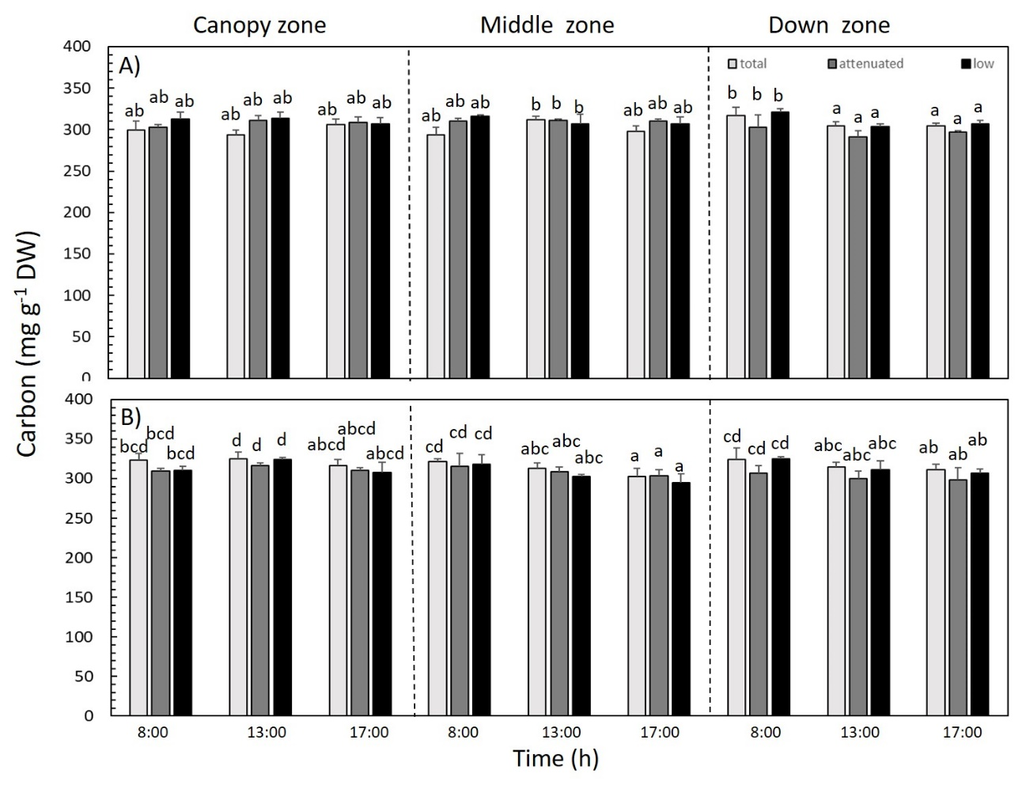

Figure S2 Internal nitrogen content in Macrocystis pyrifera fronds in the (A) first daily cycle and (B) second daily cycle experiment under different solar irradiance treatments: total, attenuated, and low radiation at 8:00, 13:00, and 17:00 h. The N was determined in three zones of the alga: canopy, middle, and down (mean ± SE, n = 3). Lower-case letters denote significant differences after the SNK test.

