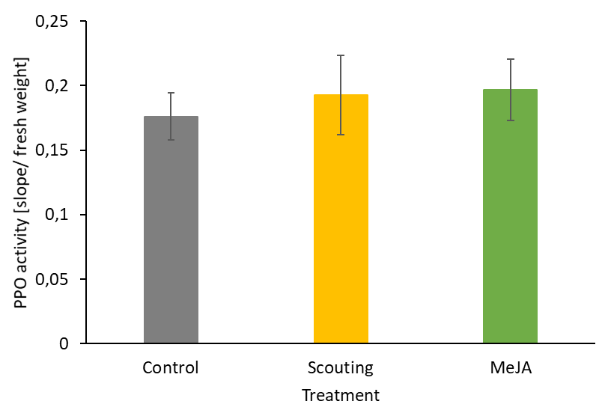

Supplementary Figure S1. Polyphenol oxidase activity (PPO) was measured one week after methyl jasmonate elicitation. Data are presented as mean ± SEM (n = 10). H(2) = 0.134, p = 0.935.

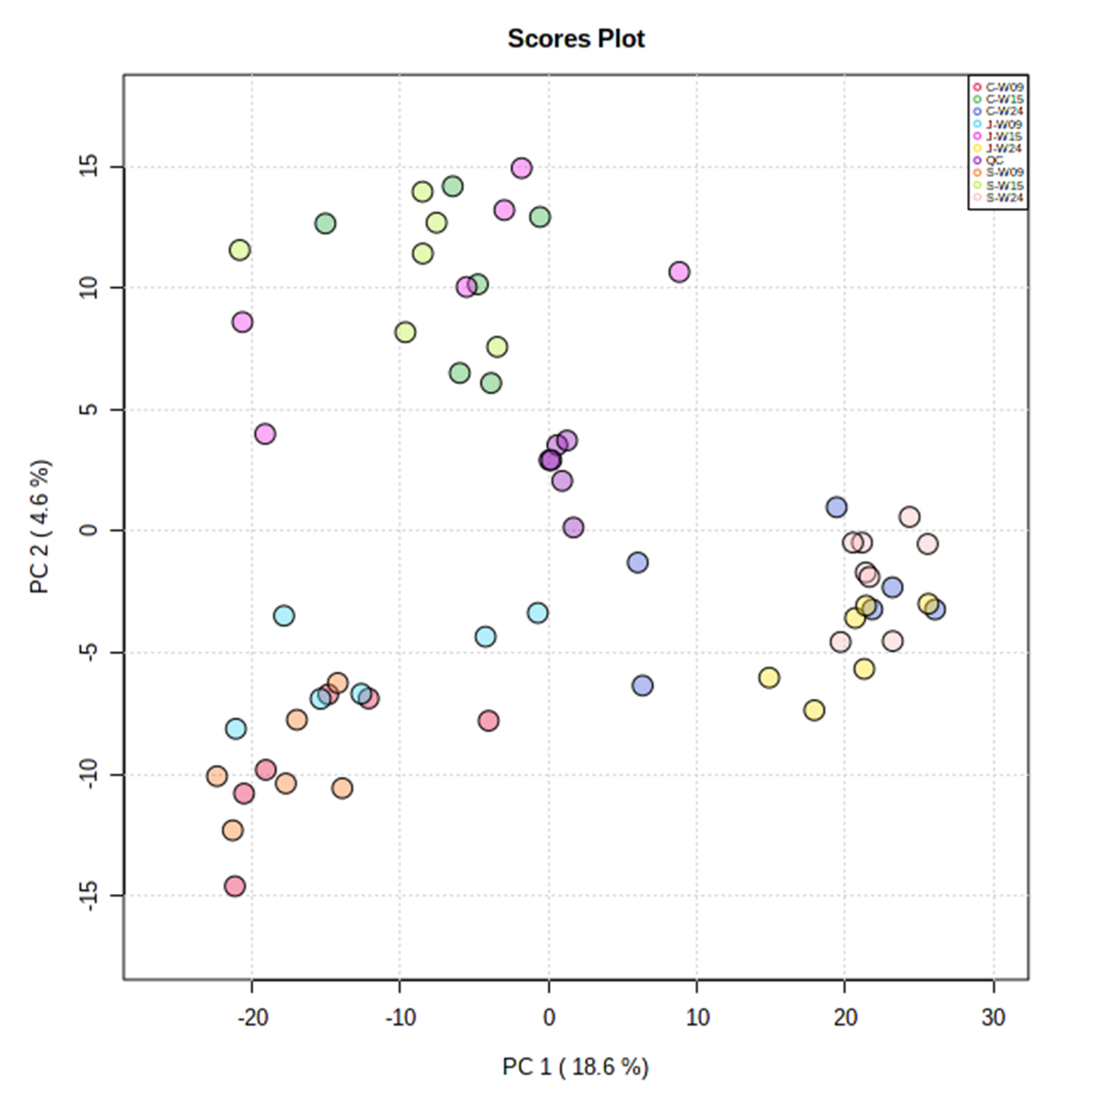
Supplemental Figure S2 Principal Component Analysis (PCA) of strawberry leaf metabolomes from 9, 15 and 24-week-old plants. Score plot is based on features obtained from both negative and positive ionization mode. C: leaves from plants that mock-treated control plants, S: leaves from plants that were treated with MeJA when this was deemed necessary based on scouting. This was in week 2, 5, 23, and 26. J: leaves from plants that were treated with MeJA every 3 weeks. Similar aliquots of all samples combined form a Quality Control (QC) samples that was analyzed within the sequence, shows high technical reproducibility’s.

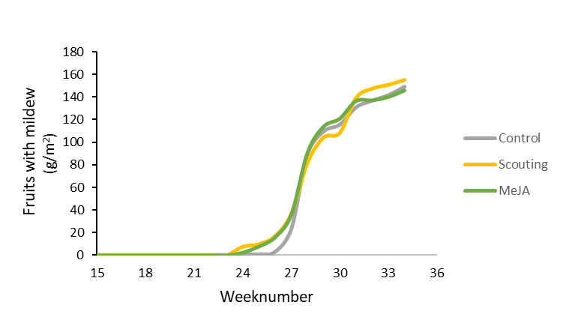

Supplementary Figure S3. Harvested fruits with mildew over time. Cumulative weight (g/m²) per week
Supplemental Table S1 Metabolite features in strawberry leaf metabolomes most responsive to Methyl Jasmonate application (MeJA/Control) > 2-fold).
Mass Formula Putative Identification δ ppm Biochemical class log2(FC) MeJA/C
Induced compounds
434.158 C22H26O9 polymethylated flavanone 0 flavanones 6.80
478.058 C24H14O11 fucofuroeckol phenolic compound 6.72
529.545 unknown 6.09
594.138 C30H26O13 pelargonidin 3-(6''-caffeylglucoside) 0 anthocyanidins 5.69
526.222 C27H32N2O6 solifenacin isoquinoline alkaloids 4.24
366.096 C17H18O9 furocoumarinic acid glucoside 4 phenolic glucoisde 4.15
175.963 unknown 3.91
446.178 C20H30O11 crosatoside 0 phenolic O-glycoiside 3.68
344.038 C13H12O11 O-galloyl-galactarolactone 0 galloyl ester 3.34
336.132 C16H20N2O6 semilepidinoside 22 phenolic O-glycosides 3.19
408.142 C20H24O9 ginkgolide 0 diterpene 3.17
197.150 unknown 3.14
622.242 C34H38O11 phenolic O-glycoside 2 phenolic O-glycoside 3.10
524.190 C25H32O12 ligustroside 1 phenolic O-glycoside 3.03
598.204 C27H34O15 catechin 3-O-rutinoside 24 flavan-3-ol-glycoside 2.75
430.272 C26H38O5 persicaxanthin 0 diterpenoids 2.56
459.183 unknown 2.54
756.169 C39H32O16 quercetin 3-(3'',6''-di-p-coumarylglucoside) flavonoid glucoside 2.51
642.362 unknown 2.49
412.173 C20H28O9 diterpenoid 0 diterpenoids 2.43
458.179 C21H30O11 hydroxychavicol rhamnosyl-glucoside 1 phenolic glycoside 2.29
400.080 C20H16O9 tetrahydroxy-methylsuccinoyl flavone 0 flavone 2.26
590.294 C36H38N4O4 dimethylprotoporphyrin dimethyl ester 8 porphyrins 2.25
450.153 C22H26O10 auriculoside 0 flavan glucoside 2.25
344.090 C18H16O7 eupatorin 1 flavone 2.18
385.080 unknown 2.15
346.063 C17H14O8 tetrahydroxy-dimethoxyflavone flavone 2.15
647.120 unknown 2.14
520.180 C22H32O14 citrusin 1 lignan glycoside .09
196.146 C12H20O2 dodecadienoic acid 0 fatty acid derivative 2.09
556.246 C34H36O7 ingenol 3,20-dibenzoate 11 diterpene derivative 2.06
241.140 unknown 2.04
450.092 C20H22N2O6S2 exserohilone sulphur compound 2.02
714.408 C37H62O13 cyclopassifloside 15 triterpene saponin 2.02
534.210 C27H34O11 hydroxy-methoxy-prenylflavan -O-glycoside1 flavan-3-ol 1.77
602.127 C28H26O15 tetrahydroxyflavanone-galloylglucoside 2 flavanone 1.77
376.204 C25H28O3 ovaliflavanone 1 flavonone 1.69
unknown 1.48
300.063 C16H12O6 diosmetin 0 Isoflavone 1.37
346.069 C17H14O8 syringetin 2 O-methylated flavonol 1.31
405.076 C12H23NO10S2 glucocleomin 5 sulphur containing compound 1.28
241.106 C10H15N3O4 5-methyldeoxycytidine 12 dinucleotide 1.27
358.069 C18H14O8 polymethoxylated isoflavone 0 isoflavone 1.08

Repressed compounds
440.0504 unknown -7.39
308.0104 unknown -7.02
475.3197 unknown -6.75
288.0634 C15H12O6 dihydrokaempferol 1 flavonol -6.74
338.0313 unknown -4.57
934.1804 C44H38O23 sennoside 14 anthracenecarboxylic acid -3.36
531.136 unknown -2.92
446.1424 C19H26O12 lucuminic acid 0 o-glycosyl compound -2.66
439.2206 C22H33NO8 parsonsine 13 pyrrolizidine alkaloid -2.61
506.2727 C24H42O11 megastigmene-diol apiosyl-glucoside 0 saccharide fatty acyl glycoside -2.49
354.0587 C15H14O10 caffeoyl isocitrate 7 -2.47
448.2308 C21H36O10 linalool xylosyl-glucoside 1 terpenoid glycoside -2.45
470.1213 C24H22O10 pongamoside 1 furanoflavonoid glucoside -2.44
410.1002 C22H18O8 epicatechin 3-O-hydroxybenzoate 1 catechin -2.40
724.4398 C39H64O12 smilanippin 0 steroidal saponin -2.33
544.252 C26H40O12 cinncassiol glucoside 0 terpenoid glycoside -2.33
314.1002 C14H18O8 glucovanillin 1 phenolic glycoside -2.26
406.057 C15H18O11S O-coumaroyl glucose-O-sulfate 11 hydroxycinnamic acid glycoside -2.02
160.110 C8H16O3 hydroxy caprylic acid 0 fatty acid derivative -0.20
572.047 C22H20O16S isorhamnetin 3-glucuronide-7-sulfate 23 flavone -0.31
145.053 C9H7NO Isoquinoline N-oxide 0 isoquinoline alkaloid -0.52
290.131 C20H18O2 methyl-pentenyl anthraquinone 14 anthraquinone -0.92

Supplemental Table S2. Top-25 metabolites that most strongly differ in abundance during development of strawberry plants
Compound ID [M-H]- d ppm putative identification
a 288.0446 6 Isocarbophos C11H16NO4PS salicylate compound
b 319.1402 1 Valproic acid glucuronide C14H24O8 fatty acid derivative
c 636.3973 21 2'-O-Methylphaseollinisoflavan C21H22O4 Flavan
d 505.2074 1 Limonoate C26H34O10 dicarboxylic acid
e 522.1916 0 Gibberellin glucosyl ester C26H36O11 diterpenoid glycoside
f 271.0616 1 (-)-Naringenin C15H12O5 Flavanone
g 552.2173 unknown
h 619.2799 6 Asclepin C31H42O10
i 521.1878 0 Kanokoside C21H32O12
j 506.2107 15 Bitolterol C28H31NO5
k 689.3394 0 diterpene glycoside C32H52O13 diterpenoid glycoside
l 479.2138 10 unknown
m 545.1885 11 Pilosanol C28H30O10
n 480.2456 12 Pentazocine glucuronide C25H35NO7
o 380.2011 17 Symlandine C20H31NO6
p 281.1397 1 Hexenol O-glucopyranoside C12H22O6
q 526.238 24 unknown
r 635.2741 3 Calafatimine C38H40N2O7

s 131.0461 27 hydrocinnamic acid C9H10O2
t 426.034 unknown
u 324.0915 6 N-Glycolylneuraminic acid C11H19NO10
v 1085.0762 unknown
w 231.0875 2 perseitol C7H16O7
x 104.0352 1 serine C3H7NO3
y 542.5361 unknown

