Supplementary Material

Supplementary note: Figures 1–6 and Tables 1-4.
Table of contents:

Supplementary Figure 1: The model of OmpC protein used for DFT calculations.
Supplementary Figure 2: Side chains of inner layer of the OmpC protein ion channel.
Supplementary Figure 3: The X-CH₃ complexes with Ag where X=Arg, Asn, Gln, Lys, Ser, Val, Trp, Asp, Glu, Tyr.
Supplementary Figure 4: The model of OmpF protein used for DFT calculations.
Supplementary Figure 5: Side chains of inner layer of the OmpF protein ion channel.
Supplementary Figure 6: The X-CH₃ complexes with Ag where X=Leu, Met, Thr and Phe.
Supplementary Table 1: Metal – ligand distance in Å. OmpC protein.
Supplementary Table 2: Metal – ligand energies of interactions in OmpC protein.
Supplementary Table 3: Metal – ligand distances in Å, for Ag..X-CH₃ where X=Leu, Met, Thr and Phe.
Supplementary Table 4: Metal – ligand energies for Ag..X-CH₃ where X=Leu, Met, Thr and Phe (OmpF protein).

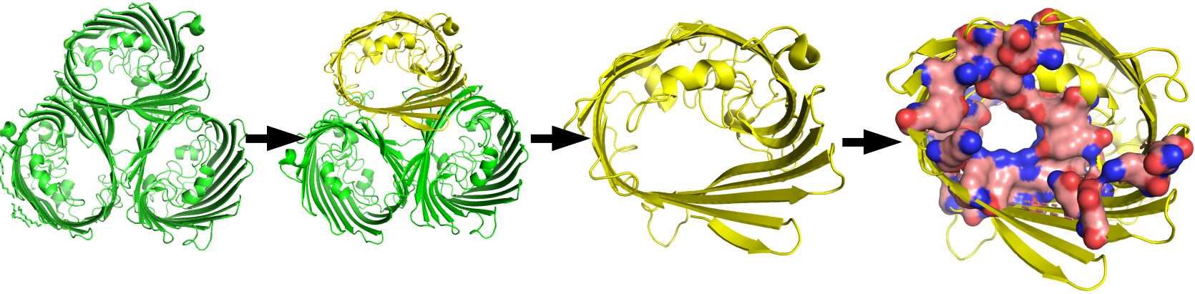
Supplementary Figure 1: The model of OmpC protein used for DFT calculations.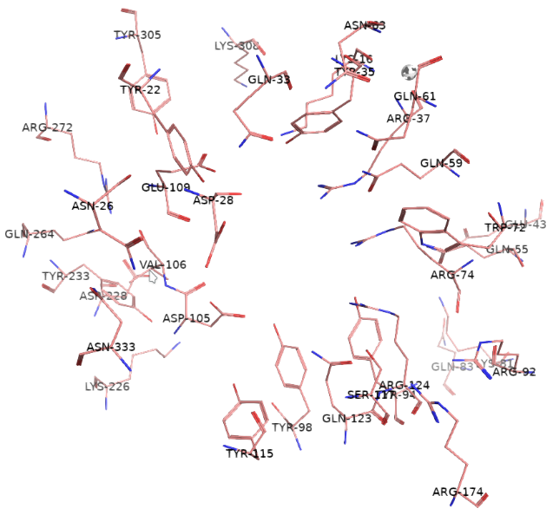
Supplementary Figure 2: Side chains of inner layer of the OmpC protein ion channel.

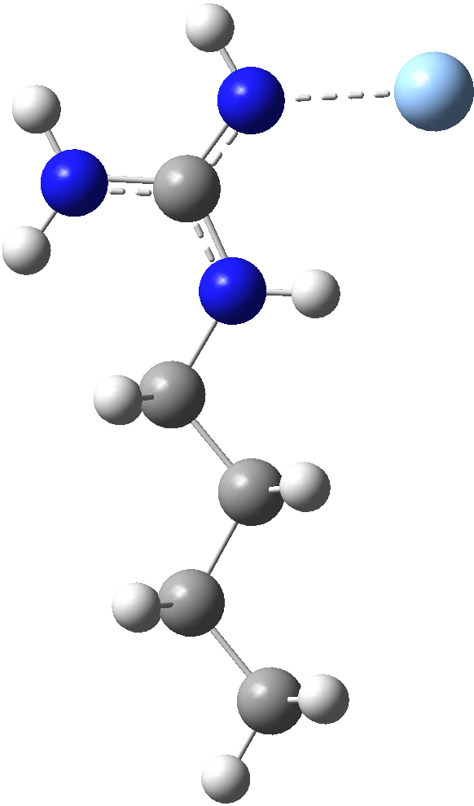
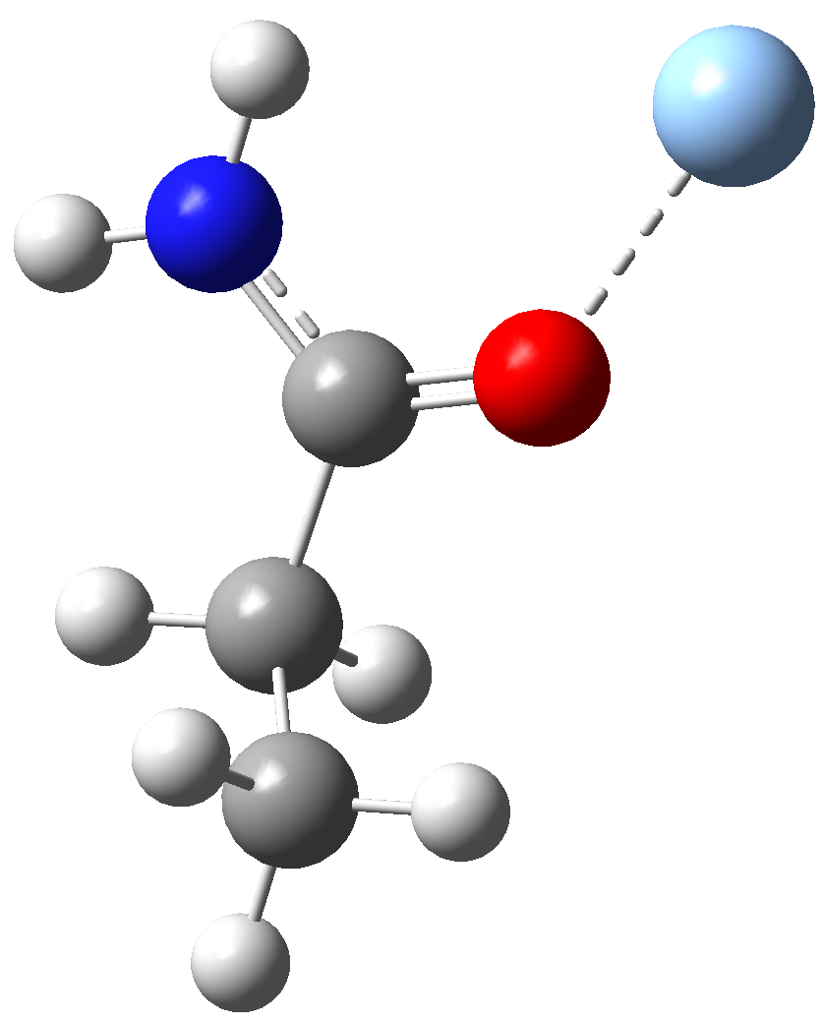
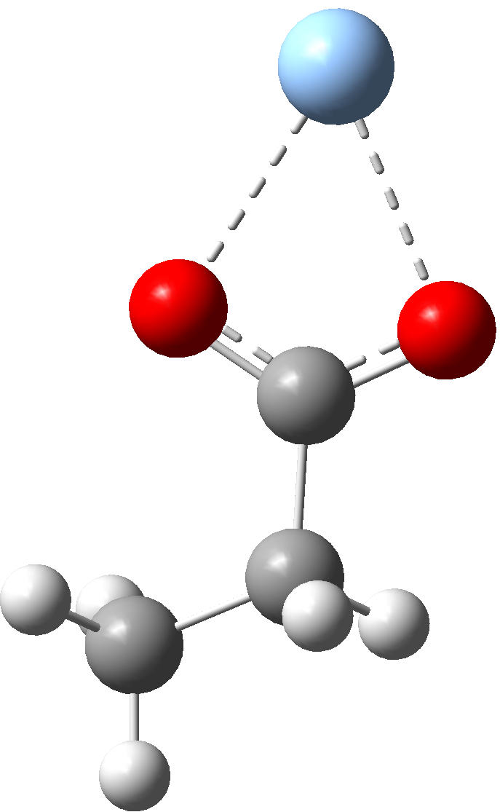
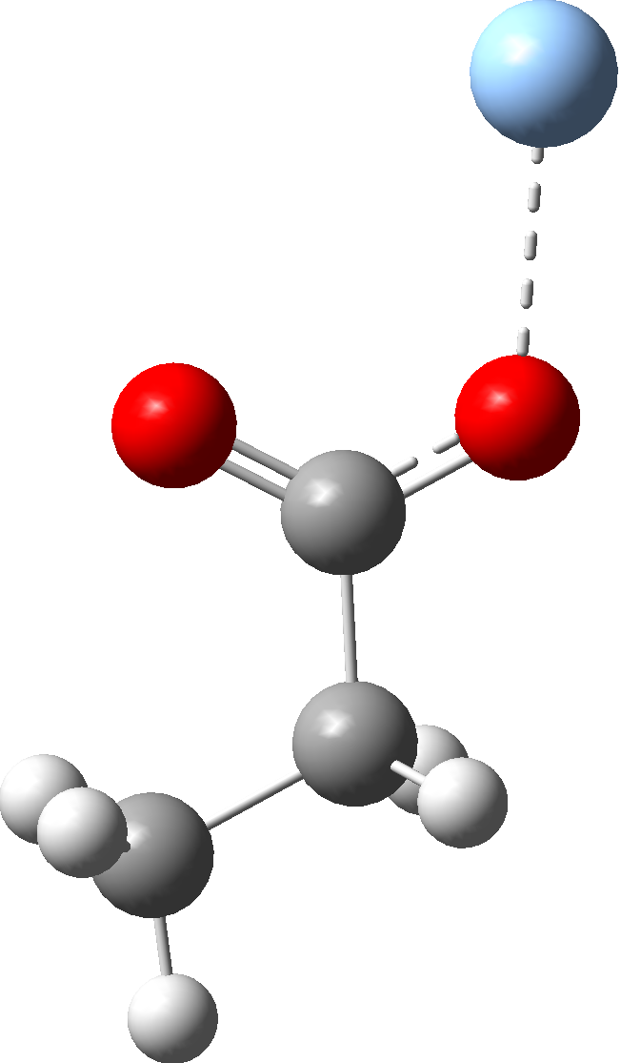
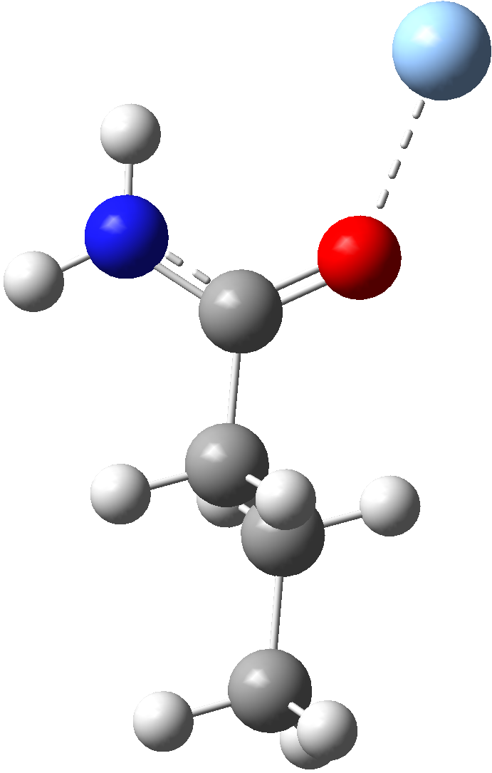

Ag..Arg-CH₃ Ag..Asn-CH₃ Ag⁺..Asp-CH₃ Ag⁰..Asp-CH₃ Ag..Gln-CH₃

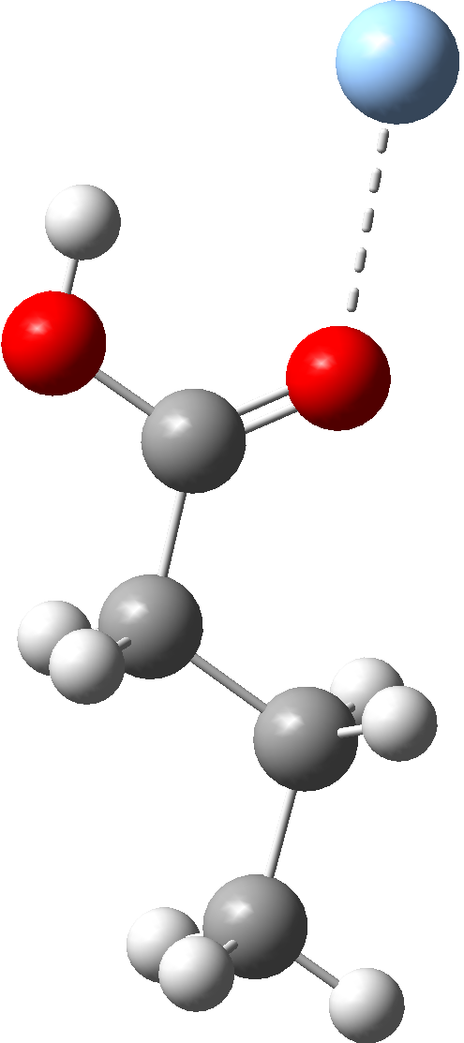
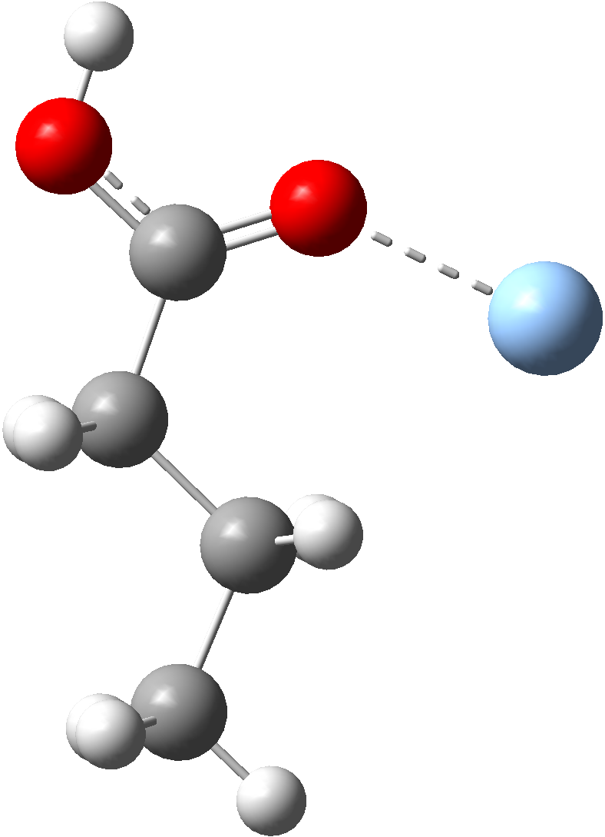
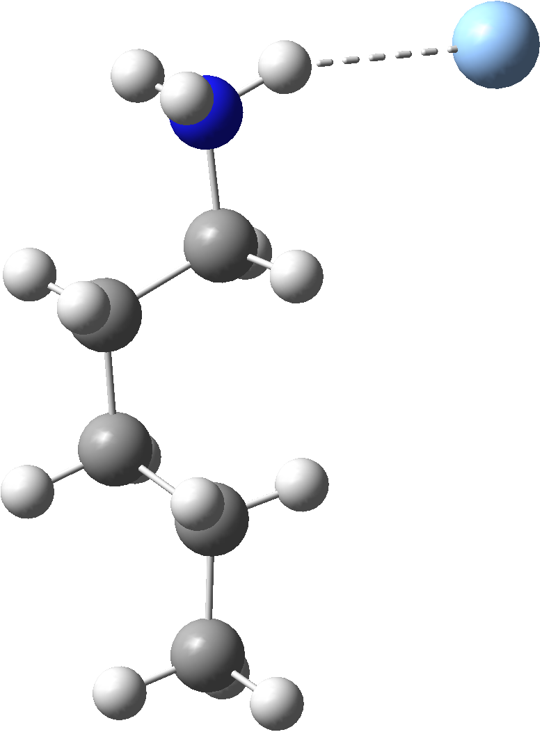
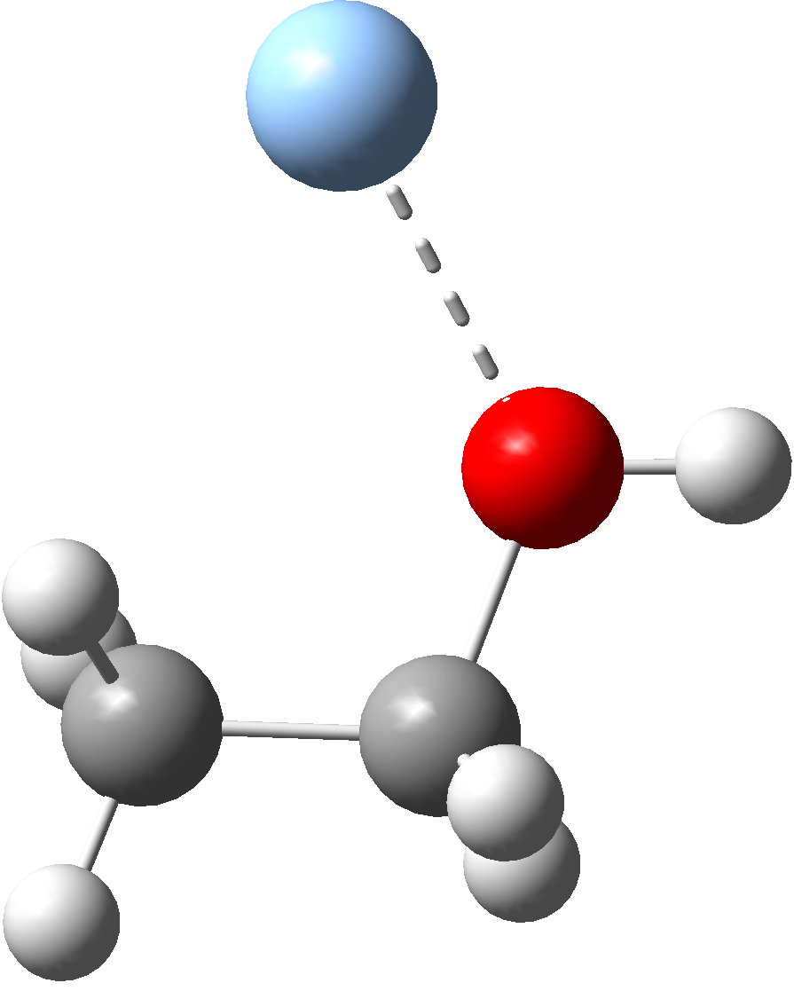
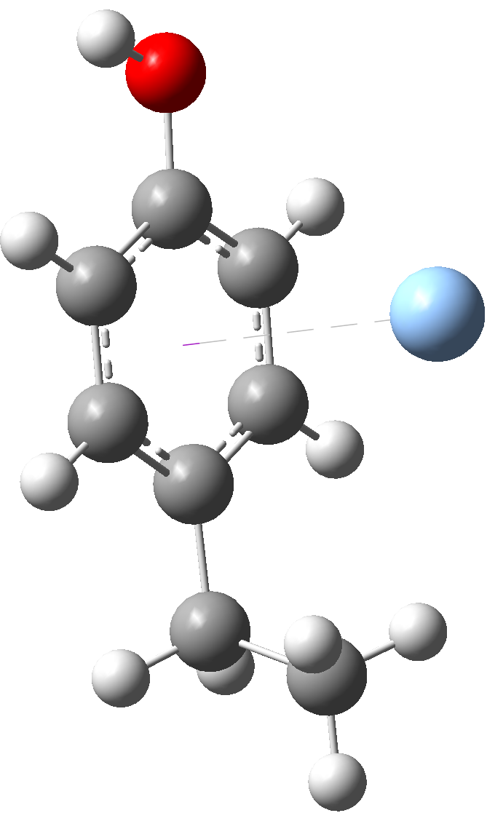

Ag⁰..Glu-CH₃ Ag⁺..Glu-CH₃ Ag..Lys-CH₃ Ag..Ser-CH₃ Ag⁰..Tyr-CH₃

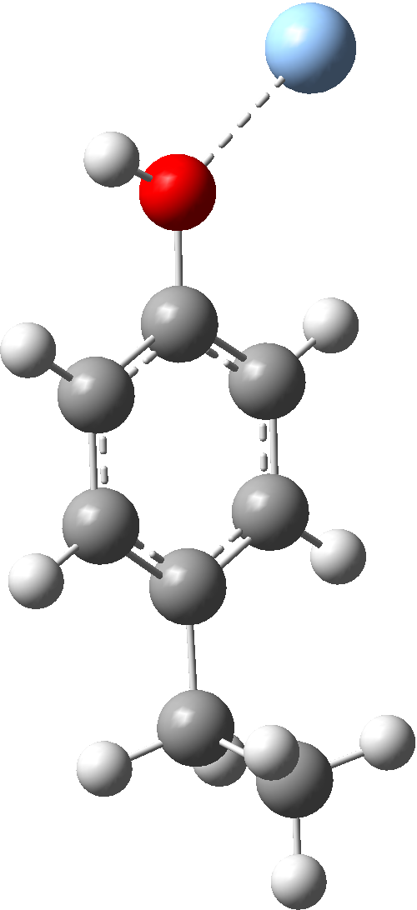
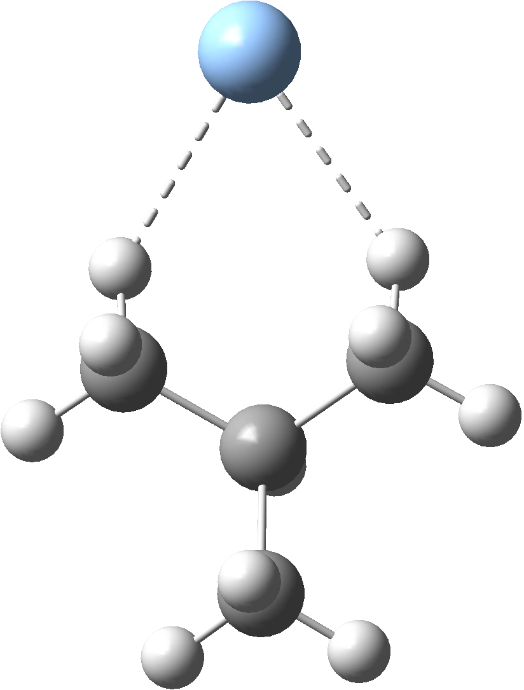
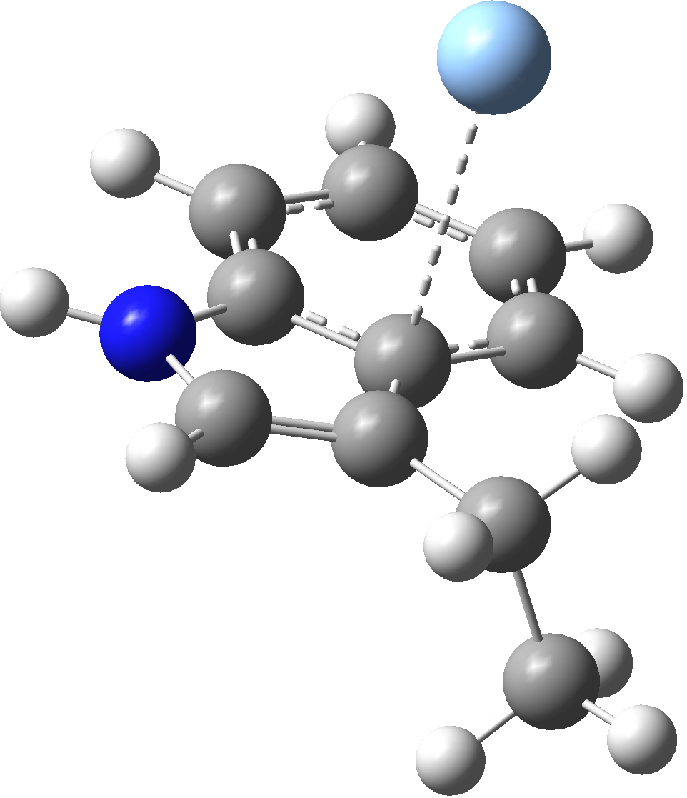

Ag⁺..Tyr-CH₃ Ag..Val-CH₃ Ag..Trp-CH₃
Supplementary Figure 3: The X-CH₃ complexes with Ag where X=Arg, Asn, Gln, Lys, Ser, Val, Trp, Asp, Glu, Tyr.
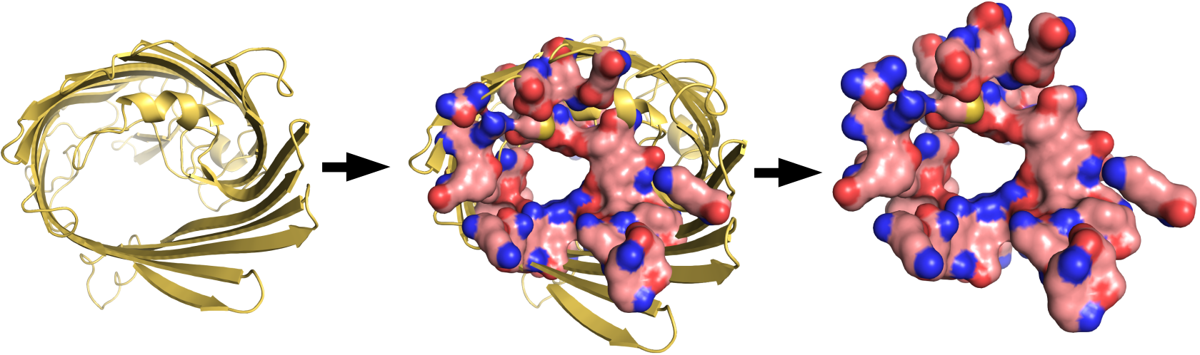
Supplementary Figure 4. The model of OmpF protein used for DFT calculations.
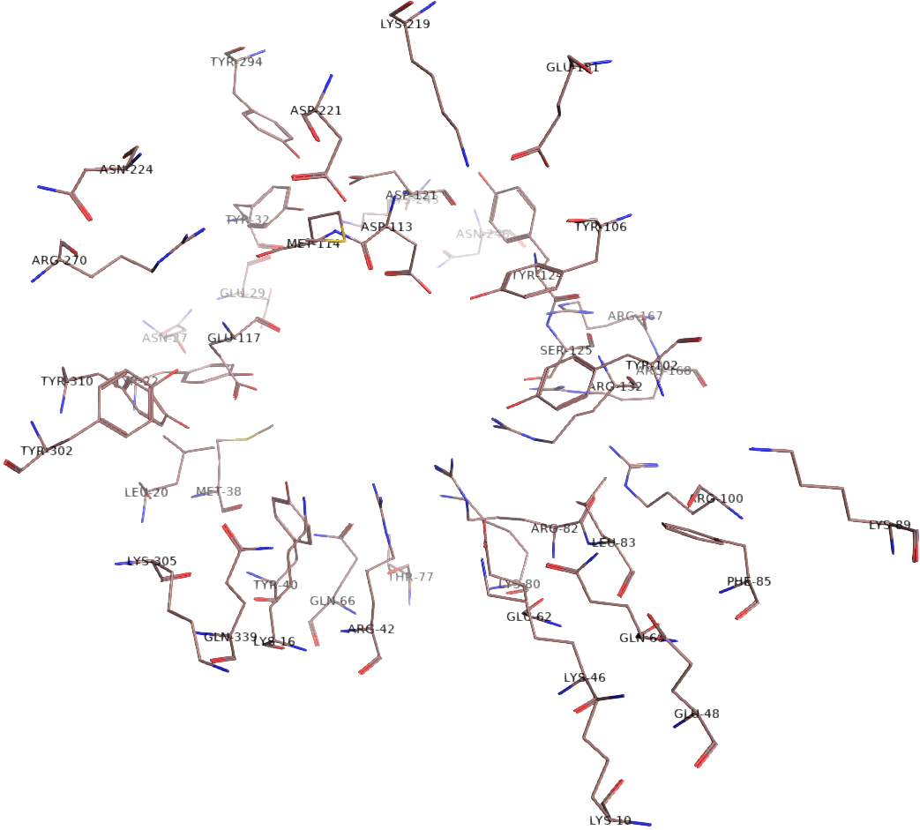

Supplementary Figure 5: Side chains of inner layer of the OmpF protein ion channel.

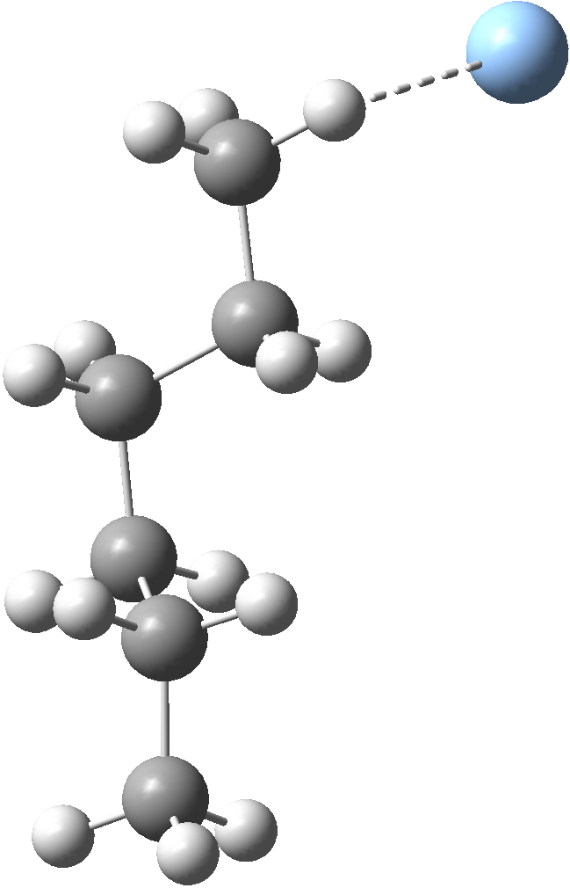
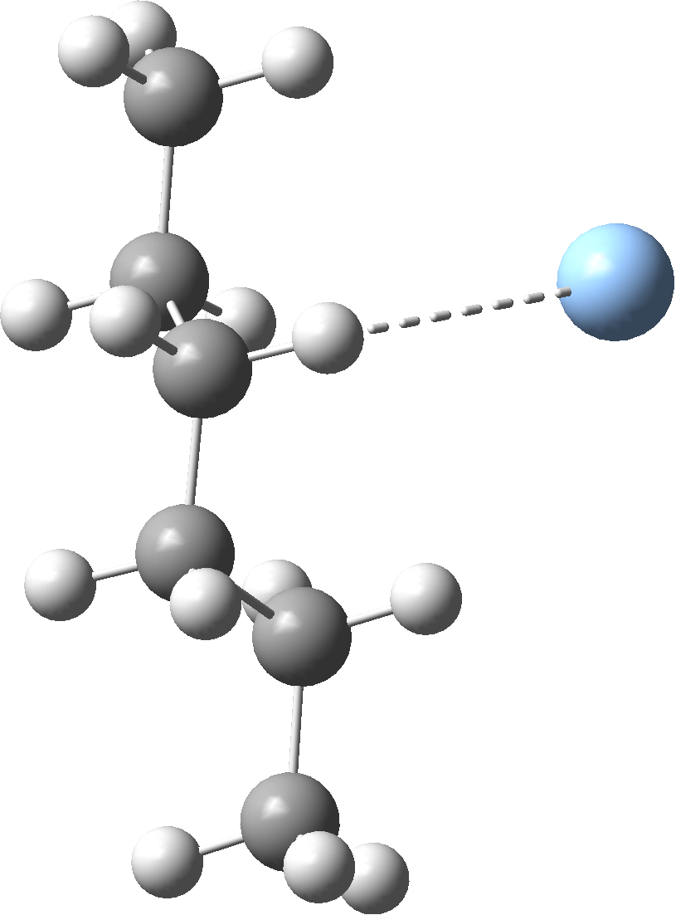
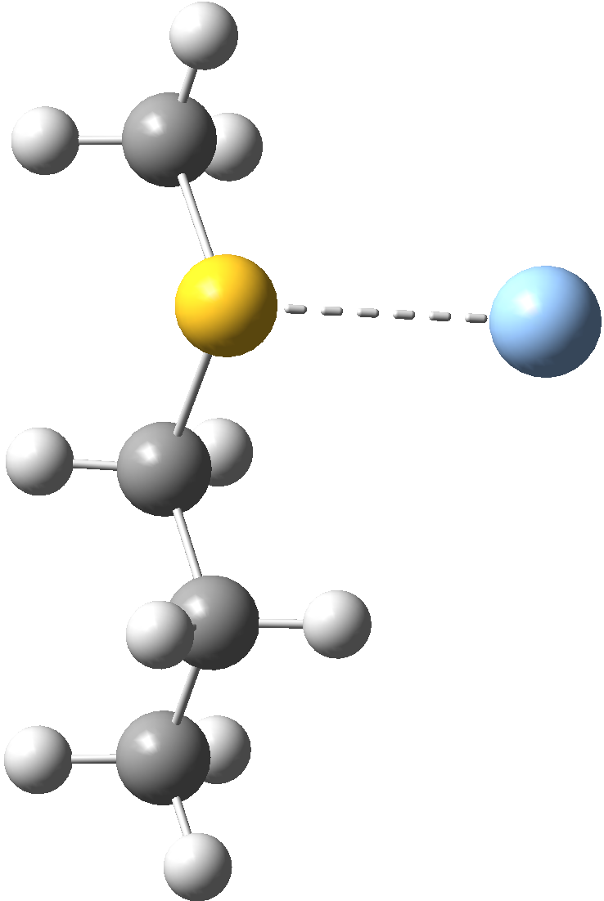
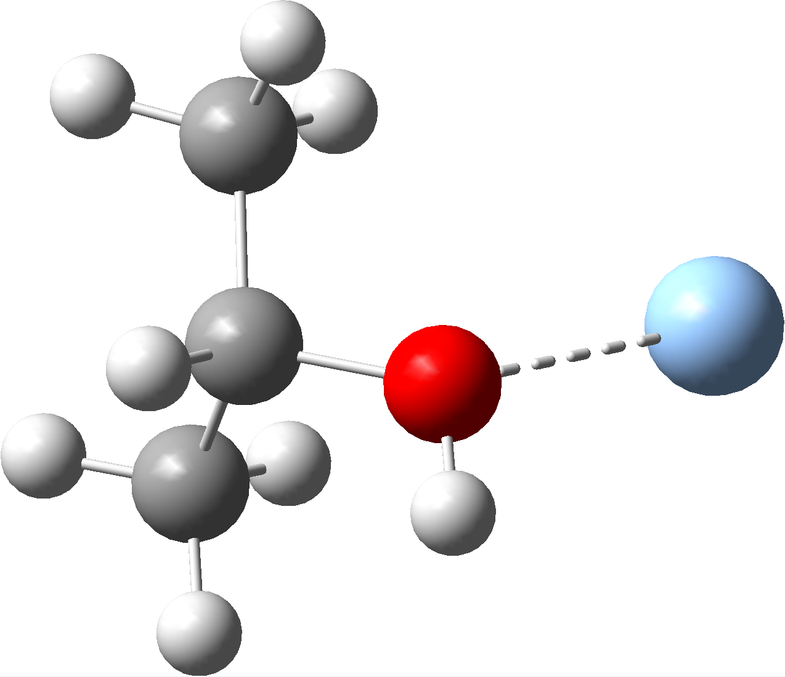
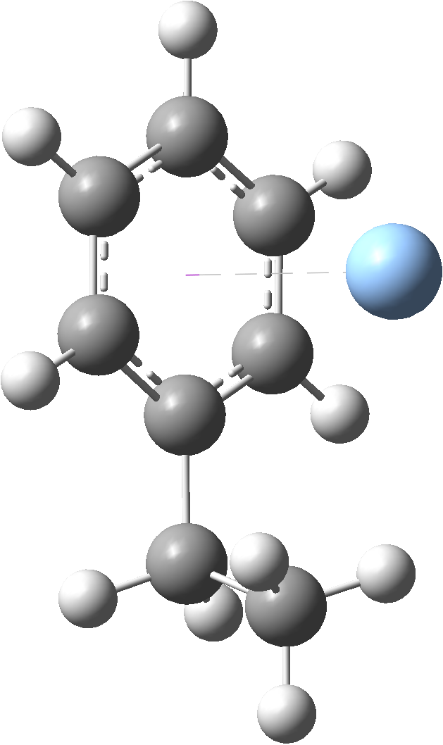

Ag⁰..Leu-CH₃ Ag⁺..Leu-CH₃ Ag..Met-CH₃ Ag..Thr-CH₃ Ag..Phe-CH₃
Supplementary Figure 6: The X-CH₃ complexes with Ag where X=Leu, Met, Thr and Phe.
X | Ag⁰..X-CH₃ | Ag⁺..X-CH₃ | Δ
Arg | 2.230 | 2.129 | -0.101
Asn | 2.436 | 2.201 | -0.235
Asp (via O₁) | 2.286 | 2.386 | 0.100
Asp (via O₂) | - | 2.415 | -
Gln | 2.429 | 2.206 | -0.223
Glu | 2.544 | 2.168 | -0.376
Lys | 2.579 | 3.305 | 0.726
Ser | 2.446 | 2.240 | -0.206
Tyr | 3.389 | 2.289 | -1.100
Val | 2.421 | 3.059 | 0.638
Trp | 3.217 | 2.489 | -0.728
Supplementary Table 1: Metal – ligand distance in Å. OmpC protein.

 | X-CH₃ | Ag⁰..X-CH₃ | Ag⁺..X-CH₃ | Ag⁰..X-CH₃ | Ag⁺..X-CH₃
 | E [a.u.] |  |  | ΔE [kcal/mol]
Arg | -362.4667 | -509.4637 | -509.3705 | -13.8 | -32.1
Asn | -248.4334 | -395.4156 | -395.3117 | -4.5 | -16.1
Asp | -267.8144 | -414.8063 | -414.7173 | -10.6 | -31.5
Gln | -287.7305 | -434.7175 | -434.6089 | -7.5 | -16.2
Glu | -307.57142 | -454.5533 | -454.3417 | -4.3 | 51.6
Lys | -253.4764 | -400.4570 | -400.3305 | -3.5 | -0.9
Ser | -154.9797 | -301.9620 | -301.8614 | -4.6 | -18.3
Tyr | -385.9291 | -532.9116 | -532.7997 | -4.7 | -11.3
Val | -158.3884 | -305.3688 | -305.2439 | -3.4 | -1.8
Trp | -442.2504 | -589.2327 | -589.1230 | -4.6 | -12.5
Supplementary Table 2: Metal – ligand energies of interactions in OmpC protein.

 | Ag⁰..X-CH₃ | Ag⁺..X-CH₃ | Δ
Leu | 2.959 | 2.453 | -0.506
Met | 2.832 | 2.549 | -0.283
Thr | 2.473 | 2.230 | -0.243
Phe | 3.664 | 3.456 | -0.208
Supplementary Table 3: Metal – ligand distances in Å, for Ag..X-CH₃ where X=Leu, Met, Thr and Phe.

 | X-CH₃ | Ag⁰..X-CH₃ | Ag⁺..X-CH₃ | Ag⁰..X-CH₃ | Ag⁺..X-CH₃
 | E [a.u.] |  |  | ΔE [kcal/mol]
Leu | -236.9799 | -383.9615 | -383.8348 | -4,1 | -1,4
Met | -556.5299 | -703.5195 | -703.4116 | -9,1 | -18,3
Thr | -194.2828 | -341.2662 | -341.1611 | -5,3 | -16,1
Phe | -310.7345 | -457.7223 | -457.6035 | -8,0 | -10,3
Supplementary Table 4: Metal – ligand energies for Ag..X-CH₃ where X=Leu, Met, Thr and Phe (OmpF protein).

