Supplementary Material
Supplementary Table 1 Formulas in the Study
 | Formulas | References
HOMA-IR | Ins (mU/L) × FPG (mmol/L)/22.5 | ¹
NFS | −1.675 + 0.037 × age (years) + 0.094 × BMI (kg/m²) + 1.13 × IFG/diabetes (yes = 1, no = 0) + 0.99 × AST/ALT– 0.013 × platelet (×10⁹/L) – 0.66 × albumin (g/dL) | ²
APRI | [AST/AST (ULN)]/ platelet (×10⁹/L) | ³
FIB-4 | (Age (years) × AST (U/L))/ ((PLT [10⁹/L]) × (ALT (U/L))^{1/2}) | ⁴
HOMA-IR, homeostasis model assessment-insulin resistance. NFS, NAFLD fibrosis score. APRI, AST-to-platelet ratio index. FIB-4, Fibrosis-4 index. ULN, upper limit normal.

Supplementary Table 2 Coefficients of selected variables in LASSO Cox regression model for all-cause mortality of participants
Variables | Coefficients
Age | 1.0934
SBP | 0.1695
CRP | 0.1599
HbA1c | 0.1340
Male | 0.1261
FIB-4 | 0.0553
TG | 0.0112
ALP | 0.0019
Waist circumference | 0.0015
Fasting insulin | 0.0011
NFS score | 0.0004
Partial likelihood deviance in the LASSO Cox regression model to analyze overall mortality among participants with complete covariates (N=12279). The variables were chosen by ten-fold cross-validation with minimum mean error.

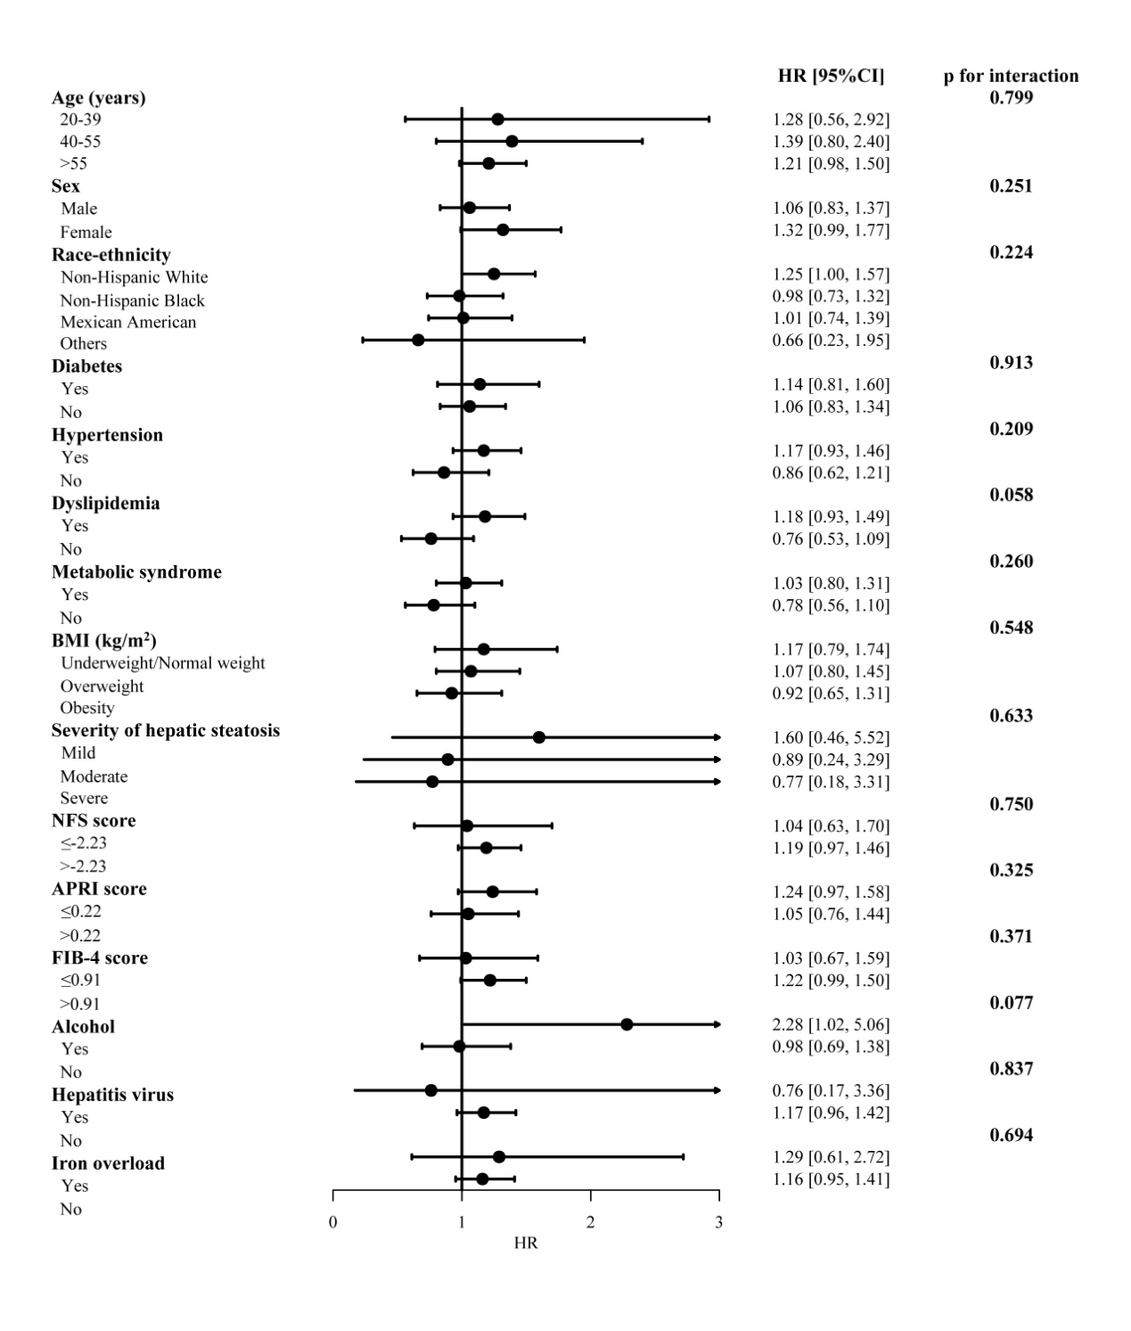
Supplementary Figure 1 Subgroup analysis for the cardiovascular mortality in participants with MAFLD.
The model was adjusted by adjusted by age, sex and race-ethnicity. MAFLD, metabolic dysfunction-associated fatty liver disease, compared with non-MAFLD participants. BMI, body mass index. HR, hazard ratio. CI, confidence internal. Significance was determined as p<0.005 (Bonferroni correction applied).
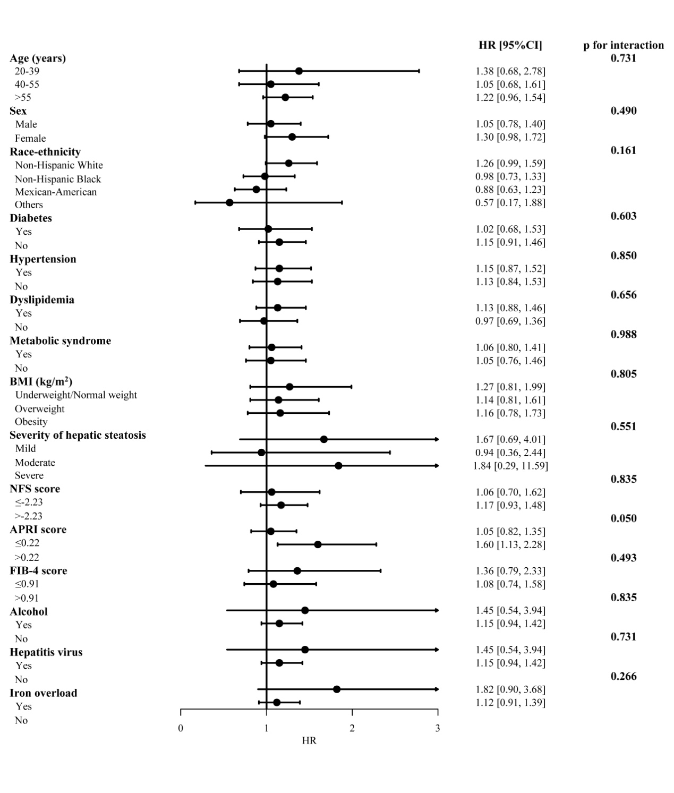Supplementary Figure 2 Subgroup analysis for the neoplasm mortality in participants with MAFLD. The model was adjusted by adjusted by age, sex and race-ethnicity. MAFLD, metabolic dysfunction-associated fatty liver disease, compared with non-MAFLD participants. BMI, body mass index. HR, hazard ratio. CI, confidence internal. Significance was determined as p<0.005 (Bonferroni correction applied).

References
1. Matthews DR, Hosker JP, Rudenski AS, Naylor BA, Treacher DF, Turner RC. Homeostasis model assessment: insulin resistance and β-cell function from fasting plasma glucose and insulin concentrations in man. Diabetologia. 1985;28:412–419.
2. Angulo P, Hui JM, Marchesini G, et al. The NAFLD fibrosis score: a noninvasive system that identifies liver fibrosis in patients with NAFLD. Hepatology. 2007;45:846–854.
3. Wai C-T, Greenson JK, Fontana RJ, et al. A simple noninvasive index can predict both significant fibrosis and cirrhosis in patients with chronic hepatitis C. Hepatology. 2003;38:518–526.
4. Vallet‐Pichard A, Mallet V, Nalpas B, et al. FIB‐4: an inexpensive and accurate marker of fibrosis in HCV infection. comparison with liver biopsy and fibrotest. Hepatology. 2007;46:32–36.

