Supplementary Material

An association between freezing response and plasma 17β-estradiol levels
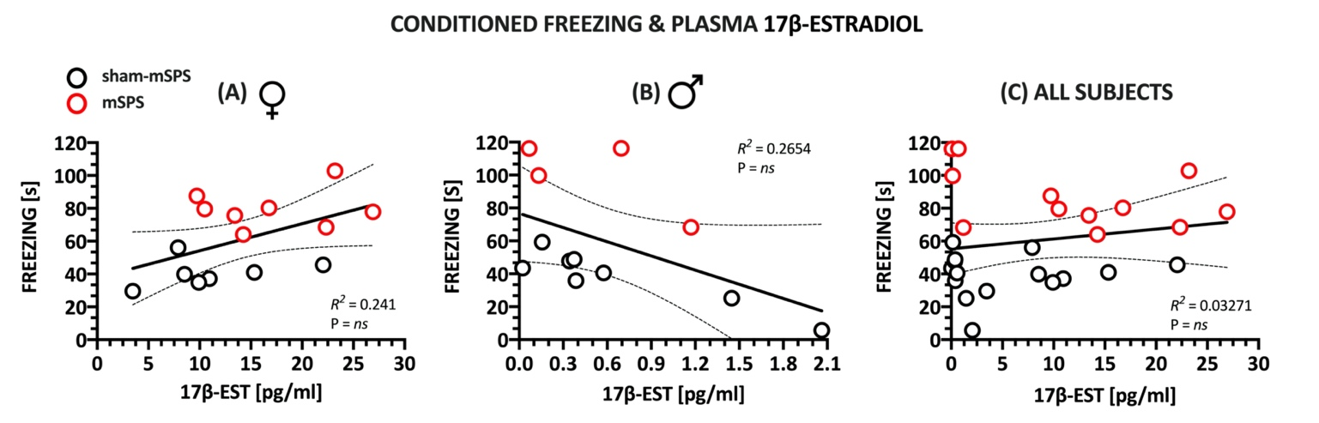
There was no significant correlation between freezing response and plasma estradiol levels in female and male mice or if sex was collapsed.

Supplementary Figure 1. Conditioned freezing did not correlate with plasma estradiol in female mice (A), male mice (B) or if sex factor was collapsed (C). Regression analyses were used to determine R² and statistical significance. The detailed statistic is included in the table below. Abbreviations: 17β-ESTR – 17β-estradiol, mSPS – mouse single prolonged stress.

The detailed results of statistical analyses included in the article and supplementary materials.
Table 1. ANOVA statistics

Figure | Statistical method | Dependent variable | Effects of independent variables and their interactions
 |  |  | mSPS | Sex | Treatment | mSPS x Sex | mSPS x Treatment | Sex x Treatment | mSPS x Sex x Treatment
Fig 2A, 2B | 3-way ANOVAa | Freezing time  [s] | F[1,84] = 60.68  P < 0.001  partial η² =0.419 | F[1,84] = 2.6  NS  partial η² = 0.03 | F[2,84] = 14.89  P < 0.001  partial η² = 0.262 | F[1,84] = 3.41  P=0.068  partial η² = 0.039 | F[2,84] = 5.35  P < 0.01  partial η² = 0.113 | F[2,84] = 0.297  NS  partial η² = 0.007 | F[2,84] = 0.706  NS  partial η² = 0.017
Fig 2A | 2-way ANOVA | Freezing time  [s] | F[1,42] = 38.18  P < 0.001  partial η² = 0.449 | NA | F[2,42] = 16.41  P < 0.001  partial η² = 0.439 | NA | F[2,42] = 4.78  P < 0.05  partial η² = 0.186 | NA | NA
Fig 2B | 2-way ANOVA | Freezing time  [s] | F[1,42] = 31.309  P < 0.001  partial η² = 0.427 | NA | F[2,41] = 4.526  P < 0.05  partial η² = 0.177 | NA | F[2,41] = 2.418  NS  partial η² = 0.103 | NA | NA
Fig 2C  Fig 2D | 3-way ANOVA | CORT  [ng/ml] | F[1,78] = 9.33  P < 0.01  partial η² = 0.107 | F[1,78] = 154  P < 0.001  partial η² = 0.664 | F[2,78] = 4.5  P < 0.05  partial η² = 0.104 | F[1,78] = 25.96  P < 0.001  partial η² = 0.25 | F[2,78] = 1.96  NS  partial η² = 0.048 | F[2,78] = 10.34  P < 0.001  partial η² = 0.21 | F[2,78] = 10.03  P < 0.001  partial η² = 0.204
Fig 2E  Fig 2F | 3-way ANOVAa | 17β-ESTR  [pg/ml] | F[1,71] = 7.3  P < 0.01  partial η² = 0.093 | F[1,71] = 46.02  P < 0.001  partial η² = 0.395 | F[2,71] = 4.06  P < 0.05  partial η² = 0.103 | F[1,71] = 0.46  NS  partial η² = 0.006 | F[2,71] = 9.5  P < 0.001  partial η² = 0.211 | F[2,71] = 2.94  NS  partial η² = 0.076 | F[2,78] = 0.8  NS  partial η² = 0.022
Fig 2E | 2-way ANOVA | 17β-ESTR  [pg/ml] | F[1,39] = 1.48  NS  partial η² = 0.037 | NA | F[1,39] = 2.86  ns  partial η² = 0.126 | NA | F[2,39] = 5.54  P < 0.05  partial η² = 0.221 | NA | NA
Fig 2F | 2-way ANOVA | 17β-ESTR  [pg/ml] | F[1,32] = 17.5  P < 0.001  partial η² = 0.353 | NA | F[1,32] = 9.87  P < 0.001  partial η² = 0.382 | NA | F[2,32] = 7.67  P < 0.01  partial η² = 0.324 | NA | NA
Fig 2G | 2-way ANOVA | TEST  [pg/ml] | F[1,37] = 13.2  P < 0.001  partial η² = 0.263 | NA | F[2,37] = 13.14  P < 0.001  partial η² = 0.415 | NA | F[2,37] = 0.75  NS  partial η² = 0.039 | NA | NA
Fig 2H | 2-way ANOVA | TEST  [pg/ml] | F[1,37] = 36.3  P < 0.0001  partial η² = 0.502 | NA | F[2,36] = 3.82  P < 0.05  partial η² = 0.175 | NA | F[2,36] = 1.68  NS  partial η² = 0.085 | NA | NA

Table 2. Regression and correlation analyses.
Correlation and regression analyses
Fig 3A | R²=0.45; F[1,14]=11.8; P<0.01; Adjusted R² = 0.4185; line: Y = 0.233*X + 37.52; slope = 0.233 ± 0.06783; 95%CI: 0.08749 to 0.3784; Y Intercept = 37.52 ± 7.724; 95%CI:20.95 to 54.09; r= 0.6762; 95%CI: 0.2716 to 0.8777
Fig 3B | R²=0.48, F[1,13]=12.47; P<0.01; Adjusted R²= 0.4503; line: Y = -0.5881*X + 79.32; slope = -0.5881 ± 0.1666; 95%CI: -0.9479 to -0.2283; Y Intercept = 79.32 ± 7.794; 95%CI:62.48 to 96.16; r = -0.6997; 95%CI: -0.8922 to -0.2921.
Fig 3C | R²=7.958e-005, F[1,29]=2.308e-003; P=NS; P<0.01 Adjusted R² = -0.0344; line: Y = -0.003934*X + 62.02; slope = -0.003934 ± 0.0819; 95%CI: -0.1714 to 0.1636; Y Intercept = 62.02 ± 7.211; 95%CI: 47.27 to 76.76; r = -0,00892; 95%CI: -0,3621 to 0,3465
Fig 3D | R²=0.6131; F[1,12]=19.02; P < 0.001; Adjusted R² = 0.5809, line: Y = 0.2357*X + 40.43; slope = 0.2357 ± 0.05405; 95%CI: 0.1179 to 0.3535; Y Intercept = 40.43 ± 5.385; 95%CI: 28.69 to 52.16; r= 0.7830; 95%CI: 0.4318 to 0.928
Fig 3E | R²=0.4922; F[1,13]=2.92; P < 0.01; Adjusted R² = 0.4532, line: Y = 0.007598*X + 37.71; slope = 0.007598 ± 0.00214; 95%C: 0.002974 to 0.0122; Y Intercept = 37.71 ± 9.994; 95%CI: 16.12 to 59.30; r= 0.7016; 95%CI: 0.2956 to 0.8929
Fig 3F | R²=0.3057; F[1,27]=11.89; P < 0.01; Adjusted R² = 0.28, line: Y = 0.005446*X + 51.41; slope = 0.005446 ± 0.00214; 95%C: 0.002205 to 0.008687; Y Intercept = 51.41 ± 9.994; 95%CI: 40.52 to 62.3; r= 0.5529; 95%CI: 0.2338 to 0.7645
Suppl Fig 1A | R²=0.241; F[1,13]=4.128; P = 0.063; Adjusted R² = 0.1826, line: Y = 1.647*X + 37.70; slope = 1,647 ± 0,8105; 95%CI: -0.1043 to 3.398; YIntercept = 37.7 ± 12.76; 95%CI: 10.13 to 65.27; r= 0.49; 95%CI: -0.02852 to 0.8016
Suppl Fig 1B | R²=0.2654; F[1,10]=3.614; P = 0.0865; Adjusted R² = 0.1920, line: Y = Y = -28.73*X + 76.71; slope = -28.73 ± 25.11; 95%CI: -62.41 to 4.945; YIntercept = 76.71 ± 13.08; 95%CI: 47.55 to 105.9; r= - 0.5152; 95%CI: - 0.8406 to 0.0833
Suppl Fig 1C | R²=0.03271; F[1,25]=0.8453; P = 0.36; Adjusted R² = -0.00598, line: Y = Y = 0.5991*X + 55.31; slope = 0.5991 ± 0.6516; 95%CI: -0.7429 to 1.941; YIntercept = 55.31 ± 7.657; 95%CI: 39.54 to 71.08; r= - 0.1808; 95%CI: -0.2139 to 0.5248

a Due to insignificant third-order interaction, but significant effects of treatment and mSPS factors and their interactions, analyses were split out into two 2-way ANOVAs based on sex. Abbreviations: 17β-ESTR – 17β-estradiol, ANOVA – analysis of variance, CORT – corticosterone, NA – not applicable, NS: P > 0.05, TEST –testosterone.
a Due to insignificant third-order interaction, but significant effects of treatment and mSPS factors and their interactions, analyses were split out into two 2-way ANOVAs based on sex. Abbreviations: 17β-ESTR – 17β-estradiol, ANOVA – analysis of variance, CORT – corticosterone, NA – not applicable, NS: P > 0.05, TEST –testosterone.
Abbreviations: 95% CI : 95% confidence interval, NS: P > 0.05.

