The biodiversity and distribution of abyssal benthic foraminifera and their possible ecological roles: a synthesis across the Clarion-Clipperton Zone.
Andrew J. Gooday^{1,2*}, Franck Lejzerowicz^{3,4}, Aurélie Goineau¹, Maria Holzmann⁵, Olga Kamenskaya⁶, Hiroshi Kitazato⁷, Swee-Cheng Lim⁸, Jan Pawlowski^{5,9,10}, Teresa Radziejewska¹¹, Zofia Stachowska¹¹, Brygida Wawrzyniak-Wydrowska¹¹

Supplementary Material
Supplementary Figure S2

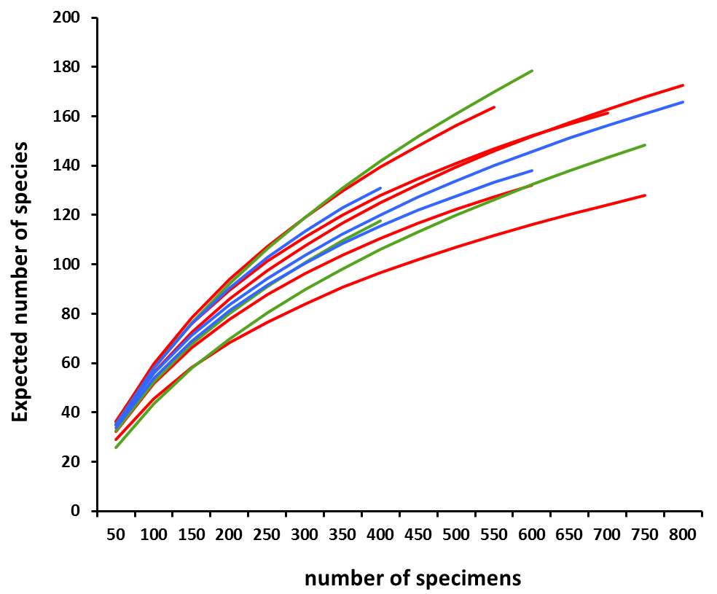
Supplementary Figure S2. Rarefaction curves for 11 megacorer samples (0-1 cm layer, >150-µm fraction) from UK-1 Strata A (red) and B (green) and OMS Stratum (blue). Data from Goineau and Gooday (2019).

