Fig. S1: Coexpression analysis of 12 TF genes with CAld5H1 and CAld5H2. The network is generated using the AspWood web resource (http://aspwood.popgenie.org).

Fig. S2: Expression patterns of 12 TF and two CAld5H genes in stem cryosections of P. tremula, generated using the AspWood web resource (http://aspwood.popgenie.org).

Fig. S3: Protein-protein interactions among 12 TFs by Luciferase Complemntary Image (LCI) assays. Two proteins were co-expressed in tobacco leaves, with one fused to N-ermianl portion of LUC (nLUC) and the other fused to C-termianl portion of LUC (cLUC). The 12 TFs are listed in Supplementary Table S2, and the numbers of interactions for homodimer and heterodimer formation among 12 TFs are shown in Supplementary Table S3.
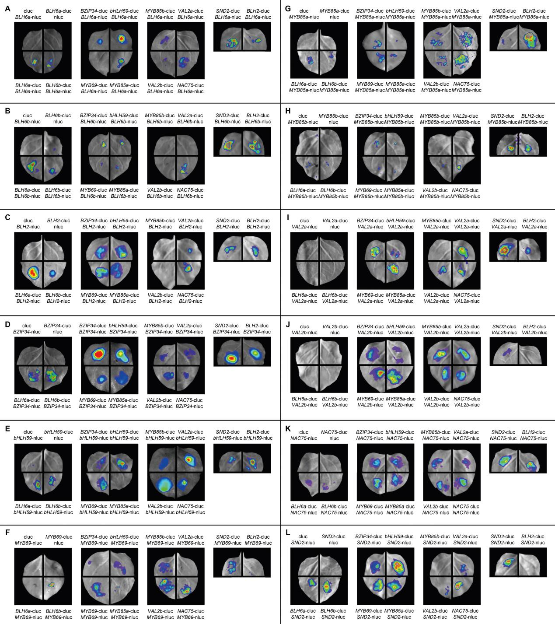

Fig. S4: Detection of transgene BLH6a:SRDX expression levels by qRT-PCR in the leaves of 36 transgenic lines.

