Supplementary Figure 2. Distribution of the cell lines
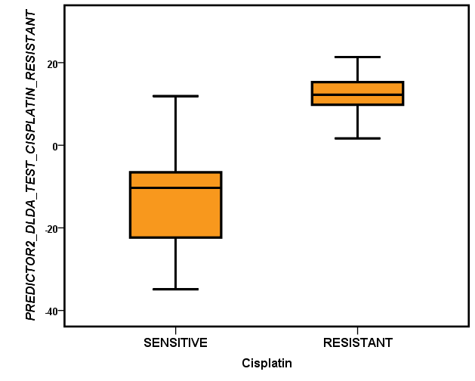

Distribution of the sensitive and resistant cell lines based on the predictor generated with the DLDA test.

